Where is the best place for a Home Care Shop in Bronx?

# Introduction/Business Problem

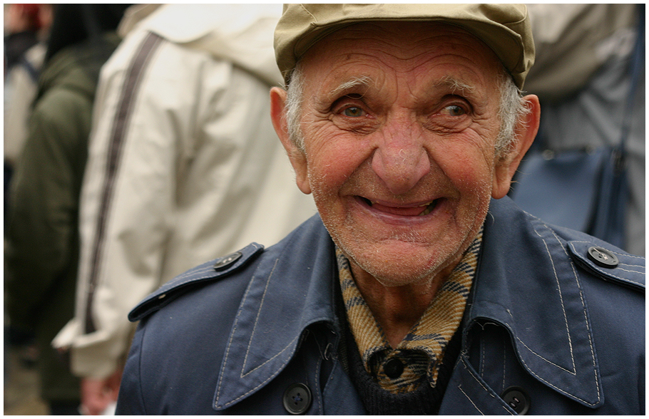

[Esta foto](https://en.wikiversity.org/wiki/Low_Vision_Rehabilitation/Optical_management_of_low_vision) de Autor desconocido está bajo licencia [CC BY-SA](https://creativecommons.org/licenses/by-sa/3.0/)

The older adult population is growing every day. For that reason, we want to know the best place at Bronx to build a nursing home. To do this, we will use information from the neighborhoods. We need to find the best neighborhood for build the nursing home. We need one with the most amount of pharmacies and doctor´s offices, because the elderly need a quick attentions if the get sick.

# Data

Based on definition of our problem, factors that will influence our decission are:

* number of doctor´s office in the neighborhood
* number of pharmacies

Following data sources will be needed to extract/generate the required information:

* The dataset of neighboors that exist for free on the web: https://geo.nyu.edu/catalog/nyu_2451_34572
* FourSquare API to get the pharmacies and Doctor´s Office of each neigborhood.

# Methodology

In this project we will detect the neighboors with most pharmacies, and most doctor's office in the area.

In first step, we classified each venue per category, and then, group rows by neighborhood and by taking the mean of the frequency of occurrence of each category of interest.

We sort then by frecuency, and get the neighboors with most pharmacies and doctor´s office.

If have to borrow if a neighborhood doesn´t have a doctor´s office.

# Analysis

First, we classified each venue

Then, we get the values we need, and sort them

The first neighborhoods don't have doctor's office, so we drop them

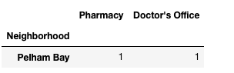

# Results and discussion

The places with the most pharmacies are Fordham, High Bridge, Melrose and Mount Eden. But they have the disadvantage of not having an Doctor´s office, so there is not viable to build a home care there.

Only one Neighborhood has a pharmacy and doctor´s office, one of each.

# Conclusion

Because both are essential services, and need to exist, the only place where the center can be built is in Pelham Bay