Luis Gerardo Bravo Ramones A01282014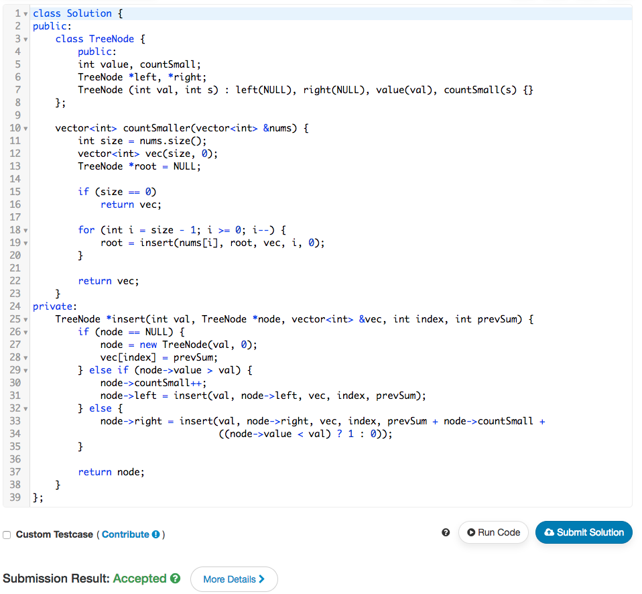

class Solution {

public:

class TreeNode {

public:

int value, countSmall;

TreeNode \*left, \*right;

TreeNode (int val, int s) : left(NULL), right(NULL), value(val), countSmall(s) {}

};

vector<int> countSmaller(vector<int> &nums) {

int size = nums.size();

vector<int> vec(size, 0);

TreeNode \*root = NULL;

if (size == 0)

return vec;

for (int i = size - 1; i >= 0; i--) {

root = insert(nums[i], root, vec, i, 0);

}

return vec;

}

private:

TreeNode \*insert(int val, TreeNode \*node, vector<int> &vec, int index, int prevSum) {

if (node == NULL) {

node = new TreeNode(val, 0);

vec[index] = prevSum;

} else if (node->value > val) {

node->countSmall++;

node->left = insert(val, node->left, vec, index, prevSum);

} else {

node->right = insert(val, node->right, vec, index, prevSum + node->countSmall +

((node->value < val) ? 1 : 0));

}

return node;

}

};