To install and test the extension follow steps:

1 Run Adobe Extension Manager

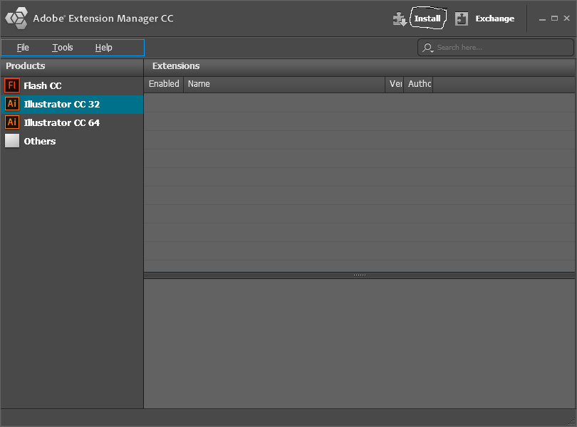

Click the button “Install” and choose file “AuthorizeDialog.zxp”. When the license dialog appears click “Acept”

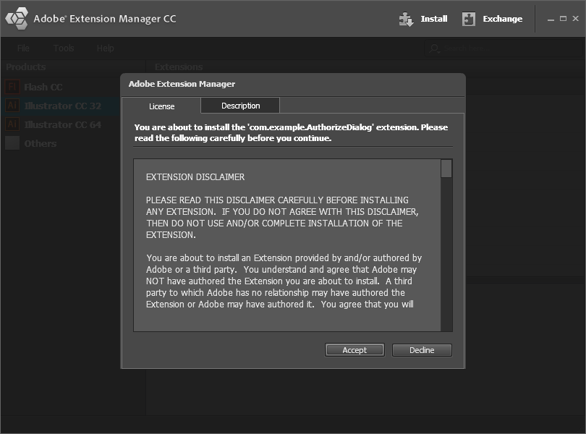

When the warning dialog appears click “Install”

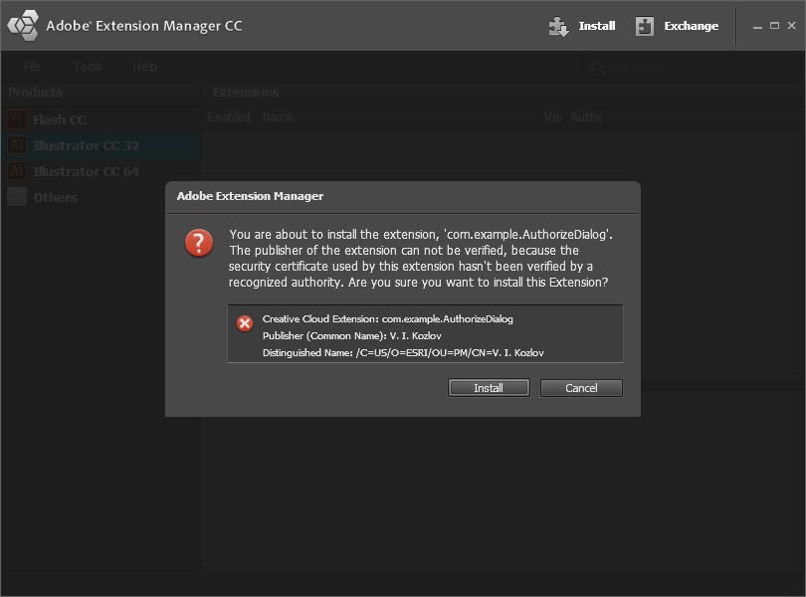

2 Install extension “AutorizationPrototype.zxp” (the same way)

3 Close Adobe Extension Manager and run Adobe Illustrator. Choose menu “Womdow\Extension”. You’ll see.

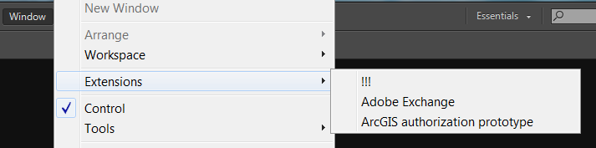

Choose “ArcGIS authorization prototype”. You’ll get the window.

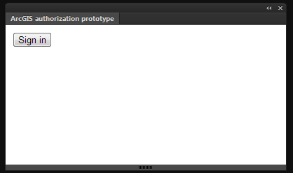

The button “Sign in” is disable in the beginning. When it is contrast (enable) press it. The authorization dialog will appear.

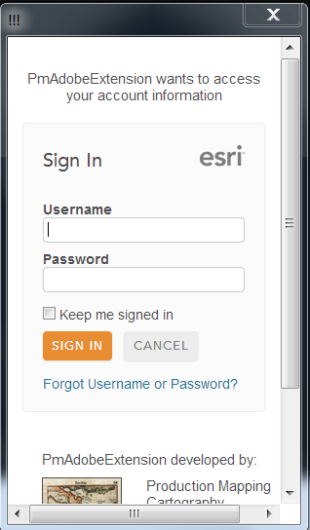

Loading the authorization page can take some time. Input your login and password then press “sign in”. The properties of your first published item will appear in the window “ArcGIS authorization prototype”.

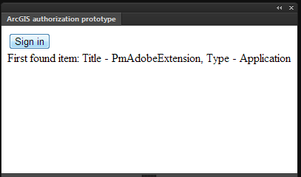

In my case it is the application which I created in ArcGIS Online.

Remarks: As you can see the menu item “!!!” is in the menu “Extension”. It is the extension which is used as “Authorization Dialog”. Now I’m finding the way to avoid this. I mean to use an extension without installation.

The procedure is following:

1. After clicking on the button “Sign in” the extension creates the unique ID of the request and save it. Then it sends the ID to the service which accumulates the statistics about authorization requests. After this it runs Authorization Dialog and waits the report from the service about execution of request. The service is published on my computer now.
2. When the Authorization Dialog runs, the ID of the request is restored and the dialog is redirected to the page http://testauth.dataeast.com/AH/oauth-callback.html . Which is published in the HTTP server on my computer for now. The redirecting is accompanied by ID of the request.
3. Code of this page saves the ID and then it is redirected to ArcGIS Online authorization page. After finishing authorizing, ArcGIS Online redirects control back to http://testauth.dataeast.com/AH/oauth-callback.html . Next it restores ID of the request and sends the information about results to the service. After this the dialog is closed by itself.
4. When the extension gets results of the authorization it requires the ArcGIS Online for appropriate resources.

I understand that it looks complicated and weird. But I tried a lot of approaches including those which Adobe staff advised. But all of them failed sooner or later. I tried to use the approach for mobile applications but it does not work too, because it is not possible to manipulate external windows from the extensions (they say: it will change). Adobe published that they are ready to issue the products with new version of browser for HTML5 extensions. But they don’t say when it happens. So it is all I could do.

Just think: is it reasonable to use this? Maybe there is a possibility to ask ArcGIS Online team to add trusted authorization? I mean the case when application itself pass user name and password. They could develop some special registration for such applications or something like this.