To install and test the extension follow steps:

1 Run Adobe Extension Manager

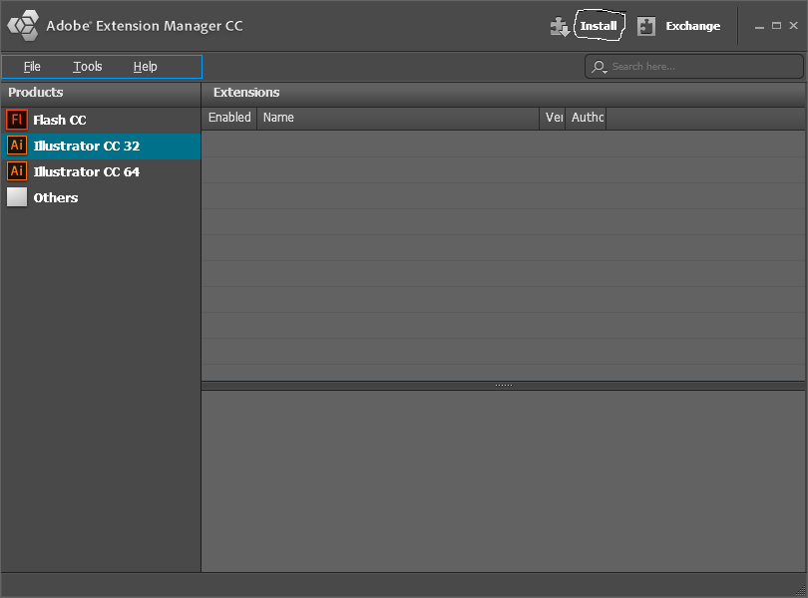

Click the button “Install” and choose file “AuthorizeDialog.zxp”. When the license dialog appears click “Acept”

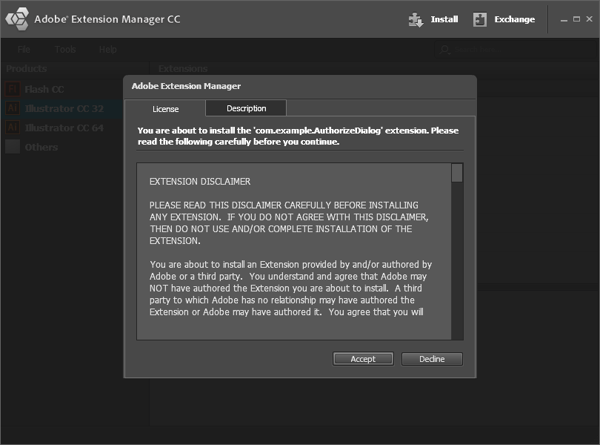

When the warning dialog appears click “Install”

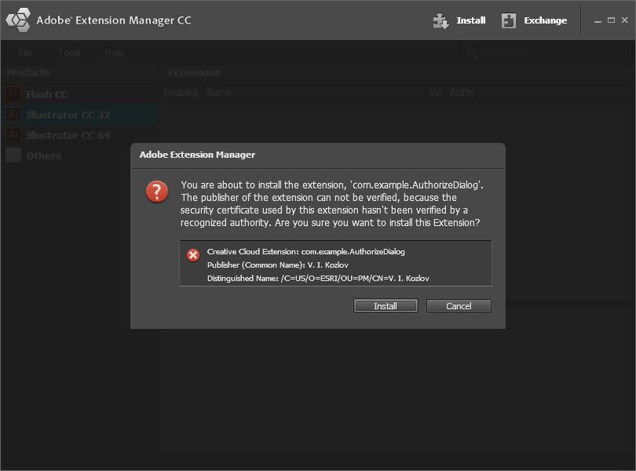

2 Install extension “AutorizationPrototype.zxp” (the same way)

3 Close Adobe Extension Manager and run Adobe Illustrator. Choose menu “Womdow\Extension”. You’ll see.

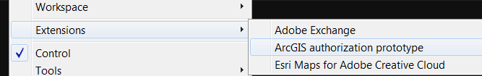

Choose “ArcGIS authorization prototype”. You’ll get the window.

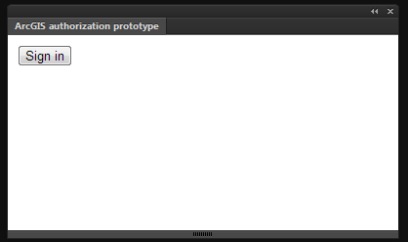

The button “Sign in” is disable in the beginning. When it is contrast (enable) press it. The authorization dialog will appear.

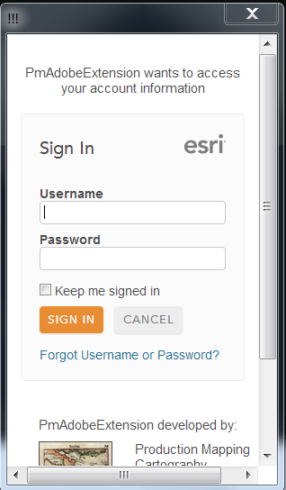

Loading the authorization page can take some time. Input your login and password then press “sign in”. The properties of your first published item will appear in the window “ArcGIS authorization prototype”.

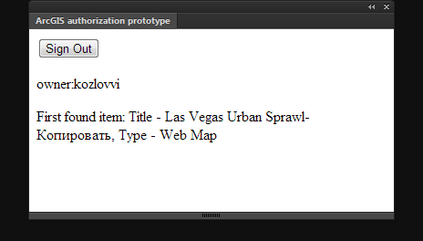

In my case it is the map which I imported from ArcGIS Online.

The procedure is following:

1. The extension creates a callback for processing events about authorizing.
2. The extension runs another extension, which acts as a modal dialog.
3. The last extension redirects to ArcGIS Online authorization page.
4. After user authorized, ArcGIS redirects to the URI - <http://pod.arcgis.com/oauth/oauth-callback.html>
5. As this page is run in AI extension dialog it creates the event with the results of authorizing and sends it out.
6. Modal dialog extension closes itself.
7. The main extension receives event and process it.

Unfortunately I could not exclude the redirect page (<http://pod.arcgis.com/oauth/oauth-callback.html>). It’s because the HTML5 Adobe extensions cannot get content of another Adobe extension. I’ve discussed this with Adobe guys: they don’t plan such functionality.