**This document lists the steps taken to prepare an Adobe Illustrator (AI) file in Adobe Illustrator that has been exported from ArcMap.**

# Legacy Text

The first difference between the exported files is the initial warning that lets you know the legacy text must be updated. I believe this is because the Illustrator version to which ArcMap exports is outdated. You always have to click *Update* otherwise there are major text issues in the Illustrator file, such as strings of text getting broken up, or kerning and tracking getting messed up (see Fig. 1).

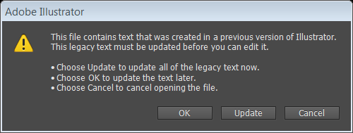

**Figure 1 –Legacy Text warning upon opening ArcMap’s Adobe Illustrator exported file for the first time**.

# Original Layer Structure

The second difference between this AI file and the PDF is a major one. The layer structure is much more usable, and is identical to the TOC from ArcMap in terms of order and organization (see Fig. 2). This is very nice, since it will not require any regrouping.

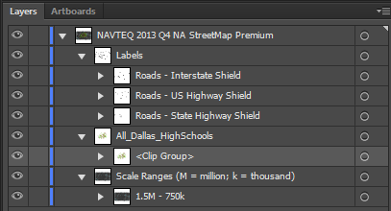

Figure 2 – The initial layer structure in the AI export with layers expanded.

# Changing Layer Hierarchy

If we keep the *NAVTEQ 2013 Q4 NA StreetMap Premium* as the top layer that contains all other layers (see Fig. 2 above), then making global changes to artwork that pertain to size and position treat the entire layer that you are trying to edit as one piece of artwork rather than individual pieces of artwork, even if you specify that you want to treat them individually. For this reason, all the layers (for this file, it is *Labels, All Dallas Schools,* and *Scale Ranges*…) will need to be dragged above the *NAVTEQ 2013 Q4 NA StreetMap Premium* layer, and then the *NAVTEQ 2013 Q4 NA StreetMap Premium* can be deleted since it will be empty.

## Select all the sub-layers

To select all the layers that will be dragged above *NAVTEQ 2013 Q4 NA StreetMap Premium*, click on the area just to the right of the layer name of each layer you want to drag (usually all layers). You can hold control to select multiple layers (see Fig. 3).

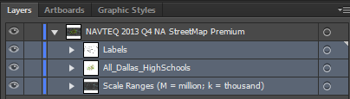

Figure 3 – The layers that are selected appear in a faint blue hue.

By clicking and dragging these layers above the *NAVTEQ 2013 Q4 NA StreetMap Premium* they will retain their layer order, and then *NAVTEQ 2013 Q4 NA StreetMap Premium* can be deleted (see Fig. 4).

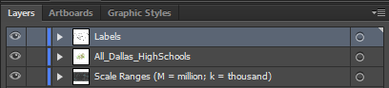

Figure 4 – The layers that were dragged above the *NAVTEQ 2013 Q4 NA StreetMap Premium* layer are now at the main level, and the *NAVTEQ 2013 Q4 NA StreetMap Premium* where they used to be embedded in has been deleted.

Upon investigating further, I notice that there are some layers that are still nested too far into other unnecessary layers. The *Roads, Hydrology, Landmarks, TZ_ZipCodes,* and *Land* layers are nested within two higher-level layers that are meaningless to the structure of the layers, and will make it a little more difficult to work with. So these layers also need to be dragged above *Scale Ranges (M = million; k = thousand) 🡪 1.5M - 750k.* (See Fig. 5a&b).

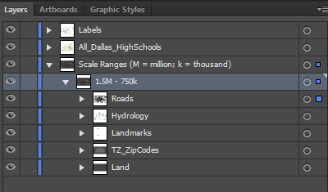 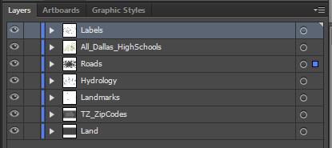

Figure 5 – The *Roads, Hydrology, Landmarks, TZ_ZipCodes,* and *Land* layers need to be dragged above *Scale Ranges (M = million; k = thousand) 🡪 1.5M - 750k.* 5a on the left shows before, and 5b on the right shows after dragging these layers and deleting the now-empty *Scale Ranges (M = million; k = thousand) 🡪 1.5M - 750k* layers.

# Clipping Paths

While the initial layer structure is much easier to work with as-is, the clipping paths still need to be removed. The process is the similar as working from the PDF file, but is a little better when working with an AI Export. Page 4 illustrates this process of deleting clipping paths and organizing layers, however I could also run the JS script that can be found on the internet. Either way, the clipping paths need to be deleted in order for it to be workable within the Illustrator environment.

**WHY?**

This structure requires “unpacking” in order to get the artwork to a point where editing can be done with ease. Notice in Fig. 6 the area that is highlighted with clicking on the map is not highlighting the polygon that was clicked, but is highlighting the entire perimeter of the artboard. That is because it is selecting all artwork in the clipping path. It takes 3 double-clicks to select an individual piece of artwork (data) to manipulate and edit. This is time consuming and problematic for many reasons, one of which is that global changes become impossible since they are applied to the clipping path as well. Fig. 6 also shows that in order to get to a level of editing, you would have to be working in isolation mode.

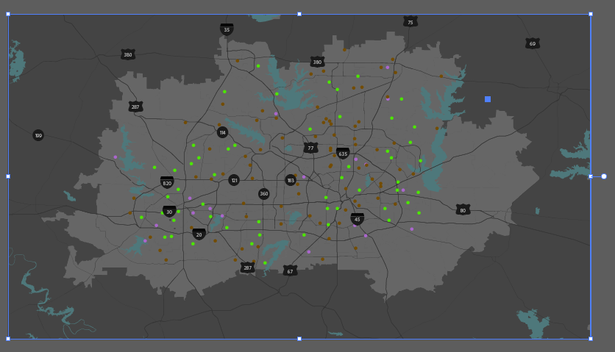

Figure 6 – Selecting artwork before removing clipping paths

# Deleting Clipping Paths and Organizing Layers when Working from an .AI Export (rather than a .PDF export).

The following steps are what need to be done manually if the RemoveClippingPaths.JS is not run.

## Expand Each layer one-by-one to locate and then delete clipping paths

1. **Expand Layers to find Clipping Path –** Each clipping path sits right above the sub-layer that actually has the artwork, so in order to find and select the clipping paths the layers have to be expanded (see Fig. 7)

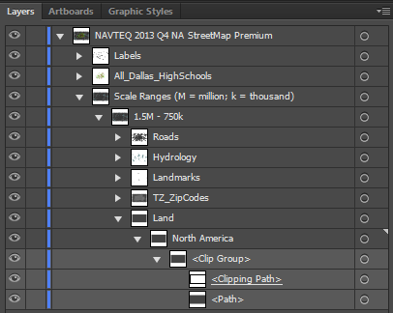

Figure 7 – The above image shows the clipping path for the bottom most layer, which had to be shown by expanding *Scale Ranges (M = million; k = thousand) 🡪 Land 🡪 North America 🡪 <Clip Group>*

1. **Delete Clipping Path –** By selecting the area on the layers panel that sits to the right of the round button in the layer name of <Clipping Path>, this selects the path itself. Then I delete the clipping path by either pressing the Delete key or by clicking on the trash can symbol at the bottom right of the Layers Panel. Notice that when I delete the clipping path, the artwork becomes visible beyond the artboard. It was always there, obviously, but the clipping path was keeping it from being visible (see Fig. 8a&b).

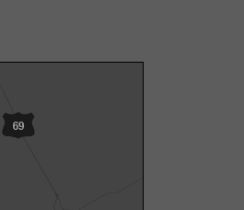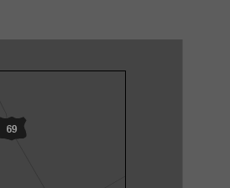

Figure 8 a (left) and 5 b (right) – Figure 8a on the left shows what the North America layer looks like before deleting the clipping path. Figure 8b shows what the North America layer looks like after deleting the clipping path. Notice that the artwork extends beyond the artboard after the clipping path is deleted. This was always the case, now it can be seen.

Another thing that happens when the clipping paths are deleted is that the artwork stays within <Group> layers that are nested within their proper layer (see Fig. 9)

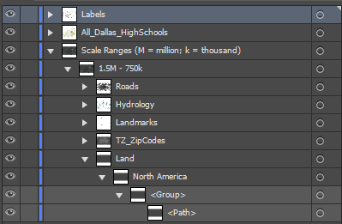

Figure 9 – Once the clipping path for the artwork in the *Land 🡪 North America* layer has been deleted, it is still grouped. I want to keep it within this North America Layer to separate it from other Land categories that I might have, but it does not need to be grouped, at least not usually.

1. **Ungrouping Layers –** Because the layer structure is so nice already, I don’t usually need them to stay in these groups ; having them in the *North America* sub-layer of *Land* is perfectly organized. Grouping is usually something that people who work will Illustrator will do with things that are parts of a whole, such as symbols, so moving them can be done with one action. I always like to ungroup my AI exports.
   1. Select the group layer and **ungroup (don’t delete).** Deleting it deletes the artwork, unlike when you delete a clipping path, which just deletes an application of a tool. To ungroup, with the group selected either press Shift+GTRL+G or go to the Object menu 🡪 Ungroup
2. **Repeat Steps a & b until all paths are gone and all layers are ungrouped.**

# Dealing with ArcMap’s weird text point size issue –

All the labels for this particular map are within Highway shields. Normally there are labels that are just text without being part of a symbol. Usually, if you have to ungroup text that is part of a symbol, you will want to re-group them later on. However, for the sake of this document, it is important to illustrate how text comes in from ArcMap as an AI export. So, I’ve ungrouped the highway shields, and selected one of the text strings. Notice that the Character settings for the text is wrong. The font is correct, the typeface is correct, but the window for point size says “1” which is clearly incorrect, since we can see and read the text on the map. If it was truly 1 pt., we would not be able to see it. (see Fig. 10).

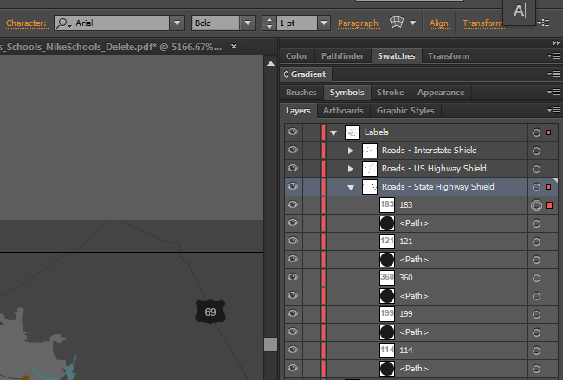

Figure 10 – After ungrouping the text layers, I have selected one of the text strings, *183* from the layers panel the Character Settings information at the top shows that the point size is 1 pt, when really it is much larger than this.

If I tried to change this by changing the character settings, for example if I changed the “1pt” to “10 pt” it would make the text string HUGE (see Fig. 11).

There is a weird strange trick that works every time:

* 1. Before editing any text in an ArcMap export of an AI file, select all the text.
  2. Then move all the selected text by pressing the up arrow key. Notice that the point size in the Character Settings updated to the true point size.
  3. With all the text still selected press the down arrow key once to reposition it to its original spot.

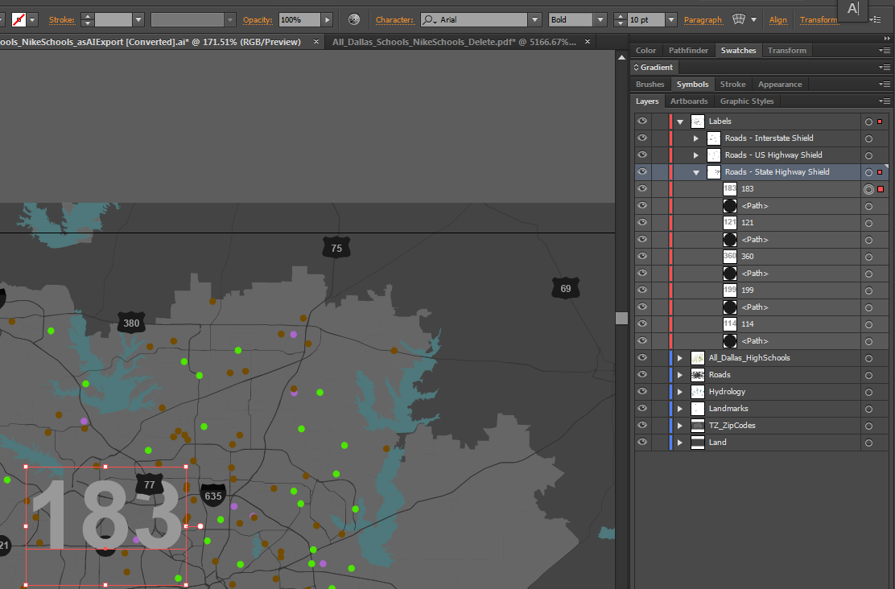

Figure 11 – The changes that happen to a text string if you try to change the initial point size via the character settings prior to doing the secret trick. Notice that I changed the point size to 10, but the font on the map is actually more like a 72 pt.

# Setting Layer Color

The actual colors of the layers can be changed in Illustrator. This helps visualize and easily find certain types of data. Also, it helps people know that the artwork they select belongs to a particular layer or particular type of layer.

1. To change the layer color in CS6 and Creative Cloud (this process varies slightly in previous versions of Illustrator), double click on the layer (but *not* on the name of the layer), and a Layer Options box will pop up (see Fig. 12).

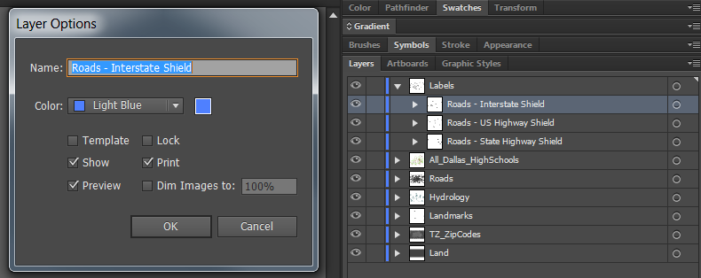

Figure 12 – After double clicking on the *Roads - Interstate Shield* layer, the Layer Options for this layer popped up.

1. From the dropdown menu in the Layer Options pop-up, I change this layer to Red. I do this for all the layers in the *Labels* layer, as well as the *Labels* layer itself. Now whenever I select a label, the bounding box will be red (see Fig. 11 above).
2. I do this layer color changing for all my layers (see Fig. 13).

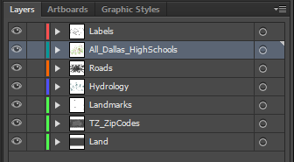

Figure 13 – My labels are all colored as categories. Land is green, hydrology is blue, roads are orange, point data is turquoise, and text is red.

The sub-layers will need to be changed individually, but path layers will take on the layer color that they reside in (see Fig. 14).

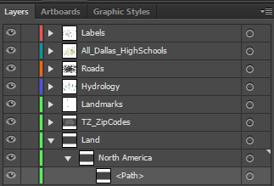

Figure 14 – The artwork path itself has taken on the layer color of the North America sub-layer.

# Creating Sub-Layers for Further Organization

When a single layer in ArcMap is symbolized based on an attribute, the AI export version of this layer retains the symbology. However, the symbols within this AI layer are not placed into a sub-layer based on the attribute they were symbolized by in ArcMap. For example, in the MXD that was used to export this particular file, the schools were symbolized based on a field called *SCHOOL_NAME*, with the categories *NIKE FOOTBALL, NIKE SPORT,* and *OTHER* (see Fig. 15).

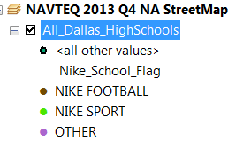

Figure 15 (above) – The symbology of the Layer *All_Dallas_HighSchools* in ArcMap

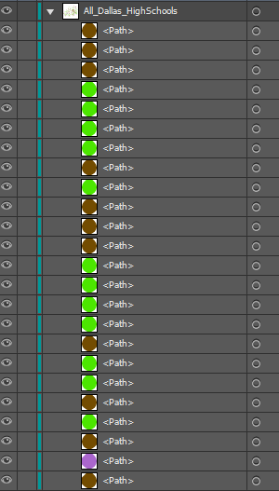

Figure 16 – When a single layer in ArcMap is symbolized based on an attribute, the AI export version of this layer retains the symbology. However, the symbols within this AI layer are not placed into a sub-layer based on the attribute they were in ArcMap

The color of the symbols did carry over to the AI export, but the symbols are not categorized into their own individual layers based on the school type they were categorized by in ArcMap (see Fig. 16). It is oftentimes necessary to select all the same type of symbology at once, or to turn off/on all the same type of symbology when using Illustrator to organize, symbolize, edit, etc. For this reason, it becomes necessary to create new sub-layers within the layer that symbols reside. In the example of *All_Dallas_HighSchools*, there needs to be sub-layers called *NIKE FOOTBALL, NIKE SPORT,* and *OTHER*. To do this:

1. **Add New Layer –** Click the New Layer button at the bottom of the Layers panel. The New Layer button is the button to the left of the Trash Can/Delete button. 
2. **Arrange the New Layer appropriately –** The new layer that you just created is going to be a sub-layer of the *All_Dallas_HighSchools*, but it did not end up within this layer when the New Layer button was clicked (see Fig. 17). Drag the layer into the *All_Dallas_HighSchools* layer (see Fig. 18).

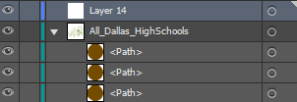

Figure 17 – The new layer called *Layer 14* will be placed as a main layer. It needs to be dragged into the *All_Dallas_HighSchools* layer.

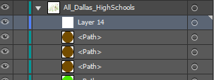

Figure 18 – The new layer *Layer 14* dragged into the *All_Dallas_HighSchools* layer.

1. **Rename the new layer –** The new layer has to be renamed *NIKE FOOTBALL.* To do this you can either double click on the layer’s name and change it to *NIKE FOOTBALL*, or you can follow the steps from VII (above) and rename it in the Layer Options window.
2. **Color the new sub-layer to match its parent layer –** follow the steps from VII (above).
3. **Repeat this step for all sub-categories within the layer –** For this example, there are 3 categories, so three sub-layers will need to be created (see Fig. 19).

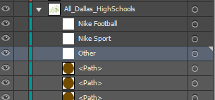

Figure 19 – The new sub-layers renamed appropriately, and colored to match the *All_Dallas_HighSchools* parent/main layer.

1. **Placing the artwork/data into the new sub-layers –** Now that the sub-layers are created, the symbology has to be placed within them.
   1. **Select one of the Nike Football schools –** Based on Fig. 15, the Nike Football schools are the brown colored points. Select one of these either by selecting from the layers panel or by selecting it directly by clicking on a brown symbol in the map.
   2. **Now select all the Nike Football schools –** With one symbol selected, you can select by that selected symbol’s properties. Go to the Select menu at the top 🡪 Same 🡪 Fill & Stroke. This will select everything that is visible and unlocked that shares the same fill and stroke color as the symbol that is already selected

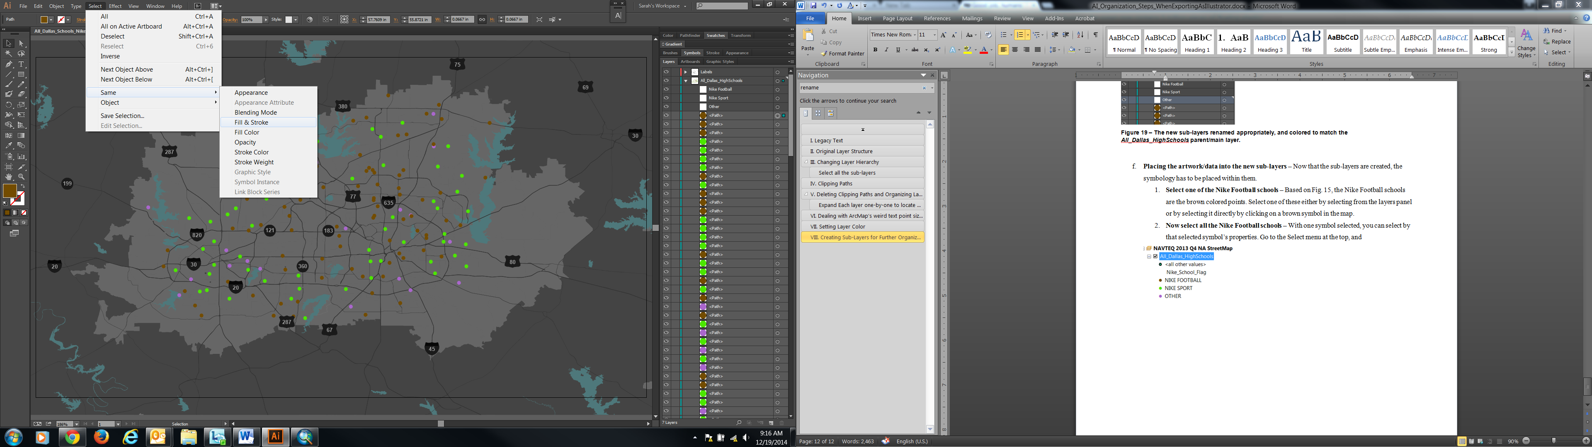

* 1. **Drag the selection to the appropriate sub-layer –** This is a little tricky. There is a colored tiny square next to the round button in the *All_Dallas_HighSchools* main layer, as well as next to all the Nike Football school symbols in the layers panel (see Fig. 20).

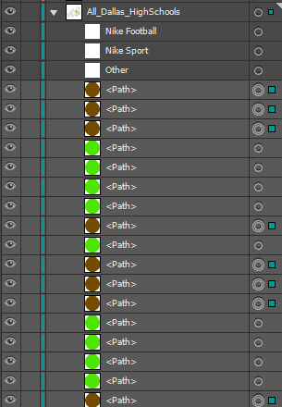

Figure 20 – The selected brown Nike Football school symbols have a colored square next the round button in their path layer, as does the *All_Dallas_HighSchools* main layer. This indicates selected artwork.

Click on the colored square next to the***All_Dallas_HighSchools*** layer name. Then drag that square down to the *Nike Football* sub-layer. This will place the selected Nike Football schools into that sub-layer (see Fig. 21).

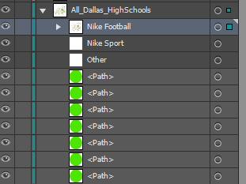

Figure 21 – After dragging the Nike Football school symbols into the appropriate sub-layer

Repeat this for all school types.

**Selecting by other attributes -** The same process for this particular AI file needs to be done for the Roads layer too. However, the roads share the same color, so when doing step VII.f.2, the Select Same step needs to specify Appearance rather than Fill & Stroke.

* 1. **Complete for all layers that need sub-layers.**

# When Point Symbols are Exported as Fonts

The following process is one way to keep the best geometric integrity of point symbols and graduated symbols that are exported as text.

## The Export Map settings in ArcMap

The Export Map settings in ArcMap can be as follows:

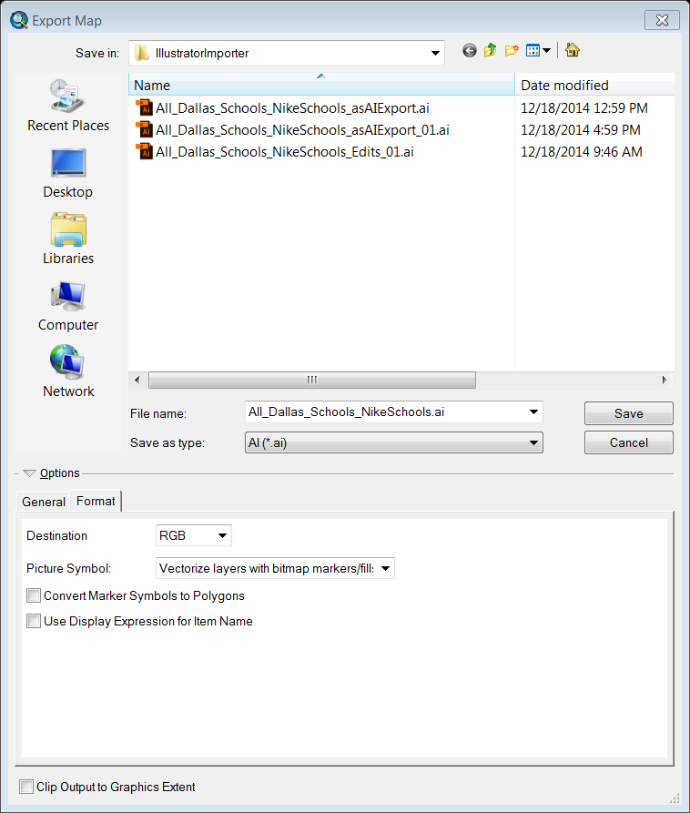

The *Convert Marker Symbols to Polygons* setting is what this section is particularly focused on. When it is selected, the exported AI file’s point symbols and graduated circles come in as polygons, but they lose a lot of their geographic integrity – the circles come in a little egg-shaped. With it unselected like the image above, the symbols come in as a font. We can change this font to a polygon in Illustrator.

## Changing the Font to a Circle in Adobe Illustrator

Figure 22 shows a series of screenshots that illustrate the point symbols are actually a font, or a line of text when opened up in Illustrator.

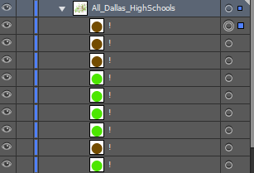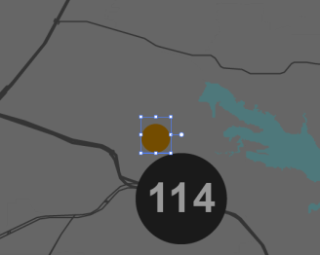

Figure 22 – The image on the top left shows that there are “!” exclamation points next to the symbol in the layers panel. This indicates that it is not a path, but rather what you get when you type an exclamation point using the Esri Default Marker font. The image to the top right shows that this is the font in the string selected. The image to the bottom left shows that the symbol selected is not really a symbol, but a string of text. You can tell because there are no anchor points highlighted on the symbol. Anchor points are analogous to nodes/points that make up lines and polygons in ArcMap.

1. To change all these one-letter-stringed lines of text to actual point symbols in Illustrator, select all of the symbols in the layer:

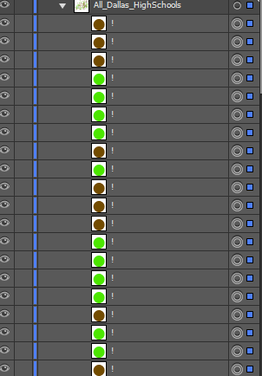

1. Then, go to the Type menu at the top, and click *Create Outlines*. This will turn your text into shapes. Notice how the brown symbol looks in Fig. 23, with just a line and one anchor point. This indicates that it is text:

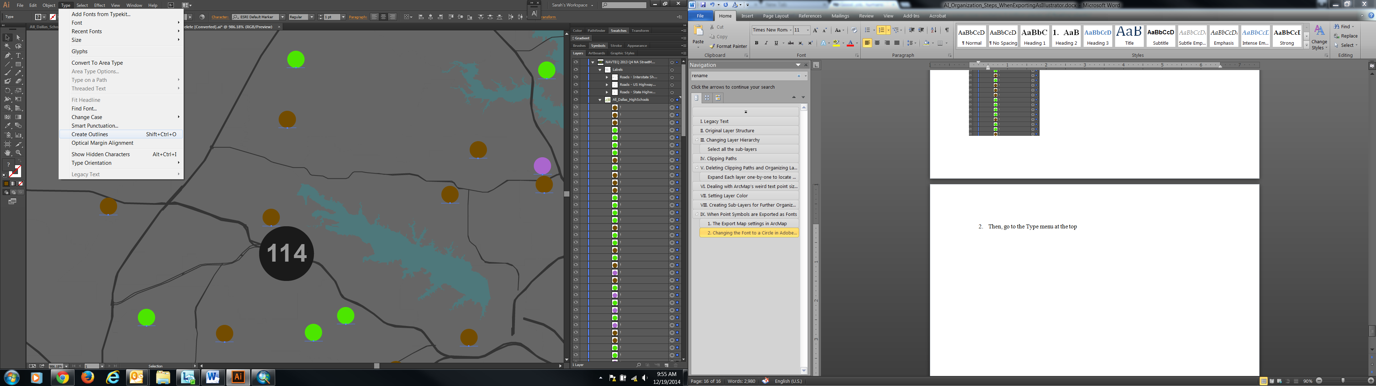

1. After clicking *Create Outlines,* observe that the symbols have been changed from text to a non-text piece of artwork. The anchor points on the circles in the image below show that these are now shapes rather than text. Doing point symbols this way keeps them more circular than exporting as polygons:

