1. Run Adobe Illustrator;
2. Choose menu item “Window\Extension\ArcGIS Online”;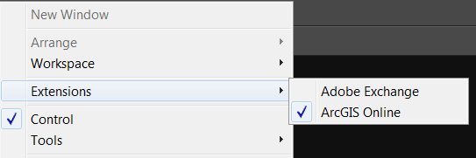
3. You’ll get the window of the Extension: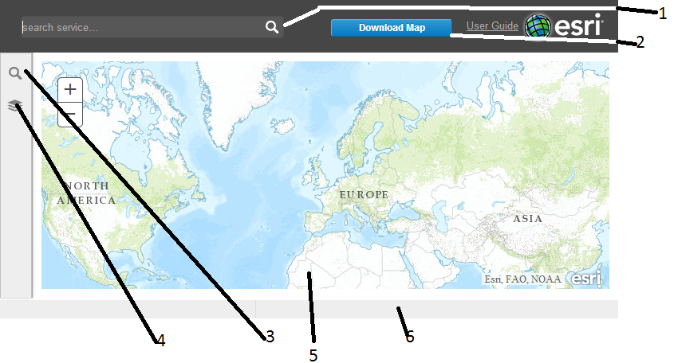
   1. The window for input the string to search;
   2. The button to download the prepared map in the Illustrator document;
   3. The button to switch the panel with search result on;
   4. The button to switch the panel with layers added into map;
   5. The base map;
   6. The status bar
4. Type some string in the window (2) and press enter key. For the string “UTM” you’ll get following; 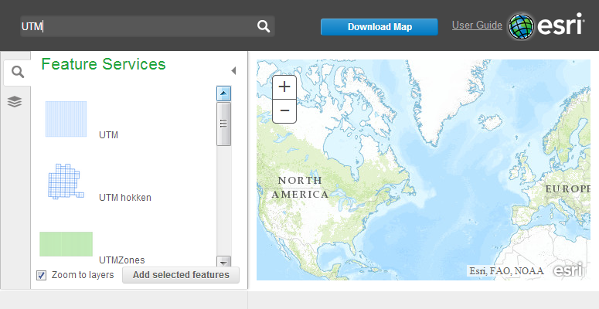
5. Now you can select one or two feature services and add them on the map (For example, Haiti Mangrove UTM). To add – click on the button “Add selected features”;
6. The extent of the map will be equal to combined extent of added layers; 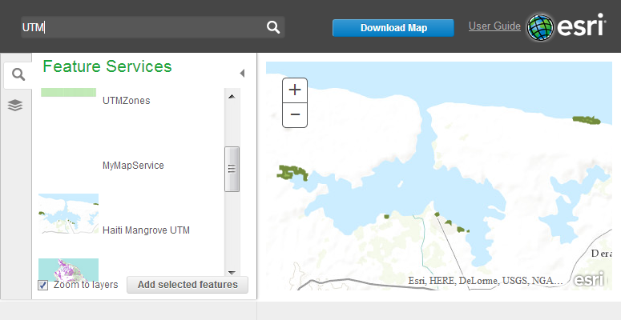
7. Click on “Download Map” button to add the chosen layers in Illustrator document;
8. 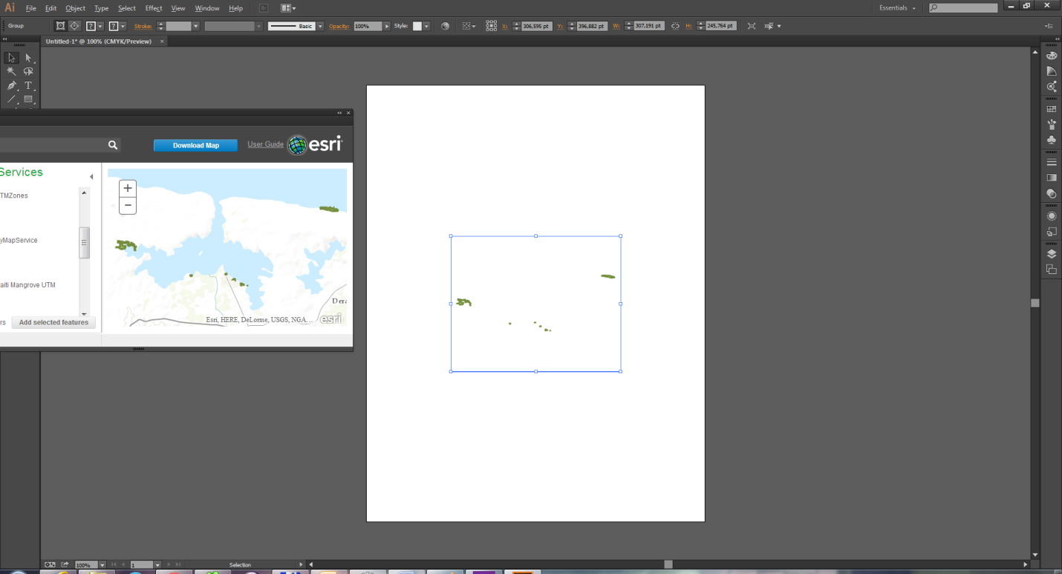
9. Chose the menu item “File\File Info…” and check metadata. They are in tab “Raw Data” at the end of XML with tag “arcGIS” 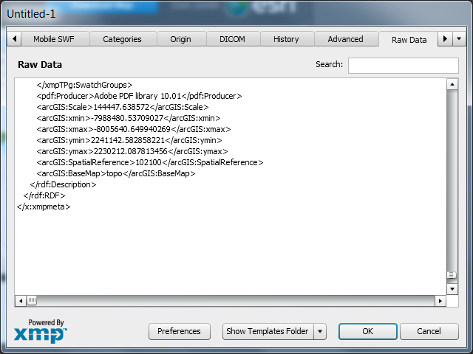

It’s just the main workflow.

I’ve added bounding box manipulating. Now the main window looks like following:

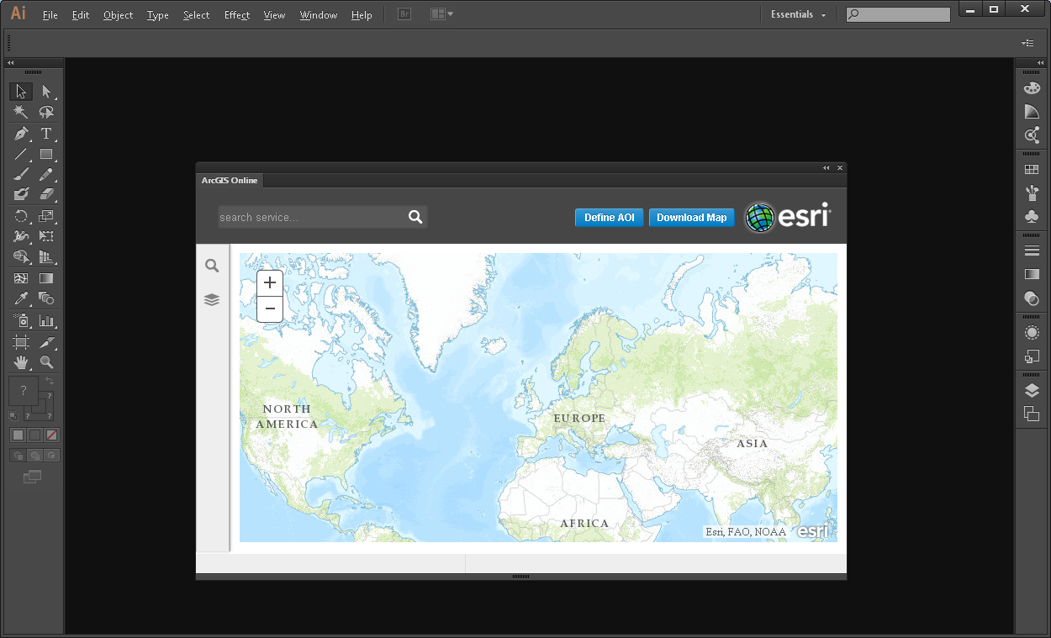

As you can see there is the additional button “Define AOI” (Area Of Interest). To define this area click on the button, then click on the map and drag the mouse cursor to get desired rectangle. When you release the mouse button the map will be focused on this rectangle.

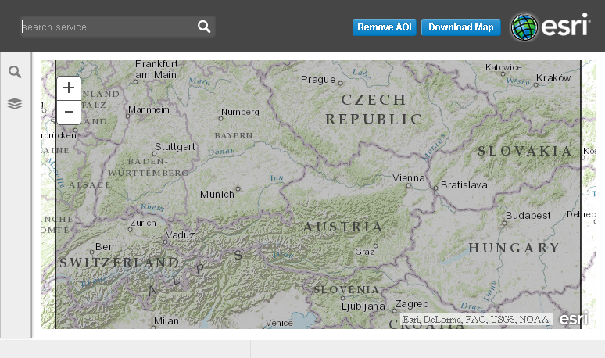

The button receives the name: ”Remove AOI”. Click this button if you want to delete the rectangle.

If you want move o resize the rectangle click on it. The rectangle receives the following shape:

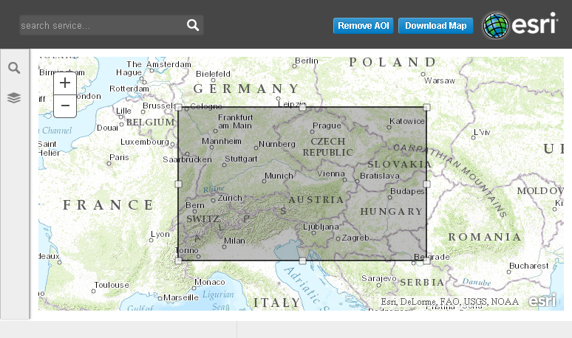

Drag the rectangle or shift small squares on edges of it. Click outside of the rectangle to finish this action. Now the extent of the exporting map is defined by this rectangle. If you remove it the extent will be defined be the extent of added layers.