# About

This is the sort description about how to use Muse widget with ArcGIS JavaScript map object.

# Preparing

1. Start Muse
2. Create new site
3. Add some design elements to “Master” or “Home” page. I’ve added the caption “Muse and ArcGIS JavaScript”

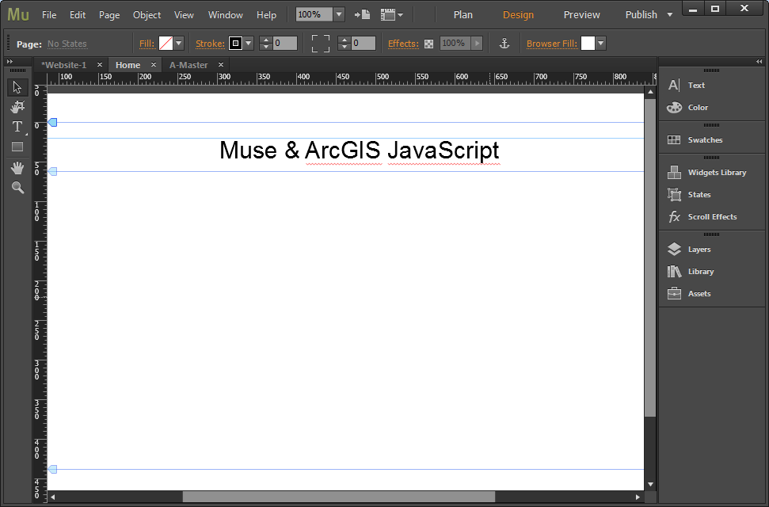

# Working with widget

## Adding widget to the site page

1. Choose menu item “File/Place …” or press “Ctrl+D”.
2. In the file open dialog choose “EsriMap.mucow” and click “Open”

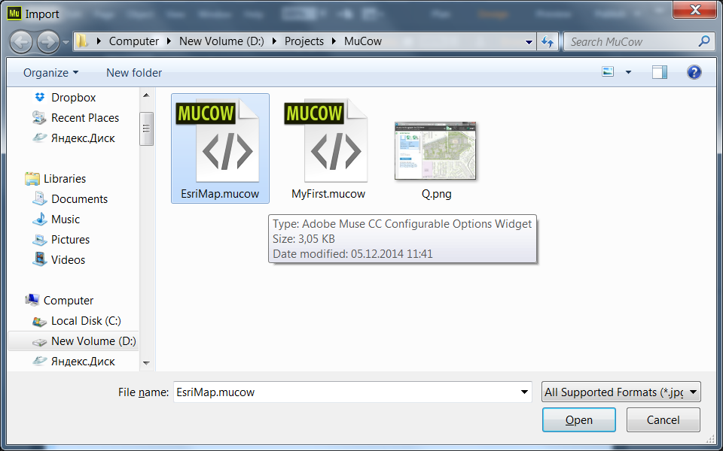

1. You’ll see the appropriate mouse cursor. Move it to the desire place and click left mouse button.

The initial widget state is following:

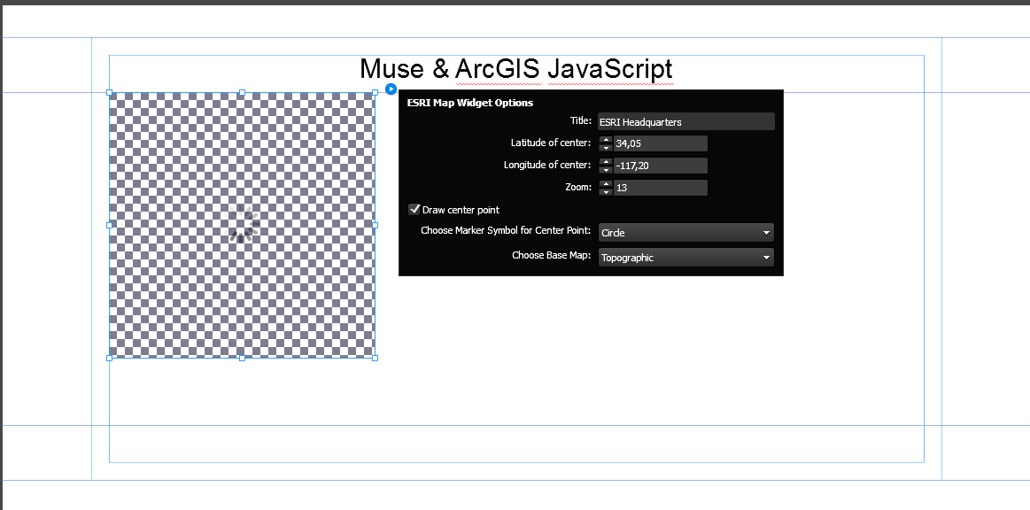

After initializing all parts of widget it will be shown

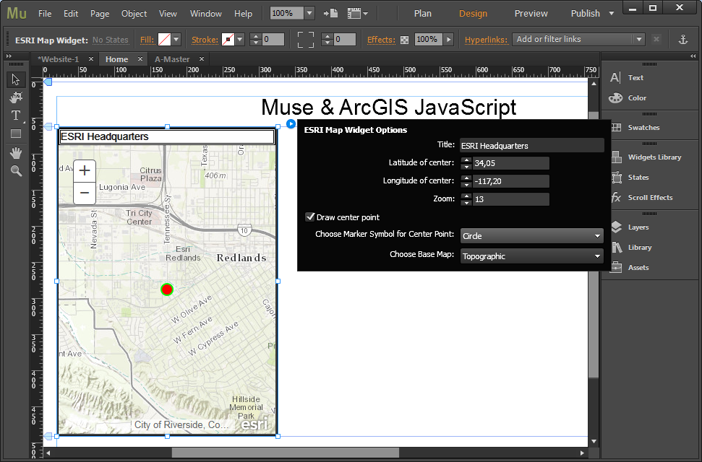

## Changing parameters of the widget

### Changing size of the widget

Click on a marker on edges of widget and pull to get desired size

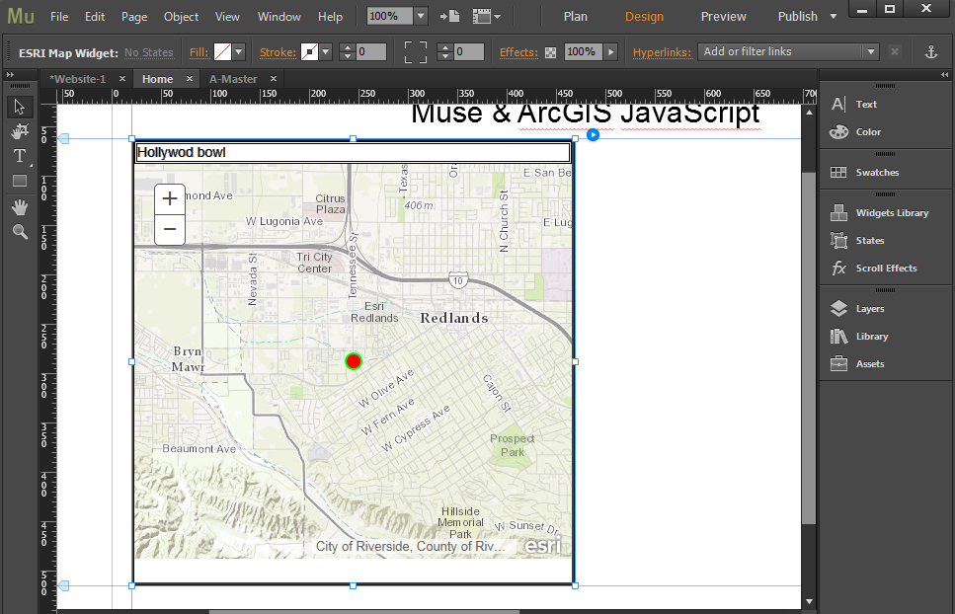

### Changing title

In edit control “Title” type new text (Hollywood bowl) and press “Enter”. The new title will appear.

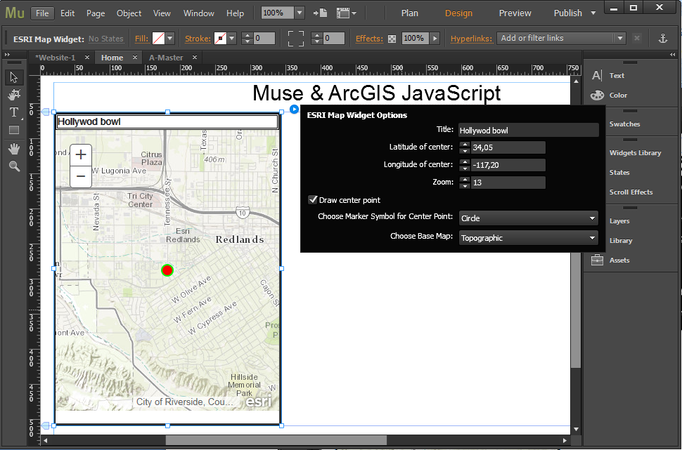

### Setting coordinates of map center and zoom

Use arrows on the left side of controls “Latitude of center” and “Longitude of center” to set new values or just type new values in edit controls.

Use the same way to set zoom.

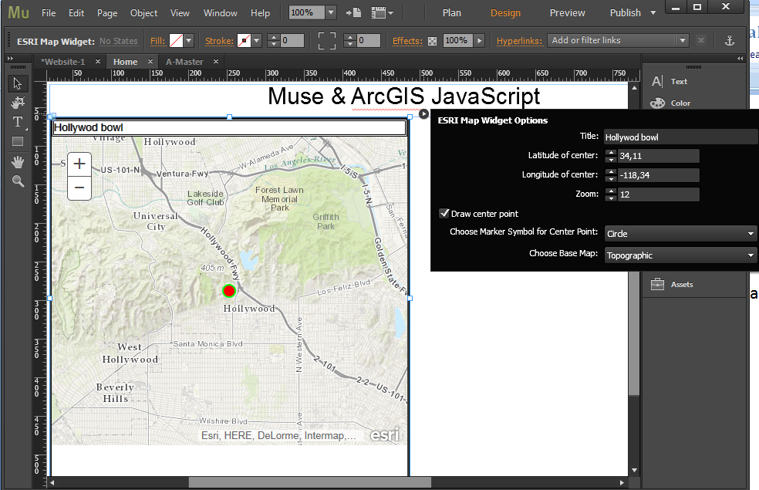

### Drawing center of the map

Check or uncheck “Draw center point” control to make map draw/not draw the marker of center point. The symbol of marker is defined by value of combo box “Choose Marker Symbol for Center Point”. If you choose “Square” you’ll get following

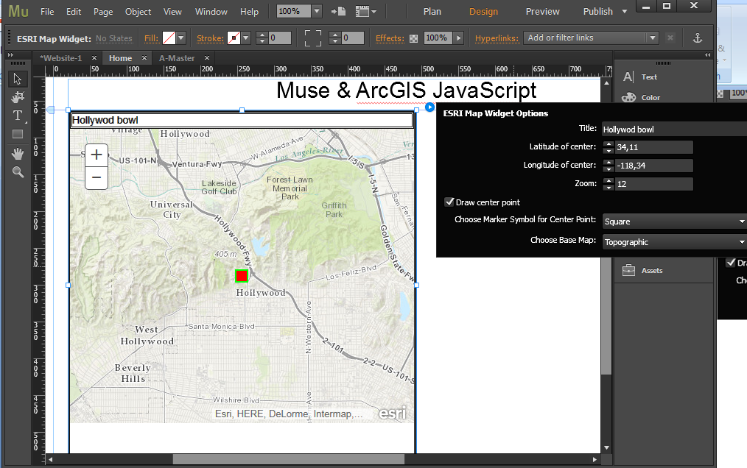

If you uncheck “Draw center point” the combo box “Choose Marker Symbol for Center point” will be disabled.

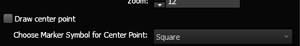

### Setting type of base map

8 types of base map are available:

* Topographic
* Satellite
* Satellite with labels (hybrid)
* Streets
* Gray
* Oceans
* National Geographic
* Open Street Map

Choosing value “Satellite with labels” in combo box “Choose Base Map” gives following result

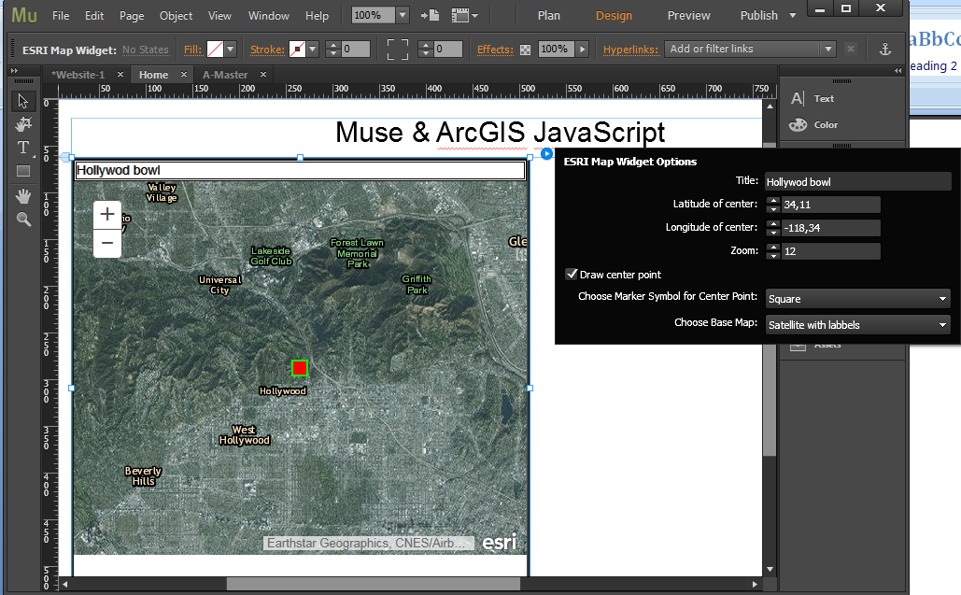

# Getting the result HTML page

After customizing the widget choose the command “File/Export as HTML …” or press Ctrl+E. Fill controls in below dialog and click OK.

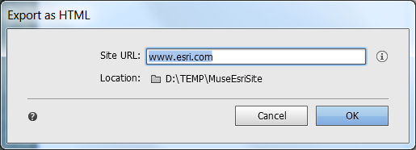

Then open index.hml file from the directory you used for export. The result should like following

