# A few words

1. I’ve put in GitHub only debugged (at least I think so) part of the extension. There are some problems with frame defining the extent of the final map still.
2. I spent a lot of time trying to make icons but I’m a bad artist (very very bad) so I used some ready to use icons. This was one of the reasons why I’ve been behind of schedule. They are colored but let’s make new stylish icons later. This part of job is too hard for me.
3. The name of this extension is “ArcGIS maps for Adobe Creative Cloud”. I understand that it’s different from the one we defined. But I did it to have possibility to run old and new extensions at the same time
4. I did not check the last version with Photo shop because my trial license has been expired. But it should work in PS too.

# Start Screen

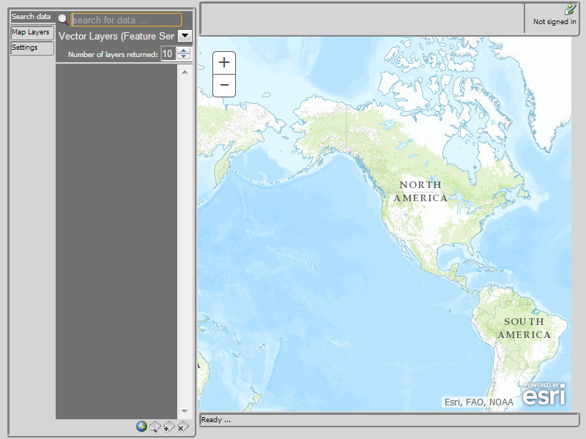

# Authorizing

We use now OAuth2. To start signing in, click on the button in the right upper corner.



You’ll get the dialog.

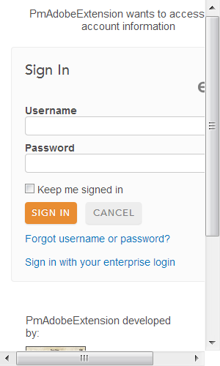

The rest is as usual. After signing in the button will show icon for signing out and you name will be shown too.



Unfortunately I cannot to change the size of the dialog. But it is the common problem with Adobe Extension. Many people wrote about it on Adobe forums. I think it can be solved. But I would not wont to do it right now.

# Searching

This is as previously.

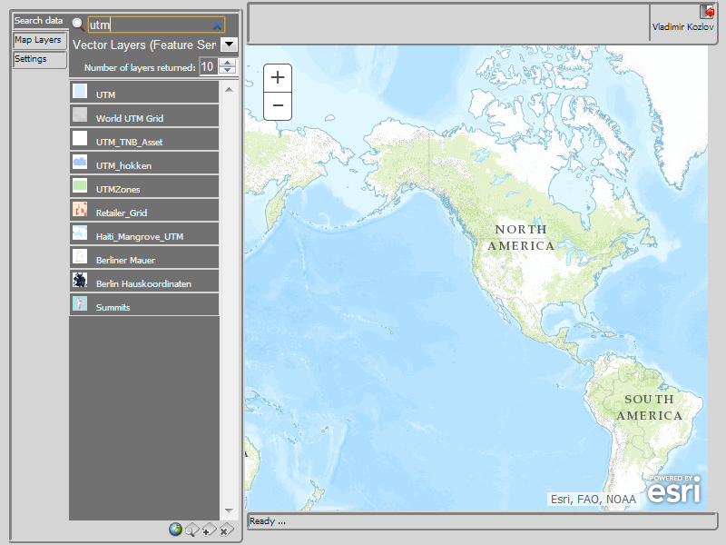

# Adding layer to the map

Click on desired service (select it).

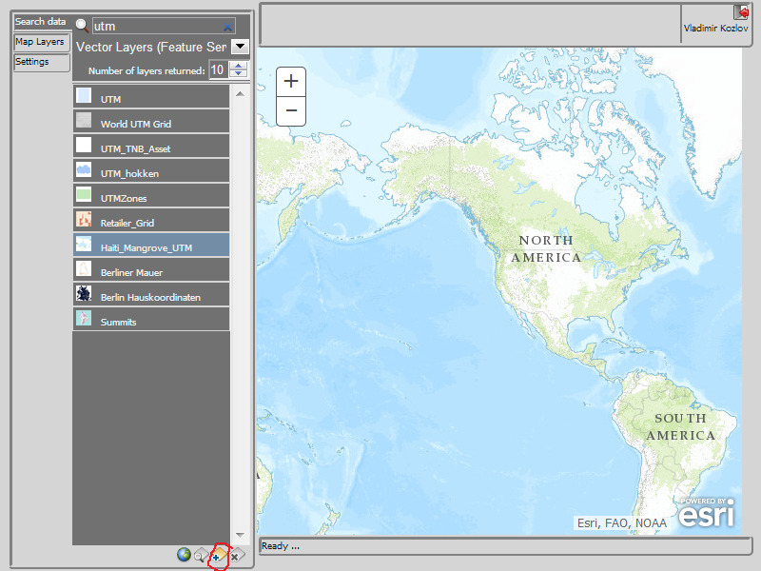

As you can see button for adding layers has been accessible. Click on it. The zoom will be set to the extent of added layer and service will be unselected.

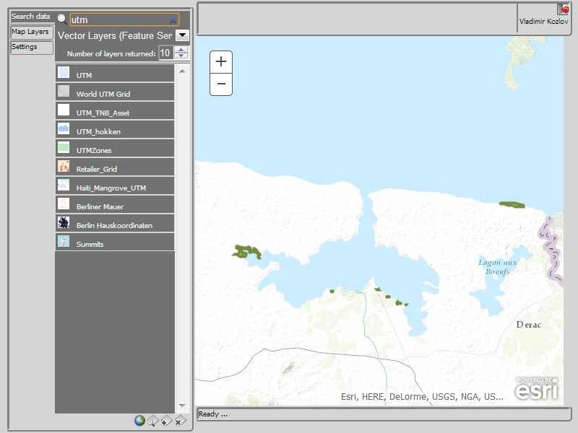

# Deleting layer

Switch to Lap Layers panel

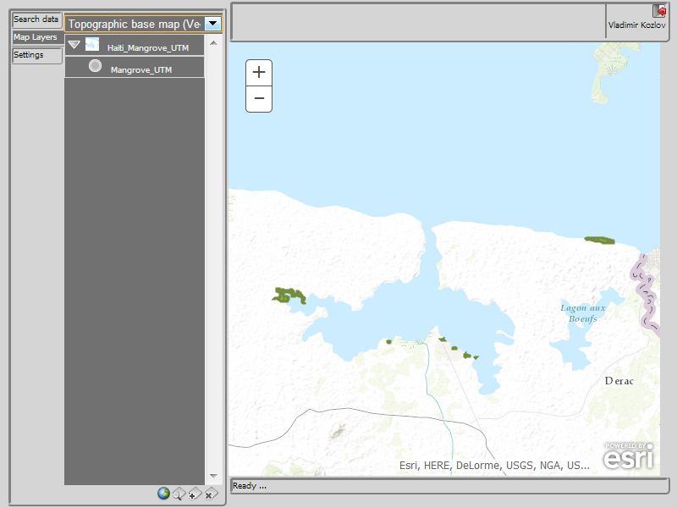

Select layer.

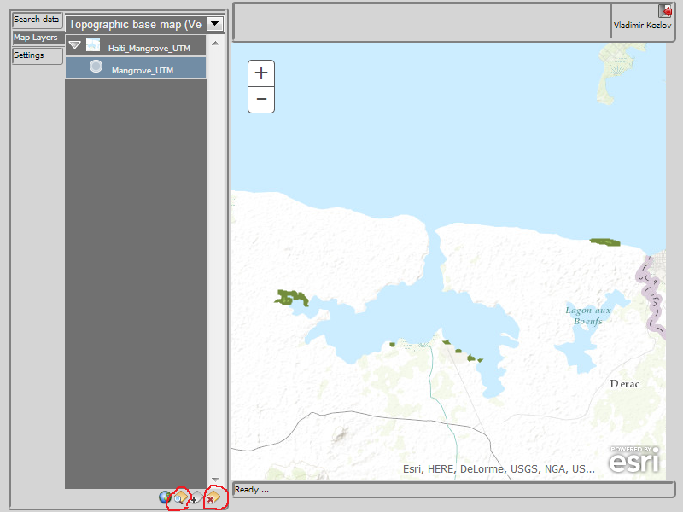

Buttons for deliting and zooming on layer will be accessible. Just click on it

# Color themes

Choose menu item Edit/Preferences/User Interface … You’ll get the dialog.

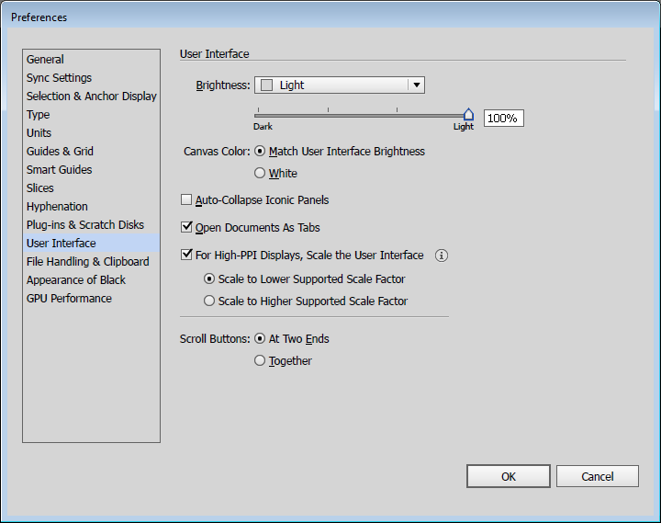

Choose different brightness to get different themes. For example, Medium dark gives following

