1. Before running the test application, be sure that you added the directory “bin” of ArcGIS desktop to the environment variable “PATH”.
2. Run the “WinPdfParserTest.exe”. The main window looks like following:

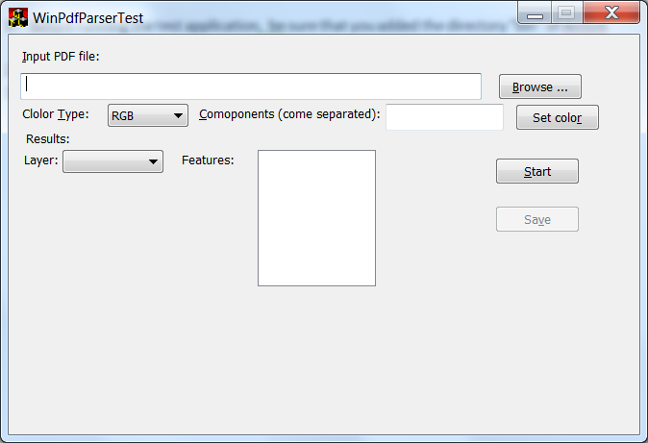

Either Type the path of the input PDF file in the first edit control or click button “Browse …” and choose the appropriate input file.

1. Choose color space type in the combo box (RGB/CMYK). And set the components of the color.
   1. RGB: 3 components from 0-255
   2. CMYK: 4 components 0-100
2. To set the color components you can use the button “Set color”. After clicking this button you’ll get the following dialog.

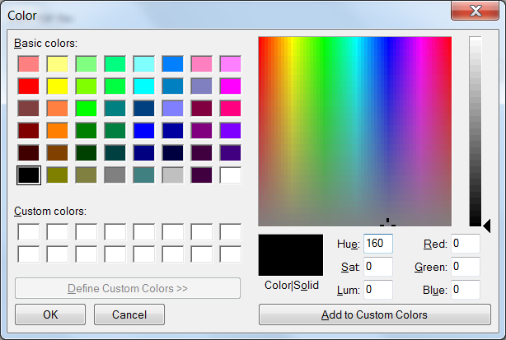

Fill appropriate components or choose the color and click “OK” button.

1. Click button “Start” on the main window. The calculation dialog will appear

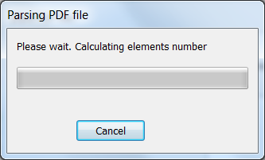

1. After finishing starting calculations youl see the progress of the parsing process

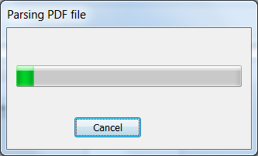

Click on the button “Cancel” if you want to abort parsing.

1. After finishing parsing you’ll see the result.

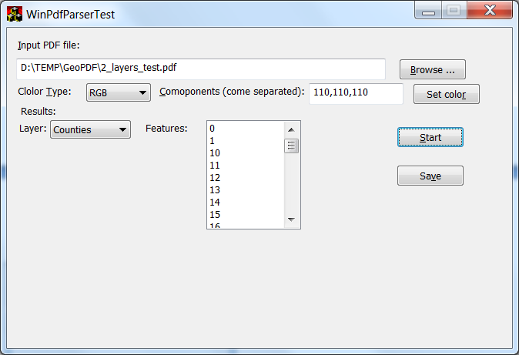

1. To save results in the text file use the button “Save”.