The geospatial PDF produced by ArcMap has tagged section where the layers and their features are listed. It is a kind of tree. Here is the simple PDF file with one layer which has two features.
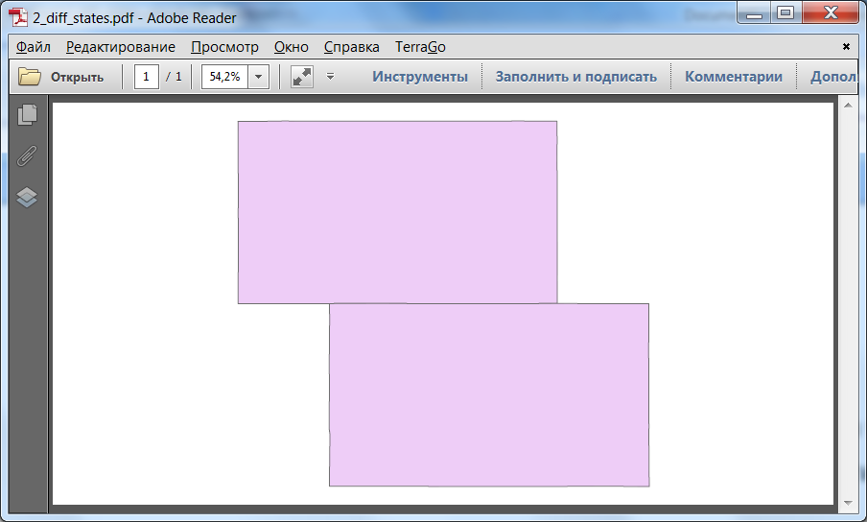

I developed a program which parses this section of PDF. Here is the result of such parsing with the description of elements of this section.
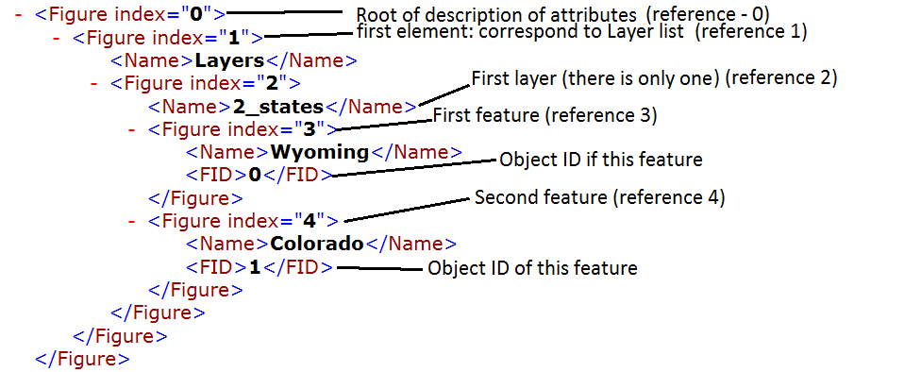
Tag “Figure” means just a structure. It’s a key word in PDF.
Now let’s look at stream of this PDF (the place where the content of a page is). I highlighted the important sections
0 0 0 RG
1 1 1 rg
/Page <</MCID 0>> BDC
EMC
/OC /OC0 BDC
/Figure <</MCID 1>> BDC
EMC
/OC /OC1 BDC
/Figure <</MCID 2>> BDC
EMC
/Figure <</MCID 3>> BDC
q
q
q
0 506.40945 m 0 -0.23513 l 984.82999 -0.23513 l 984.82999 506.40945 l 0 506.40945 l h
W* n
0.43137 0.43137 0.43137 RG
0.48005 w
1 j
1 J
10 M
0.93333 0.80392 0.96863 rg
635.59098 293.52753 m 635.35096 285.84746 l 635.59098 275.76736 l 635.59098 253.68717 l 584.94533 253.20716 l 565.26313 253.20716 l 511.97718 253.44716 l 504.77637 253.44716 l 474.05294 253.44716 l 448.85013 253.44716 l 413.56619 253.68717 l 348.51892 253.44716 l 293.79281 253.20716 l 290.19241 253.20716 l 233.54608 253.20716 l 233.54608 268.3273 l 233.54608 286.56746 l 233.78611 310.56768 l 233.78611 339.84794 l 233.54608 369.36821 l 233.78611 384.72835 l 233.78611 397.92847 l 233.54608 424.80871 l 233.54608 452.88897 l 233.54608 463.92907 l 233.30606 482.88924 l 269.31008 482.88924 l 271.47032 483.12924 l 294.27287 483.36924 l 305.55413 483.12924 l 373.00166 483.12924 l 393.88399 483.12924 l 415.00635 483.12924 l 508.85683 483.12924 l 522.53836 483.12924 l 576.30436 483.12924 l 578.70463 483.36924 l 635.11093 483.12924 l 635.35096 458.88902 l 635.11093 436.32882 l 635.11093 434.1688 l 635.35096 417.36864 l 635.35096 397.20846 l 635.35096 395.76845 l 635.35096 368.4082 l 635.35096 346.088 l 635.59098 310.80768 l 635.59098 293.52753 l h
B*
EMC
/Figure <</MCID 4>> BDC
751.04388 60.48542 m 751.04388 45.84529 l 751.52393 23.04508 l 696.31777 23.52509 l 691.51723 23.52509 l 638.95136 23.28508 l 572.70396 23.28508 l 568.86353 23.28508 l 540.30034 23.28508 l 524.21855 23.28508 l 496.61546 23.28508 l 474.29297 23.04508 l 472.61278 23.52509 l 442.60943 23.52509 l 439.24906 23.52509 l 387.40327 23.52509 l 348.51892 23.52509 l 348.75895 60.00541 l 348.99898 74.64555 l 348.99898 90.00569 l 348.2789 95.28573 l 348.2789 109.44586 l 348.51892 159.36631 l 348.2789 168.24639 l 348.2789 176.40647 l 348.51892 208.08675 l 348.75895 234.24699 l 348.51892 253.44716 l 413.56619 253.68717 l 448.85013 253.44716 l 474.05294 253.44716 l 504.77637 253.44716 l 511.97718 253.44716 l 565.26313 253.20716 l 584.94533 253.20716 l 635.59098 253.68717 l 663.19407 253.44716 l 673.99527 253.44716 l 715.99996 253.44716 l 717.92018 253.44716 l 750.80385 253.44716 l 750.80385 238.56703 l 750.80385 236.16701 l 750.80385 220.80687 l 750.80385 215.76682 l 750.56382 195.84664 l 750.80385 171.12642 l 750.80385 170.88642 l 750.80385 145.92619 l 750.80385 140.64614 l 750.80385 120.96597 l 750.80385 116.40592 l 751.04388 96.24574 l 750.80385 95.76574 l 751.04388 65.76547 l 751.04388 60.48542 l h
B*
EMC
Q
Q
Q
EMC
EMC

Each vector operation has the reference to a tagged section like this: “/Figure <</MCID 3>>”. The number in “MCID” tag means the index reference in “Figure” section. In this case, 3 means the feature with name “Wyoming” and object ID zero. Next section has reference “/Figure <</MCID 4>>”. This is feature “Colorado” with ID 1.
If there is a need to change color the stream contains operations “RG” and “rg”. First one is for stroking operations (outlines) second one is for nonstroking operations (filling). As you can see there are two places with changing colors:
0.43137 0.43137 0.43137 RG
And
0.93333 0.80392 0.96863 rg
The color is RGB but normalized to 1. So the color for boundaries is (110,110,110).
This is a kind of gray color

The second one is (238,205,247) for filling. It’s a kind of magenta.

It corresponds to what we see in PDF reader.
All files which I mentioned here are in GitHub.
I also added the file with contents of tagged section of PDF file which you gave me (AndersonIsland_small_layers_and_attributes.pdf).
So I think I can start developing a prototype of GP tool.

