We develop an Adobe Illustrator Extension to help our map designers to create the printed map from different sources. The main source is the resource center called ArcGIS online. This resource center requires authorizing via OAuth2 protocol. The authorization pages of this resource use different tools including DoJo (it uses “require”, “config” and so on). It conflicts with some tools included into Adobe CC 2014 applications. Here is what we had in CC applications loading the authorization page into Adobe HTML5 extension.

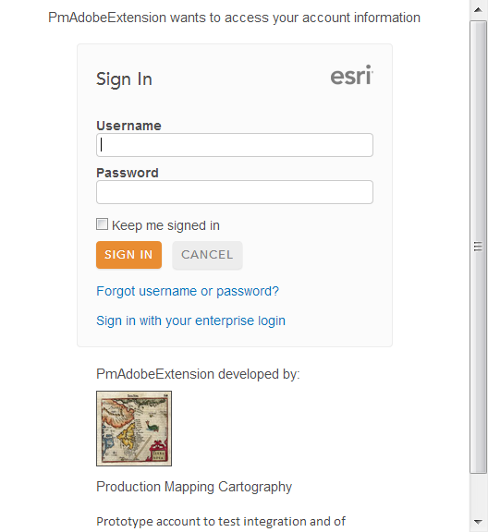

Now (in CC 2014) we have following:

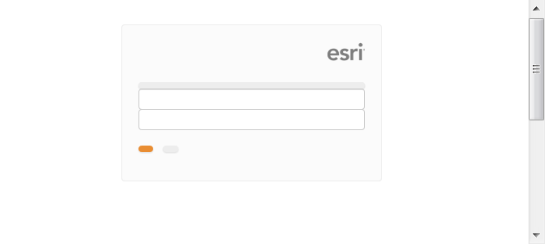

The debugger window shows following message.

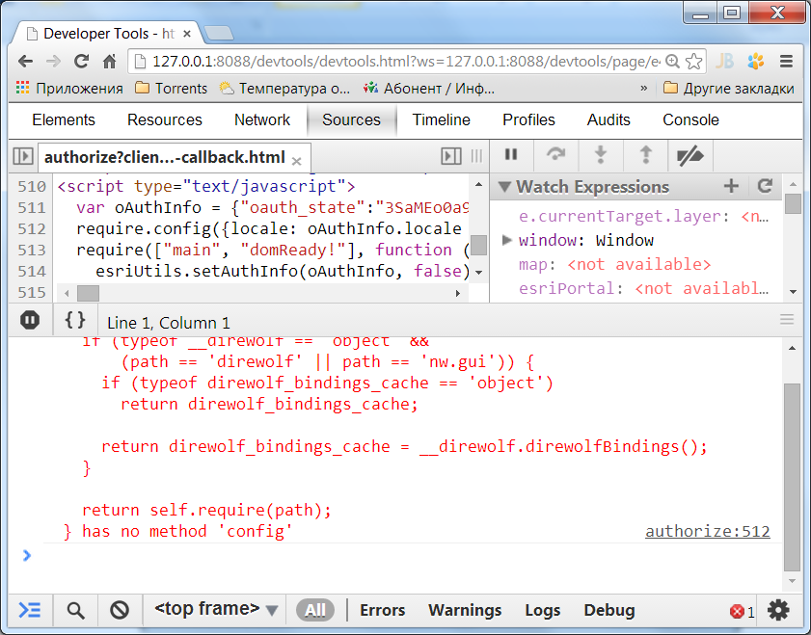

We have read your document <https://medium.com/@HallgrimurTh/extending-adobe-cc-2014-apps-ba1d101e27da> and its section “Useful bits of information”. But it does not help because we don’t manage ArcGIS online.

Maybe we are wrong but the cloud technologies imply surfing any resources in the web. So your new restrictions limit very much developing really cloud applications.