**Examen 1 : Diseño de Sistemas Digitales**

Profesor: Alexis Testa Nava

Alumno: Ramīrez Cotonieto Luis Fernando

Con base en el siguiente circuito, resuelva lo que se pide.

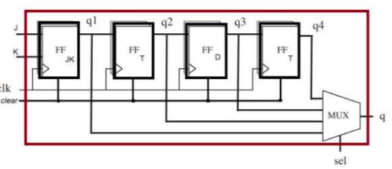

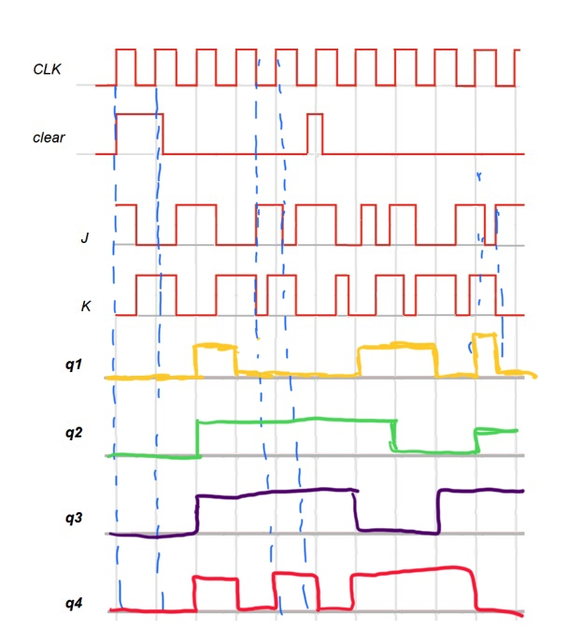1.- Realice el cronograma de tiempos correspondiente al diagrama lógico de la Fig.1

2.- Realice el circuito en Falstad y simule el correcto funcionamiento. (adjuntar el link y capturas de pantalla del circuito realizado, individual).

<https://tinyurl.com/ye3zmqpx>

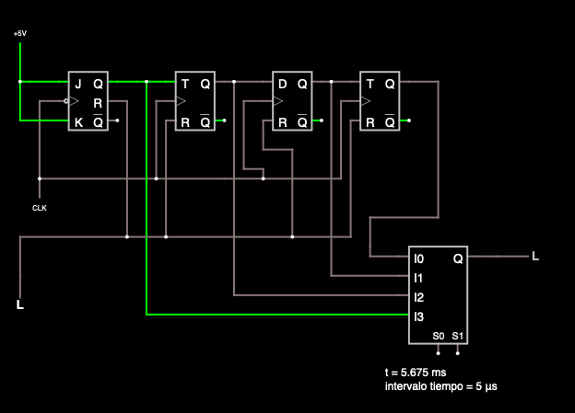

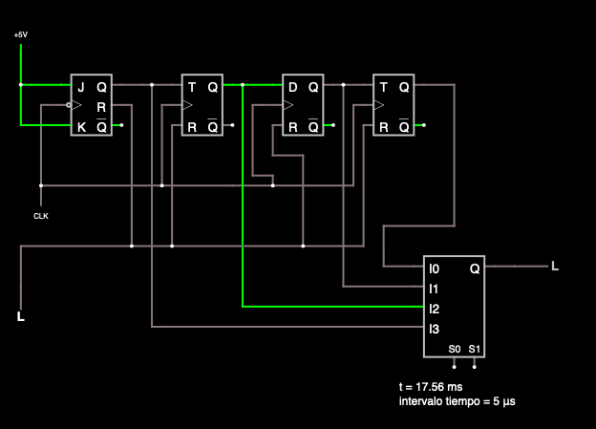

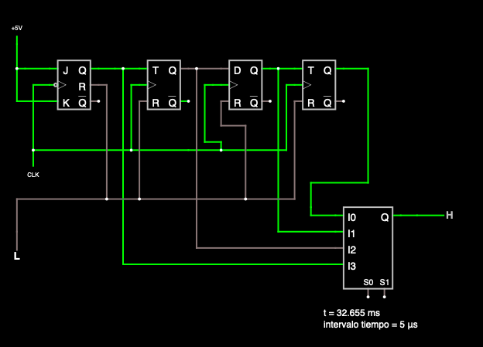

3.- Diseñar el circuito en HDL funcional (adjuntar codigo VHD en txt. Capturas del codigo, compilación y simulaciones)

library ieee;

use ieee.std_logic_1164.all;

----------------FLIP-FLOPS---------------

----------------FLIP-FLOP-D--------------

entity FFTD is port(

D,clear,preset,clock:in std_logic;

Q,Qnot: inout std_logic

);

end FFTD;

architecture funcional of FFTD is

begin

process (clear,preset,clock)

begin

if preset='1' then

Q<= '1';

Qnot<='0';

elsif clear = '1' then

Q<= '0';

Qnot<='1';

elsif (clock'event and clock='1') then

Q<= D;

Qnot<= not D;

end if;

end process;

end architecture;

----------------FLIP-FLOP-JK-------------

entity FFTJK is port(J,K,clear,preset,clock:in std_logic;

Q,Qnot: inout std_logic

);

end FFTJK;

architecture funcional of FFTJK is

begin

process (clear,preset,clock)

begin

if preset='1' then

Q<= '1';

Qnot<= '0';

elsif clear = '1' then

Q<= '0';

Qnot<='1';

elsif (clock'event and clock='1') then

if (J='0' and K='0') then

Q<=Q;

Qnot<=Qnot;

elsif(J='1' and K='0')then

Q<='1';

Qnot<='0';

elsif (J='0' and K='1')then

Q<='0';

Qnot<='1';

elsif (J='1' and K='1')then

Q<=Qnot;

Qnot<=Q;

end if;

end if;

end process;

end architecture;

----------------FLIP-FLOP-T--------------

entity FFTT is port(

T,clear,preset,clock:in std_logic;

Q,Qnot: inout std_logic

);

end FFTT;

architecture funcional of FFTT is

begin

process (clear,preset,clock)

begin

if preset='1' then

Q<= '1';

Qnot<= '0';

elsif clear = '1' then

Q<= '0';

Qnot<='1';

elsif (clock'event and clock='1') then

if T='0' then

Q<=Q;

Qnot<=Qnot;

elsif T = '1' then

Q<= Qnot;

Qnot<= Q;

end if;

end if;

end process;

end architecture;

-------------------MUX-----------------

entity MUX is port(

a,b,c,d,s0,s1: in std_logic;

y: out std_logic

);

end MUX;

architecture combinational of MUX is

signal x0,x1,x2,x3: std_logic;

begin

x0<= a and (not s0) and (not s1);

x1<= b and (not s1) and s0;

x2<= c and s1 and (not s0);

x3<= d and s0 and s1;

y<= x0 or x1 or x2 or x3;

end architecture;

----------EXAMEN PRIMER PARCIAL---------

use work.all;

architecture estructural of PrimPar is

component FFTJK

is port(

J,K,clear,preset,clock:in std_logic;

Q,Qnot: inout std_logic

);

end component;

component FFTD is port(

D,clear,preset,clock:in std_logic;

Q,Qnot: inout std_logic

);

end component;

component FFTT

is port(

T,clear,preset,clock:in std_logic;

Q,Qnot: inout std_logic

);

end component;

component MUX is port(

a,b,c,d,s0,s1: in std_logic;

y: out std_logic

);

end component;

signal Q1,Q2,Q3,Q4: std_logic;

begin

FFJK: FFTJK

port map(

J=>J,K=>K,clear=>clear,preset=>'0',clock=>clk,Q=>Q1

);

FFT1: FFTT

port map(

T=>Q1,clear=>clear,preset=>'0',clock=>clk,Q=>Q2

);

FFTD: FFTD port map(

D=>Q2, clear=>clear,preset=>'0',clock=>clk,Q=>Q3

);

FFT2: FFTT

port map(

T=>Q3,clear=>clear, preset=>'0',clock=>clk,Q=>Q4

);

MUX: MUX port map(

a=>Q1, b=> Q2, c=>Q3, d=>Q4, s0=>s0,s1=>s1, y=>Q

);

end architecture;