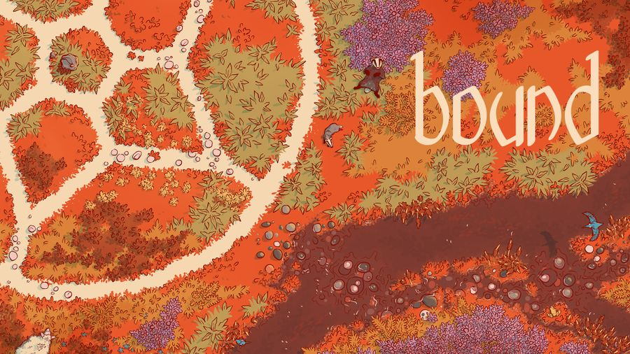

**Bound**

Artificial Intelligence 2022/2023

**First CheckPoint**

**Group 17**:

Luís Filipe Pinto Cunha, [up201709375@up.pt](mailto:up201709375@up.pt)

Inês de Magalhães Garcia, [up202004810@up.pt](mailto:up202004810@up.pt)

Henrique Correia Vicente, [up202005321@up.pt](mailto:up202005321@up.pt)

**Project Specification:**

***Bound*** is a two player strategy game normally played on a single sheet of paper.

- First, the oldest player places 4 black pieces in the outer circle, while the youngest player places 4 pieces in the middle hexagon.

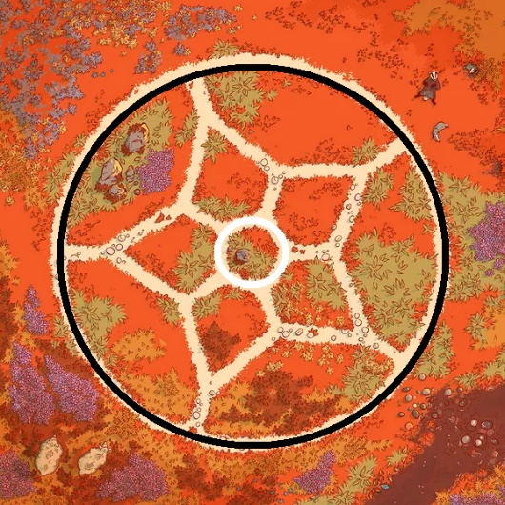

-Each turn, move one of your four standing stones in an attempt to encircle an opponent's stone.

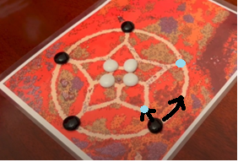

x

**-In the end, whoever manages to encircle the opponent, making it impossible to change a piece, wins.**

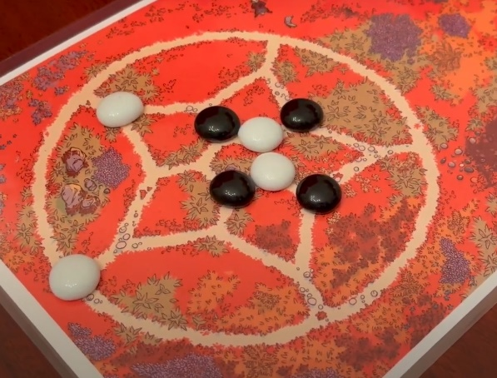

**Formulation of the problem as a search problem:**

**State Representation:** Array ‘POSITIONS’ containing all positions from the board stored in tuples with x and y coordinates. Arrays ‘black_pieces’ and ‘white_pieces’ storing the positions of the black and white pieces.

**Initial State:** Empty board (arrays ‘black_pieces’ and ‘white_pieces’ empty).

**Objective Test:** Any piece has no more valid moves.

**Operators:**

**Implementation work already carried out:**

**Programming language:** Python, with visualization using pygame package.

**Development environment:** Visual Studio Code, GitHub.

**Data Structures:** Nodes and Graphs.

**Reference and Materials:**

- <https://boardgamegeek.com/boardgame/375975/bound>

- Python,with pygame package.

- Visual Studio Code, GitHub.