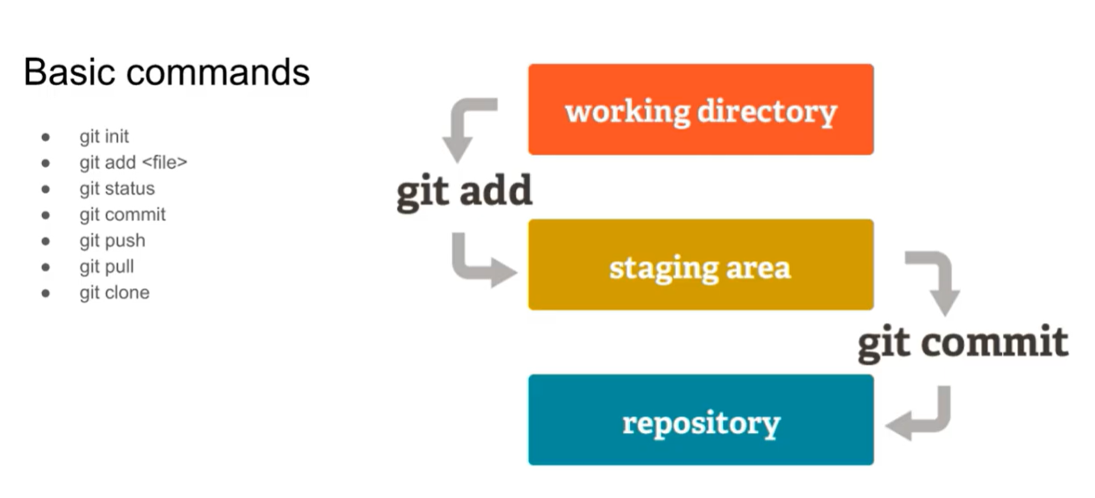
TO REMOVE FROM THE STAGING AREA
git rm --cached app.js

