Luis Felipe Díaz Loza

You must include a written description of three observable trends based on the data.

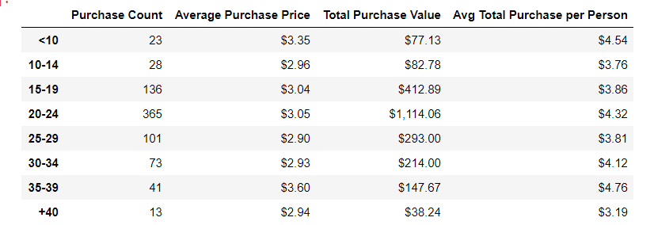

The illustration depicts the Purchase Count, the Average Purchase Price, the Total Purchase Value and the average total Purchase per person of the game: Heroes of Pymoli by five-year periods.

Firstly, 20-24-year-old players are the main consumers and the most profitable segment of the market at 365 purchases and a total revenue 1,114.06 . Secondly, 15-19-year-old players halved the number of player and their profits in comparison to the aforementioned segment at 136 units sold and a total purchase value by 412.89. Thirdly, all consumers over 25 years old almost double the latter carve-up at 228 items sold and a turnover by 692.91 . Finally, the most profitable segment is the 35-39 years old players at 4.76 average total purchase per person and an average purchase price by 3.6.

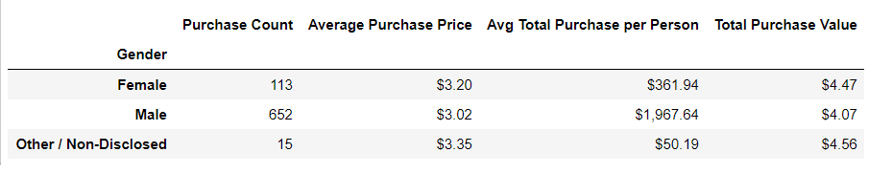

The pictures shows the Purchase Count, the Average Purchase Price, the Average Total Purchase Per Person and the Total Purchase Value by gender.

It is clear to see that almost 85 out of 100 are male players. On the other hand, the total female purchase value exceeds the male rate by 40 cents which represents almost a 10% increase over their counterparts. The male Average total purchase per person skyrockets at 1,967.64 in comparison to purchases of women by 361.94 dollars .

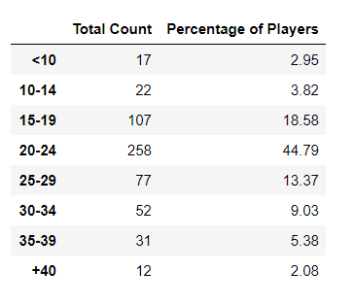

Lastly, the company should target the 16-29-year-old market in order to satisfy 76% of players demands.