You must include a written description of three observable trends based on the data.

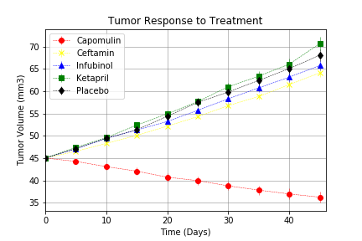

The graph illustrates the Tumor Response to different treatments such as Capomulin, Ceftamin, Infubinol, Ketapril and Placebo in a 45 day period. Capumulis had the best response with a significant decline in the tumor volume from 45 mm3 to almost 35 mm3 in 45 days. However, Ceftamin, Infubinol, Ketapril and Placebo showed a dramatic rise in the tumor volume. For instance, Ketapril has the most important increase just over 70 mm3 while Ceftamin rose almost at 65 mm3. Finally, Infubinol peaked around 65 mm3 and Placebo at 67 mm3 approximately.

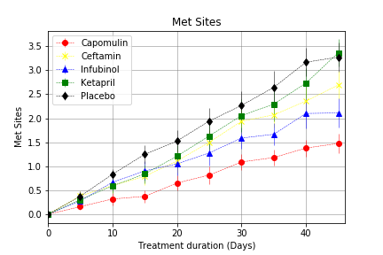

The illustration depicts the Metastatic Response to a variety of treatment including drugs such as Capomulin, Ceftamin, Infubinol, Ketapril and Placebo during a 45-day period.

Firstly, Capumulin increased slightly its metastatic response by 1.5 sites. Secondly, Infubinol gained as many as 2 sites in 45 days. It is worth to mention that this drug fluctuated significantly before levelling off during the last 15 days. Thirdly, Ceftamin rocketed just over 2.5 sites in the same period of time. A considerable majority of sites were found at the end of the 45-day treatment in Ketapril and Placebo at 3.25 sites each.

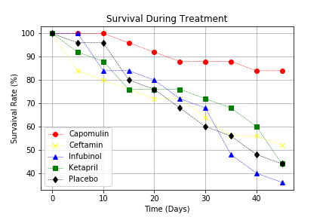

The scatter graph plots the Survival Rate of Mice during a drug treatment in a 45-day period. The least damaging drug in the whole period is the Capomulin by over 80% of survivors. Ceftamin, levelled off during the last third of the period to reach a survival rate just over 50 %. Placebo and Ketapril fell below 50% the rate of mice alive after 30 days of treatment. Finally, Infubinol also plummeted after a month to less than 40% of success.

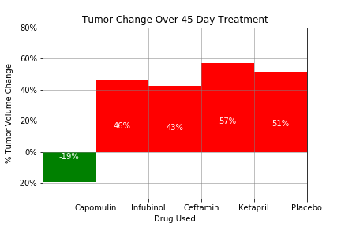

The bar chart shows the percentage of change in the tumor volume over a 45-day treatment in drugs such as Capomulin, Infubinol, Ceftamin, Ketapril and Placebo. Capomulin decreased the Tumor Volume by almost 20% as the aforementioned analysis. On the other hand, Ketapril and Placebo increased the tumor volume significantly up to 57% and 51% respectively. Lastly, Infubinol and Ceftamin also rose the volume of the tumor up to 46% and 43% consequently.

Overall, the Capomulin was the only treatment with successful results in all analysis. It provides a slightly increase of metastatic sites of 1.5 units, a survival rate over 80% and a reduction of almost 10 mm3 which equals almost a dramatic decrease by 20% in a period of a month and half.