Luis Felipe Díaz Loza

You must include a written description of three observable trends based on the data.

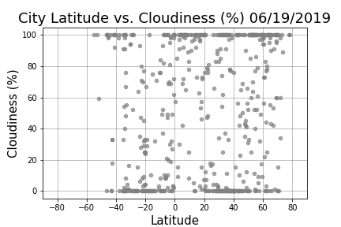

The scatter graph depicts the number of cities with certain percentage of cloudiness per degree of Latitude on June 19th 2019. The highest number of cities were allocated in the range of –40 to 70 degrees of latitude with either none or absolute degrees of cloudiness. At the same time, there were very few cities allocated at the lowest percentage of cloudiness from zero to twenty degrees of latitude. In other words, it could be seen a significant number of cities with zero cloudiness in the range from -40 to 0 degrees of latitude and from almost 20 to over 60 degrees of latitude.

It could be concluded that in the first negative twenty degrees of latitude, the number of cities with a 100 percent of cloudiness was small. The amount of cities with a percentage around 50 % of cloudiness was not as significant in comparison with the ones allocated on the extremes rates of cloudiness. |

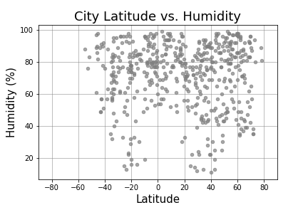

The scatter graph illustrates the number of cities with a wide range of humidities in percentage per degree of Latitude on June 19th 2019. The highest number of cities had over 60 percent of humidity while few of them laid under that threshold. It could be appreciated an increase in the number of cities in the range from zero to almost 80 degrees of latitude. However, that amount was not as significant as the one in the range from -60 to 0 degrees of latitude. Overall, the number of cities with high humidity increased from -40 to over 60 degrees of latitude.

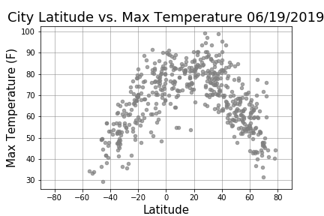

The scatter graph shows the number of cities with a variety of temperatures in percentage per degree of Latitude on June 19th 2019. The number of cities with high temperature skyrocketed from -40 to zero degrees of latitude. On the other hand, the number of cities with low temperatures decreased from 20 to 80 degrees of latitude. It is worth to mention that an order 2 polynomial trendline, with a negative coefficient of the x2 , was observed.

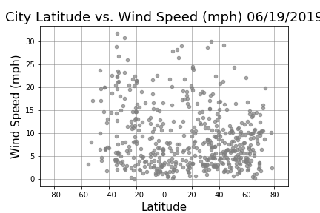

The scatter graph shows the number of cities with multiple speeds per degree of Latitude on June 19th 2019. The amount of cities with wind speeds under 10 miles per hour was significant from -40 to over 60 degree of latitude. It could be observed an increase in the number of cities along the degrees of latitude.