**QUESTION:**Observe what you see with the agent's behavior as it takes random actions. Does the smartcab eventually make it to the destination? Are there any other interesting observations to note?

To make the agent perform random actions:

**action = random.choice(Environment.valid_actions)**

Run for **n_trials = 100** and **enforce_deadline = True**, this is done so it can be compared in the same terms with the later iterations of the agent.

Statistics of the random run agent saved in the file **random_run.txt**

* total reward accumulated = 118**(1)**
* % of success = 27/100 = 27%
* # of actions taken = 2750
  + -0.5 pts. actions taken = 798
  + -1.0 pts. actions taken = 747
  + 0.0 pts. actions taken = 708
  + 2.0 pts. actions taken = 497
  + 10 pts. rewards received = 27
* # of state-action pairs discovered = 101
* % of state-action pairs discovered = 101/(2*4^3*3*4) = 6.57%
* Time:
  + 
* Distance:
  + 
* Environment statistics:
  + 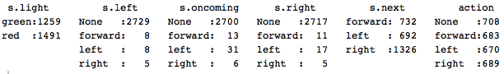

(1) The file failed to account for the rewards of achieving the goal and the sum of rewards for the 100th iteration, these were added here manually.

The smartcab does reach the destination by chance in this particular run 27% of the time. Worth of attention is how the reward system works, that is, what state-action pairs result in positive reward and which in negative ones.

The actions as expected are somehow evenly distributed as are the green/red lights. The streets are fortunately for the smartcab not heavily transited.

**QUESTION:**What states have you identified that are appropriate for modeling the smartcab and environment? Why do you believe each of these states to be appropriate for this problem?

The identified states are the following:

* Traffic light: [red,green] (2)
* Left street: [left,right,forward,none] (4)
* Right street: [left,right,forward,none] (4)
* Oncoming street: [left,right,forward,none] (4)
* Next waypoint: [left,right,forward] (3)

This is the information the agent can perceive as it travels the streets; with this information it will learn and decide the optimal actions to take to arrive to the goal in an optimal way.

These variables were included in the state space because they provide the agent information on how to choose the actions given the current state.

* **Light:** Going forward on a red light is a traffic violation and should be avoided, and with green light is a go. Other actions can be performed depending on other inputs.
* **Left, oncoming, right streets:** These variables show the agent the presence of cars and their intended course of action at each waypoint. This information allows the agent to avoid performing risky maneuvers, and is aware of other cars, which is a must in this simulation and on real life. The conditions of the road traffic impact as well the rewards and that is how the agent knows how to exploit them accurately.
  + On a green light, a left turn is permitted if there is no oncoming traffic making a right turn or coming straight through the intersection.
  + On a red light, a right turn is permitted if no oncoming traffic is approaching from your left through the intersection.
* **Next waypoint:** This input is crucial, as it tells the agent how to navigate towards the goal and if followed without incurring in traffic violations accounts for the biggest rewards.
* **Deadline (not included):** It is a time countdown, [-1] each time step, originally established by the environment. It is equivalent to 5 times the distance and is the crucial measure within which the goal should be reached. It wasn’t included because:
  + Taking the maximum deadline seen is 55 that would make our state space 55 times larger. But that wouldn’t be a problem if it actually provided the agent a better way to navigate the environment. But several steps would be very similar, <55,<s>> and <54,<s>> for example, and it wouldn’t provide any improvement to the agent.
  + An advantage could be thought of if the time is about to run out, and thus would make the agent try to reach the goal however this could encourage committing invalid or suboptimal action, which is something the agent shouldn’t do.
  + Another possibility would be for a dishonest agent that is close to the goal but with plenty of spare time, it could increase it’s reward (this would need to be inside the planner as well) by taking suboptimal but positive rewarding actions before reaching just in time to the target (this can too be adjusted by limiting gamma or the horizon of future rewards if implemented). That is why deadline wasn’t included as part of the states for the agent.
  + Even if included taking precaution with the previous points, the exploration would take too long and wouldn’t be feasible within 100 trials.

I believe this information is enough to model the states for the problem, so much in fact that it can be modeled as a deterministic environment (the agent will always know exactly what to expect of a given state-action if the state-action has been already visited).

**OPTIONAL:**How many states in total exist for the smartcab in this environment? Does this number seem reasonable given that the goal of Q-Learning is to learn and make informed decisions about each state? Why or why not?

The number of states-actions is the multiplication of the number of options in each of the variables that create the states and the possible actions we can take in each of these states.

* **# of <s,a>** = (lights*left*right*oncoming*waypoint)*action = (2*4*4*4*3)*4 = **1,536**

It seems reasonable, the states can be added as they are seen, so the agent can start with an empty table and start populating and updating it as it explores the world. If all the <s,a> are visited, then it will need a 1538*(6+1) table, adding also the rewards for each <s,a>. From there when exploiting the world, it can just look up for the specific <s> it is in and select the <a> that has the biggest <r>.

But in practice, there are <s> that are rarely seen. The random run only visited 101**(*)** different states in 2750 turns.

(*)Thinking about the “what if” deadline was included, there would be 1536*55 states (the maximum deadline seen), thus 84,480 states, we wouldn’t even have scratched the surface on exploring the states. Deadline would be helpful I believe implemented alongside a position/destination and/or distance metric on the Qtable (part of the functions that the planner does).

**QUESTION:**What changes do you notice in the agent's behavior when compared to the basic driving agent when random actions were always taken? Why is this behavior occurring?

The logic behind the Qlearning algorithm implemented is the following:

* Detect current state, if not in the table add it.
  + Choose random action and record Qvalue of action-reward.
* If state is found, check ε vs. random variable:
  + If ε greater, choose randomly from the actions.
    - It will randomly choose first from untaken actions if any, if not it will choose randomly from all actions.
  + If ε lesser choose the best action from the Qtable.
    - If there is a tie choose randomly from them.
    - Unvisited actions within a state have a high start Qvalue; this is to encourage the learner to explore (optimist).

Thus, it incorporates random learning when at a state it hasn’t been before or with actions it hasn’t done before. If state-action is completely know, it chooses the highest recorded reward. ε is calculated as follows, the value of timestep can be fiddled with to calibrate the rate of change of ε.

$$ε= \frac{1}{1+timestep}$$

This way it reduces its value as time passes, going from exploration to exploitation.

In order to update the reward, a learning rate α is used.

$${Qvalue}_{t+1}={Qvalue}_{t}*\left(1-α\right)+α*r$$

For this deterministic environment, the choice of $α$ has no impact as the same <s,a> always results in the same <r>. Still $α$ is calculated as follows:

$$α=\frac{1}{\# of visits to this<s,a>}$$

Statistics of the Qlearner agent saved in the file **smart_run4.txt**

* total reward accumulated = 2180.5**(2)**
* % of success = 99/100 = 99%
* # of actions taken = 1363
  + -0.5 pts. actions taken = 33
  + -1.0 pts. actions taken = 23
  + 0.0 pts. actions taken = 692
  + 2.0 pts. actions taken = 615
  + 10 pts. rewards received = 99
* # of state-action pairs discovered = 86
* % of state-action pairs discovered = 86/(2*4^3*3*4) = 5.59%
* Time:
  + 
* Distance:
  + 
* Environment Statistics:
  + 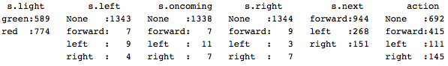

(2) The file failed to account for the sum of rewards for the 100th iteration; these were added here manually.

Many things become evident now, time, distance and the inputs of the environment are very similar between the 2 runs, as they are randomly generated and the agent has no impact on them.

The real differences appear on what the agent is doing and learning. In the runs it can be appreciated that most of the negative actions at the start which is to be expected as it is learning; after that rarely negative actions are seen whereas in the random runs they are uniformly distributed.

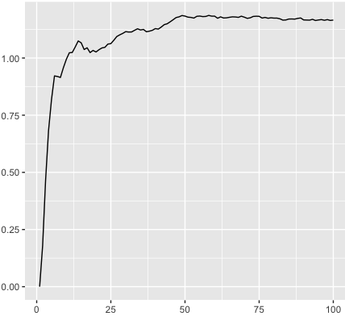 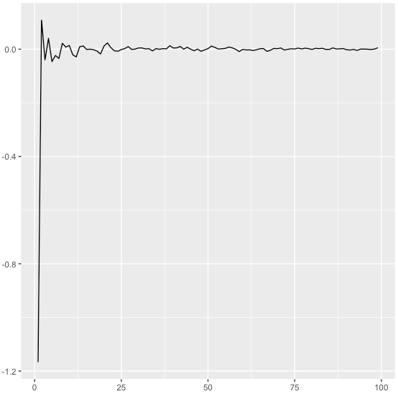

Cumulative average for Qlearn agent. Cumulative average for Random Agent.

The previous plots show the cumulative mean reward calculated with the following equation, it is calculated 100 times, 1 for each run of the algorithm.

$${Mean Reward}_{t}=\frac{{Reward CumSum}_{t}}{{\# of timesteps}_{t}}$$

It can be appreciated a convergence of the algorithms, at about:

* 1.17 pts/timestep with the Qlearner
* 0.005 pts/timestep with the random agent.

Worth noticing as well is the success rate of the agents. From 27% to 99%, and the fact that the Qlearner almost never incurs in traffic violations or suboptimal decisions.

Although two runs are presented and compared here, each agent performed several runs and are overall consistent with the results presented.

Before continuing, there are some aspects of the planner, environment and overall functions of problem worth highlighting.

* The position of the smartcab and the destination change each run (as one would expect of a realistic simulation for a cab).
* In the current configuration were the smartcab follows the planner function, the best policy is to follow the planner whenever that doesn’t lead to incurring in a traffic violation.
* If the planner is optimal, and the Qlearner is optimal, the smartcab should reach the destination in the minimum time without incurring in traffic violations.
* An optimal planner would need to receive feedback (ex. destination NE, cab facing North with ‘red light’, planner proposes ‘forward’ feedback ‘red light’, then proposes right turn and assigns a reward for following new direction), but since that isn’t the case, the best policy is to follow the planner whenever valid.
* In the current configuration, rewards can mess up the learner at the beginning of the training, suboptimal action could reach the goal thus receiving a high reward and reinforcing this suboptimal behavior.

**QUESTION:**Report the different values for the parameters tuned in your basic implementation of Q-Learning. For which set of parameters does the agent perform best? How well does the final driving agent perform?

The Qlearner was initially configured with epsilon = 1, and an alpha = 1 for each <s,a,r>. They change as mentioned earlier, epsilon by 1/(1+0.1*t) and alpha (1/#visits) to <s,a,r>. This really has no impact in the calculation of the reward (an average, or substituting the old value with the new reward work as well) since the reward received doesn’t change (deterministic).

Gamma “γ” is set to 0, the reason of this is that the agent searches for optimal behavior in the present, the states are unrecognizable by the position, and by being in a state and performing an action we can arrive to any other state without foresight or intuition. The rewards in current time are the drivers.

Including gamma “γ” in our Qlearning agent would change the code as follows:

self.Q[self.state][action] = (1.0 - self.alpha) * self.Q[self.state][action] + self.alpha * (reward + self.gamma * max(self.Q[next_state][next_action] for next_action in self.actions))

This way we would include the utility of reaching a state and then choosing the best course of action for maximizing long term utility (discounted by gamma).

Said this, Gamma was not used, the value of Alpha has little to none impact as the agent was envisioned and that leaves epsilon.

Since the new unseen actions are initialized with a high reward (optimistic with the unknown), the algorithm always will sweep all unvisited actions. Also since the rewards do not change, if the agent is in “exploration mode” but all the states have been visited previously, then it goes automatically to “exploitation mode” selecting the max from the Qtable. The decreasing of epsilon was fiddled with, increasing or decreasing the change rate without noticeable impact. The agent has to explore in the unknown whether by choice of by circumstance.

Finally, although the state space for this problem is big (1536), there the majority of the theoretical states rarely if ever appear, ex. Traffic coming from all 3 other streets, thus learning the states that appear frequently is very fast and the agent can start exploiting early on.

The configuration of the expected reward doesn’t really affect the expected reward since the reward is deterministic, can either use an average:

$$E(r)= \sum_{t=0}^{T}{\frac{r_{t}}{T}}$$

Or substituting directly the reward from the previous one (1 timestep memory)

$$E\left(r\right)=r_{t}$$

or by using Alpha as it is done in the agent:

reward<s,a> = (1-alpha)*reward<s,a>(t-1) + alpha*reward(t)

Where alpha:

$$α=\frac{1}{\# of visits to this<s,a>}$$

Four different rates of change for **epsilon** were tested **(1/(1+x*timestep))** where **x=[1,2,4,8]** and the agent was run independently 10 times for each value of the parameter, the dependent value measured was the mean of the total rewards accumulated, this was chosen because it reflects the cumulative impact of reaching the goal within time and the rewards and penalties found along the way.

|  |  |
| --- | --- |
| X value | Mean total reward accumulated |
| 1 | 2190.9 |
| 2 | 2202.55 |
| 4 | **2209.55** |
| 8 | 2186.9 |

From this runs we appreciate a greater value at x = 4, with 2209.55 which is the value that was used to the agent thereafter. Thus runs are documented in **“epsilon_runs.xls”.**

What does the value mean, by increasing the value from 1 to 4, we are decreasing epsilon faster thus making the agent go to exploitation mode faster as well. Perhaps with x = 8, the agent found some suboptimal state-actions as it needed to explore more at the start.

**QUESTION:**Does your agent get close to finding an optimal policy, i.e. reach the destination in the minimum possible time, and not incur any penalties? How would you describe an optimal policy for this problem?

I believe it does, taking a look at the last run:

Simulator.run(): Trial 99

Environment.reset(): Trial set up with start = (2, 3), destination = (8, 6), deadline = 45

RoutePlanner.route_to(): destination = (8, 6)

total reward: 2178.0, epsilon: 0.0

**‘light’,’left,’oncoming’,’right’,’waypoint’,’action’,’reward’,’state visits’**

red,None,None,None,right,right,2.0,60

red,None,None,None,forward,None,0.0,567

red,None,None,None,forward,None,0.0,568

red,None,None,None,forward,None,0.0,569

red,None,None,None,forward,None,0.0,570

green,None,None,None,forward,forward,2.0,388

red,None,None,None,forward,None,0.0,571

red,None,None,None,forward,None,0.0,572

red,None,None,None,forward,None,0.0,573

green,None,None,None,forward,forward,2.0,389

red,None,None,None,forward,None,0.0,574

red,None,None,None,forward,None,0.0,575

red,None,None,None,forward,None,0.0,576

red,None,None,None,forward,None,0.0,577

red,None,None,None,forward,None,0.0,578

green,None,None,None,forward,forward,2.0,390

red,None,None,None,forward,None,0.0,579

red,None,None,None,forward,None,0.0,580

red,None,None,None,forward,None,0.0,581

red,None,None,None,forward,None,0.0,582

green,None,None,None,forward,forward,2.0,391

green,None,None,left,forward,forward,2.0,3

red,None,None,None,right,right,2.0,61

green,None,None,None,forward,forward,2.0,392

red,None,None,None,forward,None,0.0,583

red,None,None,None,forward,None,0.0,584

red,None,None,None,forward,None,0.0,585

red,None,None,None,forward,None,0.0,586

**Environment.act(): Primary agent has reached destination!**

green,None,None,None,forward,forward,2.0,393

It doesn’t incur in any penalty and follows the planner. It consistently reached the destination.

A snip of the Qtable’s state & action-reward at the end on the 100th iteration is:

[{'light':'green','oncoming':None,'right':None,'next':'right','left':None} {'forward':[-0.5,1],'None':[0.0,1],'right':[2.0,69],'left':[-0.5,1]}]

[{'light':'green','oncoming':None,'right':None,'next':'right','left':'right'} {'forward':[-0.5,1],'None':[13.0,0],'right':[13.0,0],'left':[13.0,0]}]

[{'light':'green','oncoming':None,'right':'left','next':'right','left':None} {'forward':[13.0,0],'None':[0.0,1],'right':[2.0,1],'left':[-0.5,1]}]

In the first line we see a state with action = ‘right’ that has been visited 69 times with a utility of 2.0, and that has already tried the other actions (‘forward’,None,’left’) and has updated the corresponding utilities for them.

The optimal policy would be to follow the planner whenever that doesn’t incur in a penalty. And it does that.