Assignment 02 - Work with Linux

1DV721 - Systems administration



Luis Eduardo Martín Hernández
lm223sg@student.lnu.se
20050201-T273
27/03/2026

Index

Introduction 2
Requirements 01 - Server Setup and Configuration 3
1.1 System Preparation and Updates 3
1.2 Comprehensive System Inspection 4
1.3 Database Installation (MariaDB) 5
1.4 Web Server Deployment (Apache2) 6
1.5 Content Customization: Hello World 6
1.6 Advanced Server Configuration: CGI Integration 8
1.7 Server Status Automation (info.bash) 8
1.8 Automated Backups (backup.bash) 9
1.9 Optional Task: Database Integration via CGI (database.bash) 11
Requirements 02: Build your own customized docker image 12
2.1 Adding the cowsay program to the image 12
2.2 Updating docker-compose.yaml for automated builds 12
2.3 Verification: Running the cowsay program 13
2.4 Containerized Web Server and CGI Execution (info.bash) 14
2.5 Script Development for Automated Remote Retrieval 15
2.6 Local Execution and Troubleshooting 16
2.7 Persistent Containerization via Docker Volumes 17
Requirements 03: Find, evaluate and install a Linux distro 19
3.1 Selection and Research of the Distribution 19
3.2 Installation Process (VirtualBox) 19
3.3 Browser Installation and CSCloud Connectivity 20
3.4 Multimedia Capabilities (yt-dlp Integration) 21
3.5 Remote Connectivity: SSH and SFTP 22
3.6 Hardware Footprint Measurement 23
3.7 Final Evaluation 23
3.8 Comparative Analysis: antiX (VM) vs. Raspberry Pi OS Lite (Physical Hardware) 24
Technical Comparison and Footprint 24
Evaluation and Personal Opinion 25
Conclusion 25
TIL (Today I Learned): Final Reflection 26
Resources and References 27
Primary Resources Utilized: 27
References (IEEE Style): 27
Video Link 27

Introduction
This assignment explores the lifecycle of system administration, from cloud-based infrastructure to localized containerization and hardware optimization. The project is divided into three core pillars:
- Remote Server Management: Deploying a web server on a CSCloud instance and implementing dynamic CGI (Common Gateway Interface) scripts for system telemetry.
- Infrastructure as Code (IaC): Using Docker and Docker-Compose to containerize services, emphasizing data persistence through volumes and automated remote backups via SSH/SFTP.
- Resource Optimization: Evaluating "small footprint" Linux distributions (antiX and Raspberry Pi OS) to prove the feasibility of reviving legacy hardware for modern administrative tasks.
The goal is to demonstrate a comprehensive understanding of Linux-based systems, security protocols, and efficient resource management.

Requirements 01 - Server Setup and Configuration

1.1 System Preparation and Updates
The first phase of the assignment involved preparing the CSCloud environment. I ensured that the local package repositories were synchronized and all system software was upgraded to the latest stable versions to mitigate security vulnerabilities.
Commands executed:
sudo apt update
sudo apt upgrade -y
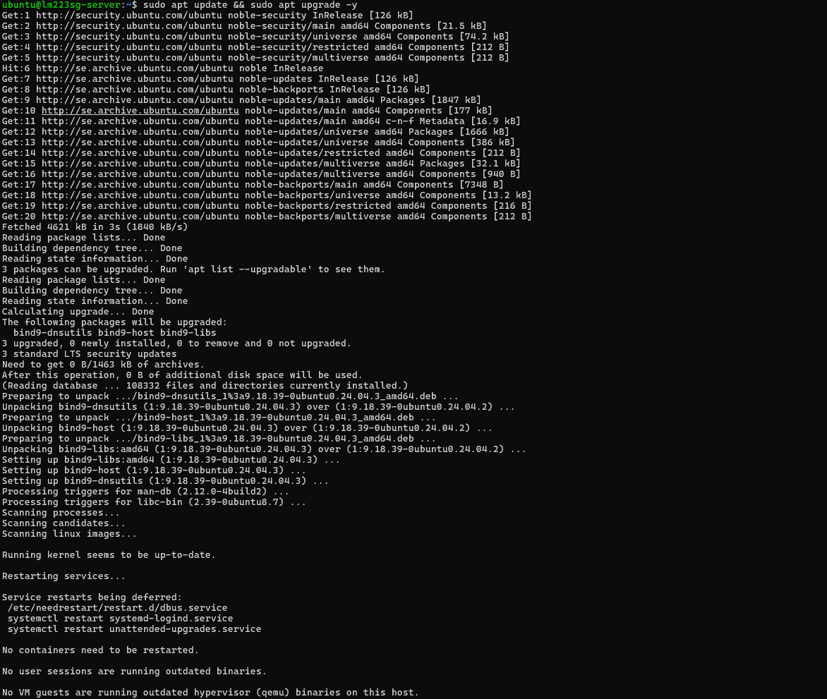
Caption: Figure 1: Successful system update and package synchronization.

1.2 Comprehensive System Inspection
To establish a baseline of the server environment, I performed a detailed inspection of the OS, storage, and networking services.
- Operating System: The server is running Ubuntu 24.04.4 LTS (Noble Numbat), a Long Term Support release suitable for server stability.
- Storage and Filesystem: The root partition resides on /dev/sda1 with a capacity of 8.7 GB. Current utilization is at 30%, leaving ample space for the assignment tasks.
- Network and Services: I monitored active listening ports to identify running services.
  - Port 22 (SSH): Remote access via OpenSSH.
  - Port 80 (HTTP): Apache web server.
  - Port 3306 (MySQL/MariaDB): Database listener.
- Identity: Operations are executed under the ubuntu user account, which has sudo privileges for administrative tasks.
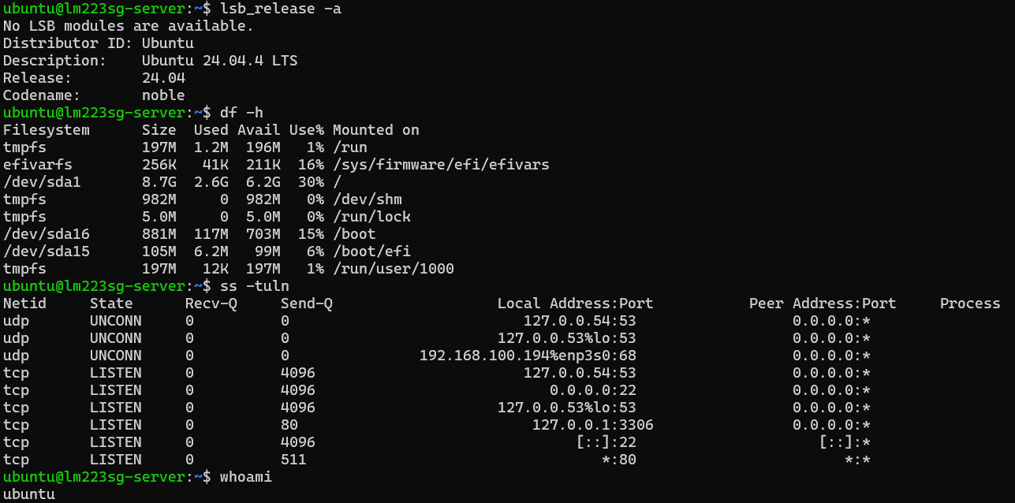
Caption: Figure 2: System inspection results showing OS version, disk usage, and active listening ports.

1.3 Database Installation (MariaDB)
I installed the MariaDB relational database management system following this guide: https://mariadb.com/docs/server/mariadb-quickstart-guides/installing-mariadb-server-guide. To verify the integrity of the installation and the service status, I executed a direct SQL query to retrieve the version string.
Verification Command:
sudo mariadb -e "SELECT VERSION();"
System Response:
+-----------------------------------+
| VERSION() |
+-----------------------------------+
| 10.11.14-MariaDB-0ubuntu0.24.04.1 |
+-----------------------------------+
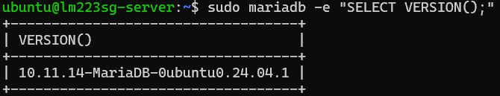
Caption: Figure 3: Verification of MariaDB installation and version retrieval.

1.4 Web Server Deployment (Apache2)
I deployed the Apache2 web server to serve as the platform for the subsequent web-based requirements. After installation, I verified that the service was active by accessing the server's public IP address (172.27.61.43). Initially, the server displayed the standard Ubuntu welcome page. Task done following this guide: https://ubuntu.com/tutorials/install-and-configure-apache#1-overview
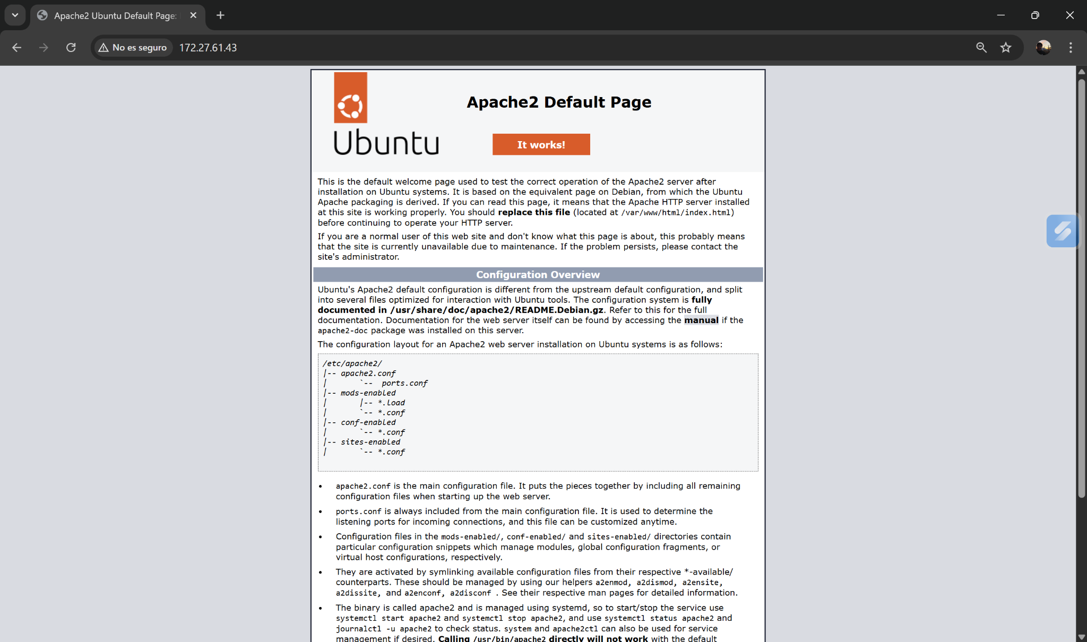Caption: Figure 4: Initial Apache2 default landing page confirming successful installation.

1.5 Content Customization: Hello World
To fulfill the requirement of hosting custom content, I replaced the default landing page. I modified the index.html file located in the web root directory (/var/www/html/) to display a simple "Hello World" message. This step confirms write access to the web directory and the ability to modify server-side content. Task done following this guide: https://discourse.ubuntu.com/t/install-and-configure-apache/13955/2
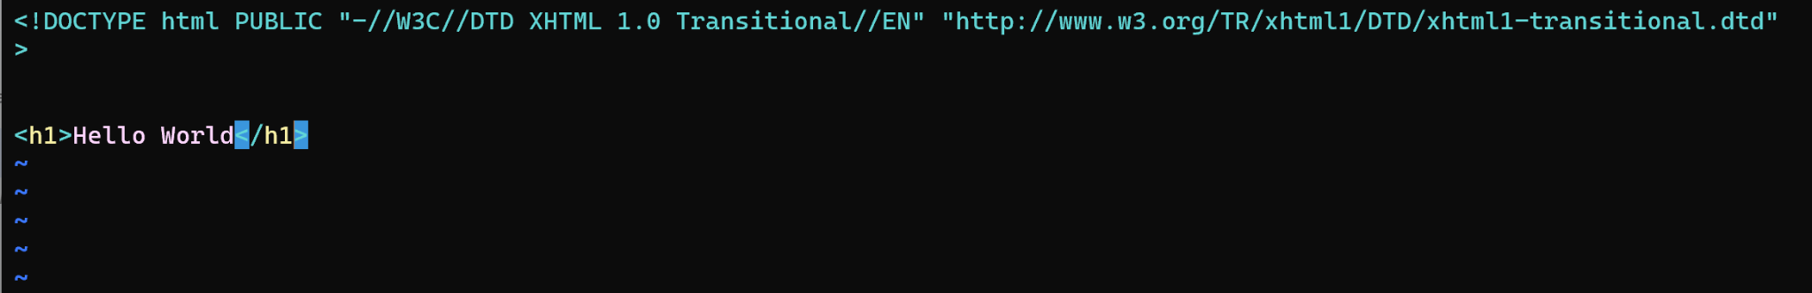
Caption: Figure 5: Updated content of index.html
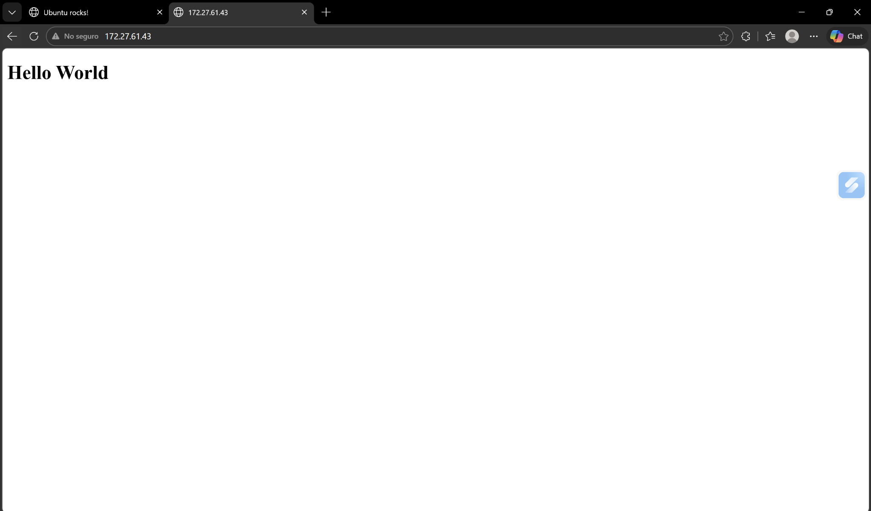
Caption: Figure 6: Customized web content verifying the replacement of the default landing page.
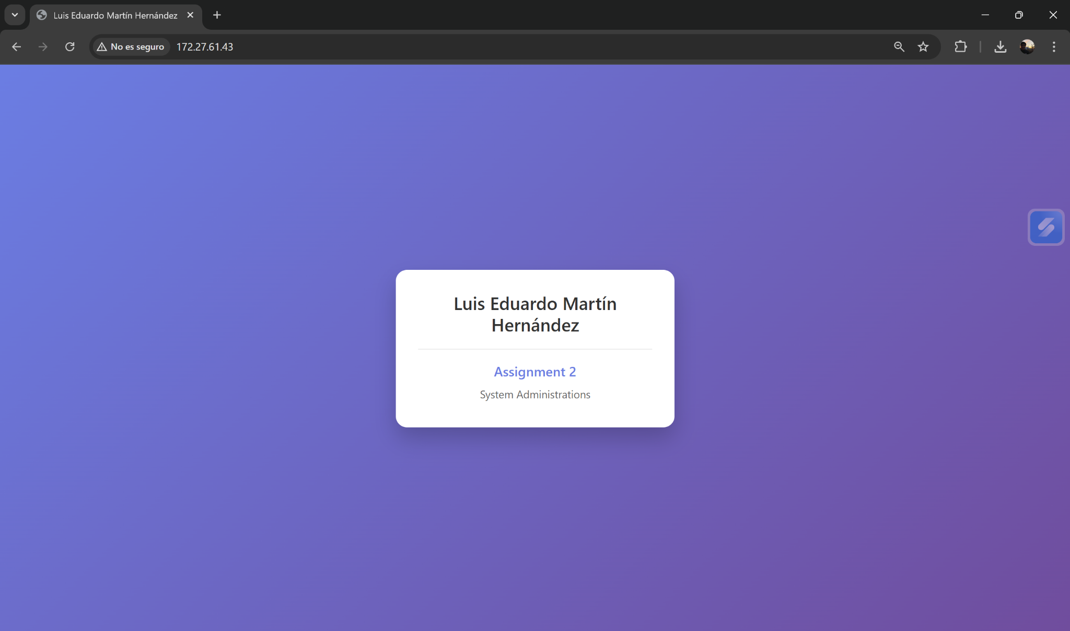
Caption: Figure 7: Personalized content for index.html

1.6 Advanced Server Configuration: CGI Integration
To enable dynamic content processing, I configured the Apache2 server to support the Common Gateway Interface (CGI). This allows the server to execute scripts and interact with system resources directly.
- Module Activation: I utilized the a2enmod management script to enable the CGI module. Due to the threaded nature of the Ubuntu Apache2 installation, the system automatically selected the cgid (CGI Daemon) variant to ensure thread safety.
- Service Persistence: After activation, I performed a graceful restart of the apache2 service using systemctl to ensure the new configuration was loaded into the binary.
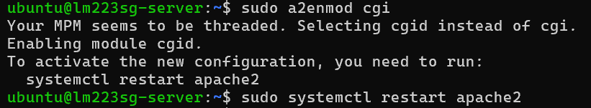
Caption: Figure 8: Enabling the CGI/cgid module and restarting the Apache2 service.

1.7 Server Status Automation (info.bash)
I developed a Bash script named info.bash to provide real-time telemetry of the server's status. As specified in the requirements, the script reports more than five essential system metrics, including uptime, kernel version, disk utilization, and memory availability.
- Security and Permissions: The script was placed in the restricted /usr/lib/cgi-bin/ directory and granted executable permissions (chmod +x) to comply with Ubuntu's standard security layout for CGI execution.
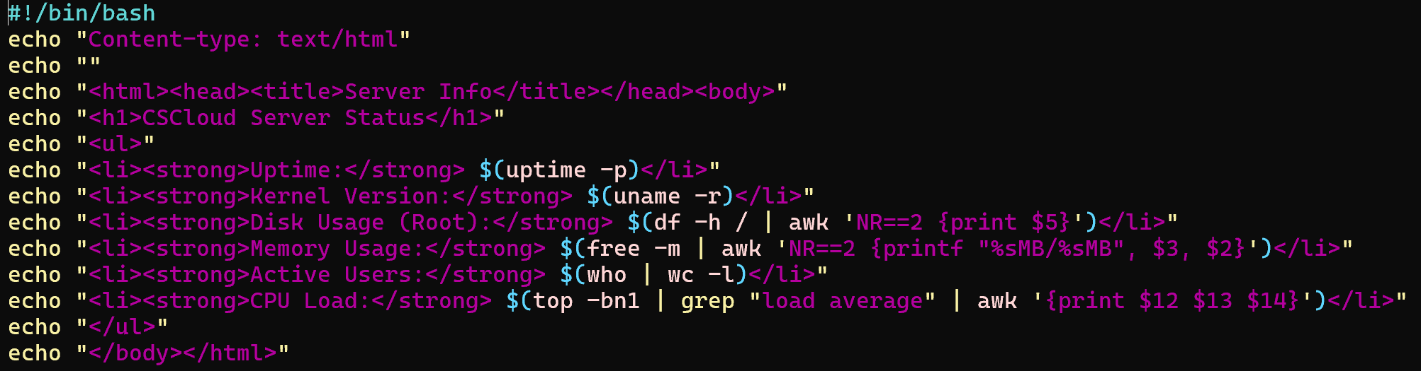
Caption: Figure 9: Source code of the info.bash CGI script.
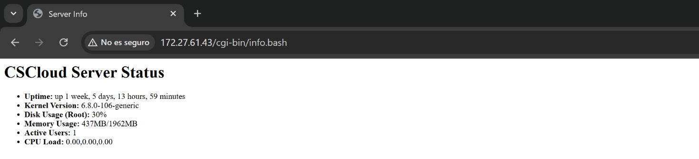
Caption: Figure 10: Web output of the server status information.

1.8 Automated Backups (backup.bash)
To ensure data integrity and facilitate disaster recovery, I developed a shell script titled backup.bash located in the user's home directory. This script automates the process of archiving critical server components.
- Logic and Compression: The script utilizes the tar utility with the -czvf flags to create a compressed Gzip archive (.tar.gz). This reduces storage overhead while preserving file permissions and directory structures.
- Scope of Backup: As specified in the requirements, the archive includes:
  - Web Content: All files within /var/www (including the custom index.html).
  - Configuration: Essential settings from /etc/apache2, ensuring that site-available and module configurations can be restored.
- Execution: The script was granted executable permissions and tested to verify that the resulting backup.tar.gz file contains the correct directory tree.
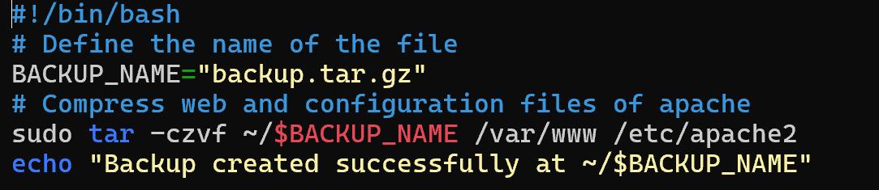
Caption: Figure 11: Source code of the backup automation script.
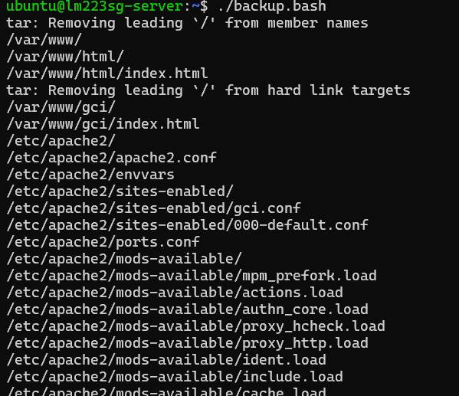
Caption: Figure 12: Successful execution of the backup script and verification of the generated archive.

Backup created successfully at ~/backup.tar.gz


1.9 Optional Task: Database Integration via CGI (database.bash)
To demonstrate a higher level of full-stack integration within a Linux environment, I implemented a dynamic CGI script that interfaces directly with the MariaDB database engine.
- Database Schema: I initialized a new database named assignment_db and a table named classmates. This involved executing SQL commands to define the schema and populate it with sample data to simulate a production environment.
- Dynamic Querying: The script database.bash was programmed to:
  - Establish a connection to the local MariaDB instance.
  - Retrieve the current database version string.
  - Execute a SELECT statement to fetch and format the contents of the classmates table into an HTML-readable format.
- Verification: Accessing the script via the web browser confirms that the Apache2 server correctly handles the CGI request, executes the Bash logic, and communicates successfully with the database service.
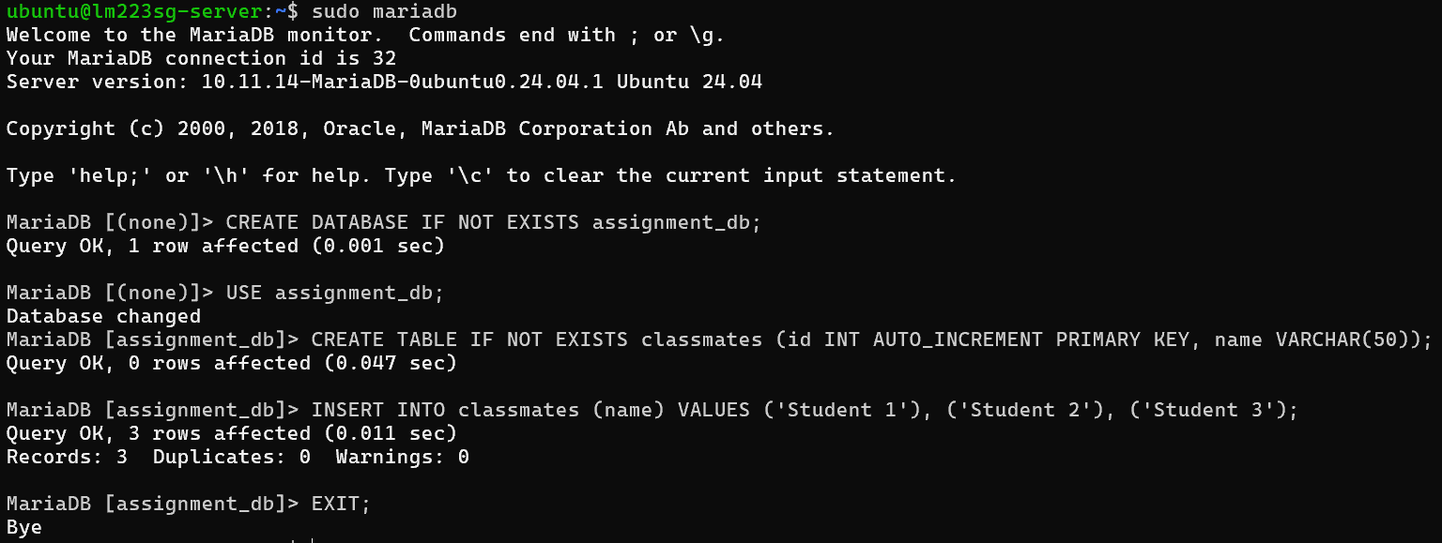
Caption: Figure 13: Create and fill up the database tables.
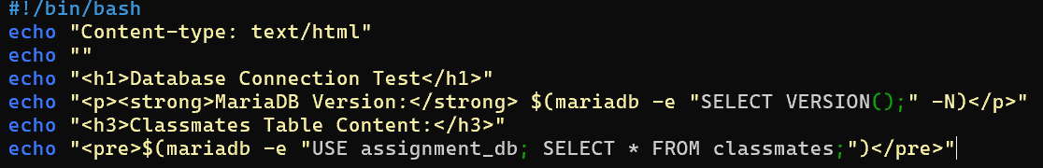
Caption: Figure 14: Implementation of the database-connected CGI script.
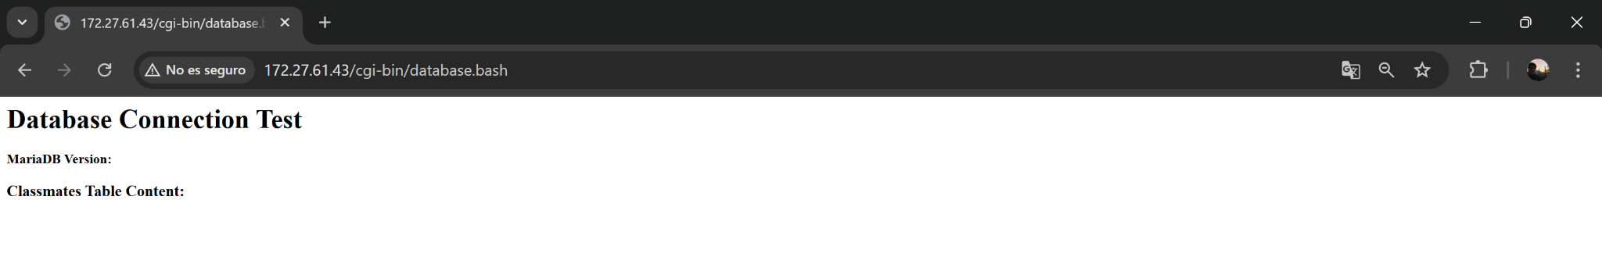
Caption: Figure 15: Web-based report generated dynamically from MariaDB data.

Requirements 02: Build your own customized docker image
In this section, I transitioned from manual server configuration to Infrastructure as Code (IaC) by utilizing Docker and Docker-Compose. The objective was to demonstrate the ability to create, configure, and orchestrate isolated Linux environments. This approach ensures portability and consistency, allowing services to run identically on my local WSL2 environment as they do on the CSCloud server.

2.1 Adding the cowsay program to the image
The first step in building a customized environment was the creation of a Dockerfile. I used ubuntu:latest as the base image to maintain consistency with the remote server.
- Implementation: I utilized the RUN instruction to synchronize the package index and install the cowsay utility.
- Path Configuration: Since the binary is installed in a non-standard directory (/usr/games), I modified the ENV PATH variable within the Dockerfile to ensure the command is globally accessible within the container's shell.
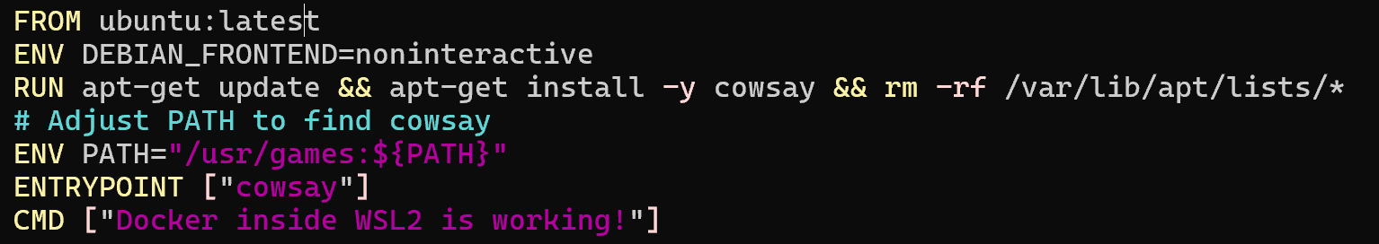
Caption: Figure 16: Dockerfile configuration for the customized cowsay image.

2.2 Updating docker-compose.yaml for automated builds
To manage the lifecycle of the container effectively, I implemented a docker-compose.yaml file. This orchestration tool allows for a declarative definition of the service.
- Build Logic: I updated the configuration to include the build: “.” directive. This ensures that Docker-Compose triggers a build of the image whenever it is needed (e.g., if the image is missing or the source code changes).
- Efficiency: This method replaces manual docker build commands, streamlining the development workflow.
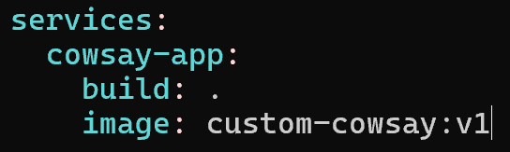
Caption: Figure 17: Docker Compose configuration utilizing the build context.

2.3 Verification: Running the cowsay program
Once the image was built and the orchestration was configured, I verified the functionality by initiating the container.
- Execution: By running docker compose up, the container was instantiated, and the entrypoint command was executed.
- Result: The successful output in the terminal confirms that the software dependencies and environment variables were correctly captured during the build process.
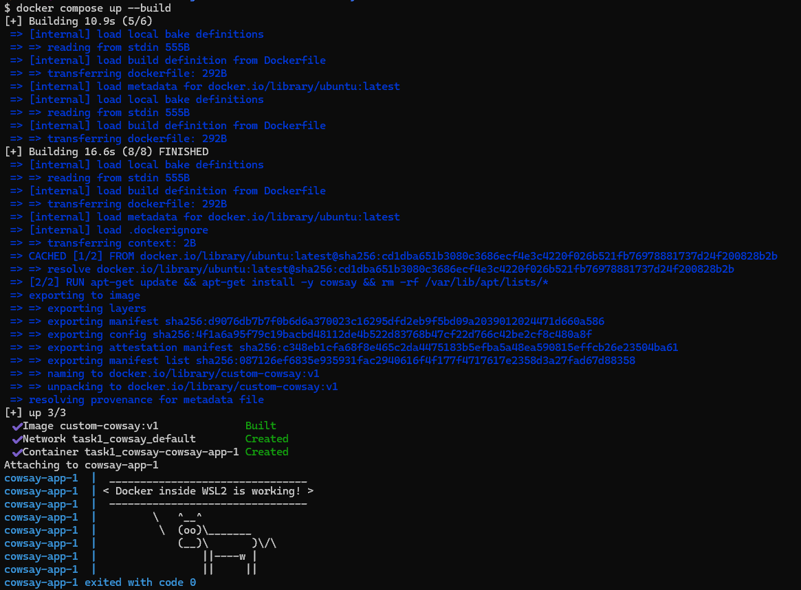
Caption: Figure 18: Functional verification of the customized Docker image.

2.4 Containerized Web Server and CGI Execution (info.bash)
The final task in this requirement involved creating a second, more complex image to host the web-based telemetry service.
- Service Deployment: This image automates the installation of the Apache2 web server.
- CGI Configuration: I enabled the cgid module using the a2enmod script, which is the standard Ubuntu helper for managing Apache modules.
- Script Integration: I copied the info.bash script—previously developed for the CSCloud environment—into the container's /usr/lib/cgi-bin/ directory.
- Connectivity: The container maps port 8081 on my local machine to port 80 inside the container, allowing me to view the server status via a standard web browser.
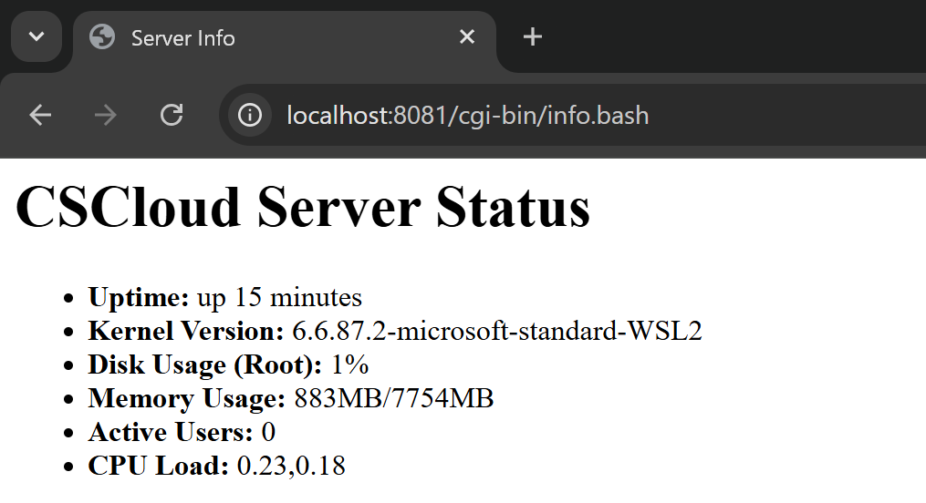
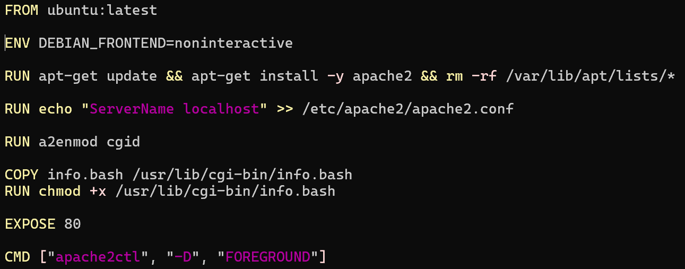
Caption: Figure 19 & 20: Deployment of the containerized web server and successful execution of the CGI script.

2.5 Script Development for Automated Remote Retrieval
To bridge the gap between the remote cloud infrastructure and the local development environment, I developed a specialized Bash script named download.bash. This script automates a two-stage synchronization workflow:
- Remote Triggering: The script establishes a Secure Shell (SSH) connection to the CSCloud instance to execute the previously developed backup.bash script, ensuring the archive contains the most recent server state.
- Secure Data Transfer: I utilized the SFTP (Secure File Transfer Protocol) in batch mode to retrieve the backup.tar.gz file. This method was chosen over standard scp for its robustness in handling stream-based transfers within automated scripts.
- Identity Management: The script explicitly references the private RSA key using the -i flag to comply with the server's strict public-key authentication requirements.
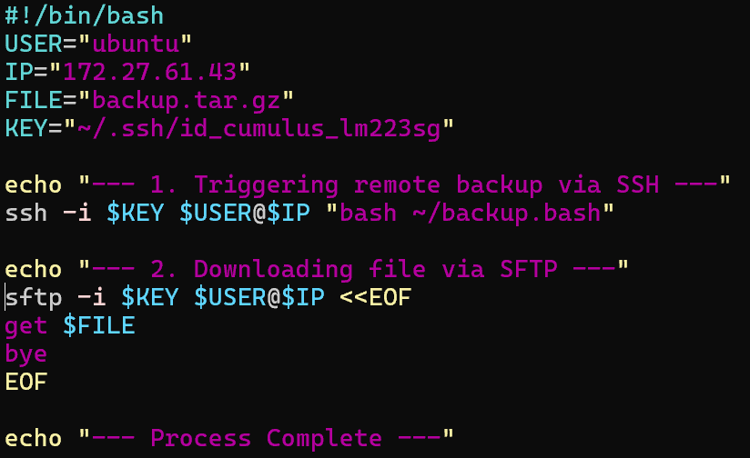
Caption: Figure 21: Implementation of the automated download script using SSH and SFTP.

2.6 Local Execution and Troubleshooting
The transition from manual commands to automated scripts provided an opportunity for advanced system troubleshooting.
- Authentication Challenge: During the initial execution, the process failed with a Permission denied (publickey) error. This highlighted that the local shell environment was not automatically presenting the required credentials to the CSCloud gateway.
- Resolution: By explicitly defining the path to the private key within the script variables, I successfully established the encrypted tunnel.
- Verification: Upon execution, the script confirmed the successful "get" operation. I verified the integrity of the transfer using the ls -lh command in the WSL2 terminal, confirming that the 35KB archive was successfully moved from the cloud to the local physical disk.
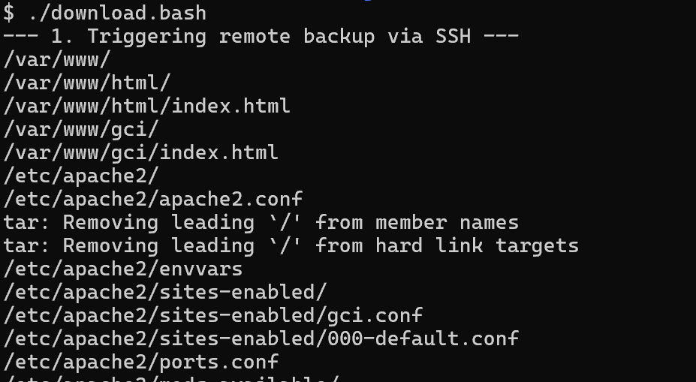
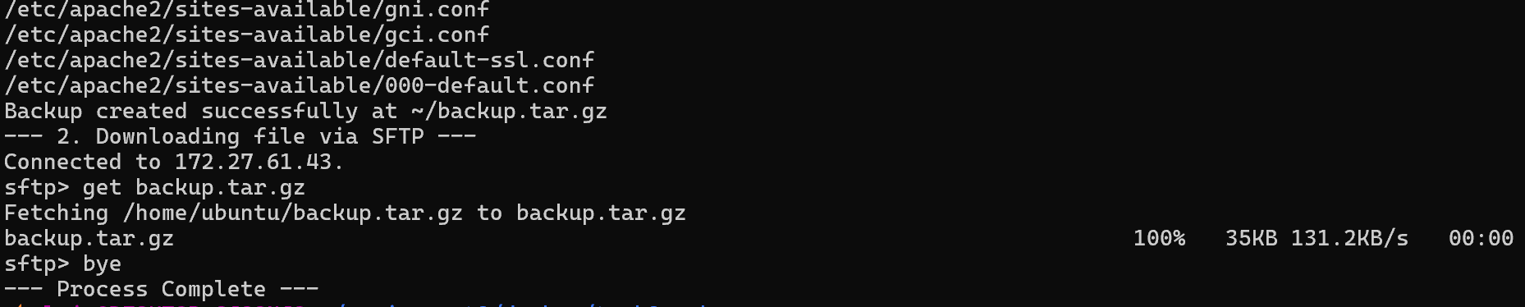
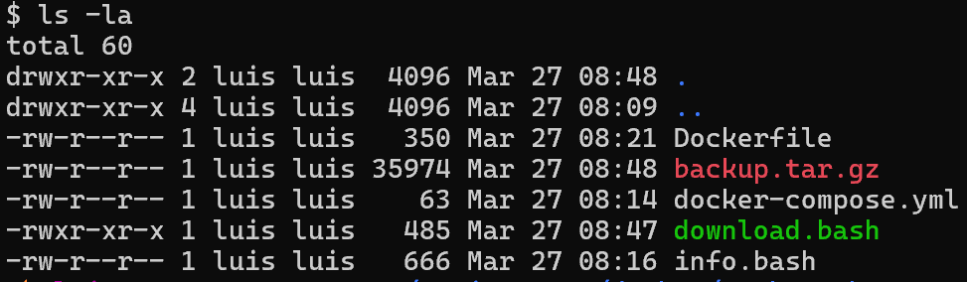
Caption: Figure 22: Successful script execution and local file verification.

2.7 Persistent Containerization via Docker Volumes
The final requirement was to encapsulate the retrieval logic within a Docker container while ensuring the data survived the container's termination. This demonstrates a deep understanding of Docker Volumes.
- Custom Utility Image: I built a dedicated Docker image based on ubuntu:latest, provisioned with the openssh-client package. This ensures the container has the necessary protocols to communicate with external servers.
- Volume Mapping and Host Integration:
  - Data Persistence: I utilized the -v $(pwd):/work flag to mount the host's current working directory into the container. This ensures that any file downloaded by the script is written directly to the host's disk.
  - Credential Passing: To allow the container to authenticate, I mapped the local .ssh directory as a read-only volume (:ro), providing the containerized process with the necessary identity files without compromising host security.
Conclusion: This implementation proves that administrative and backup tasks can be fully containerized and portable, while still interacting seamlessly with the host's filesystem for long-term data storage.
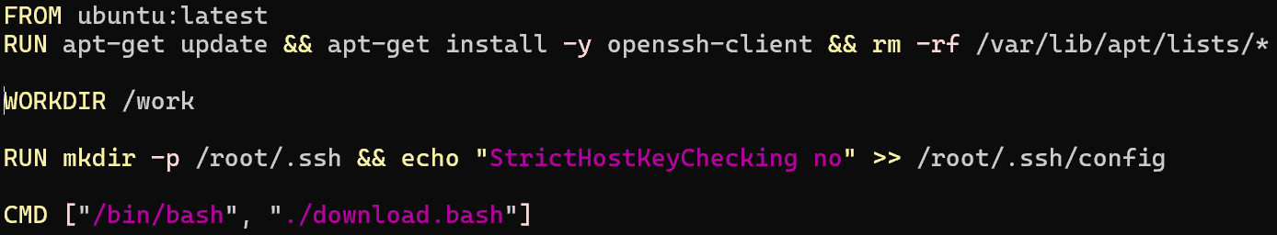
Caption: Figure 23: Content of Dockerfile.download.

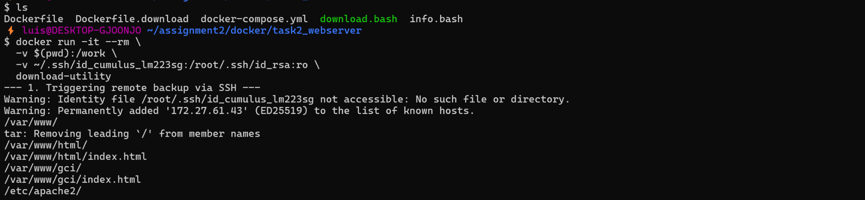
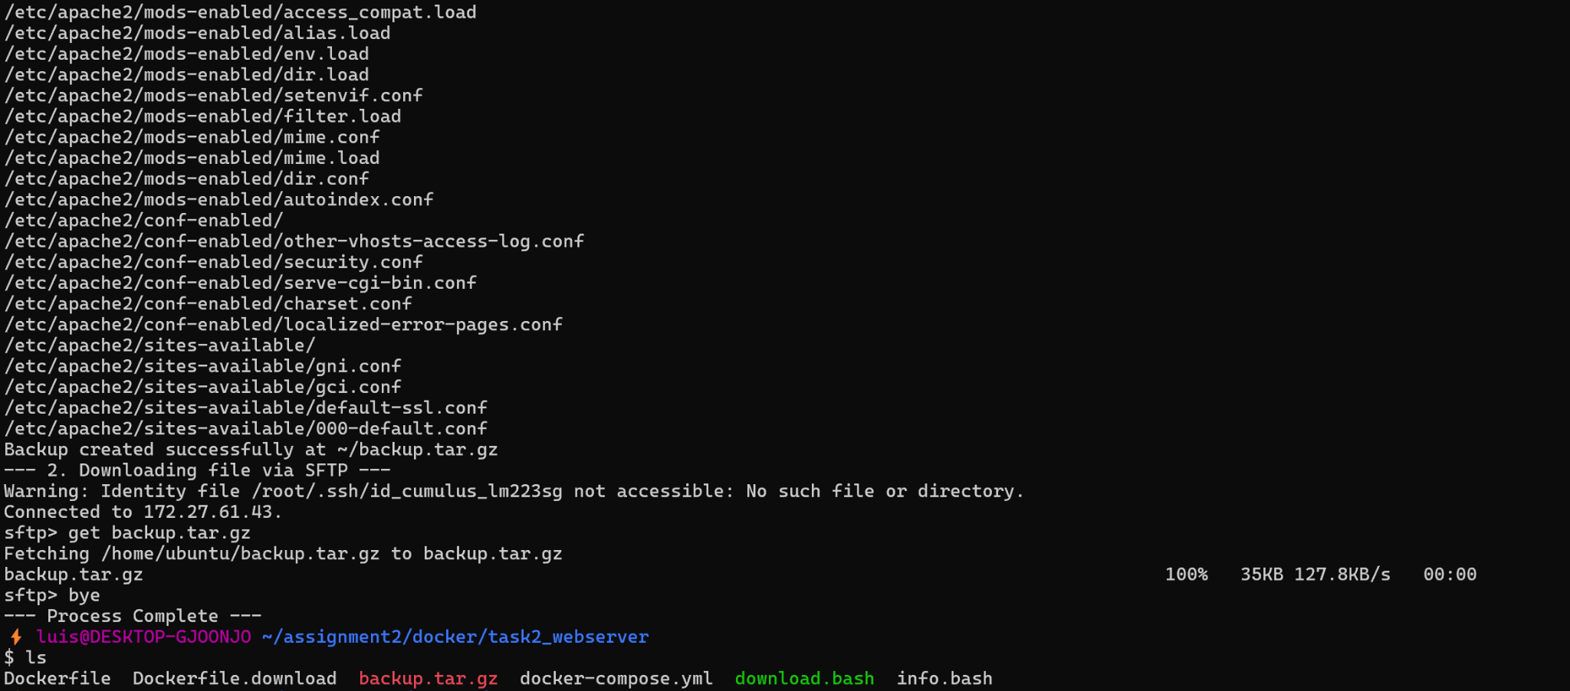
Caption: Figure 24: Containerized execution showing volume mapping and data persistence on the host machine.

Requirements 03: Find, evaluate and install a Linux distro
The final phase of this assignment focused on identifying a Linux distribution capable of reviving legacy hardware. The primary objective was to find a "small footprint" operating system that remains functional for modern tasks. After evaluating several options, I selected antiX Linux for its exceptional efficiency and Debian-based stability.

3.1 Selection and Research of the Distribution
I chose antiX Linux because it is a systemd-free distribution specifically designed to provide a fast, functional environment on aging hardware. By omitting the systemd init system, antiX significantly reduces background overhead. It perfectly matches the requirement for a small disk and memory footprint while maintaining compatibility with modern tools like apt and ssh.

3.2 Installation Process (VirtualBox)
To simulate a resource-constrained environment, I performed the installation in VirtualBox with 1024 MiB of RAM and 8 GB of storage. The installation was efficient, utilizing the antiX GUI installer to configure the partition table and the GRUB bootloader.
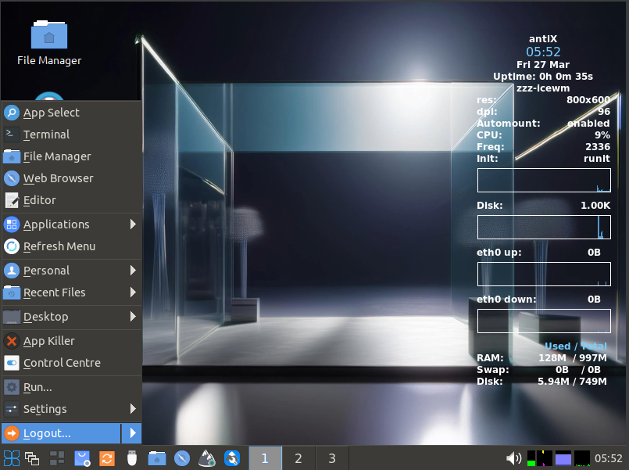
Caption: Figure 25: Initial desktop environment of the antiX Linux installation.

3.3 Browser Installation and CSCloud Connectivity
While antiX includes lightweight tools, I installed Firefox ESR as an additional modern web browser to test compatibility with current web standards.
- Installation: I utilized the terminal to synchronize repositories and install the browser via sudo apt install firefox-esr.
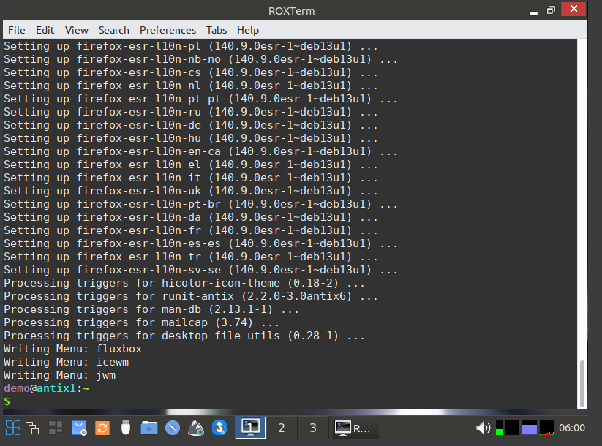
Caption: Figure 26: Terminal process for the installation of the Firefox ESR package.
- Verification: I used Firefox to connect to my CSCloud server at 172.27.61.43. The browser successfully rendered the customized "Hello World" page, proving that the lightweight OS handles modern protocols seamlessly.
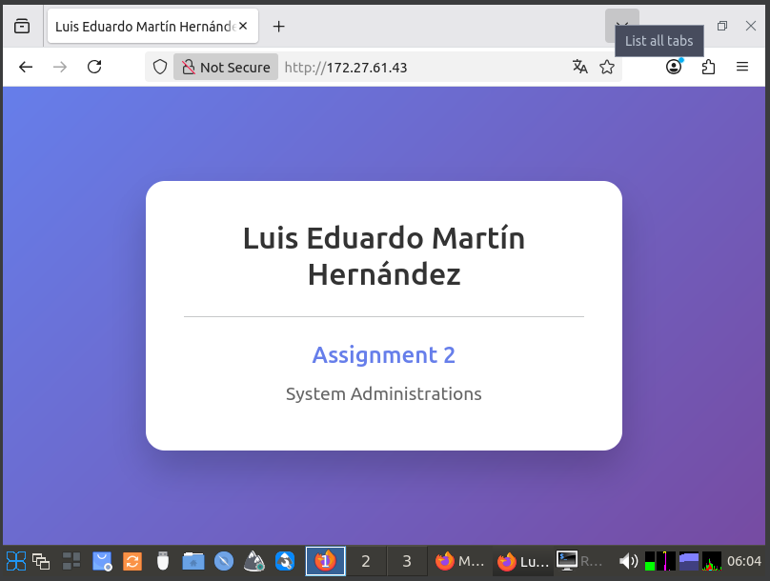
Caption: Figure 27: Firefox rendering the remote web content hosted on the CSCloud instance.

3.4 Multimedia Capabilities (yt-dlp Integration)
To test multimedia performance, I installed the command-line utility yt-dlp. I used this tool to download a high-definition sample video directly from a stream. The video was then played using the native MPV Media Player. The playback was smooth, demonstrating that antiX can handle modern video codecs even on legacy-simulated hardware.
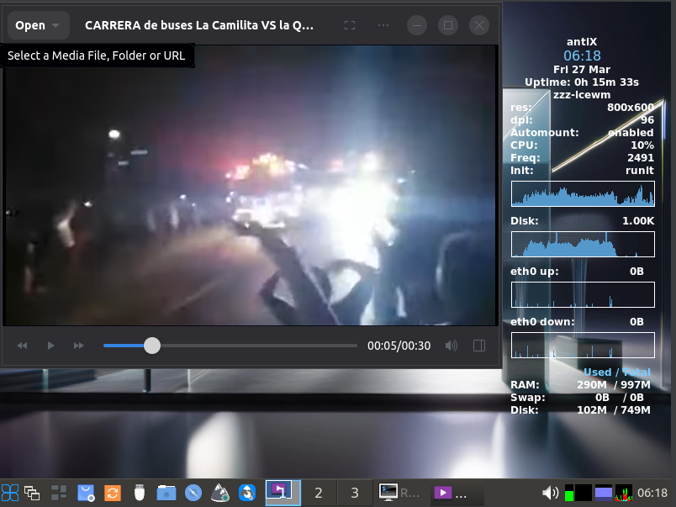
Caption: Figure 28: Successful video playback on the antiX desktop environment.

3.5 Remote Connectivity: SSH and SFTP
I verified the connectivity between the local machine and the CSCloud infrastructure. After migrating my private RSA key and setting the correct chmod 600 permissions, I performed the following:
- SSH Access: I established a secure shell connection to the remote server.
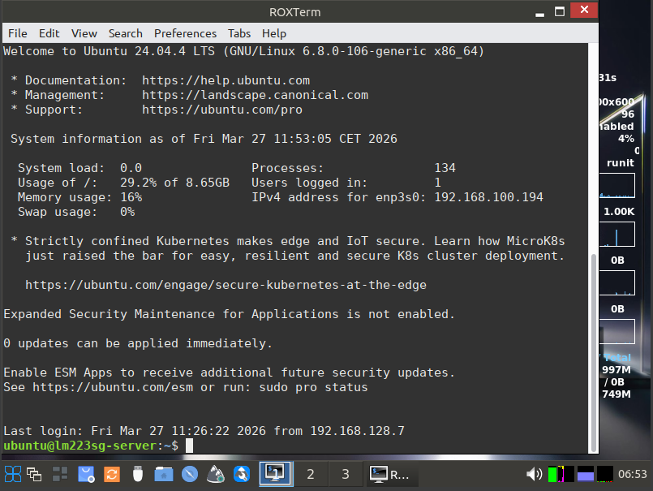
Caption: Figure 29: Active SSH session from the antiX terminal to the CSCloud server.
- SFTP Data Migration: I used SFTP to upload a local test file to the remote server, validating the integration of the lightweight client into a professional cloud-based workflow.
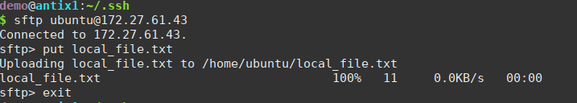
Caption: Figure 30: File transfer process using the SFTP protocol.
- Server-Side Verification: Finally, I verified the presence of the file on the remote server to confirm a successful transfer.
Caption: Figure 31: Remote directory listing confirming the successful reception of the file.

3.6 Hardware Footprint Measurement
Following the full installation, I performed an empirical measurement of the system's resource consumption using the free -h and df -h commands.
- Memory Utilization: The system reported a total of 997 MiB of RAM, with only 351 MiB used while idle, leaving 645 MiB available.
- Disk Footprint: The root partition and system overlay utilized a minimal portion of the allocated space, highlighting the extreme efficiency of the antiX file structure.
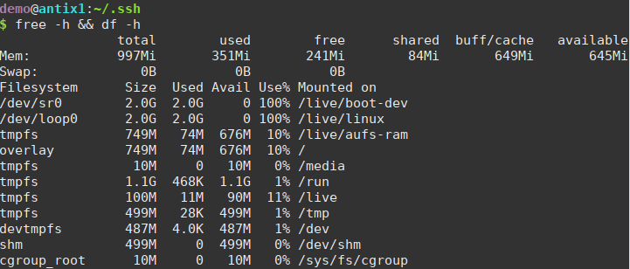
Caption: Figure 32: Empirical measurement of RAM and Disk utilization in antiX Linux.

3.7 Final Evaluation
antiX Linux exceeds the requirements for a "small footprint" operating system. It provides a functional desktop environment with modern connectivity while remaining exceptionally efficient. Its ability to run advanced tools like yt-dlp and manage secure cloud credentials proves it is a top-tier choice for resource-constrained scenarios.

3.8 Comparative Analysis: antiX (VM) vs. Raspberry Pi OS Lite (Physical Hardware)
I performed a secondary installation on physical hardware using a Raspberry Pi Zero 2 W. This allowed me to compare a desktop-oriented lightweight distro (antiX) against a headless, server-oriented distribution: Raspberry Pi OS Lite.

Technical Comparison and Footprint
Metric | antiX Linux (VirtualBox) | Raspberry Pi OS Lite (RPi Zero 2 W)
Architecture | x86_64 (Virtual) | ARM64 (Physical)
Interface | Desktop Environment (GUI) | Headless (CLI only)
RAM Usage (Idle) | ~351 MiB | ~35 MiB
Disk Usage | ~3.9 GB | ~1.4 GB

Evaluation and Personal Opinion
While antiX is an incredible achievement for legacy desktops, the Raspberry Pi OS Lite takes the "small footprint" concept to its logical extreme. Operating without a Graphical User Interface (GUI) allows the system to run on just a fraction of the memory, making it the superior choice for dedicated server tasks or IoT applications where every megabyte of RAM counts.
One feature that particularly impressed me is the Raspberry Pi Connect service. In a professional workflow, being able to access a remote terminal through a web interface without the need for a VPN or being on the same local network is a massive advantage. This external service bypasses complex firewall configurations and provides a secure, instant gateway to the system from any browser.

Conclusion
Comparing these two environments has provided me with a comprehensive understanding of resource optimization. antiX is the ideal solution for reviving old PCs that still require a visual workspace, whereas Raspberry Pi OS Lite represents the pinnacle of efficiency for headless infrastructure. Both distributions fulfill the "small footprint" requirement but serve different specialized niches in the Linux ecosystem.

TIL (Today I Learned): Final Reflection
Completing this lab has been a significant learning curve in system architecture. Below are my reflections on the process:
- The Challenging: The most difficult part was managing SSH permissions within Docker containers. I learned that SSH is extremely sensitive to file permissions (chmod 600). Mounting a Windows/WSL2 directory as a volume often causes permission mismatches, which I resolved by using a dedicated Dockerfile and explicit volume mapping for the identity key.
- The Tricky: Configuring the CGI (Common Gateway Interface) module inside a Docker container was a subtle challenge. It wasn't enough to just copy the script; I had to learn how to use a2enmod cgid programmatically and ensure the ServerName directive was set to avoid FQDN warnings in the logs.
- The Easy: Setting up the initial Apache server on CSCloud was straightforward, thanks to the robust documentation of the apt package manager and the simplicity of the index.html structure.
- Key Insight: My biggest "Eureka" moment was the comparison between antiX and Raspberry Pi OS Lite. I was amazed to see a physical Raspberry Pi Zero 2 W running a full server environment with only 35 MB of RAM. Furthermore, discovering Raspberry Pi Connect changed my perspective on remote management—accessing a terminal via a web interface without a VPN is a game-changer for accessibility.
Conclusion: This assignment taught me that "Infrastructure as Code" is not just about making things run; it's about making them portable, secure, and efficient regardless of whether the hardware is a high-end cloud server or a $15 micro-computer.

Resources and References

Primary Resources Utilized:
- Infrastructure: CSCloud OpenStack Instance (Ubuntu 24.04 LTS) for remote deployment.
- Local Development: Windows 11 with WSL2 (Ubuntu 24.04) and Docker Desktop for container orchestration.
- Database Management: MariaDB Server for back-end data structure and environment preparation.
- Virtualization: Oracle VM VirtualBox for evaluating antiX Linux.
- Hardware: Raspberry Pi Zero 2 W (Physical ARM64 hardware) for footprint benchmarking.
- Protocols & Tooling: OpenSSH (Key-based authentication), SFTP (Batch mode), Apache2 (CGI/CGID modules), and yt-dlp for multimedia stress testing.

References (IEEE Style):
- Apache Software Foundation, "Apache HTTP Server Documentation Version 2.4," [Online]. Available: https://httpd.apache.org/docs/2.4/
- Apache Software Foundation, "Apache Module mod_cgid: Common Gateway Interface Daemon," [Online]. Available: https://httpd.apache.org/docs/2.4/mod/mod_cgid.html
- MariaDB Foundation, "MariaDB Server Documentation: Getting Started with MariaDB," [Online]. Available: https://mariadb.com/kb/en/documentation/
- Canonical Ltd., "Ubuntu Server Guide: Apache2 Web Server Setup," [Online]. Available: https://ubuntu.com/server/docs/web-servers-apache
- Docker Documentation, "Docker Compose Specification and Best Practices," [Online]. Available: https://docs.docker.com/compose/compose-file/
- antiX Linux Project, "antiX-FAQ: Lightweight Linux for legacy hardware optimization," [Online]. Available: https://antixlinux.com/about/
- Raspberry Pi Foundation, "Raspberry Pi Connect: Remote access and terminal management," [Online]. Available: https://www.raspberrypi.com/documentation/services/connect.html
- T. Parker, "Shell Scripting: Expert Recipes for Linux, Bash and More," [Online]. (Reference for SSH/SFTP automation).

Video Link
https://drive.google.com/file/d/1F4N8zsHIN3DTQq6H9D7Y-OZZ8Pe1KVgS/view?usp=sharing

