System Administration
Flow Analysis


Luis Eduardo Martín Hernández
lm223sg@student.lnu.se
20050201-T273
20/03/2026

Index
3.1 Flow Identification 2
3.1.1. Capture Summary Information 2
3.1.2. Protocol Hierarchy (OSI Model) 3
Link Layer (Layer 2) 3
Network Layer (Layer 3) 3
Transport Layer (Layer 4) 3
Application Layer (Layer 7) 3
3.1.3. Flow Identification and Selection 5
1. ERP Application Flow (TCP Port 8880) 5
2. Web Traffic (HTTP – TCP Port 80) 6
3. VoIP Signalling (SIP – UDP Port 5060) 6
4. Email Services (SMTP / POP3 – TCP Ports 25 and 110) 7
3.1.4. Flow Profiling 8
ERP Flow Profile (Data-Intensive / Transactional) 8
Web Traffic Profile (Bursty / Client–Server) 8
VoIP Signalling Profile (Latency-Sensitive / Control Traffic) 9
Email Flow Profile (Periodic / Low-Volume) 9
3.1.5. Expert Info Analysis 10
3.1.6. Protocol Dissectors (The HTTP Experiment) 10
3.1.7. "Decode As" (Port 8880) 11
3.2 Flow Engineering 12
3.2.1. Individual vs Composite Flows 12
3.2.2. Sources and Sinks 12
ERP Flow 12
Web Traffic Flow 13
VoIP Signalling Flow 13
Email Flow 13
3.2.3. Flow Models 14
ERP Flow – Client–Server Model 14
Web Traffic – Client–Server Model 14
VoIP Signalling – Transactional Flow Model 15
Email Traffic – Store-and-Forward Model 15
3.2.4. Reconstruction of the ERP Application Layer 15
3.2.5. Graph of the Flow 16
3.2.6. Example Conversation Analysis 17
3.2.7. Five Flow Graphs 18
Measurement Units and Time-Based Analysis 18
Use of Bits as a Measurement Unit 18
Use of Packets as a Measurement Unit 18
Importance of Time-of-Day Analysis 19
References 19

3.1 Flow Identification

3.1.1. Capture Summary Information
The capture provides a snapshot of the operational network at LNU Co. Ltd:
- Duration: 283.776 seconds (approx. 4:44 minutes).
- Total Packets: 90,035.
- Avg. Throughput: 995 kbps
- Avg. Packet Rate: 317.3 pps
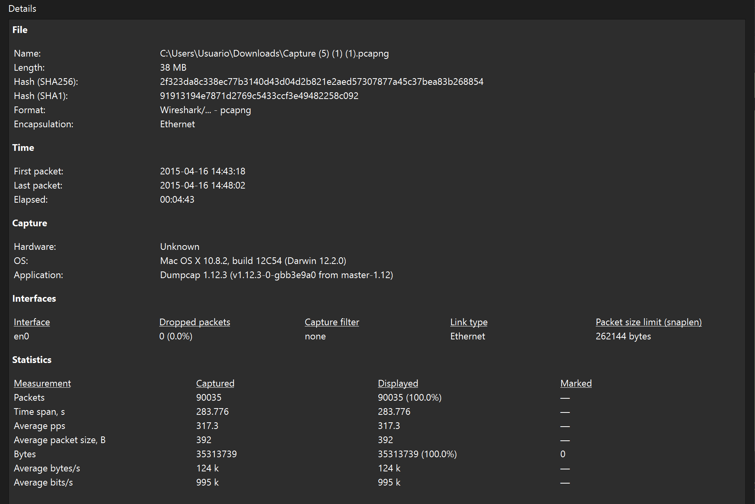

3.1.2. Protocol Hierarchy (OSI Model)
The network relies heavily on the TCP/IP stack. The hierarchy shows a standard distribution with a dominant custom application:

Link Layer (Layer 2)
At the link layer, all traffic is carried over:
- Ethernet II (100%)
This indicates that the entire communication is encapsulated using Ethernet framing, which is expected in LAN environments.

Network Layer (Layer 3)
The dominant network layer protocol is:
- IPv4 (99.8%) → main carrier of traffic
- IPv6 (0.1%) → minimal usage, likely for local discovery
- Minor control protocols:
  - ICMPv6
  - OSPF

Transport Layer (Layer 4)
At the transport layer:
- TCP (99.1%) → dominant protocol
- UDP (~0.6%) → used for lightweight or real-time services
This indicates that most communication is connection-oriented, ensuring reliability.

Application Layer (Layer 7)
The application layer shows a more diverse distribution:
- Line-based text data (65.7%) → dominant payload
- HTTP (17.2%) → web-based communication
- SMTP (1.8%) & POP (0.3%) → email services
- DNS (0.3%) → name resolution
- SIP (0.3%) → VoIP signalling
- DHCP & others (<0.1%) → network support services
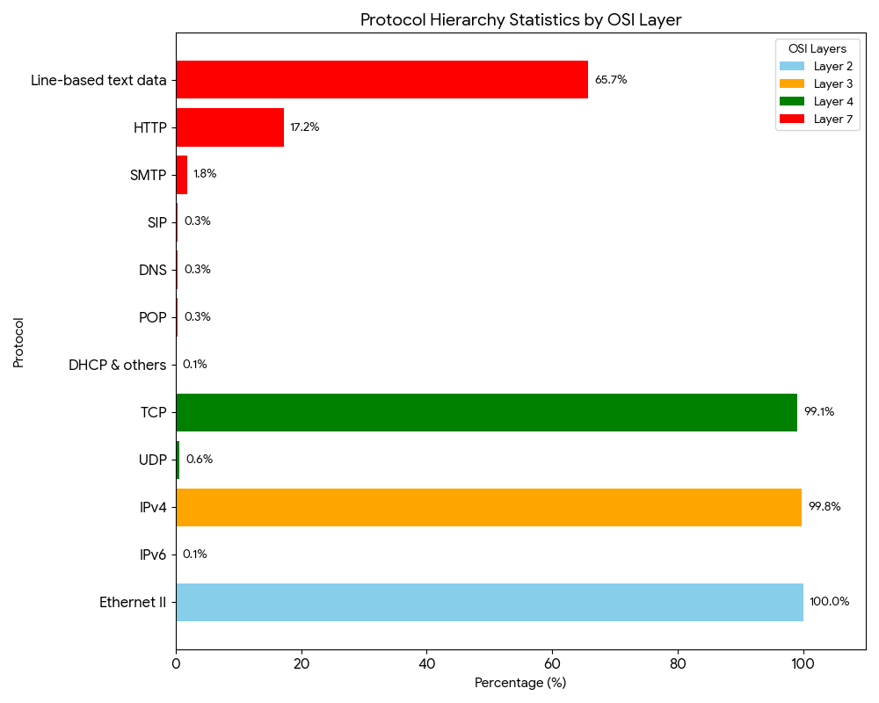
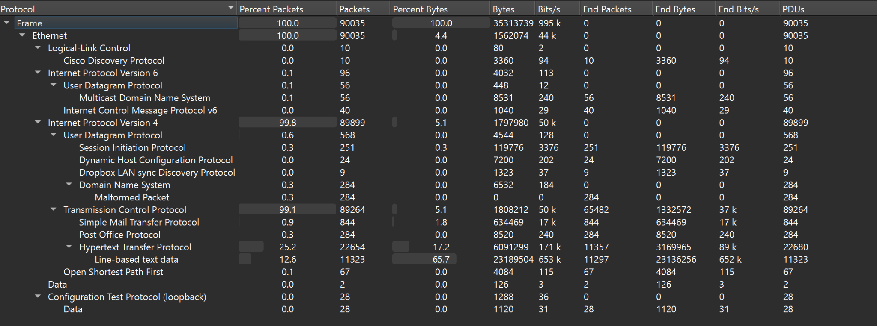

3.1.3. Flow Identification and Selection
The Wireshark capture reveals a large number of individual communication streams between hosts within the network and external services.
By analysing the Statistics → Conversations feature in Wireshark, the following number of flows were identified:
- TCP flows: 4,022 streams
- UDP flows: 379 streams
This results in a total of 4,401 flows observed during the capture period.
Although thousands of flows exist, only a small subset of them significantly influence network architecture and design decisions. For this reason, the analysis focuses on flows that are either:
- High-volume traffic generators
- Essential business services
- Latency-sensitive services
Based on the traffic analysis, the following flows were selected for further analysis.

1. ERP Application Flow (TCP Port 8880)
The ERP system communicates using TCP port 8880.
This flow represents the primary internal business application used by employees.
ERP traffic typically consists of:
- Long-lived TCP sessions
- Large volumes of application data
- Continuous communication between client workstations and the ERP server
Because ERP systems support core organizational operations, they are considered mission-critical applications. Any network redesign must ensure that sufficient bandwidth and reliability are provided for these flows.
For this reason, ERP traffic is selected as one of the main flows for detailed analysis.
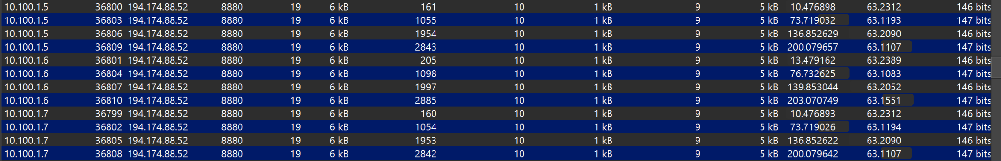

2. Web Traffic (HTTP – TCP Port 80)
The capture shows a large number of HTTP conversations between internal hosts (10.100.16.x) and the server 172.20.88.6.
Each conversation typically contains:
- Around 30–50 packets
- Approximately 12–21 kB of transferred data
These flows are short-lived but occur very frequently, which indicates normal web browsing behaviour or access to internal web services.
Even though each individual HTTP flow is relatively small, the large number of connections makes web traffic an important component of overall network load. Therefore, HTTP traffic must be considered when designing network capacity and gateway resources.
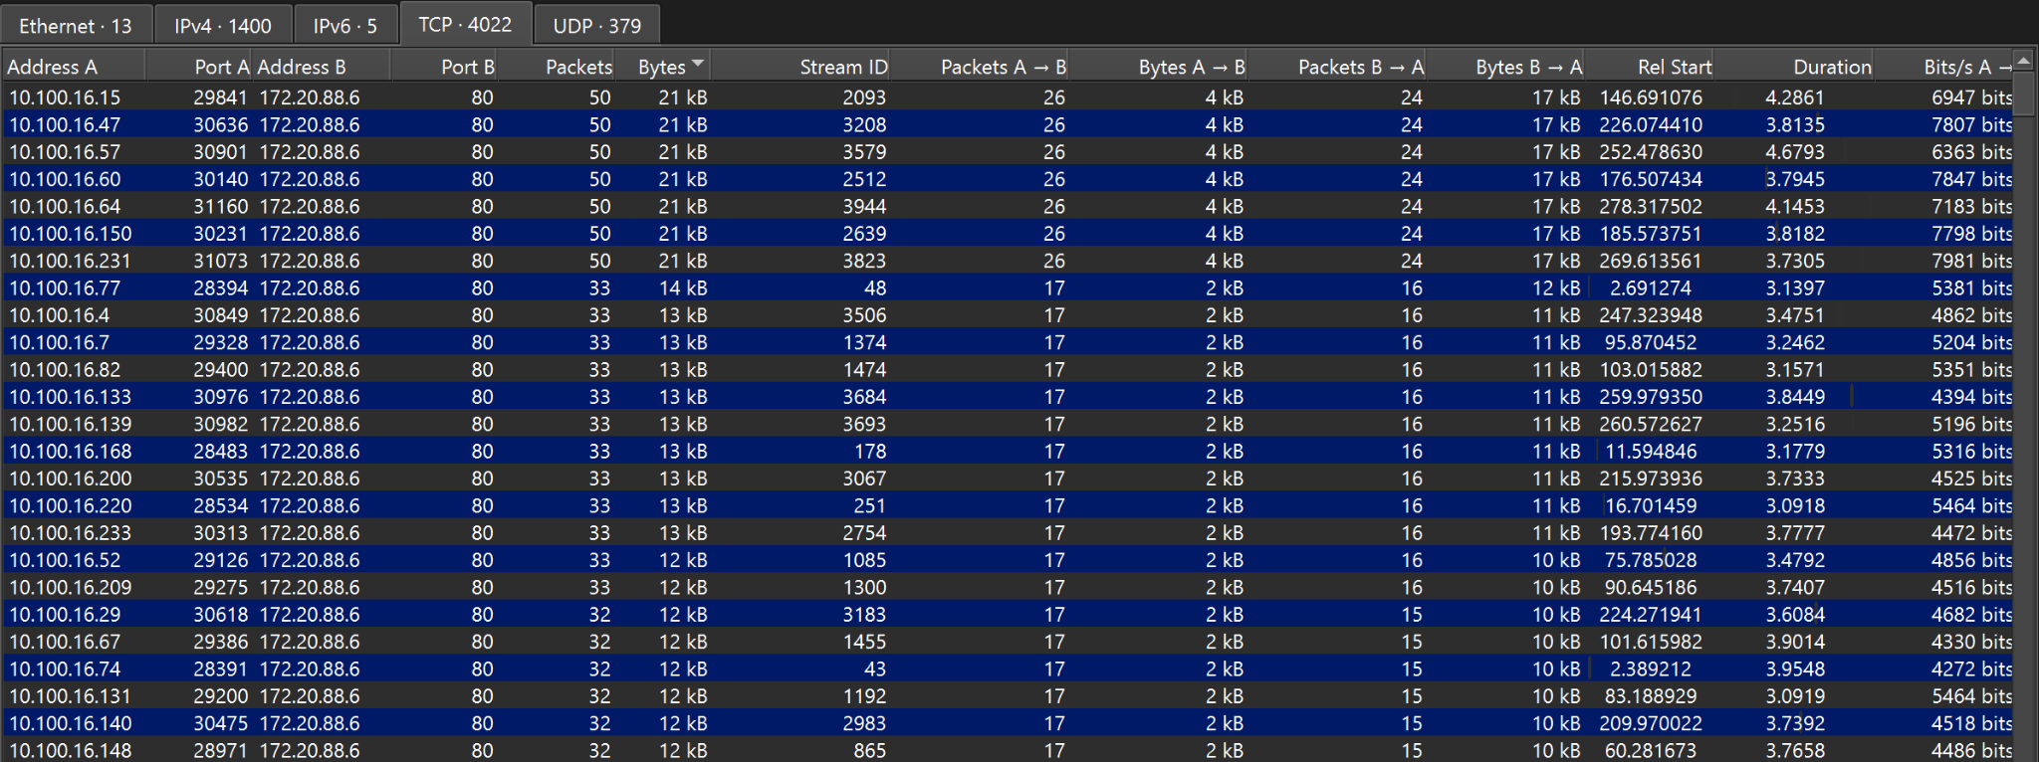

3. VoIP Signalling (SIP – UDP Port 5060)
The UDP analysis reveals multiple conversations using port 5060, which corresponds to the Session Initiation Protocol (SIP).
SIP is commonly used for Voice over IP (VoIP) signalling, which manages the establishment and termination of voice calls.
Although the SIP packets themselves are small, VoIP systems are highly sensitive to network latency, jitter, and packet loss. For this reason, VoIP traffic often requires Quality of Service (QoS) prioritization in network architectures.
Due to these strict performance requirements, SIP flows are considered important for the design of the network infrastructure.
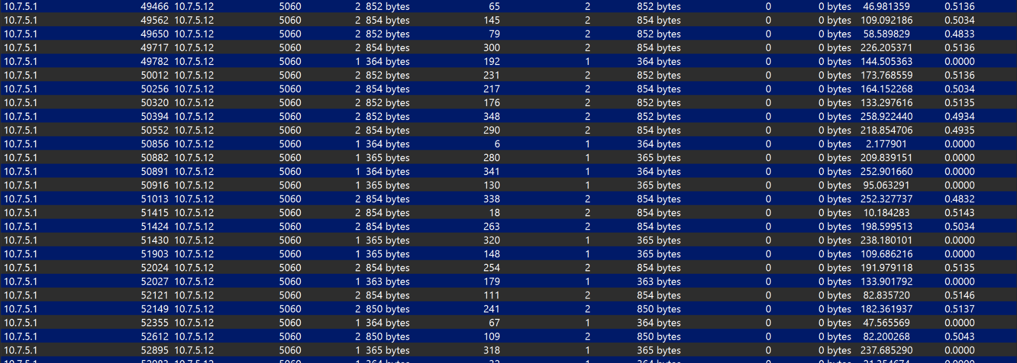

4. Email Services (SMTP / POP3 – TCP Ports 25 and 110)
The capture also contains traffic associated with email services, specifically:
- SMTP (port 25) for sending mail
- POP3 (port 110) for retrieving mail
Email traffic is generally lower in volume compared to web or ERP traffic, but it is still business-critical communication infrastructure. The failure of email services would significantly impact daily organizational operations.
Therefore, email flows are included in the analysis to represent enterprise communication services.
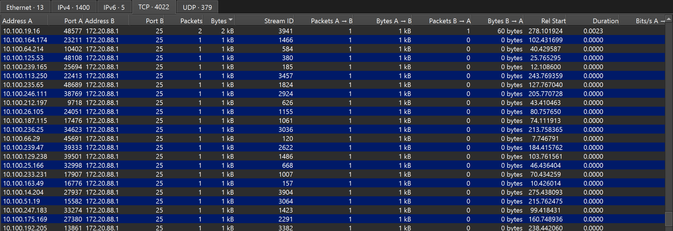
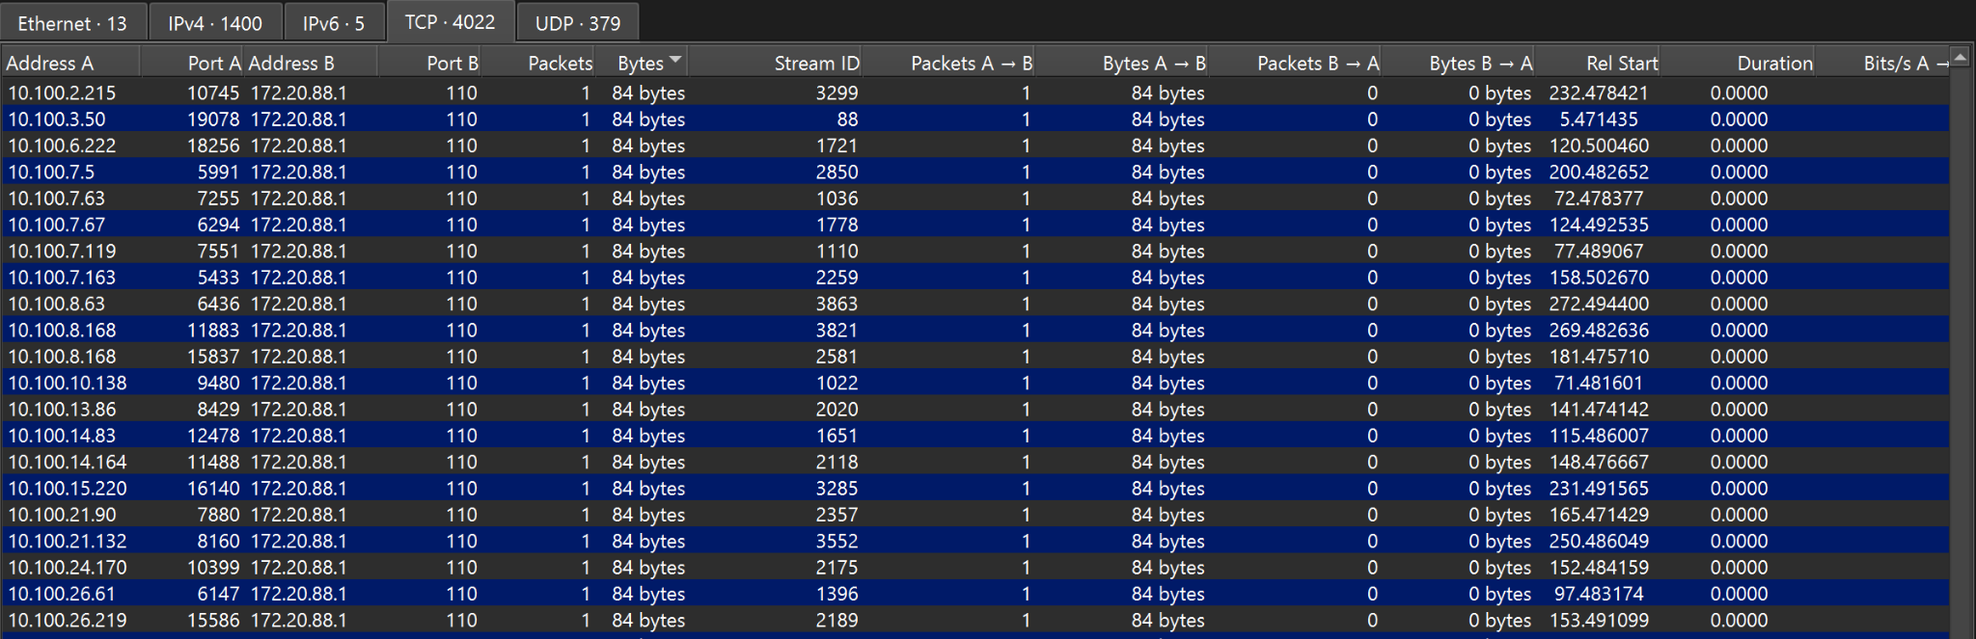

3.1.4. Flow Profiling
To better understand the behaviour of the selected flows, traffic profiles were created for each flow category. Profiling allows network designers to understand how different applications behave and what network resources they require.
The profiles of the selected flows are described below.

ERP Flow Profile (Data-Intensive / Transactional)
The ERP traffic profile is characterized by:
- Long-lived TCP sessions
- Continuous data exchange
- Relatively high byte counts compared to other flows
- Structured application-layer data
This behaviour indicates a transactional enterprise application, where multiple users interact with a central system that processes business data.
Profiling ERP traffic is important because it helps determine:
- Required bandwidth allocation
- Need for reliable connectivity
- Possible need for traffic prioritization

Web Traffic Profile (Bursty / Client–Server)
Web traffic shows a typical client–server pattern with:
- Short-lived TCP connections
- Small client requests
- Larger server responses
- Frequent new connections
This type of traffic is bursty, meaning traffic spikes occur whenever users request web pages or resources.
Profiling web traffic helps understand:
- Aggregate network load
- Server capacity requirements
- Internet gateway utilization

VoIP Signalling Profile (Latency-Sensitive / Control Traffic)
SIP traffic consists of:
- Small UDP packets
- Short signalling exchanges
- Frequent connection setup messages
Even though SIP traffic uses minimal bandwidth, it is extremely sensitive to latency and packet loss.
Profiling VoIP signalling helps determine:
- QoS requirements
- Priority queuing policies
- Network latency constraints
This makes VoIP traffic an important factor in network architecture design.

Email Flow Profile (Periodic / Low-Volume)
Email traffic typically appears as:
- Periodic bursts of activity
- Message uploads via SMTP
- Retrieval via POP3
These flows are generally low-volume but important for communication reliability.
Profiling email traffic allows administrators to understand:
- Expected mail server load
- Periodic usage patterns
- Backup and reliability requirements.

3.1.5. Expert Info Analysis
Summarizes anomalies like Malformed Packets (284 in DNS), TCP Retransmissions, and Connection Resets. It identifies "health" issues. The malformed packets suggest a protocol mismatch, and the retransmissions indicate congestion on the link between West Campus and the Network core.
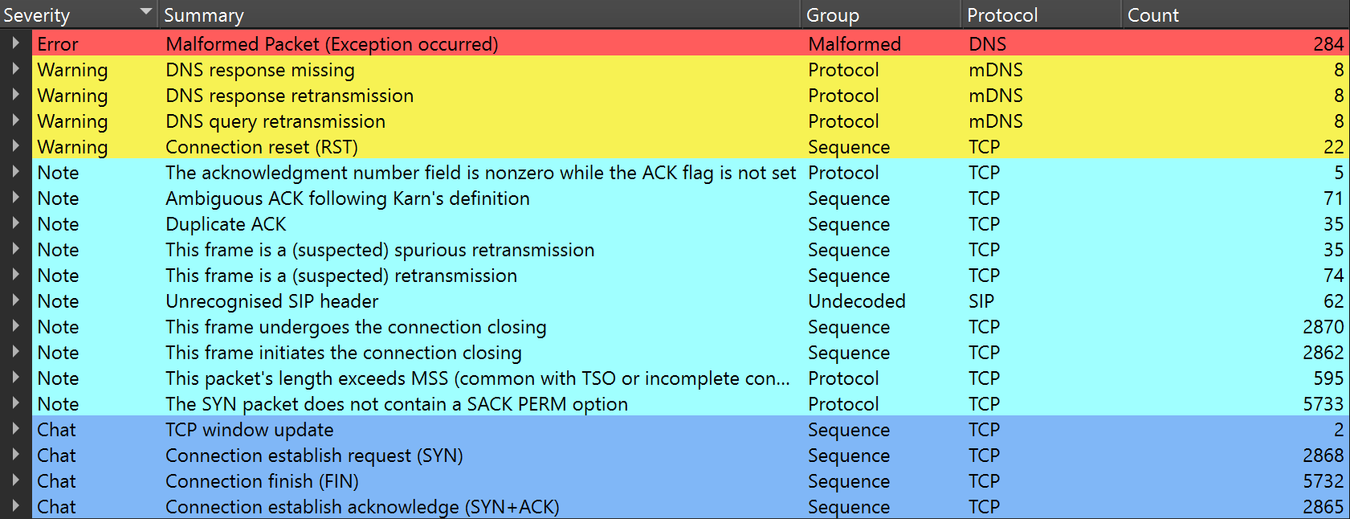

3.1.6. Protocol Dissectors (The HTTP Experiment)
After disabling HTTP in "Enabled Protocols” wireshark stops interpreting the payload. Packets previously labeled as "HTTP" now appear as generic "TCP."
Protocol dissectors are essential because they allow the analyzer to look into the Payload. Without them, we can see where data goes, but not what it is (e.g., we couldn't see the specific GET requests or ERP commands).
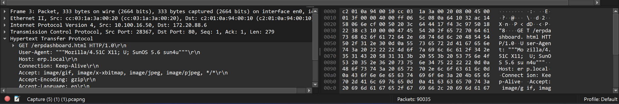
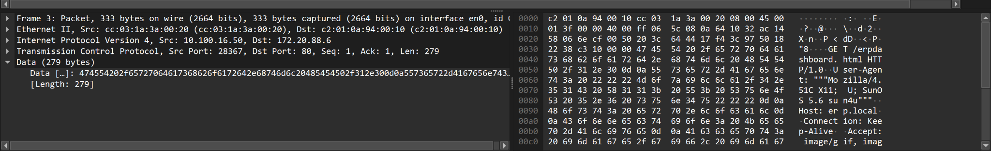

3.1.7. "Decode As" (Port 8880)
After forcing port 8880 to be interpreted as HTTP. Raw data is transformed into structured HTTP headers and text.
Many enterprise applications use non-standard ports to avoid conflicts or for security. "Decode As" is necessary because Wireshark's default library only maps port 80 to HTTP. It allows us to analyze the application layer of custom or legacy software like the ERP used at LNU.
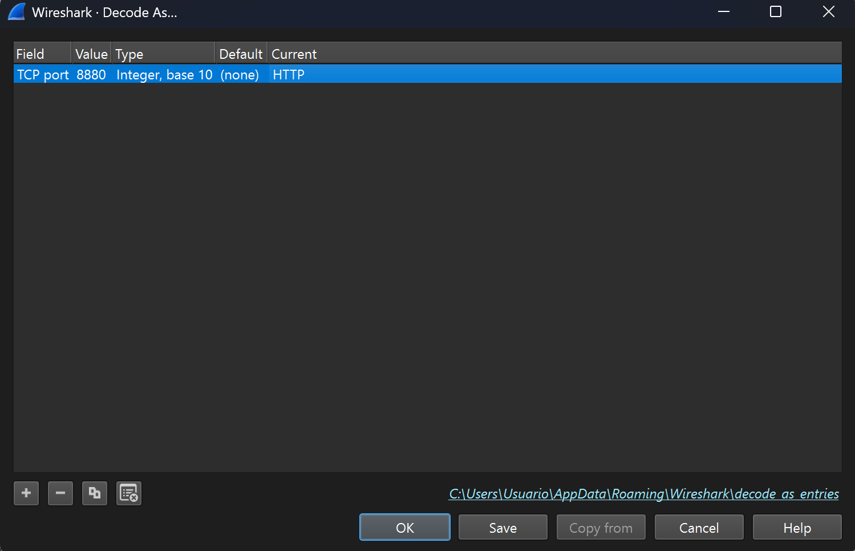
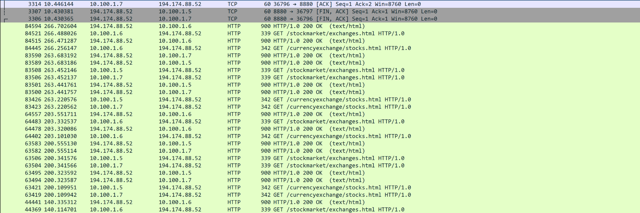

3.2 Flow Engineering

3.2.1. Individual vs Composite Flows
The selected flows were analysed using the Wireshark Conversations statistics, which revealed that each flow consists of multiple independent connections between hosts.
Because multiple sessions exist for each service, these flows are considered composite flows rather than individual flows.
A composite flow represents the aggregation of multiple individual conversations that belong to the same application or service.
The analysed flows behave as composite flows for the following reasons:
- ERP traffic (TCP 8880) consists of multiple requests between client workstations and the ERP server.
- Web traffic (HTTP – TCP 80) contains many short-lived connections generated by multiple clients requesting web resources.
- VoIP signalling (SIP – UDP 5060) includes multiple signalling exchanges between communication endpoints.
- Email services (SMTP / POP3) involve periodic connections between clients and mail servers.
Since each service generates multiple sessions across time and across multiple hosts, they are best modelled as composite flows in the network analysis.

3.2.2. Sources and Sinks
The source represents the device initiating the communication, while the sink is the system receiving or responding to the request.
Using the Wireshark Conversations view, the packet exchange direction and volume can be observed.
Example flows are shown below.

ERP Flow
Source → Sink communication:
Source: 10.100.1.5
Destination: 194.174.88.52
Service: ERP (TCP 8880)
Packet exchange:
Packets A → B : 10
Packets B → A : 9
Bytes A → B : 1kB
Bytes B → A : 5kB
This indicates a bidirectional communication pattern between the ERP client and server.

Web Traffic Flow
Example conversation:
Source: 10.100.16.15
Destination: 172.20.88.6
Service: HTTP (TCP 80)
Packet exchange:
Packets A → B : 26
Packets B → A : 24
Bytes A → B : 4kB
Bytes B → A : 17kB
This pattern shows a typical client request followed by a server response.

VoIP Signalling Flow
Example conversation:
Source: 10.7.5.1
Destination: 10.7.5.12
Service: SIP (UDP 5060)
Packet exchange:
Packets A → B : 2
Packets B → A : 0
This indicates a short signalling exchange where one endpoint initiates communication.

Email Flow
Example conversation:
Source: 10.100.12.128
Destination: 172.20.88.1
Service: SMTP / POP3
Packets A → B : 1
Packets B → A : 0
This type of flow represents short message transfers typical for email communication.

3.2.3. Flow Models
Based on the packet direction and communication patterns, the flows can be associated with different flow models.

ERP Flow – Client–Server Model
The ERP traffic follows a client–server model, where client systems send requests to a centralized ERP server.
Evidence for this model includes:
- bidirectional communication
- request–response interaction
- multiple client sessions to a single server
The ERP server acts as the sink for requests and the source of application data responses.

Web Traffic – Client–Server Model
Web traffic also follows a client–server architecture.
Clients request web resources using HTTP requests, and the server returns the requested content.
This can be seen in the HTTP messages such as:
GET /currencyexchange/stocks.html HTTP/1.0
HTTP/1.0 200 OK
The client sends the GET request, and the server responds with the requested web page.

VoIP Signalling – Transactional Flow Model
VoIP signalling flows follow a transactional model, where short control messages are exchanged to establish communication sessions.
These flows consist of small packets used to initiate or manage calls rather than transfer large data volumes.

Email Traffic – Store-and-Forward Model
Email traffic follows a store-and-forward communication model, where messages are sent to a mail server and later retrieved by recipients.
This communication pattern typically involves short bursts of activity.

3.2.4. Reconstruction of the ERP Application Layer
The ERP application layer communication was reconstructed using the Follow TCP Stream feature in Wireshark.
The reconstructed stream shows standard HTTP messages exchanged between the ERP client and server.
Example request:
GET /currencyexchange/stocks.html HTTP/1.0
Host: erp.local
Connection: Keep-Alive
This request asks the server to retrieve the resource stocks.html from the ERP system.
Example server response:

HTTP/1.0 200 OK
Server: Apache/1.3.3
Content-Type: text/html
Content-Length: 2048

Explanation of protocol elements:
Command | Meaning
GET | Client requests a specific resource
HTTP 200 OK | Server confirms successful request
Content-Type | Indicates the format of the returned data
Content-Length | Size of the transmitted content
The response then contains the HTML document, which is transmitted from the server to the client.

3.2.5. Graph of the Flow
The flow can be visualized using TCP Stream Graphs in Wireshark. The graph represents the communication timeline between the client and server. The start of the flow can be identified by the TCP three-way handshake:
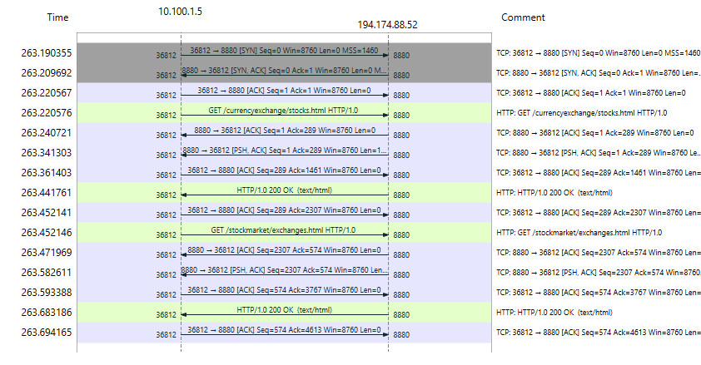

Example from the capture:
TCP: 36812 → 8880 [SYN]
TCP: 8880 → 36812 [SYN, ACK]
The end of the flow is identified by the TCP connection termination:
FIN | ACK
In some cases a RST packet.
These events mark the beginning and end of the communication session.

3.2.6. Example Conversation Analysis
A section of the ERP flow conversation is shown below.
GET /currencyexchange/stocks.html HTTP/1.0
Host: erp.local
Connection: Keep-Alive

HTTP/1.0 200 OK
Content-Type: text/html

Explanation:
- The client sends an HTTP GET request asking for the resource stocks.html.
- The server processes the request and responds with HTTP 200 OK, indicating that the request was successful.
- The server then sends the requested HTML content, which represents the ERP webpage or application interface.
This exchange demonstrates the typical request–response behaviour of web-based enterprise applications.

3.2.7. Five Flow Graphs
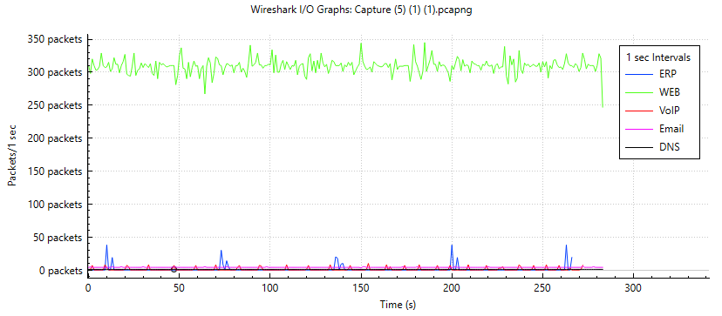

Measurement Units and Time-Based Analysis
When analysing network traffic, the choice of measurement unit plays a crucial role in understanding different aspects of network performance.

Use of Bits as a Measurement Unit
Using bits (or bits per second) is most appropriate when the objective is to analyse the volume of data being transmitted across the network. This type of measurement is particularly useful for:
- Bandwidth planning, as it reflects how much data capacity is required on network links
- Link utilization analysis, helping to determine whether a link is underutilized or congested
- Throughput evaluation, showing how efficiently data is being transmitted between endpoints
In this context, bits provide a clear indication of the load placed on the network infrastructure.

Use of Packets as a Measurement Unit
Using packets (or packets per second) is more suitable when analysing how the network devices handle traffic at a processing level. This measurement is useful for:
- Evaluating router and switch CPU load, since devices process traffic on a per-packet basis
- Understanding packet processing requirements, especially in high-traffic environments
- Assessing network device performance, where a large number of small packets may create higher processing overhead than fewer large packets
Basically, packet-based analysis focuses on the operational stress placed on network devices, rather than the total data volume.

Importance of Time-of-Day Analysis
Incorporating time-of-day as a dimension in traffic analysis provides valuable insights into network usage patterns. By observing how traffic varies over time, it becomes possible to:
- Identify peak usage hours, when network demand is highest
- Understand user behaviour patterns, such as typical working hours or application usage trends
- Support capacity planning decisions, ensuring that the network is designed to handle peak loads efficiently
Time-based analysis therefore enhances the ability to design scalable and efficient network architectures.

References
- Wireshark User Guide: https://www.wireshark.org/docs/
- Wireshark Foundation Documentation: https://www.wireshark.org/docs/wsug_html_chunked/
- Internet Engineering Task Force – TCP (RFC 793): https://datatracker.ietf.org/doc/html/rfc793
- Internet Engineering Task Force – UDP (RFC 768): https://datatracker.ietf.org/doc/html/rfc768
- Internet Engineering Task Force – HTTP/1.1 (RFC 2616): https://datatracker.ietf.org/doc/html/rfc2616
- Internet Engineering Task Force – SMTP (RFC 5321): https://datatracker.ietf.org/doc/html/rfc5321
- Internet Engineering Task Force – POP3 (RFC 1939): https://datatracker.ietf.org/doc/html/rfc1939
- Internet Engineering Task Force – SIP (RFC 3261): https://datatracker.ietf.org/doc/html/rfc3261

