

Linnaeus University
Faculty of Technology – Department of Computer Science

2DV702 - Internet Security
Assignment 1

Student: Luis Eduardo Martín Hernández

Student ID: lm223sg@student.lnu.se
20050201-T273

Index

Part 1. Authentication - Web Browsers and Certificates 3
1.1 Website Visit and Certificate Warnings 3
1.2 Root Certificate Installation 4
1.3 Questions and Answers 5
Part 2. Obtaining a Public-Key Certificate 6
2.1 PKI Setup and Certificate Generation 6
2.2 Unsecured Network Analysis (HTTP) 7
2.3 Secured Web Server Configuration and Analysis (HTTPS) 8
2.4 Comparison and Reflection 9
Part 3. The SSL Handshake - OpenSSL, s_client and Wireshark 10
3.1 OpenSSL Ciphers and RSA Theory 10
3.2 Wireshark Capture: Google Handshake 11
3.3 Manual Connection with s_client 11
3.4 TLS Decryption using SSLKEYLOGFILE 12
Bibliography 14

Part 1. Authentication - Web Browsers and Certificates

1.1 Website Visit and Certificate Warnings
In this task, I visited two specific URLs to observe how modern browsers handle invalid or untrustworthy security certificates.
- revoked.badssl.com: Upon visiting this site, the browser (Firefox) displayed a "Your connection is not private" warning with the error code NET::ERR_CERT_REVOKED. This occurs because the Certificate Authority (CA) has placed this certificate on a Revocation List (CRL), indicating it is no longer valid due to a security compromise or administrative request.
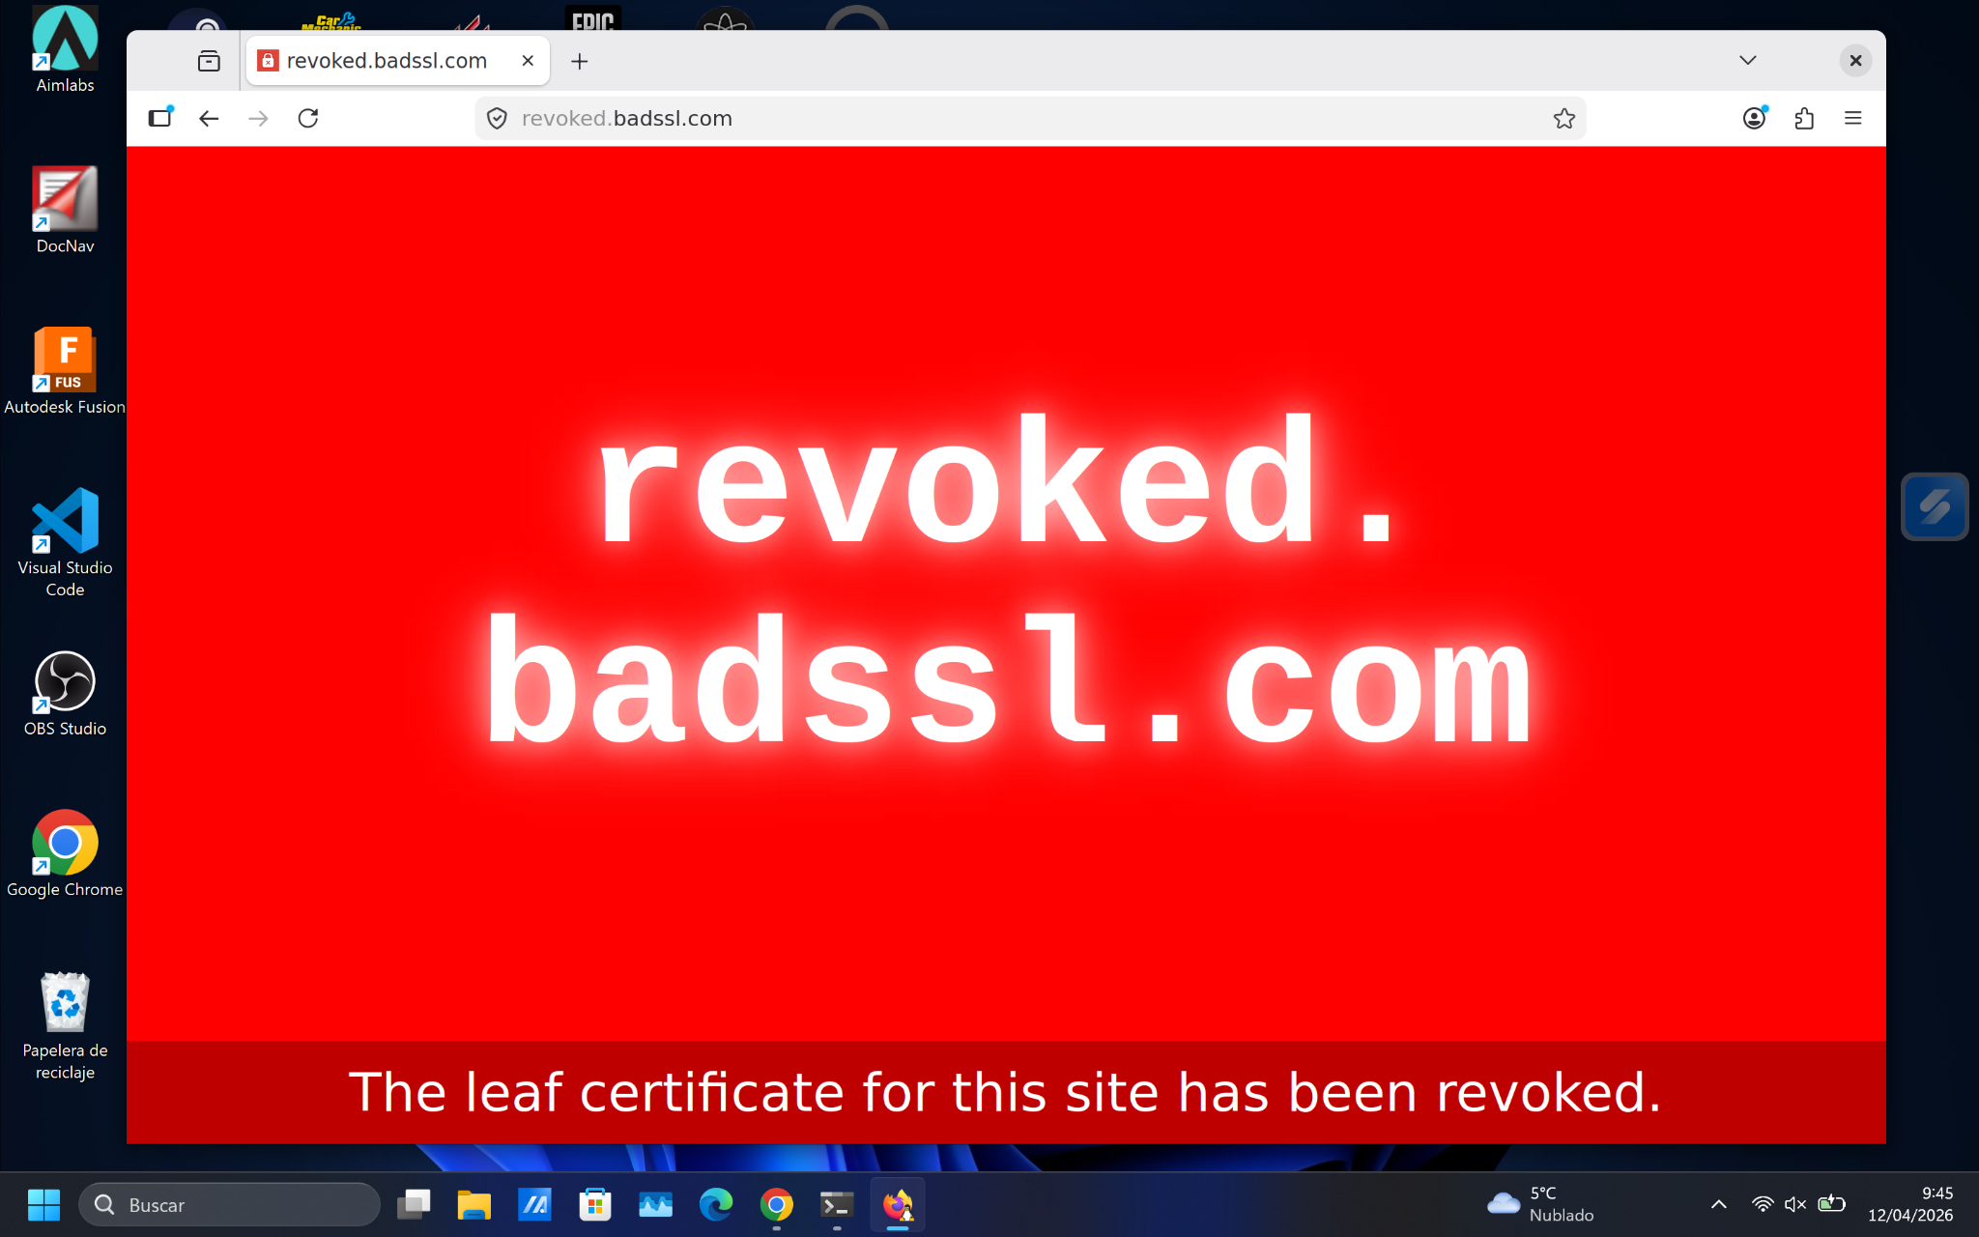
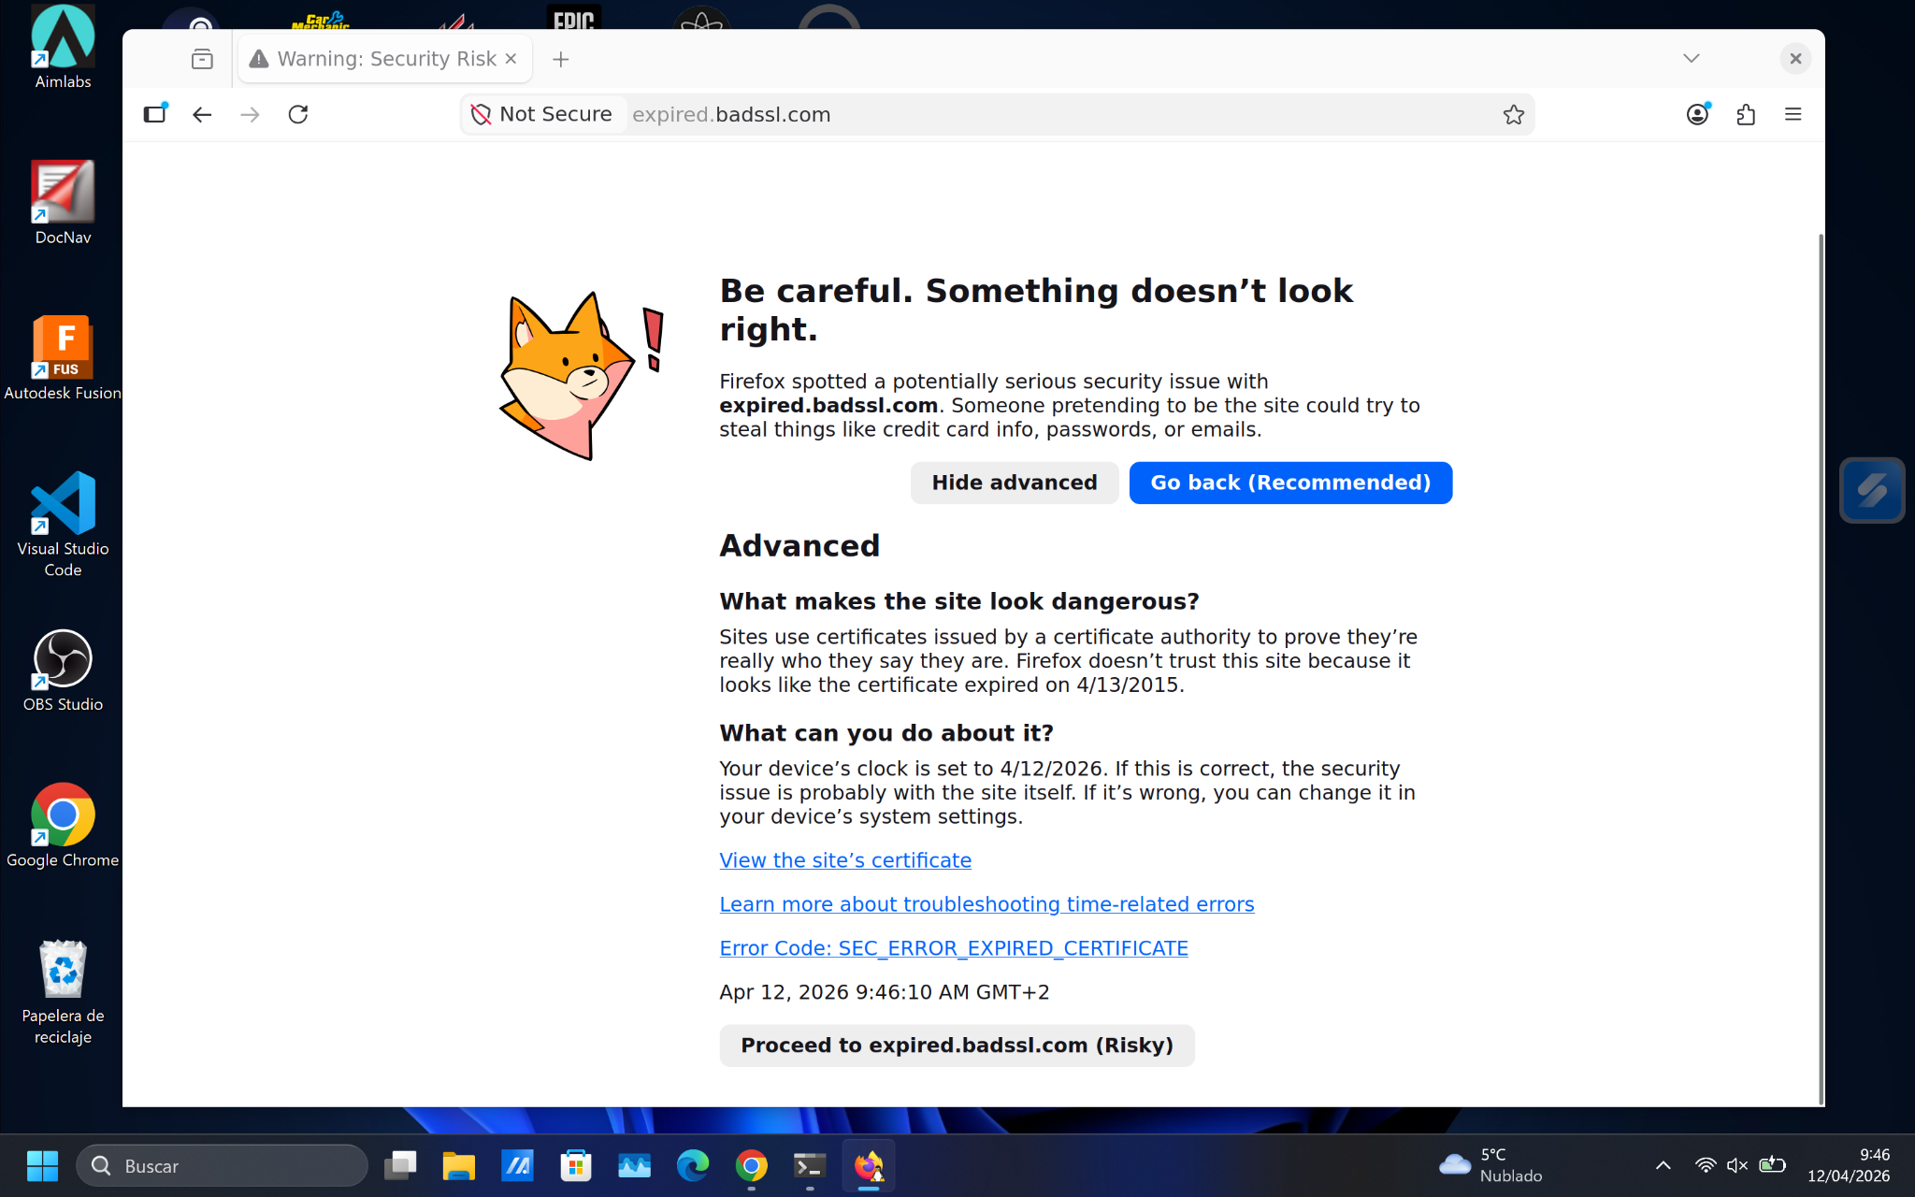
- expired.badssl.com: When using Firefox, a "Warning: Security Risk Ahead" message appeared with the error code SEC_ERROR_EXPIRED_CERTIFICATE. This message is triggered because the current system date is outside the certificate's predefined validity period (it expired in 2015), meaning the browser can no longer guarantee that the site’s identity is still legitimate.

1.2 Root Certificate Installation
Following the instructions, I downloaded and installed the CAcert Class 1 Root Certificate into the Firefox certificate manager in my Ubuntu environment.
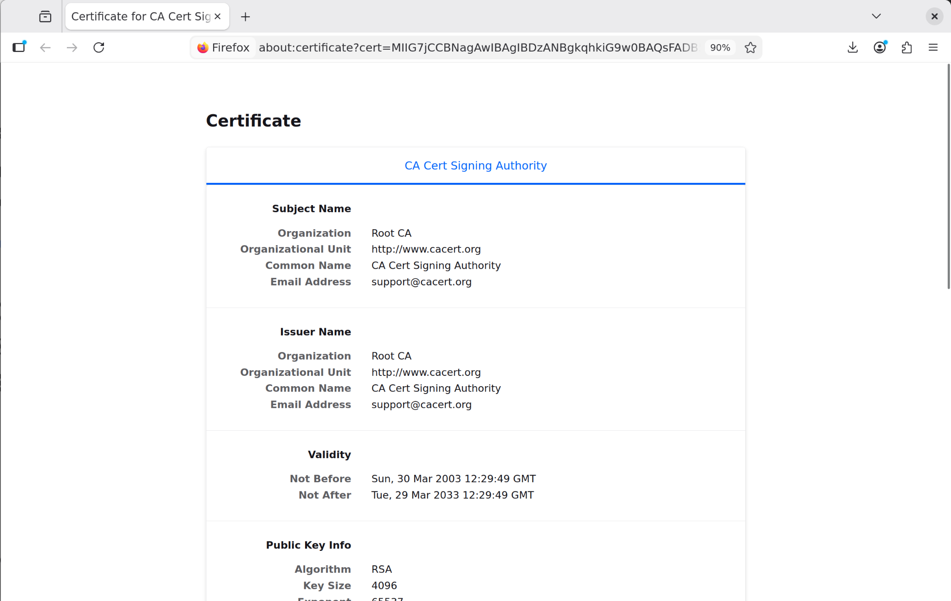

- Issuer (Emisor): Root CA / CA Cert Signing Authority.
- Subject (Sujeto): Root CA / CA Cert Signing Authority.
- Analysis: As seen in the screenshot before, the Issuer and the Subject are identical. This is the defining characteristic of a Root Certificate, as it is self-signed to act as the "anchor of trust" for all other certificates signed by this authority. By manually importing this into the browser's "Authorities" tab (as shown in next screenshot), I have explicitly granted trust to this CA for identifying websites.
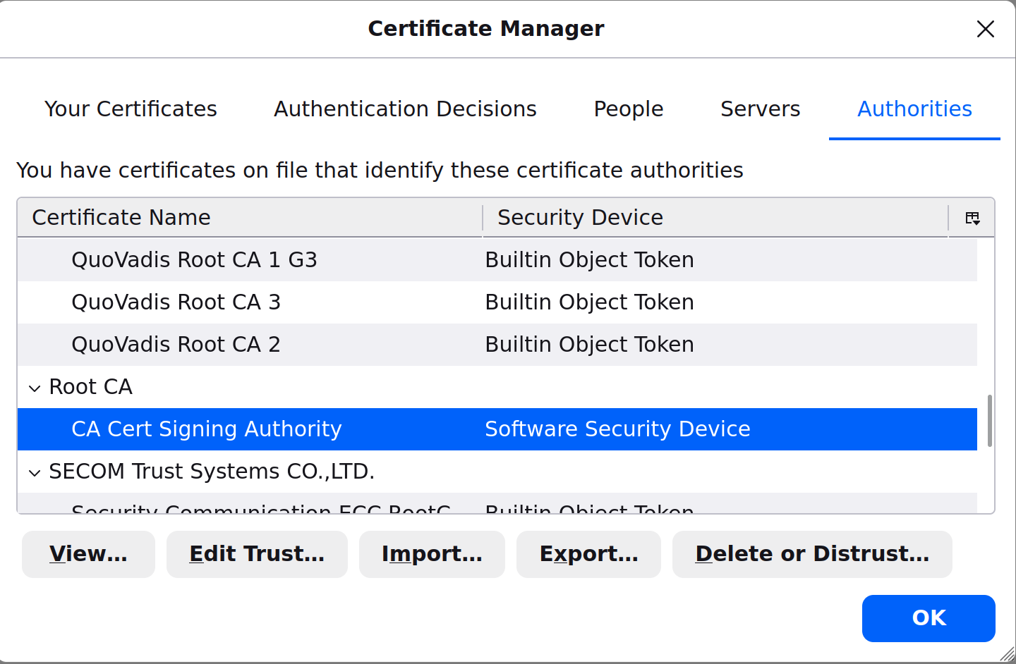

1.3 Questions and Answers
(a) What is a chain of trust and how is this related to certificates?
A chain of trust is a hierarchical verification system where a certificate is validated by tracing it back to a trusted Root CA. The browser trusts the "Root" (anchor); the Root signs an "Intermediate" certificate, which in turn signs the "Leaf" (website) certificate. This link ensures that if the browser trusts the top-level authority, it can mathematically verify the entire hierarchy below it.
(b) Why do we need SSL/TLS when shopping online? Can we not simply use the Internet as it is? How is this connected to authentication? Confidentiality?
Standard Internet protocols (HTTP) transmit data in plain text, making it easy for attackers to steal sensitive information. SSL/TLS provides confidentiality by encrypting communication so only the intended recipient can read it. It also ensures authentication, allowing the user to verify that they are connected to the genuine online shop and not a phishing site.
(c) What is a self-signed certificate and when is it used? How would your browser respond if you directed it towards a site using a self-signed certificate?
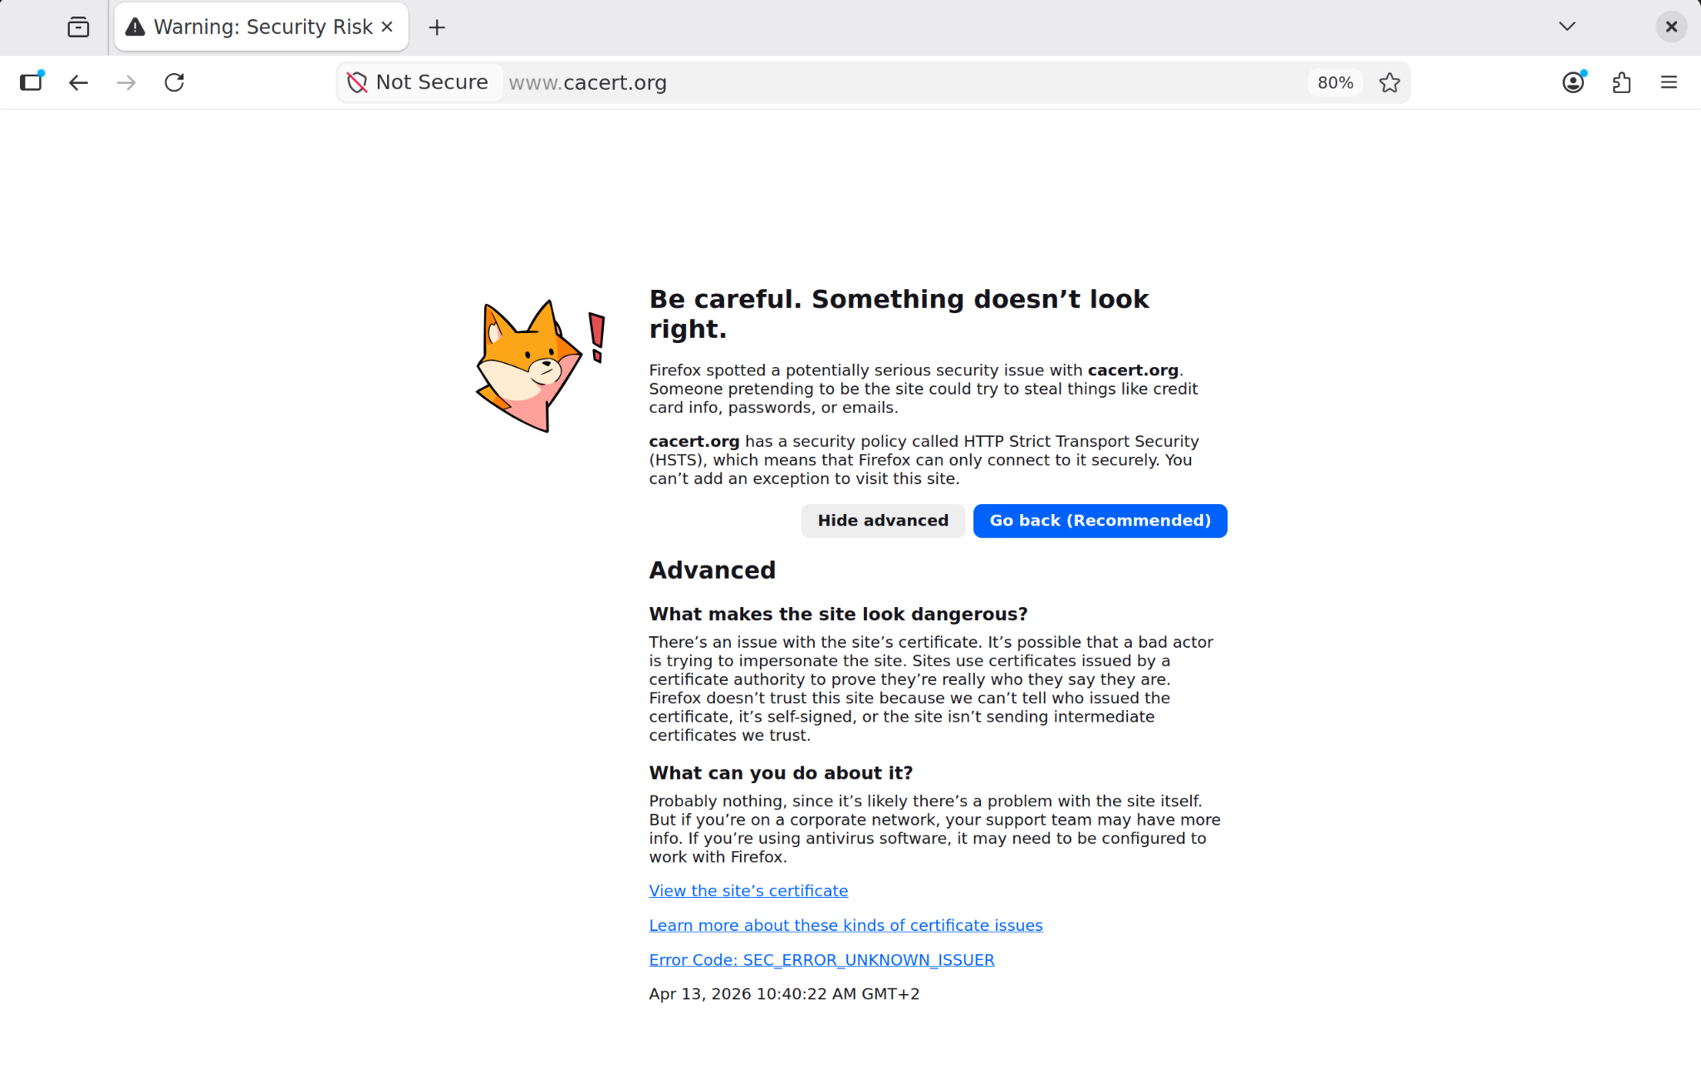
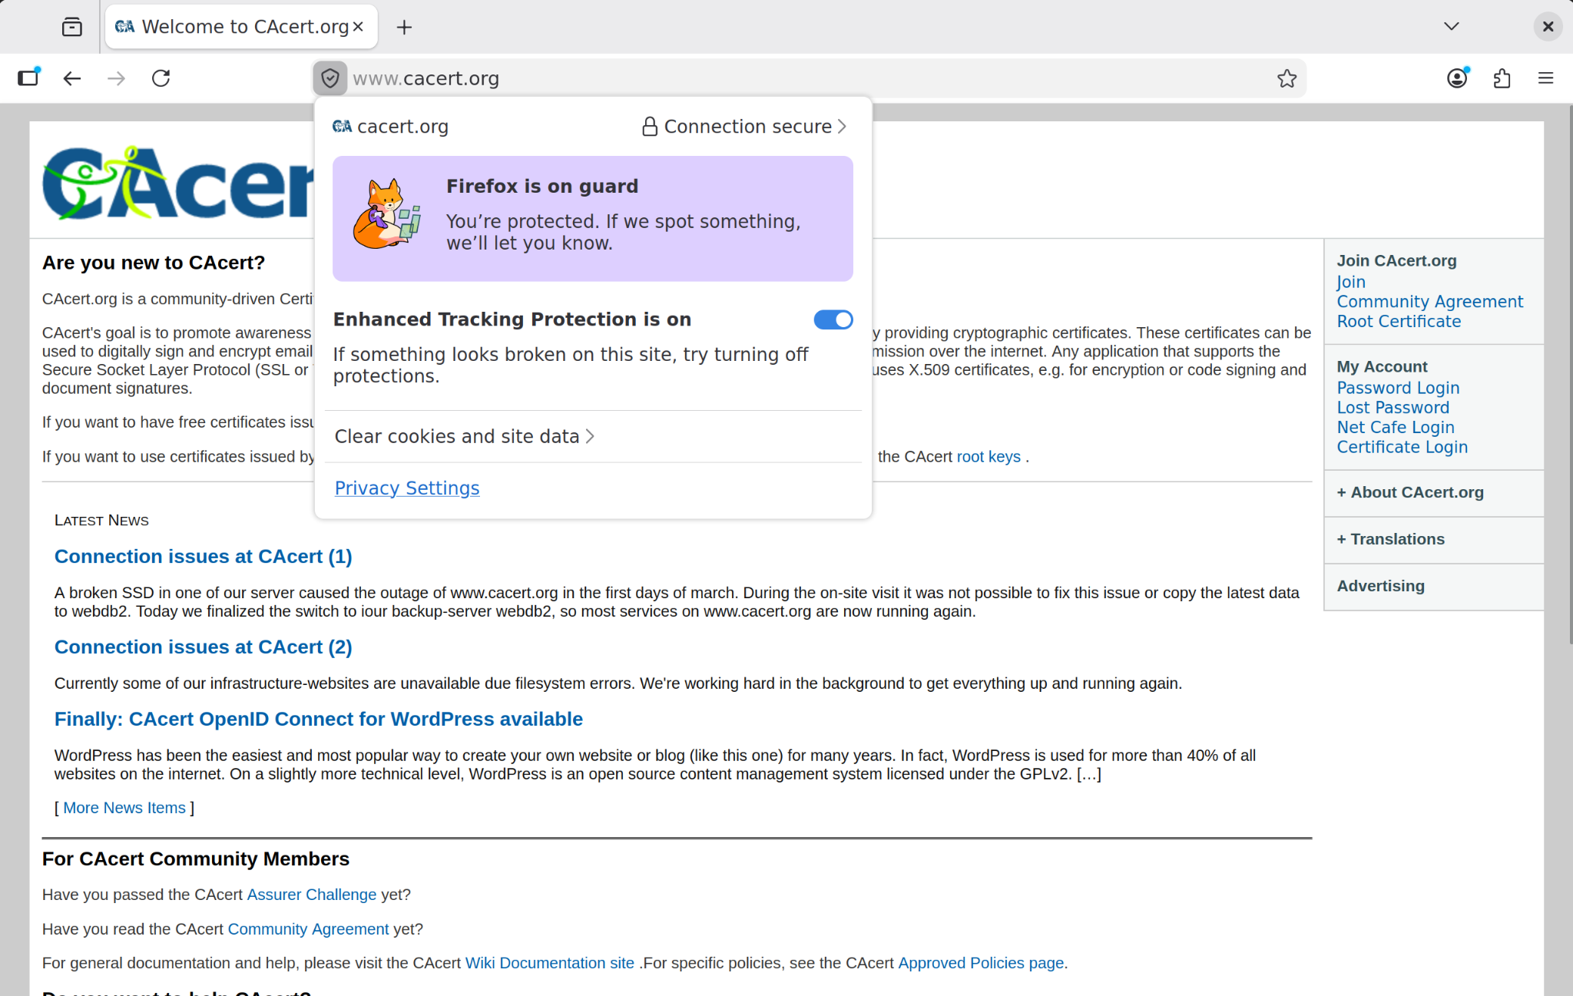
A self-signed certificate is one where the issuer and subject are the same, without any validation from a recognized third-party CA. They are typically used for internal testing or private server environments. A browser will display a security warning because it lacks an external "anchor" to verify the identity of the server, forcing the user to manually accept the risk.

(d) Does the CA’s signature mean that you can trust the site holding the certificate? What does the CA’s signature guarantee?
No, a CA's signature does not imply the site is ethical or safe to use; it only guarantees identity and integrity. It confirms that the public key belongs to the domain stated in the certificate (authentication) and that the certificate has not been altered since it was signed. It does not protect the user against fraudulent business practices.
(e) What are the different types of certificates available commonly used for securing websites and online transactions?
Beyond standard versions, there are three primary validation levels:
- Domain Validation (DV): Only verifies ownership of the domain; it is fast and common.
- Organization Validation (OV): The CA verifies the physical and legal existence of the organization.
- Extended Validation (EV): Involves the most rigorous background checks; it provides the highest level of assurance for high-risk sites like banks.

Part 2. Obtaining a Public-Key Certificate

2.1 PKI Setup and Certificate Generation
In this task, I established a secure web environment on an Ubuntu system within WSL 2. The first step involved creating the necessary cryptographic identity for the server. I used OpenSSL to generate a 2048-bit RSA private key and a self-signed X.509 certificate.
A crucial aspect of this process was the configuration of the Subject Alternative Name (SAN). Modern browsers and tools like curl require the SAN field to validate that the certificate matches the intended domain or IP address. As shown in my req.conf file, I explicitly included localhost and 127.0.0.1 in the alt_names section to ensure proper DNS validation.
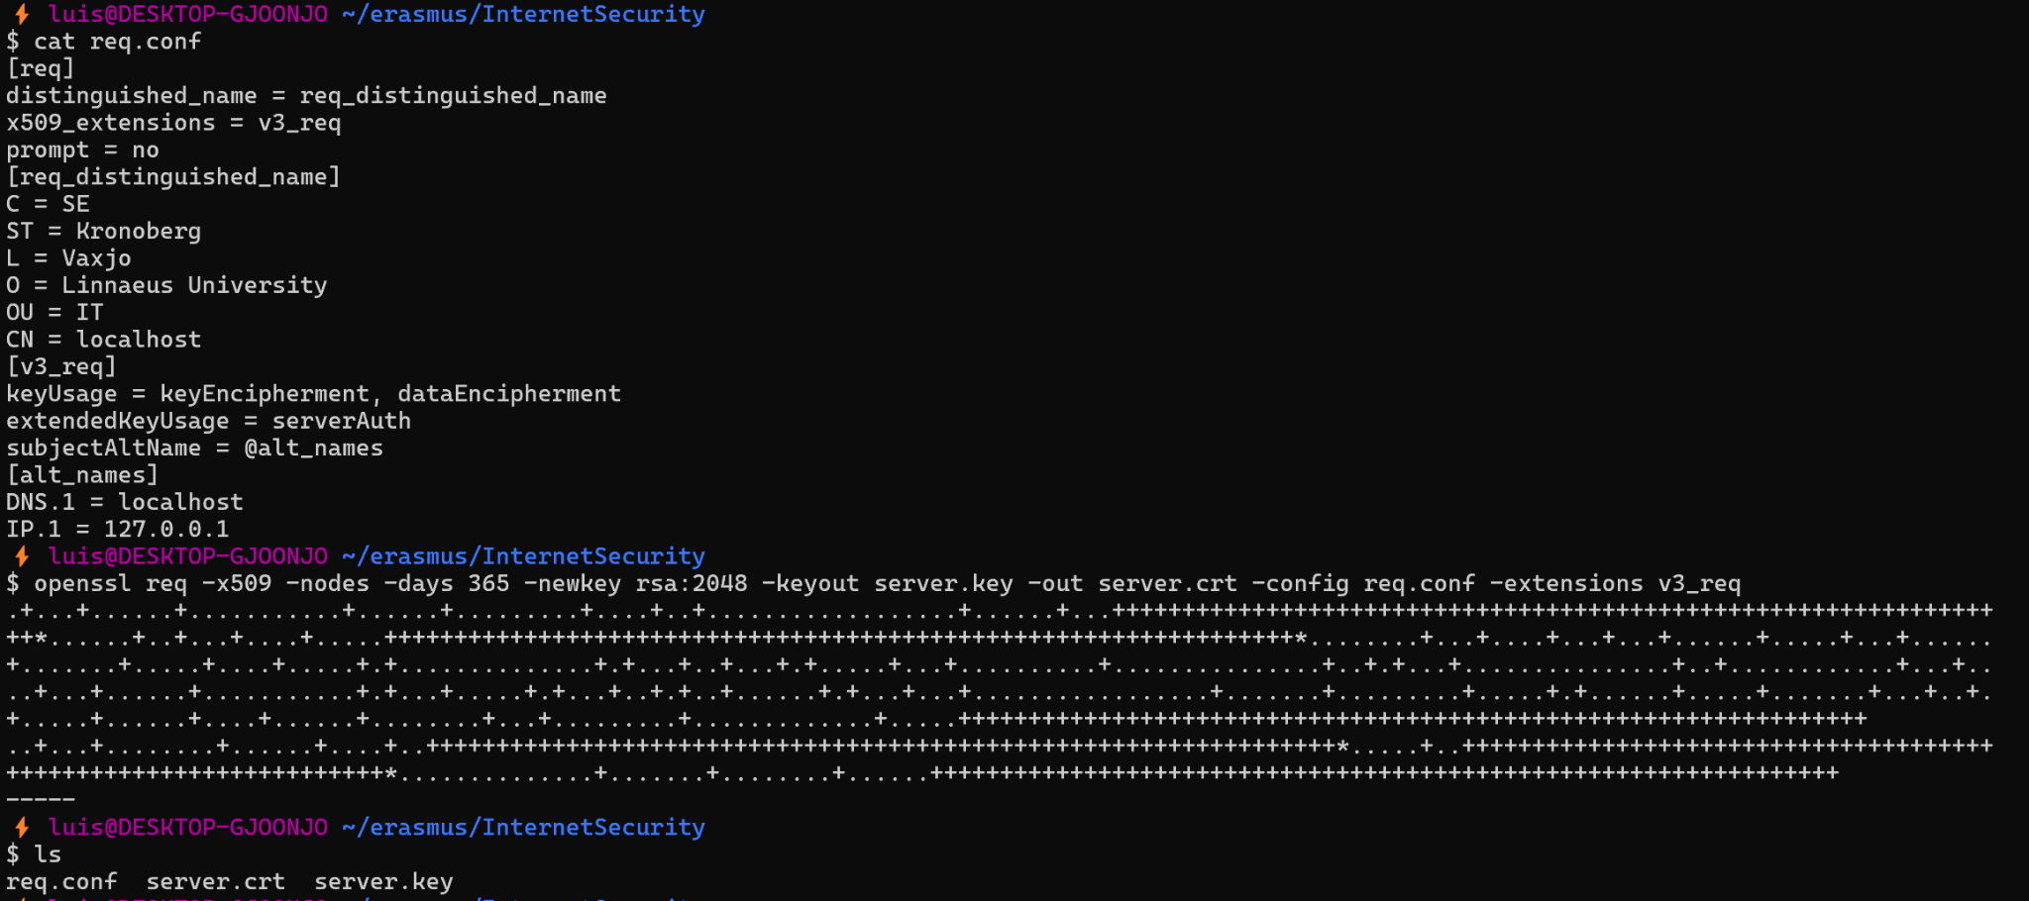

2.2 Unsecured Network Analysis (HTTP)
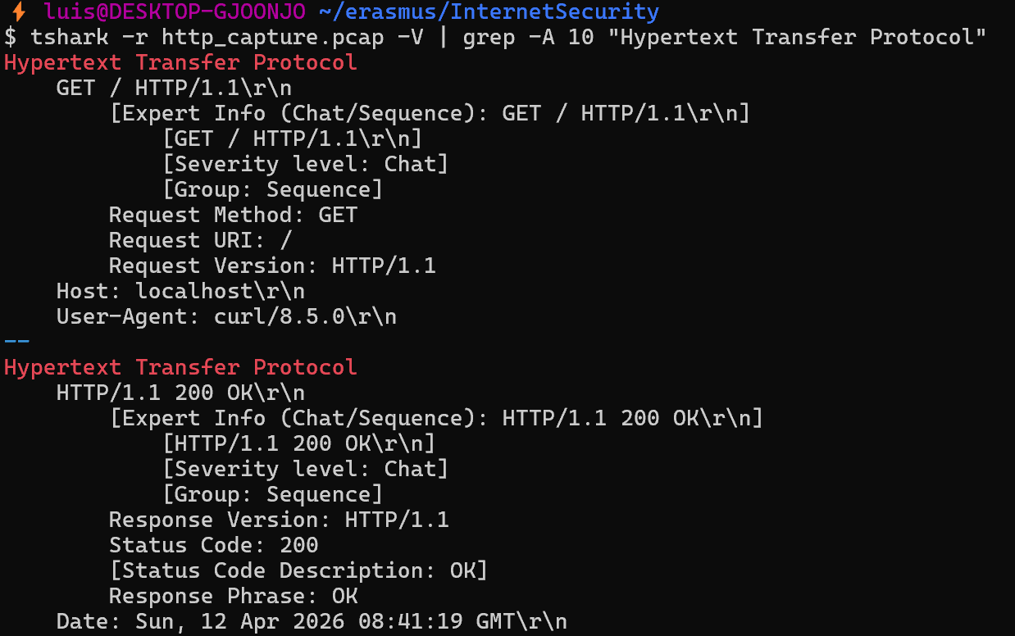
Before securing the server, I analyzed the risks associated with unencrypted communication. I initiated a network capture using Tshark on the loopback interface and saved it to http_capture.pcap. While the capture was running, I performed a standard request using curl http://localhost.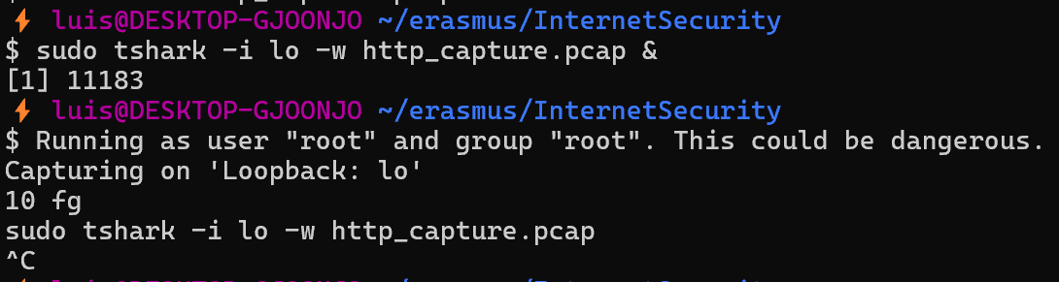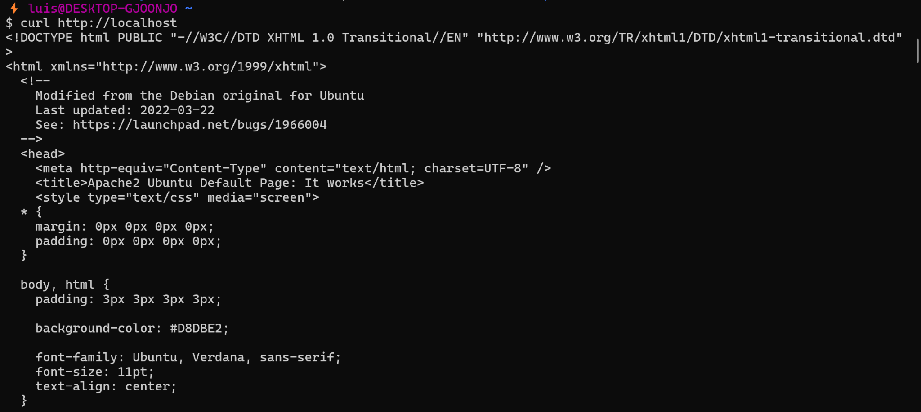Upon analyzing the capture with the command tshark -V, I observed that the entire Hypertext Transfer Protocol (HTTP) exchange was transmitted in plaintext. As seen in the report's screenshots, the GET request, the host headers, and the server's HTML response are fully visible. This demonstrates that an attacker capable of intercepting this traffic could easily read sensitive data, such as credentials or session cookies, due to the lack of encryption and authentication.

2.3 Secured Web Server Configuration and Analysis (HTTPS)
To secure the communication, I configured the Apache web server to use the generated TLS certificate. This involved:
- Enabling the SSL module and the default SSL site configuration.
sudo a2enmod ssl
sudo a2ensite default-ssl
sudo systemctl restart apache2
- Editing the default-ssl.conf file to point SSLCertificateFile and SSLCertificateKeyFile to the previously generated server.crt and server.key.
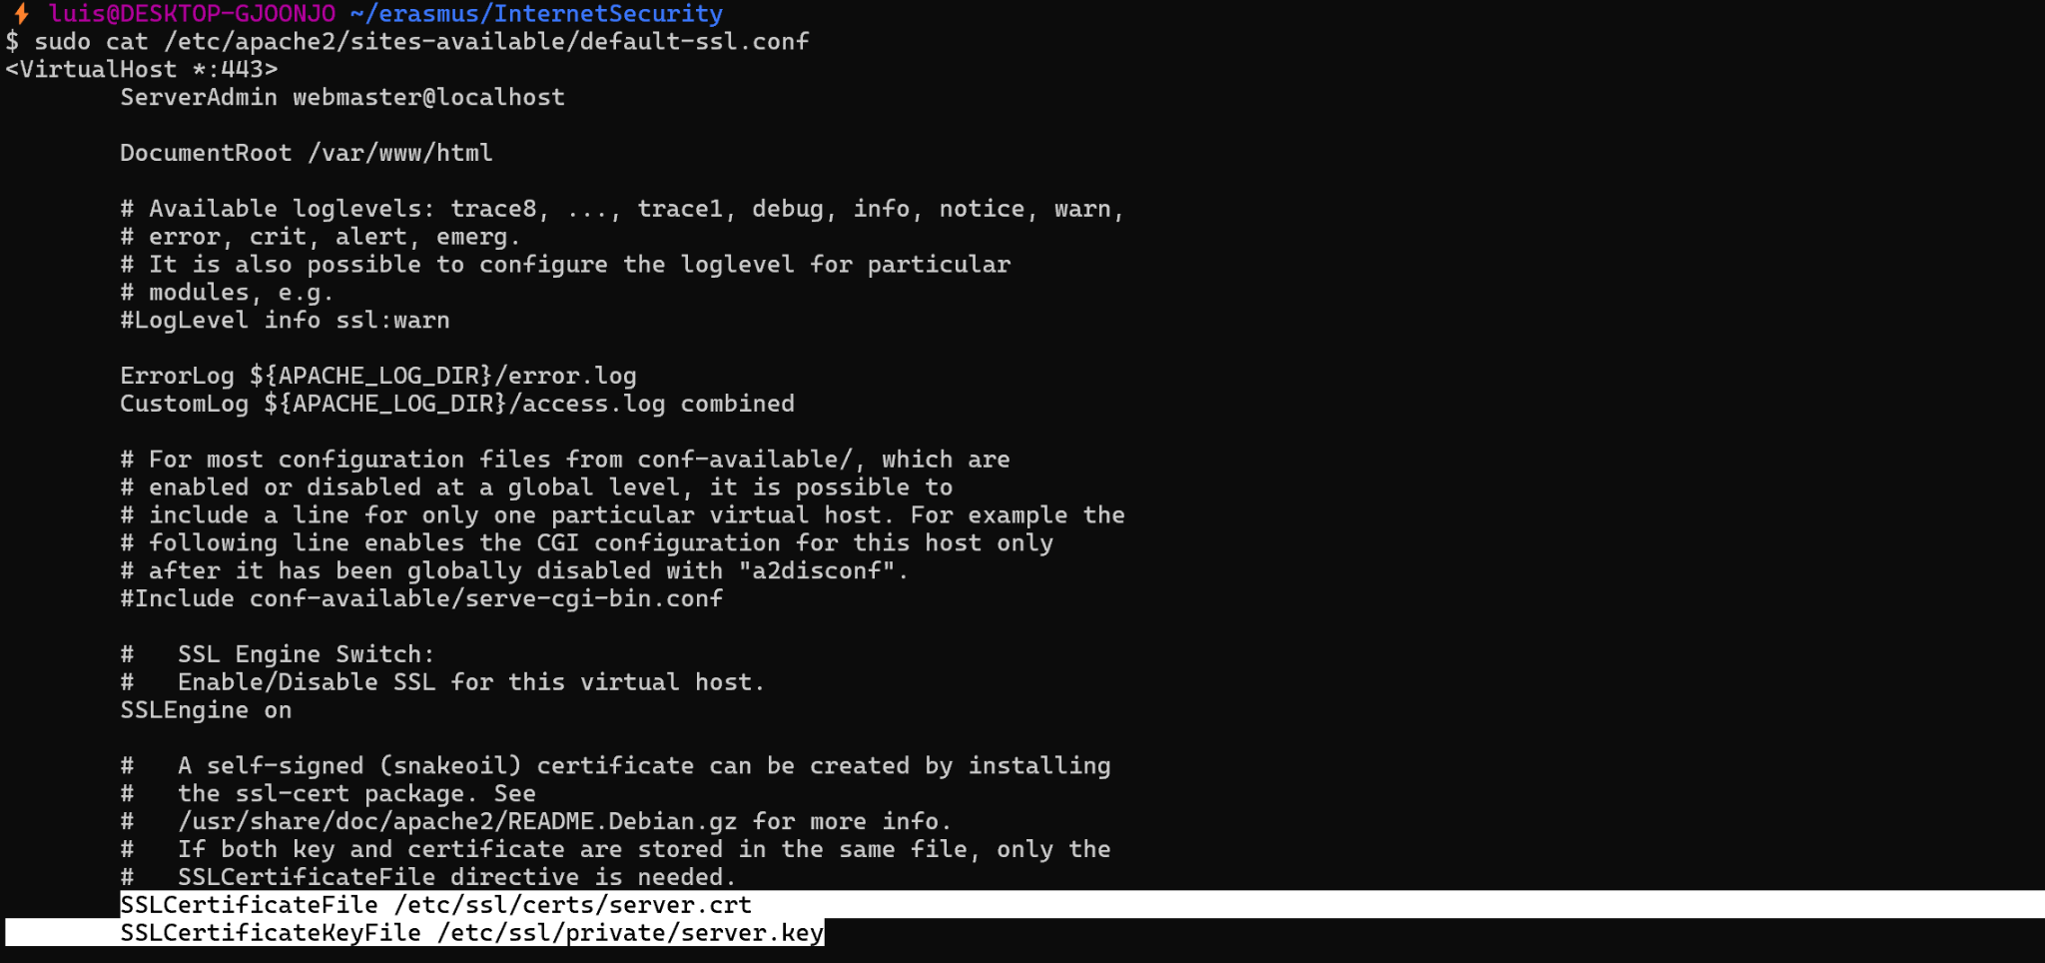
I then conducted a second Tshark capture while connecting via https. By using the command:
curl --cacert server.crt https://localhost -v
Doing so I was able to verify the security of the connection. The "verbose" output provides clear evidence of a successful TLS 1.3 handshake, including the exchange of 'Client Hello' and 'Server Hello' messages, and the successful verification of the server's certificate.
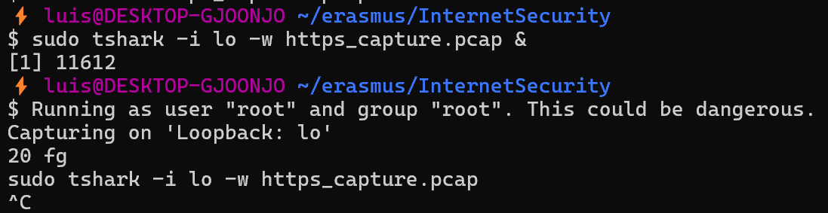
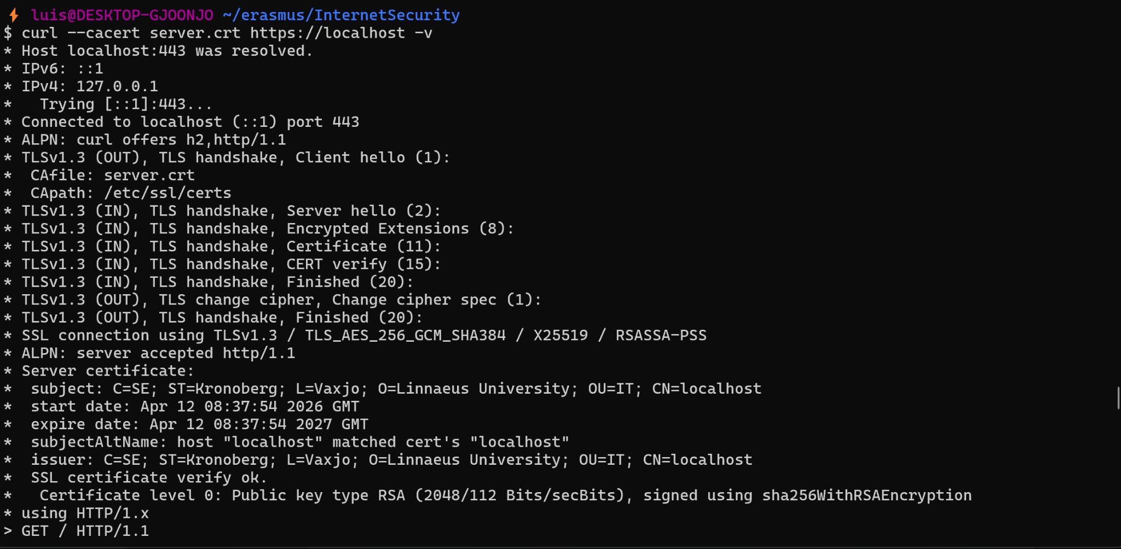
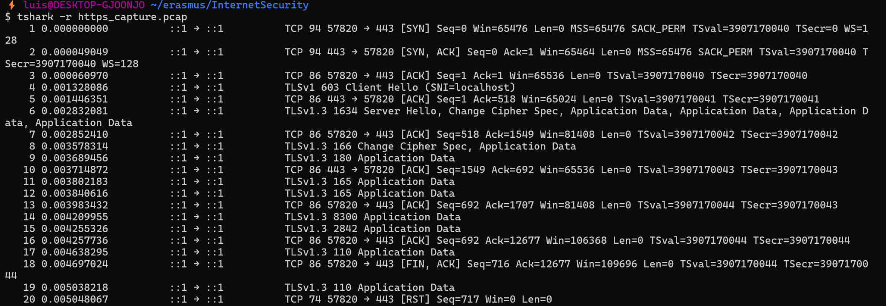

2.4 Comparison and Reflection
Comparing the two sessions highlights the fundamental role of PKI and SSL/TLS in internet security.
- HTTP session: Provided no confidentiality, all data was intercepted in plaintext.
- HTTPS session: Provided both authentication and confidentiality. The Tshark capture for the secure session shows only "Encrypted Application Data," making the content unreadable to unauthorized parties.
This experiment illustrates that a Public Key Infrastructure is vital for establishing trust. Even though I used a self-signed certificate, providing the root certificate to the client allowed for a "Chain of Trust" to be established, ensuring that the client was communicating with the intended, verified server.

Part 3. The SSL Handshake - OpenSSL, s_client and Wireshark

3.1 OpenSSL Ciphers and RSA Theory
After investigating the supported ciphers with openssl ciphers -v, I identified that the most common standard used for modern encryption is AES (Advanced Encryption Standard), specifically in GCM (Galois/Counter Mode), such as TLS_AES_256_GCM_SHA384. This is the preferred choice because it provides high security and is optimized for performance in modern CPUs.
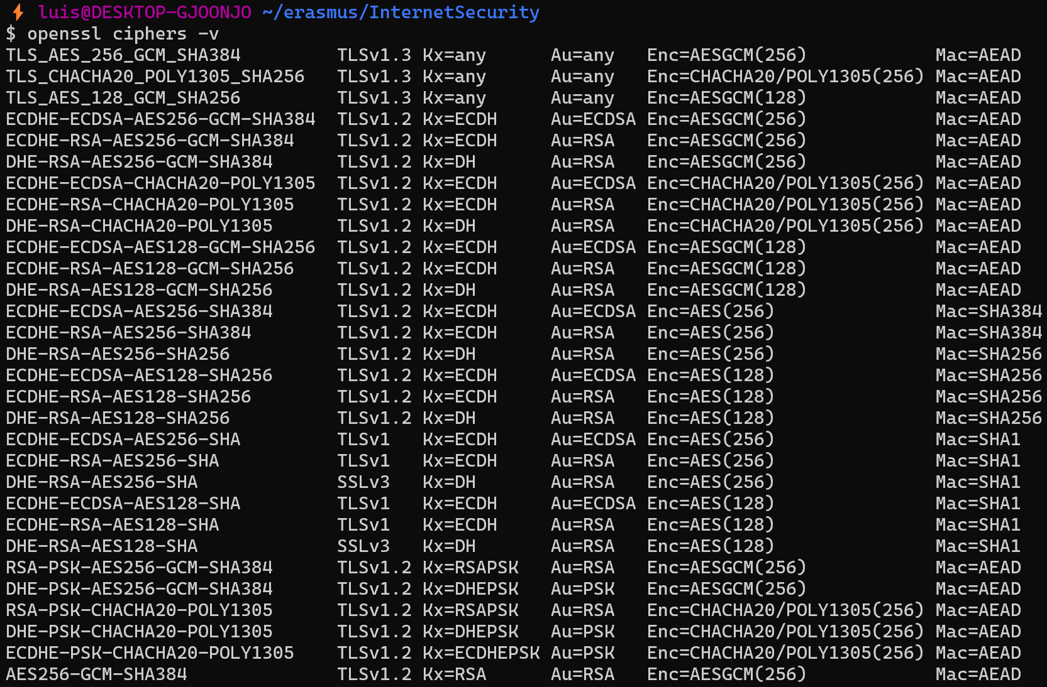
Regarding RSA, it is primarily used for authentication (digital signatures) and key exchange during the initial handshake. It is not used for bulk data encryption because asymmetric encryption is significantly slower and more computationally expensive than symmetric encryption (like AES). Instead, RSA ensures the identity of the server before a faster symmetric session key is negotiated.

3.2 Wireshark Capture: Google Handshake
I used the filter tls and ip.addr == [Google_IP] to isolate the traffic. The capture clearly shows the TLSv1.3 Handshake process:
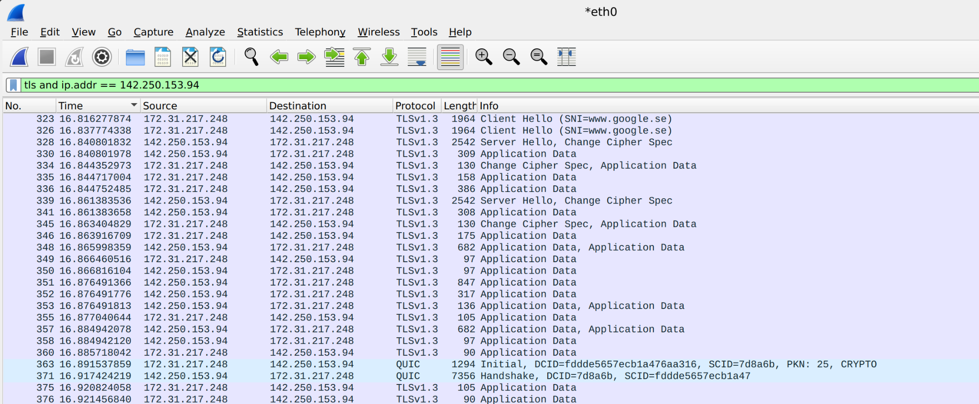
- Client Hello: The browser proposes cipher suites and extensions.
- Server Hello: Google selects the cipher suite and provides its certificate.
- Change Cipher Spec / Handshake Protocol: The encrypted connection is established.

3.3 Manual Connection with s_client
I established a manual connection using the command: openssl s_client -connect www.google.se:443
After the handshake was verified (Verification: OK), I manually sent the request: GET / HTTP/1.1 Host: www.google.se

⚡ luis@DESKTOP-GJOONJO ~/erasmus/InternetSecurity
$ openssl s_client -connect www.google.se:443
CONNECTED(00000003)
depth=2 C = US, O = Google Trust Services LLC, CN = GTS Root R1
verify return:1
depth=1 C = US, O = Google Trust Services, CN = WR2
verify return:1
depth=0 CN = *.google.se
verify return:1
---
Certificate chain
0 s:CN = *.google.se
i:C = US, O = Google Trust Services, CN = WR2
...
No ALPN negotiated
Early data was not sent
Verify return code: 0 (ok)
---
GET / HTTP/1.1

---
Post-Handshake New Session Ticket arrived:
SSL-Session:
Protocol : TLSv1.3
Cipher : TLS_AES_256_GCM_SHA384
Session-ID: 3405BC4EBEA7ABC33A597A75237BDE56B9DBA9F50266A07D02658C529DCED184
Session-ID-ctx:
Resumption PSK: 3149D1C124CB4C0D2B16F9D7EB499D38515B18C95DAEE5C8965AA6F8FEFCEB9ADAF3B1413B37A57A31A7ED804FE0E135

...
Console Output: The server responded with a 200 OK status and the HTML content of the page. Wireshark Analysis: In Wireshark, the GET message is contained within a packet labeled "Application Data". Without the decryption keys, this packet is completely unreadable; it appears as an encrypted payload of hexadecimal characters, guaranteeing confidentiality.

3.4 TLS Decryption using SSLKEYLOGFILE
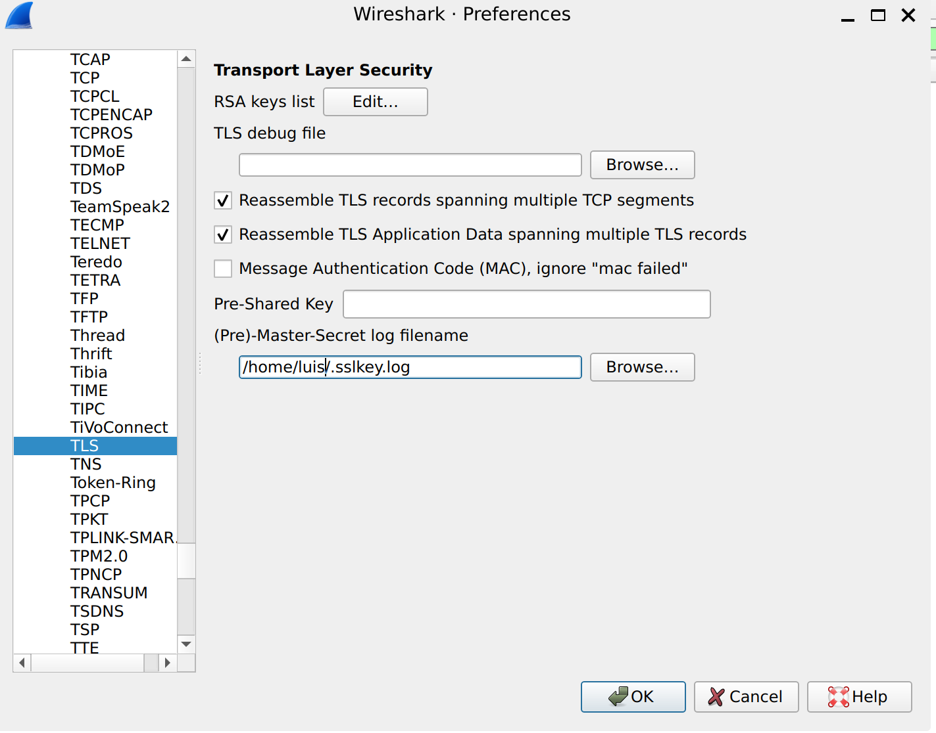
Finally, I configured the environment variable SSLKEYLOGFILE to capture the master secrets from the Chromium browser. I then pointed Wireshark to this log file under TLS Protocol Preferences.

Effects of Decryption: The capability to decrypt TLS traffic transforms "Encrypted Application Data" into readable HTTP packets.
- What I can see now: I can inspect the full HTTP GET request, including headers like User-Agent, Accept-Language, and the server's full HTML response.
- Example: In my capture of https://www.eff.org/about/history, I can now read the Frame [296] which contains the decrypted GET request for the EFF website history page, showing the Host as www.eff.org.
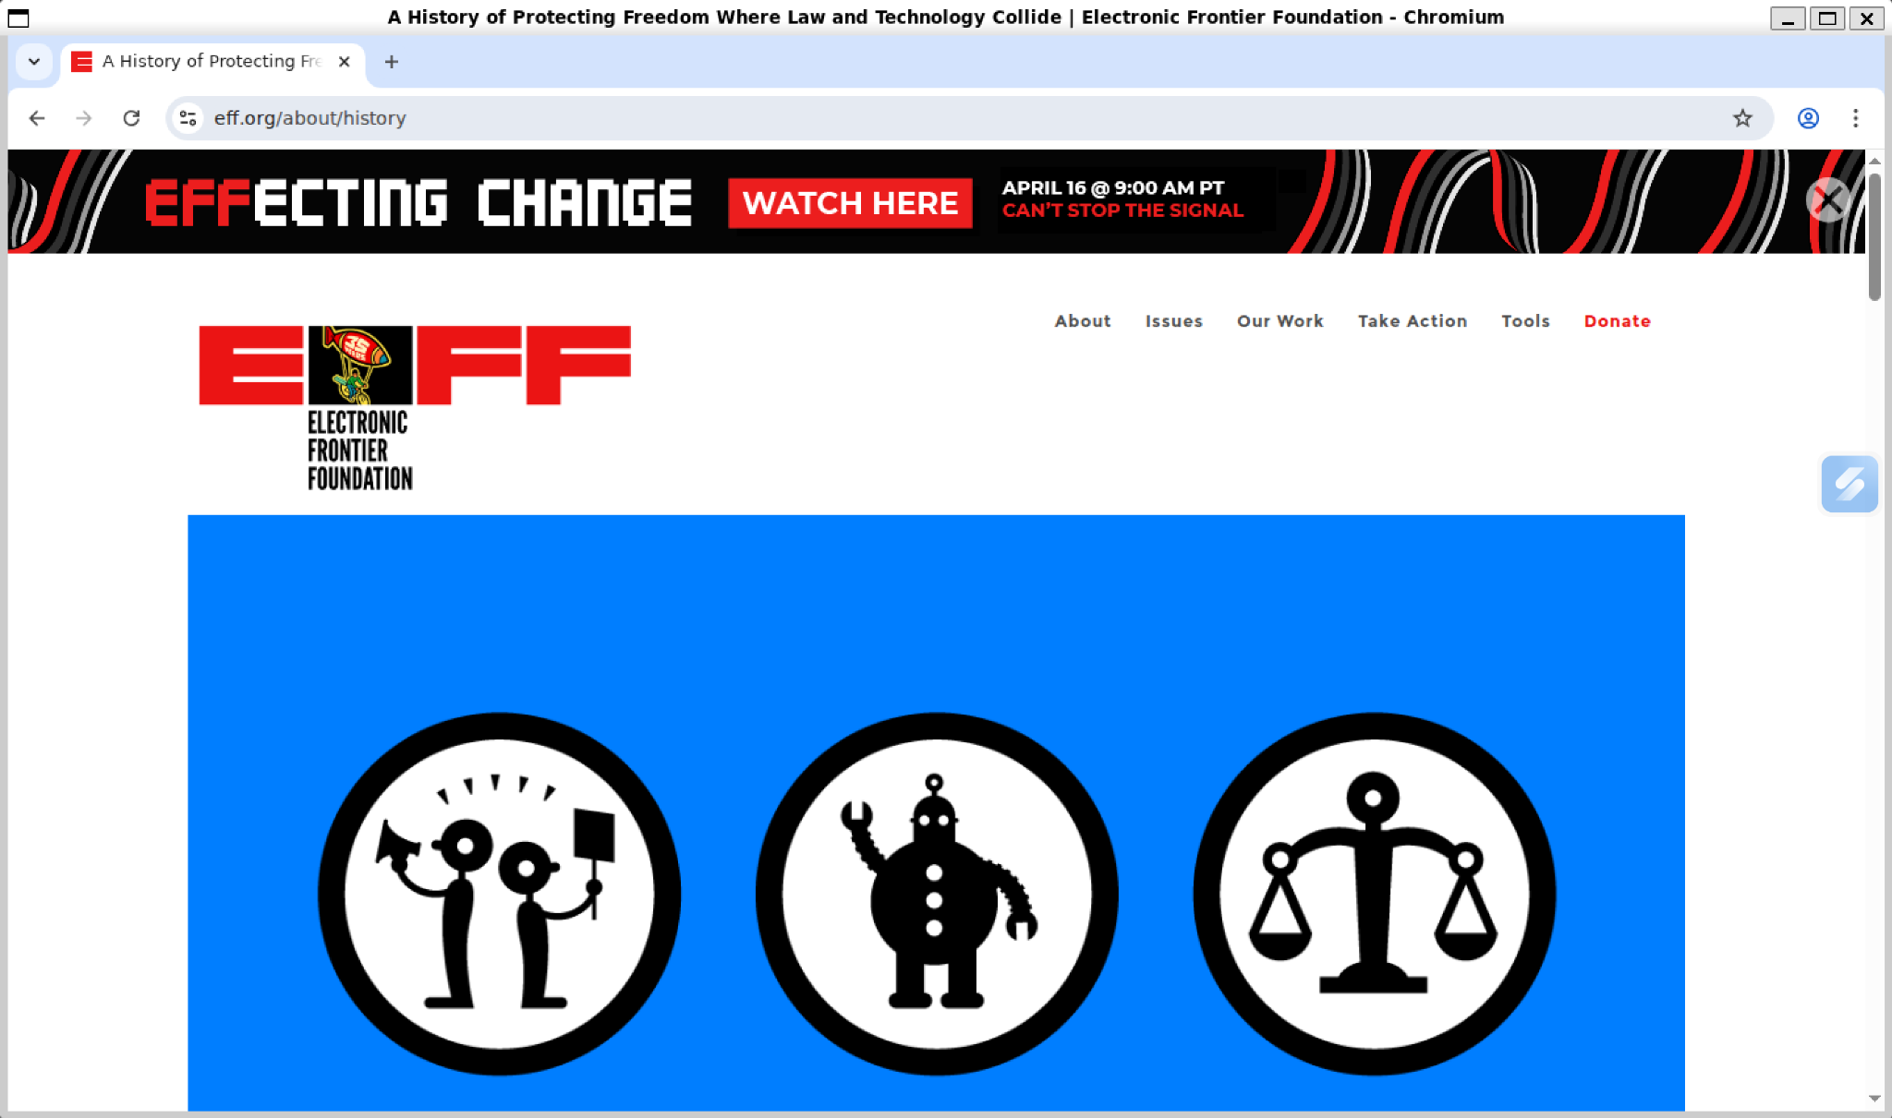
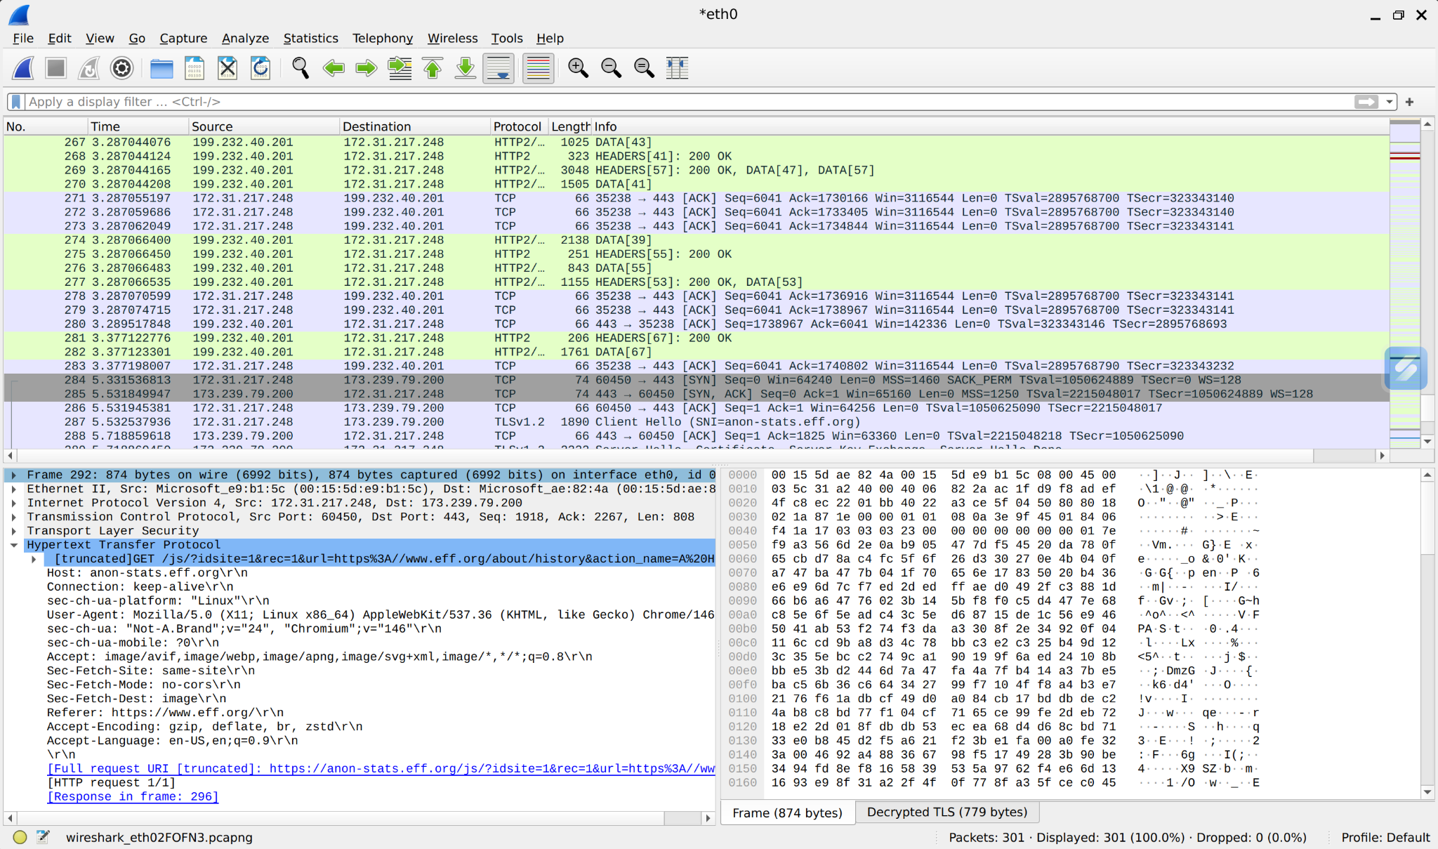

Bibliography

[1] Gordon Lyon, "Nmap Security Scanner", https://nmap.org. [Accessed: 2026-04-12].

[2] BadSSL, "Certificate Revocation and Expiration tests," https://badssl.com. [Accessed: 2026-04-12].

[3] CAcert.org, "Root Distribution License and Certificates," http://www.cacert.org. [Accessed: 2026-04-12].

[4] D. Cooper, S. Santesson, S. Farrell, S. Boeyen, R. Housley, and W. Polk, "Internet X.509 Public Key Infrastructure Certificate and Certificate Revocation List (CRL) Profile", RFC 5280, May 2008. https://datatracker.ietf.org/doc/html/rfc5280. [Accessed: 2026-04-12].

[5] E. Rescorla, "The Transport Layer Security (TLS) Protocol Version 1.3", RFC 8446, August 2018. https://datatracker.ietf.org/doc/html/rfc8446. [Accessed: 2026-04-12].

[6] National Institute of Standards and Technology (NIST), "Selection, Configuration, and Use of Transport Layer Security (TLS) Implementations", SP 800-52 Rev. 2, August 2019. https://nvlpubs.nist.gov/nistpubs/SpecialPublications/NIST.SP.800-52r2.pdf. [Accessed: 2026-04-12].

[7] Wireshark Foundation, "Wireshark User Guide", https://www.wireshark.org/docs/wsug_html_chunked/. [Accessed: 2026-04-12].

[8] OpenSSL Project, "OpenSSL Toolkit Documentation", https://www.openssl.org/docs/. [Accessed: 2026-04-12].

[9] DigiCert, "What is a SAN (Subject Alternative Name) Certificate?", https://www.digicert.com/faq/subject-alternative-name.htm. [Accessed: 2026-04-12].

[10] Mozilla Wiki, "Security/Server Side TLS", https://wiki.mozilla.org/Security/Server_Side_TLS. [Accessed: 2026-04-12].

[11] GlobalSign, "Difference Between DV, OV and EV Certificates", https://www.globalsign.com/en/blog/difference-between-dv-ov-and-ev-certificates. [Accessed: 2026-04-12].

[12] Luis Sismonda, "CA Interna - Certification Authority OpenSSL en Ubuntu", https://www.sismonda.com.ar/736-2020-05-22-ca-interna-certification-authority-openssl-en-ubuntu/. [Accessed: 2026-04-12].

