

Linnaeus University
Faculty of Technology – Department of Computer Science

2DV702 - Internet Security
Assignment 2

Student: Luis Eduardo Martín Hernández

Student ID: lm223sg@student.lnu.se

Index
Email Security 3
Task 1: Introduction and Software Setup 3
1.1 Reasons for Using PGP 3
1.2 Software Description and Installation 3
1.3 PGP vs. GPG and Personal Preference 3
Task 2: Key-Pair Generation, Identities, and Exchange 4
2.1 Key Generation Process 4
2.2 Managing Multiple Identities 4
2.3 Key Fingerprint and Verification 4
2.4 Public Submission and Peer Exchange 5
Task 3 5
3.1 Encrypted and Signed Email Exchange 5
3.2 Detached Signatures Test 6
Task 4: Finding and Verifying the TA’s Public Key 6
4.1 Search and Verification Process 6
4.2 Is Fingerprint Verification Enough? 6
4.3 Risks of Failing to Verify 7
Task 5: Fingerprint Submission and MITM Protection 7
Task 6: Encrypted and Signed Submission 7
Task 7: Email Authentication and Validation 8
7.1 Services and Methodology 8
7.2 Visual Verification in the Interface 8
7.3 Header Analysis and Authentication: 8
Task 8: Comparing Keyservers (keys.openpgp.org) 9
8.1 Process and Verification 9
8.2 Comparison with SKS/Ubuntu Keyservers 9
Task 9: S/MIME 10
9.1 How S/MIME Works 10
9.2 Main Differences: S/MIME vs. GPG 10
9.3 Steps of Communication and Key Usage 10
Anonymity 11
1. Research on Anonymity Methods 11
2. Service Tested: 11
3. Observations and Technical Analysis 11
4. Conclusion 11
Bibliography 12

Email Security

Task 1: Introduction and Software Setup

1.1 Reasons for Using PGP
Phil Zimmermann argues that PGP is essential for digital privacy because conventional email is as insecure as a postcard and susceptible to massive, automated surveillance. By adopting encryption routinely, citizens provide "safety in numbers," ensuring that sensitive communication does not draw unnecessary suspicion while maintaining individual control over data without relying on government protocols that may contain "trap doors".

1.2 Software Description and Installation
I have installed GnuPG (GPG), which is a complete and free implementation of the OpenPGP standard.
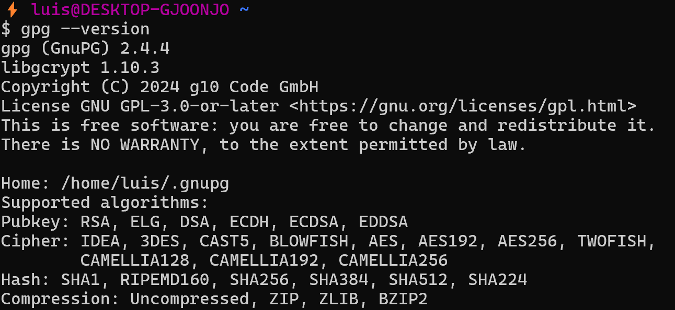
- System Environment: I am using WSL2 (Windows Subsystem for Linux) running Ubuntu, which fulfills the course requirement to use a GNU/Linux system.
- Version Details: My installed version is gpg (GnuPG) 2.4.4, utilizing libgcrypt 1.10.3. This version supports modern cryptographic algorithms such as RSA, AES256, and SHA512.

1.3 PGP vs. GPG and Personal Preference
While PGP (Pretty Good Privacy) was the original software, it eventually evolved into various commercial versions. GPG, on the other hand, is Open Source software released under the GNU General Public License.
My Choice: GPG
I have chosen to install GPG for my personal use for the following reasons:
- Transparency and Auditability: Being open-source allows the global security community to audit the source code. This ensures there are no hidden backdoors, which is a critical trust factor for security software.
- Linux Integration: It is the standard tool for encryption on GNU/Linux systems, making it highly compatible with terminal workflows in WSL2.
- Cost and Accessibility: It is free software, ensuring that high-grade "military" encryption is accessible to everyone, as Zimmermann originally intended.

Task 2: Key-Pair Generation, Identities, and Exchange

2.1 Key Generation Process
To establish my digital identity for this course, I generated a GPG key pair using the RSA algorithm with a key size of 4096 bits. I set the expiration date to one year (April 20, 2027) to ensure long-term security while maintaining a window for renewal.
⚡ luis@DESKTOP-GJOONJO ~
$ gpg --full-generate-key
...
public and secret key created and signed.

pub rsa4096 2026-04-20 [SC] [expires: 2027-04-20]
6F0531606FE6DF8E77C5D23AF1C47E255E193B22
uid Luis <lm223sg@student.lnu.se>
sub rsa4096 2026-04-20 [E] [expires: 2027-04-20]


2.2 Managing Multiple Identities
As required by the assignment, I associated more than one identity with my key pair. My primary identity is my official Linnaeus University student email, and I added a secondary personal email address to demonstrate the flexibility of OpenPGP identities.
⚡ luis@DESKTOP-GJOONJO ~
$ gpg --edit-key lm223sg@student.lnu.se
...
gpg> adduid
...
Save changes? (y/N) y


2.3 Key Fingerprint and Verification
After generating the keys and adding the identities, I verified my unique 40-character fingerprint. This fingerprint is the unique identifier of my public key and is essential for manual verification by third parties to prevent supplantation or tampering.
- My Public Key Fingerprint: 6F05 3160 6FE6 DF8E 77C5 D23A F1C4 7E25 5E19 3B22
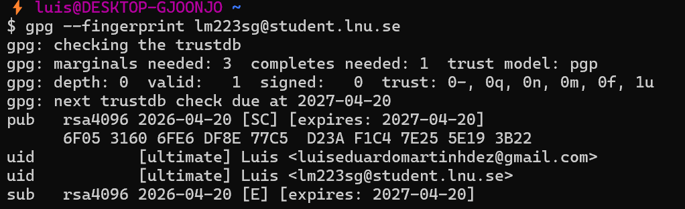

2.4 Public Submission and Peer Exchange
I uploaded my public key to the keyserver.ubuntu.com server to make it accessible to my classmates and instructors. Subsequently, I exchanged and signed public keys with two classmates to build a small "Web of Trust". Below are the direct search index URLs for our public keys:
- My Public Key URL: https://keyserver.ubuntu.com/pks/lookup?search=lm223sg%40student.lnu.se&fingerprint=on&op=index
- Classmate 1 Public Key URL: https://keyserver.ubuntu.com/pks/lookup?search=0x18D101BBF49F4FA9D0B11FEA96886106BD7BB8FB&fingerprint=on&op=vindex
- Classmate 2 Public Key URL: https://keyserver.ubuntu.com/pks/lookup?search=0x73FD2B315E8E64B7CCE77957D643B9DD94620C75&fingerprint=on&op=vindex

Task 3
After establishing a Web of Trust, I proceeded to verify the practical application of GPG with two classmates, including Ryan Shi Ding. This task confirms that the cryptographic keys are functional for daily communication.

3.1 Encrypted and Signed Email Exchange
I used Thunderbird with OpenPGP to exchange messages, focusing on two security pillars:
- Confidentiality: I encrypted messages using my peers' public keys, ensuring that only they could decrypt the content with their respective private keys.
- Authenticity: I digitally signed my outgoing emails to provide non-repudiation and proof of identity.
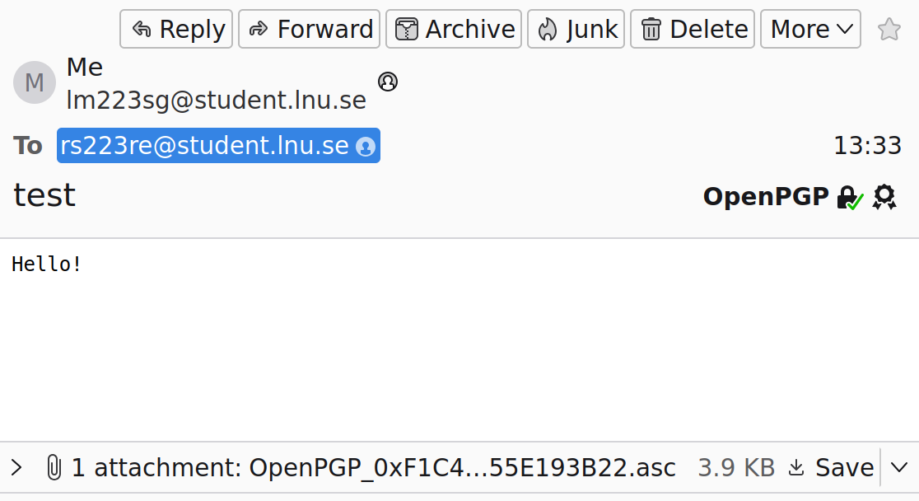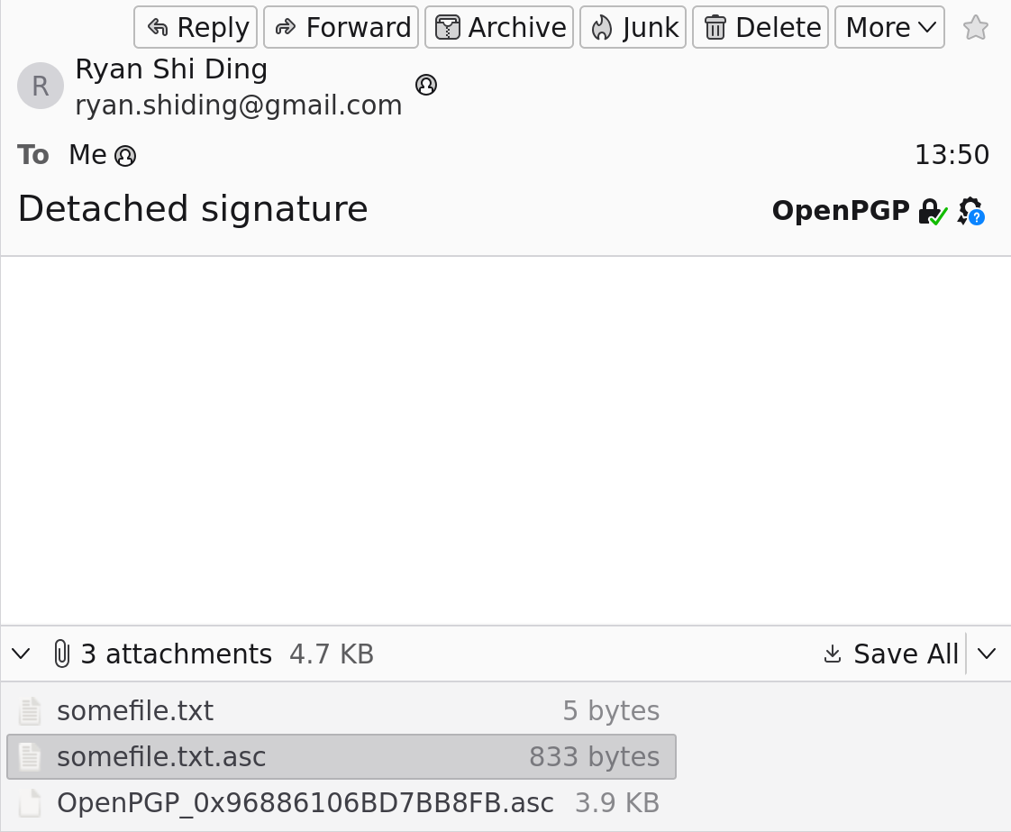
Thunderbird successfully verified the signatures of incoming messages, as indicated by the OpenPGP security headers and icons displayed in the interface.

3.2 Detached Signatures Test
To test file integrity protection, we exchanged detached signatures. This method is crucial for verifying files without modifying the original data.
- Transmission: My peer sent a message containing two separate attachments: the original somefile.txt and the cryptographic signature somefile.txt.asc.
- Verification: I downloaded both files to my WSL2 environment and executed the verification command: gpg --verify somefile.txt.asc somefile.txt
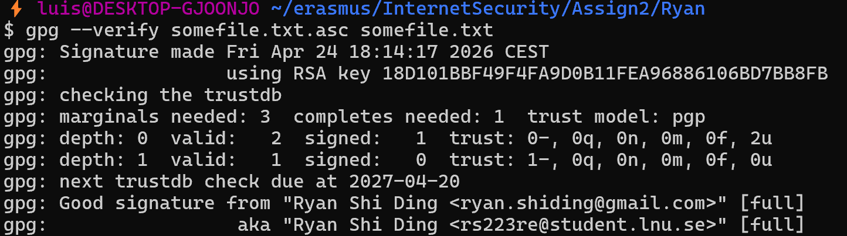
The terminal output confirmed a "Good signature" from a "full" trusted source. This proves that the file was not altered during transit and that the signature originates from my peer's verified identity.

Task 4: Finding and Verifying the TA’s Public Key

4.1 Search and Verification Process
I searched for the public GPG key of my instructor, Danial, using the public keyserver keyserver.ubuntu.com. I used the specific fingerprint provided in the assignment slides and Moodle: B2F0F43028702DE93F1B979C1CFC16EDDEC84D46.
After successfully importing the key into my local keyring, I executed the command gpg --fingerprint to verify the key's authenticity. I carefully compared the terminal output with the fingerprint listed in the course requirements to ensure they were identical.
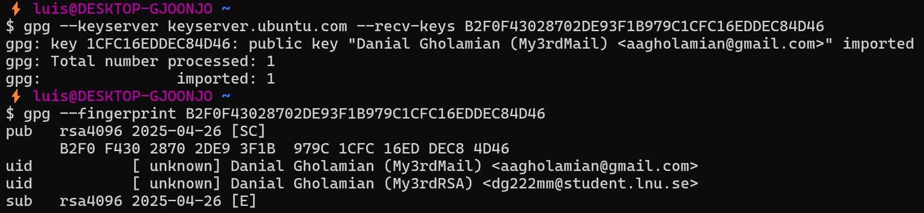

4.2 Is Fingerprint Verification Enough?
While matching the fingerprint ensures that the public key I downloaded is exactly the same one the TA published, it is not entirely sufficient to relate a certificate to its owner with absolute certainty. This is because:
- A keyserver only confirms that a key with a certain name and email exists, not that the person controlling the email is the one who created it.
- To achieve full certainty, a Web of Trust model or an out-of-band verification (such as meeting the owner in person to exchange fingerprints) would be required.

4.3 Risks of Failing to Verify
Failing to verify the public key of a claimed identity exposes the communication to a Man-in-the-Middle (MITM) attack. If I were to use an unverified, malicious key:
- An attacker could intercept my message, decrypt it with their own private key, read the contents, and then re-encrypt it with the TA's actual key to forward it, leaving the breach undetected.
- Sensitive documents, such as the Commitment of Responsibility, could be stolen or altered by unauthorized parties.

Task 5: Fingerprint Submission and MITM Protection
To establish a secure foundation for my digital identity, I submitted my unique 40-character public-key fingerprint to the authenticated Moodle platform, creating a reliable out-of-band verification channel. This action is a critical security measure because public keyservers are not inherently trusted entities and are susceptible to fraudulent uploads where an attacker might impersonate a user. By providing this fingerprint on a secure university platform, I establish a "ground truth" that allows the instructor to verify the authenticity of any key received, effectively preventing Man-in-the-Middle (MITM) attacks that rely on key substitution. This verification process is also a vital fulfillment of the university's Liability Obligations, which hold students personally accountable for all activities performed under their digital identity. Neglecting this verification could allow an attacker to hijack my identity for disruptive activities, for which I could still be held liable or face disciplinary measures due to a failure in properly securing my cryptographic credentials.

Task 6: Encrypted and Signed Submission
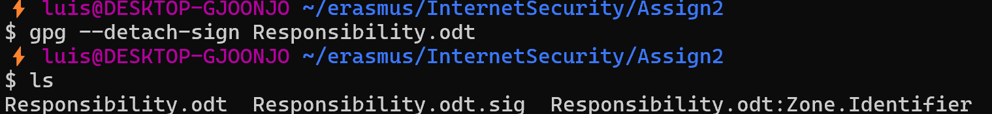
After filling out the Responsibility.odt file, acknowledging the university's regulations and Swedish laws regarding IT resource usage. I generated a detached signature (.sig) for the document using my private key and compressed both files into a ZIP archive titled responsibility_package.zip.
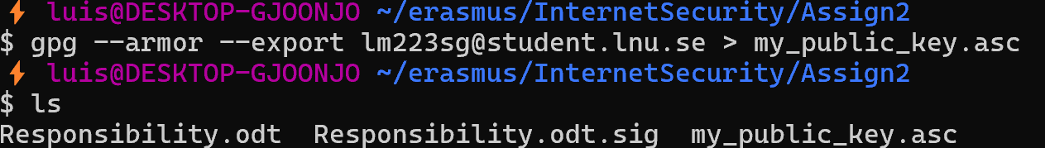

I used Thunderbird's OpenPGP integration to send the email. I enabled both Encryption (ensuring that only the TA (Danial) can read the message using his private key) and Digital Signing (ensures that the message originates from my verified identity).

Task 7: Email Authentication and Validation

7.1 Services and Methodology
For this task, I analyzed the authentication and validation measures used by Gmail and LNU Student Mail (hosted via Google/Outlook services). I sent test messages between these two accounts to examine how modern email providers verify the sender's identity and ensure message integrity.

7.2 Visual Verification in the Interface
In the Gmail interface, I verified that incoming emails are authenticated by checking the sender details:
- For the LNU email: The interface displayed "mailed-by: student.lnu.se" and "signed-by: student.lnu.se", indicating successful validation.
- For the Gmail email: It showed "mailed-by: gmail.com" and "signed-by: gmail.com".

7.3 Header Analysis and Authentication:
By inspecting the "Original Message" headers, I identified the following authentication results for both test cases:
- Case A: Email from LNU Student Mail to Gmail
  - Evidence File: LNU to Gmail .eml
  - SPF (Sender Policy Framework): pass. Google verified that the domain student.lnu.se designates the sending IP (209.85.220.41) as a permitted sender.
  - DKIM (DomainKeys Identified Mail): pass. The digital signature (header.i=@student.lnu.se) was verified, ensuring the message body and headers were not tampered with.
  - DMARC: pass. The policy for lnu.se was successfully applied.
- Case B: Email from Gmail to LNU Student Mail
  - Evidence File: Gmail to LNU .eml
  - SPF: pass. The domain gmail.com authorized the sending server.
  - DKIM: pass. The cryptographic signature for header.i=@gmail.com was valid.
  - DMARC: pass. The message aligned with Gmail's published security policies.

Task 8: Comparing Keyservers (keys.openpgp.org)

8.1 Process and Verification
For this task, I uploaded my public key to a different keyserver: https://keys.openpgp.org/. Unlike the Ubuntu keyserver used in Task 2, this server follows a strict verification policy.
First, I exported my public key from my terminal and uploaded it to the platform. An instance after doing that, the server sent a verification link to my student email, therefore, my identity and email address only became searchable and visible to the public after I clicked the verification link, confirming my ownership of the account.
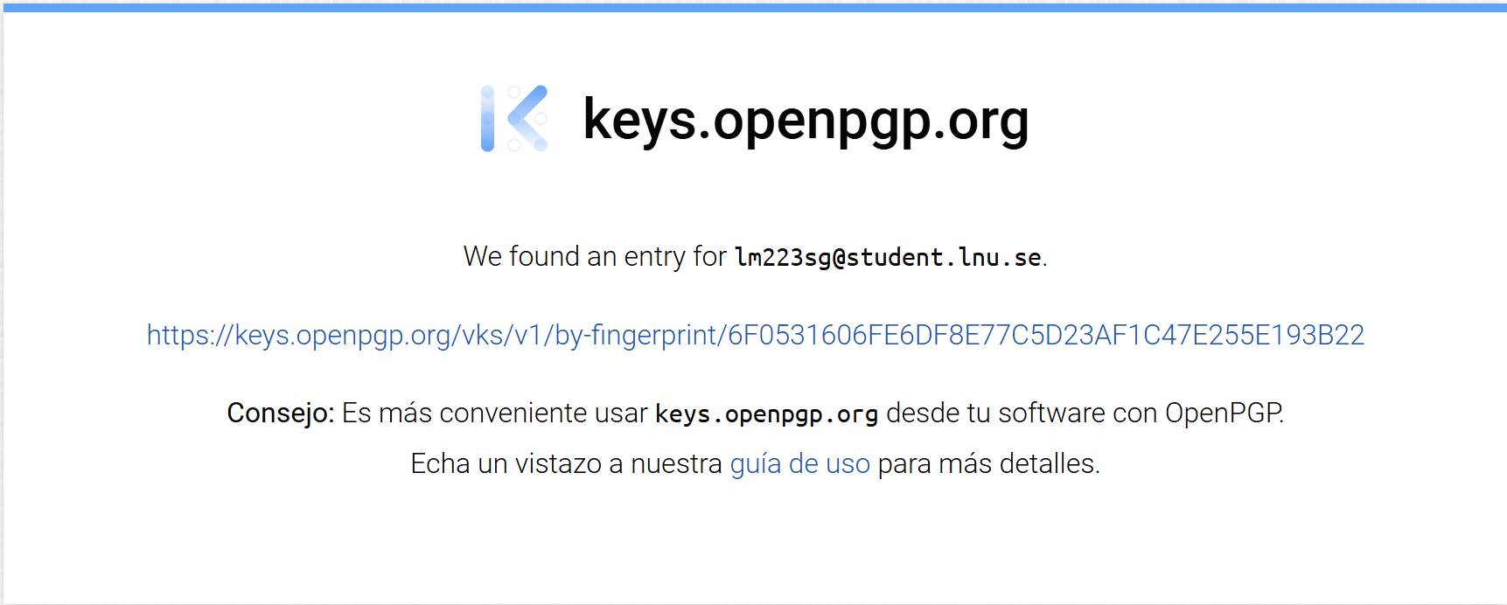

8.2 Comparison with SKS/Ubuntu Keyservers
During my analysis, I identified several critical differences between keyserver.ubuntu.com and keys.openpgp.org:
- Identity Verification: Traditional SKS keyservers (like Ubuntu) allow anyone to upload a key with any name or email without verification. keys.openpgp.org requires a "double opt-in" via email, which significantly reduces the risk of identity theft and fraudulent keys.
- Privacy: On keys.openpgp.org, User IDs (names and emails) are encrypted and hidden by default unless verified. This protects users from email harvesters and spam bots.
- Key Poisoning Protection: Traditional servers are often vulnerable to "key poisoning" (where a key is flooded with thousands of fake signatures to make it unusable). keys.openpgp.org prevents this by only distributing a cleaned version of the key, stripping away non-essential or unverified third-party signatures.

Task 9: S/MIME

9.1 How S/MIME Works
S/MIME is a security protocol used to sign and encrypt email messages. It works by using digital certificates issued by a centralized Certificate Authority (CA). These certificates link a user's public key to their specific email identity, ensuring that the communication is both private and authentic.

9.2 Main Differences: S/MIME vs. GPG
The primary difference lies in the Trust Model:
- S/MIME (Centralized): Relies on a hierarchical structure where a trusted third party (the CA) verifies and "vouchers" for your identity. It is natively supported by most enterprise email clients like Outlook.
- GPG (Decentralized): Uses a "Web of Trust" where users verify each other’s identities without a central authority. It usually requires external software or plugins.

9.3 Steps of Communication and Key Usage
S/MIME communication begins with a certificate exchange where Alice and Bob obtain each other's public keys. To send a secure message, Alice signs the email using her Private Key to ensure authenticity and non-repudiation, then encrypts the content with Bob’s Public Key to guarantee confidentiality. Upon receipt, Bob verifies the digital signature using Alice’s Public Key to confirm the sender's identity and message integrity, finally decrypting the message with his own Private Key.

Anonymity

1. Research on Anonymity Methods
While encryption (GPG) ensures the confidentiality of a message's content, anonymity focuses on hiding the metadata and the identity of the participants. During my research, I identified several methods used to achieve this:
- Anonymous Remailers: Servers that receive an email, strip all identifying headers (like the sender's name and original IP), and forward it to the destination.
- Disposable Email Services: Platforms that provide temporary, no-registration-required addresses to prevent a message from being traced back to a permanent personal account.
- Tor-Based Communication: Using privacy-focused email providers through the Tor network to mask the user’s physical location and IP address from the service provider itself.
- Web-Based Anonymous Proxies: Specialized websites that act as an intermediary, sending the email from their own servers so the recipient only sees the service's technical data.

2. Service Tested:
For the practical part of this task, I conducted a test using Anonymousemail.me. I sent a message from their web interface to my university account to analyze how a professional anonymity service handles delivery and metadata. Anonymous Email .eml

3. Observations and Technical Analysis
After receiving the test email, I inspected the original headers to verify the level of anonymity provided. The results were highly successful:
- Identity Masking: The "From" field was completely replaced by Anonymousemail <noreply@anonymousemail.se>, successfully hiding my real identity.
- IP Anonymization: Upon checking the Received headers, I found that my home IP address was stripped. The message originated from the server s3.inboxpress.net with the IP 185.82.217.109, which belongs to the service provider's infrastructure in Sweden.
- Advanced Authentication: Unlike many basic anonymous services, this one passed all major security checks (SPF: pass, DKIM: pass, and DMARC: pass). By having a valid cryptographic signature from the service's domain, the email avoided the spam folder and reached my inbox directly, despite its anonymous nature.

4. Conclusion
This test demonstrates that achieving anonymity requires more than just hiding a name; it involves masking the network trail (IP address) while maintaining enough technical legitimacy (SPF/DKIM) so that modern email filters do not reject the message.

Bibliography

[1] Zimmermann, P., Why do you need PGP? [Online]. Available: https://groups.csail.mit.edu/mac/classes/6.805/articles/crypto/cypherpunks/zimmermann-why-pgp.html.
[2] Anonymousemail.se, Anonymous Email Service. [Online]. Available: https://anonymousemail.me/.
[3] Martín Hernández, L. E., Email Evidence Folder (.eml files). [Online]. Available: https://drive.google.com/drive/folders/1j7FEnlH5UU50c06bQ9J5aKQEaqDQpdHj?usp=sharing.
[4] The GnuPG Project, GnuPG Documentation: Invoking GPG. [Online]. Available: https://gnupg.org/documentation/manuals/gnupg/Invoking-GPG.html.
[5] Callas, J., et al., RFC 4880: OpenPGP Message Format. [Online]. Available: https://datatracker.ietf.org/doc/html/rfc4880.
[6] keys.openpgp.org, About keys.openpgp.org: Verification and Privacy. [Online]. Available: https://keys.openpgp.org/about.
[7] Ramsdell, B., RFC 8551: S/MIME Version 4.0 Message Specification. [Online]. Available: https://datatracker.ietf.org/doc/html/rfc8551.
[8] Ducharme, B., Email Authentication: SPF, DKIM, and DMARC Explained. [Online]. Available: https://visuals.net/blog/spf-dkim-dmarc-explained/.

