

Linnaeus University
Faculty of Technology – Department of Computer Science

2DV702 - Internet Security
Assignment 3

Student: Luis Eduardo Martín Hernández

Student ID: lm223sg@student.lnu.se

Index

0 PREREQUISITES 3
1. WireGuard 3
1.1 Installation 3
A. WireGuard Installation on Both Nodes
To deploy WireGuard, the official package was installed on both nodes. 3
B. Key Pair Generation
Secure key pairs were generated inside /etc/wireguard. A strict file creation mask (umask 077) was applied to protect the private keys from unauthorized local access. 3
1.2 Tunnel Configuration 3
1.3 Traffic Analysis (Wireshark) 5
1.4 Cryptographic Review 6
2 OpenVPN 7
2.1 Installation 7
2.2 Tunnel Configuration 7
A. & B. Server and Client Configuration Files 7
2.3 Traffic Analysis (Wireshark) 9
2.4 Theoretical Review 9
3 WireGuard vs. OpenVPN 10
Differences and Deployment Complexity 10
Cryptographic Foundations 10
Security and Stealth Capabilities 11
Administrative Scenarios 11
4 Tailscale 11
4.1 Installation 11
4.2 IP Address Definition 11
4.3 Connectivity Testing (Standard Ping) 11
4.4 Connection Diagnostics (Tailscale Ping) 12
4.5 Connection Comparison 12
1. Between the virtual instances 12
2. From your local computer/laptop to the virtual instances 12
Bibliography 13

0 PREREQUISITES
Before installing any VPN software, it is technically essential to verify the baseline security state of both virtual nodes. Pre-existing routing policies, network address translations (NAT), or restrictive firewall rules inside the kernel space could skew latency measurements or block VPN traffic, leading to false negatives during connection attempts.

1. WireGuard

1.1 Installation

WireGuard Installation on Both Nodes
To deploy WireGuard, the official package was installed on both nodes.
sudo apt update && sudo apt install -y wireguard wireguard-tools

Key Pair Generation
Secure key pairs were generated inside /etc/wireguard. A strict file creation mask (umask 077) was applied to protect the private keys from unauthorized local access.
ubuntu@server1-lm223sg:~$ sudo -i
root@server1-lm223sg:~# cd /etc/wireguard
root@server1-lm223sg:/etc/wireguard# umask 077
root@server1-lm223sg:/etc/wireguard# wg genkey | tee private.key | wg pubkey | tee public.key

- Which cryptographic algorithm (curve) is used for generating these keys?
WireGuard uses Curve25519, an elliptic curve designed by Daniel J. Bernstein. Specifically, it employs the ECDH (Elliptic Curve Diffie-Hellman) key exchange protocol, allowing peers to securely establish a shared symmetric session key over an insecure physical network.
- Why is this preferred over RSA in modern implementations?
Curve25519 is preferred over traditional RSA for three main reasons:
- Performance & Efficiency: Elliptic curve operations require significantly less CPU power and memory than RSA modular exponentiation, reducing latency and resource consumption.
- Compact Key Size: A Curve25519 key is only 32 bytes (256 bits) long, yet it offers equivalent or superior cryptographic strength compared to a massive 3072-bit or 4096-bit RSA key.
- Side-Channel Attack Resistance: Curve25519 is natively designed to execute in constant time. This completely mitigates timing attacks, a common vulnerability in RSA implementations where attackers measure calculation times to deduce private keys.

1.2 Tunnel Configuration
A. & B. Configuration Files (/etc/wireguard/wg0.conf) and Peer Exchange
To establish the secure tunnel, configuration files were created on both nodes. This setup implements WireGuard's Cryptokey Routing by defining a virtual IP range (10.0.0.0/24) and explicitly binding the peer's public key to its allowed logical tunnel IP.
- Client Node Configuration (server1-lm223sg):
  - Virtual IP: 10.0.0.1/24
  - Allowed Peer IP: 10.0.0.2/32 (Server)
- Server Node Configuration (server2-lm223sg):
  - Virtual IP: 10.0.0.2/24
  - Allowed Peer IP: 10.0.0.1/32 (Client)
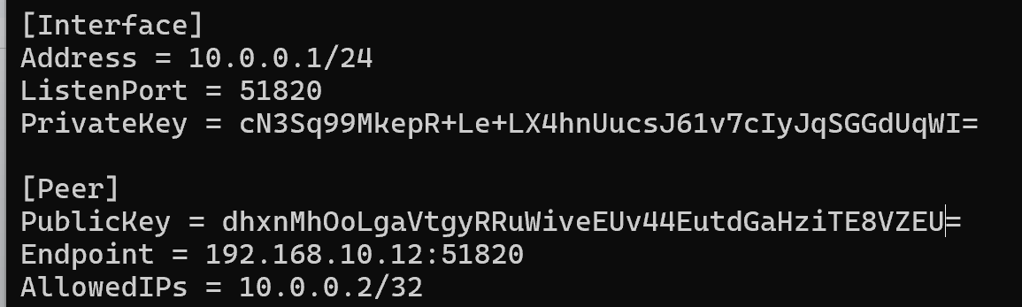
Figure 3: Client’s peer-to-peer configuration profiles defining cryptokey routing and endpoints.
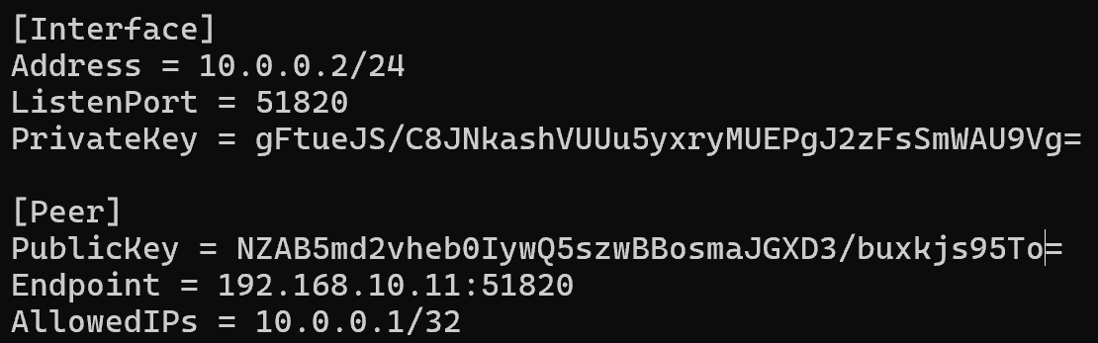
Figure 4: Server’s peer-to-peer configuration profiles defining cryptokey routing and endpoints.
C. Tunnel Activation and Connectivity Verification
The virtual interfaces were initialized on both nodes using the wg-quick routing utility wrapper:
Client:
ubuntu@server1-lm223sg:~$ wg-quick up wg0
[#] ip link add wg0 type wireguard
[#] wg setconf wg0 /dev/fd/63
[#] ip -4 address add 10.0.0.1/24 dev wg0
[#] ip link set mtu 1420 up dev wg0
Server:
ubuntu@server2-lm223sg:~$ wg-quick up wg0
[#] ip link add wg0 type wireguard
[#] wg setconf wg0 /dev/fd/63
[#] ip -4 address add 10.0.0.2/24 dev wg0
[#] ip link set mtu 1420 up dev wg0
To verify the cryptographic association and packet routing, a standard ICMP diagnostic ping was executed from the client (10.0.0.1) to the server (10.0.0.2), showing 0% packet loss and a successful connection.
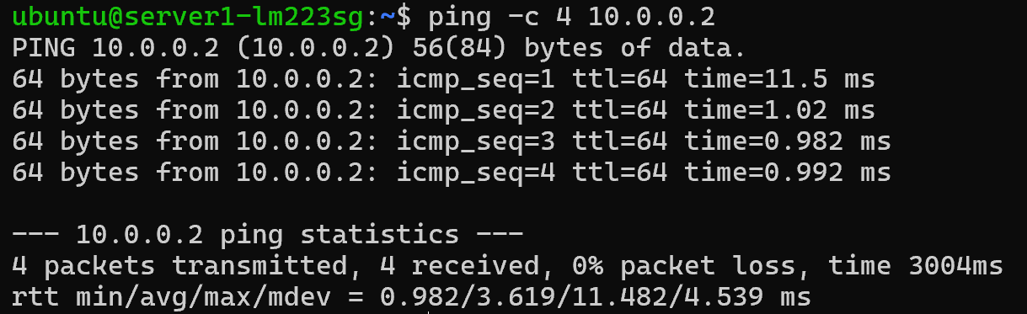
Figure 5: Connectivity verification showing successful end-to-end ICMP transmission through the tunnel.
Finally, the tunnel active status and active handshake time were audited using the wg show diagnostic utility:
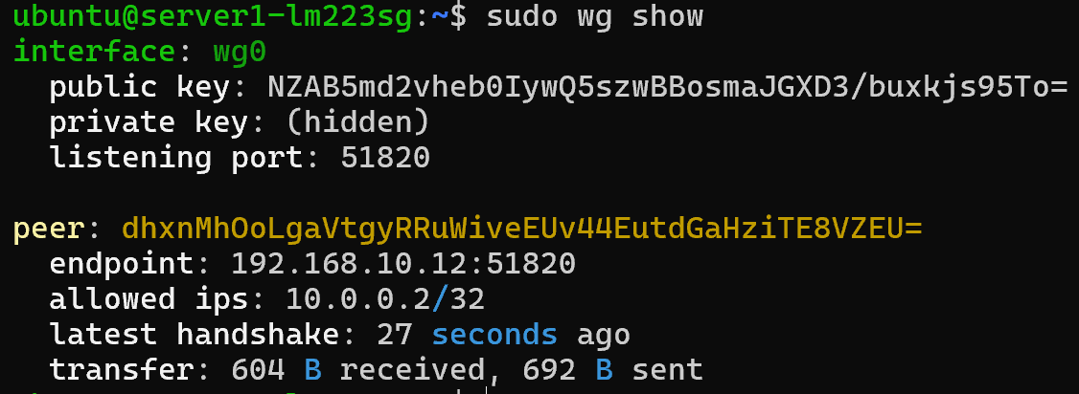
Figure 6: Verification of successful security associations and data transfer rates.

1.3 Traffic Analysis (Wireshark)
To evaluate tunnel confidentiality, a packet capture was initiated on the physical network interface (enp3s0) while sending an unencrypted HTTP request through the virtual interface (wg0).
ubuntu@server1-lm223sg:~$ curl http://10.0.0.2
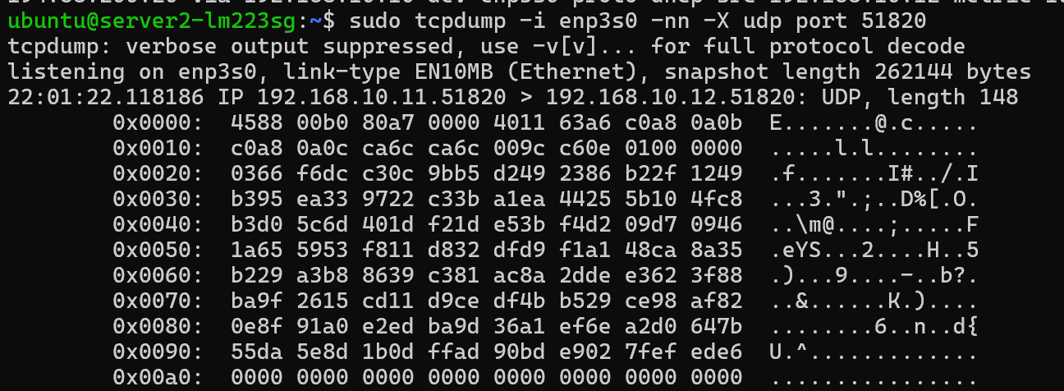
Figure 7: Packet capture on the physical interface enp3s0 displaying encrypted WireGuard payloads.
- Can you read the content of the packets? (¿Puedes leer el contenido?)
No, it is completely impossible to read the original data payload. When inspecting the tcpdump output on the physical interface, the packet payload displays only as an unreadable sequence of hexadecimal values and random ASCII characters (dots and randomized symbols). This confirms that all original transport data (such as the HTTP request) was successfully encapsulated and encrypted end-to-end by WireGuard's symmetric primitives before entering the physical transport medium.
- Which transport protocol and port are used by default by WireGuard?
By default, WireGuard operates exclusively over the UDP transport protocol on port 51820.
- Explain how this differs from IPsec or OpenVPN in terms of resisting network scanning.
WireGuard's "silent" architecture provides a significant structural security advantage against malicious network scans compared to traditional VPN protocols:

- OpenVPN and IPsec Behavior (Active Handshake): These legacy protocols operate on an active state model. If a port scanner (such as nmap) sends an unauthorized probe packet (e.g., a TLS Client Hello), the server's daemon actively responds to negotiate or reject the connection. This immediate response discloses to an attacker that an active VPN gateway is listening on that IP address.

- WireGuard Behavior (Silent Mode): WireGuard does not reply to any incoming packet unless it is authenticated and signed with a pre-registered public key listed in its configuration. When a scanner sends unauthorized packets to port 51820, the server silently discards them (drop) without sending any reply or ICMP error. To the scanner, the port appears completely closed (or the host offline), hiding the infrastructure from the internet.

1.4 Cryptographic Review
- Roles of ChaCha20 and Poly1305 in the Protocol
These two algorithms work in tandem as an AEAD (Authenticated Encryption with Associated Data) scheme to secure the data channel once the tunnel is established:
- ChaCha20 (Symmetric Stream Cipher): Provides confidentiality. It encrypts plaintext data packets (such as ICMP pings or FTP traffic) into high-entropy, unreadable ciphertext before physical transmission.
- Poly1305 (Message Authenticator): Provides integrity and authenticity. It generates a constant-time cryptographic message authentication code (MAC) tag for each encrypted packet. If a single bit is altered in transit, the validation fails at the destination, and the packet is immediately dropped.
- Perfect Forward Secrecy (PFS) and Periodic Re-keying
- The Concept of PFS: Perfect Forward Secrecy is a cryptographic property ensuring that if an attacker captures and records encrypted traffic today, and compromises the long-term static private keys of the servers in the future, they still cannot decrypt the historical traffic. This prevents a current breach from exposing past data.
- How WireGuard Achieves PFS: Instead of using a single static key for the lifetime of the connection, WireGuard implements an automated, ephemeral re-keying mechanism based on the Noise Protocol Framework. Every 2 to 3 minutes, the nodes silently perform a new handshake to derive fresh, temporary symmetric session keys. Once the new session keys are active, the old ones are securely and permanently erased from the RAM.
- Purpose of BLAKE2s over Legacy Hash Functions (MD5 / SHA-1)
- Obsolescence of MD5 and SHA-1: These legacy hashing algorithms are completely broken due to cryptographic collision vulnerabilities, where different inputs can produce identical hash outputs. This makes them highly unsafe for key derivation or verifying packet integrity.
- Purpose of BLAKE2s: WireGuard utilizes BLAKE2s for secure hashing and within its HKDF (HMAC-based Key Derivation Function). It is selected because it provides modern, collision-resistant security (equivalent to SHA-256) while being optimized natively for 32-bit and 64-bit architectures, allowing it to perform much faster in software than legacy or complex hash functions.

2 OpenVPN

2.1 Installation
- Install OpenVPN on both nodes
sudo apt update && sudo apt install -y openvpn
- Generate Parameters/Keys using gen-dh
Rather than using a custom script, standard Diffie-Hellman parameters were generated inside the /etc/openvpn directory on both nodes using the openssl toolkit with a standard key length of 2048 bits:
cd /etc/openvpn
sudo openssl dhparam -out dh.pem 2048


Figure 8: Verification of the generated Diffie-Hellman parameters (dh.pem) on both instances.
- Which cryptographic algorithm is used for generating these keys?
The cryptographic algorithm used in this process is Finite Field Cryptography (FFC) Diffie-Hellman (DH) (specifically utilizing a 2048-bit prime group).

Unlike symmetric encryption keys or permanent certificates, Diffie-Hellman parameters are not used to encrypt raw data directly. Instead, they establish a secure mathematical baseline. The dh.pem file contains global public values—specifically a large prime number $p$ and a generator $g$. During the initial TLS handshake, these parameters enable the client and server to negotiate a temporary, shared symmetric session key over an insecure network (Internet) without ever transmitting the key itself, providing the system with Perfect Forward Secrecy (PFS).

2.2 Tunnel Configuration

A. & B. Server and Client Configuration Files
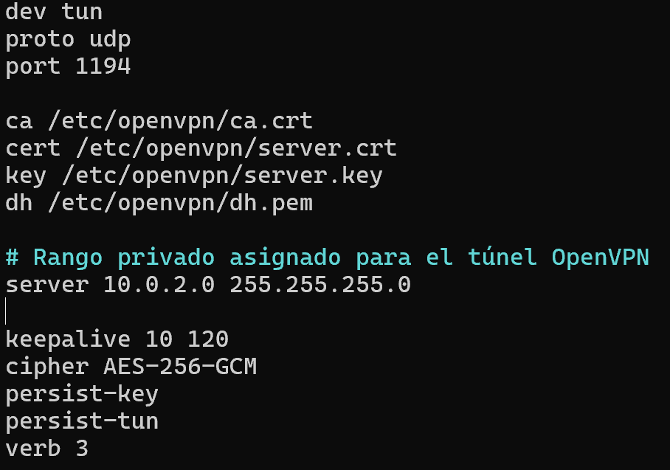
To configure the secure Layer 3 tunnel, an asymmetric certificate-based PKI was established, and the private network range 10.0.2.0/24 was allocated for virtual addressing.
- Server Configuration (/etc/openvpn/server.conf): Defines the tun0 virtual Layer 3 interface operating over UDP port $1194$. It references the CA parameters (ca.crt, server.crt, server.key, dh.pem) and enforces symmetric encryption using AES-256-GCM.
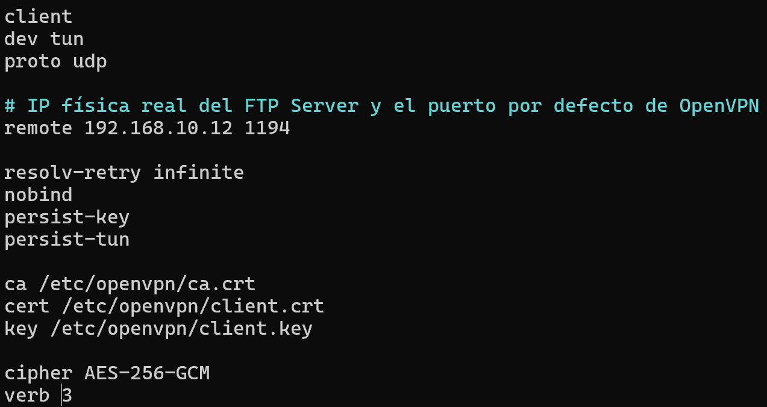
- Client Configuration (/etc/openvpn/client.conf): Defines the client node operating in remote mode, targeting the server's physical socket (192.168.10.12:1194). It references its own cryptographic credentials (ca.crt, client.crt, client.key) and matches the server's encryption cipher.

cd /etc/openvpn
# 1. Create a CA
openssl req -nodes -x509 -days 365 -newkey rsa:2048 -keyout ca.key -out ca.crt -subj "/CN=OpenVPN-CA"
# 2. Create the key and server certificate
openssl req -nodes -newkey rsa:2048 -keyout server.key -out server.csr -subj "/CN=OpenVPN-Server"
openssl x509 -req -days 365 -in server.csr -CA ca.crt -CAkey ca.key -CAcreateserial -out server.crt
# 3. Create the key and client certificate
openssl req -nodes -newkey rsa:2048 -keyout client.key -out client.csr -subj "/CN=OpenVPN-Client"
openssl x509 -req -days 365 -in client.csr -CA ca.crt -CAkey ca.key -CAcreateserial -out client.crt
C. Tunnel Activation, Connection Verification, and Routing Analysis
The virtual interfaces were initialized on both nodes by executing the openvpn daemon with their respective configuration profiles:
ubuntu@server1-lm223sg:/etc/openvpn$ sudo openvpn --config /etc/openvpn/client.conf

ubuntu@server2-lm223sg:/etc/openvpn$ sudo openvpn --config /etc/openvpn/server.conf
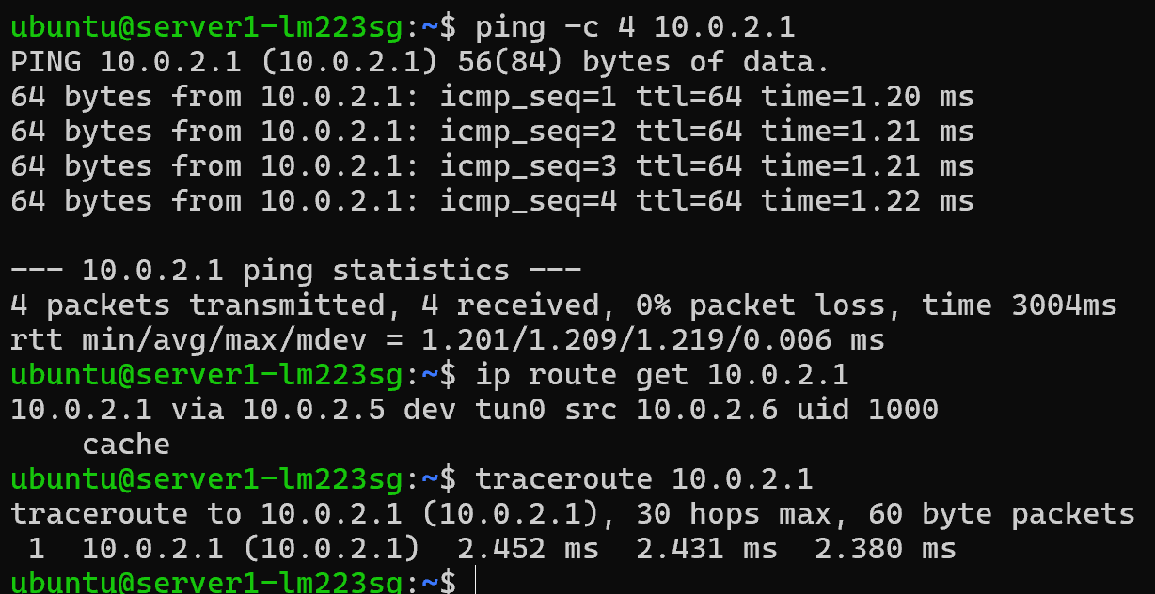
Once the tunnel was active, end-to-end logical connectivity was verified via a standard ICMP ping from the client node to the server's virtual interface (10.0.2.1). To determine the exact logical path of the packets, routing queries and path tracing were performed on the client node:

Figure 9: ICMP diagnostic ping verifying communication through the OpenVPN tunnel.

Routing Analysis:
The output of the ip route get command reveals that the operating system forwards traffic intended for 10.0.2.1 through the logical gateway 10.0.2.5 using the tun0 virtual interface. This occurs because OpenVPN defaults to the legacy net30 topology, which allocates narrow /30 point-to-point subnets for each client session.

2.3 Traffic Analysis (Wireshark)
To verify the confidentiality of the OpenVPN tunnel, a packet capture was conducted on the physical interface (enp3s0) while transmitting test data through the virtual interface (tun0). The captured packets were saved to a file (/tmp/openvpn_capture.pcap) and read using the tcpdump utility in read mode with hexadecimal and ASCII output
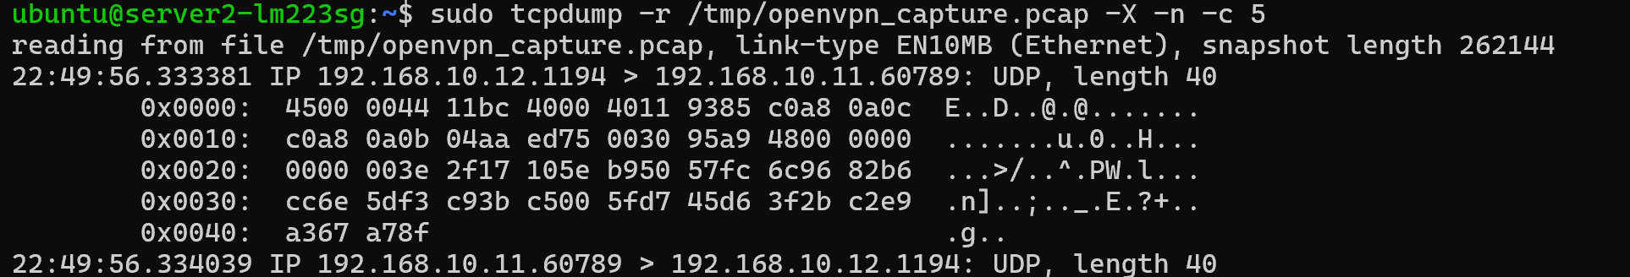
Figure 10: Raw packet inspection on physical interface enp3s0 proving OpenVPN encryption.

- Can you read the content of the packets?
No, the content of the packets is completely unreadable. While the outer IP headers are visible in plaintext to allow physical routing between the hosts (192.168.10.11 and 192.168.10.12), the actual message data (payload) is entirely encrypted.

As shown in the ASCII column on the right side of the dump (e.g., row 0x0020 and 0x0030 containing strings like ...>/..^.PW.l... and ...J-.....k....@), all inner application layer data is represented as random characters and dots. This confirms that OpenVPN successfully encapsulates and encrypts the traffic using the negotiated AES-256-GCM symmetric key.
- Which transport protocol and port are used by default by OpenVPN?
By default, OpenVPN utilizes the UDP transport protocol over destination port 1194.
This is confirmed by the capture headers, which show communication originating from or destined to port 1194 (e.g., IP 192.168.10.12.1194 > 192.168.10.11.60789).

2.4 Theoretical Review
- What transport protocol does OpenVPN use? Why does it use that?
OpenVPN defaults to UDP to avoid "TCP Meltdown". If a TCP-based application stream is tunneled over a TCP-based VPN, a single packet loss triggers independent retransmission loops at both the application and VPN layers. These layers then compete for bandwidth, causing exponential timeout backoffs and connection collapse. UDP's stateless nature allows the inner application to handle packet drops natively without tunnel interference.

- What happens when an OpenVPN client connects to a server? Explain the different steps with the help of some screenshots.
The connection sequence follows four key phases:

- Control Channel Setup: Client sends an initial UDP packet; a secure TLS 1.3 control channel is negotiated using Diffie-Hellman parameters (dh.pem).
- Mutual Authentication: Nodes validate each other's certificates (server.crt and client.crt) using the trusted root CA (ca.crt).
- Parameter Exchange: The server pushes routing directives, session keys, and virtual addressing (10.0.2.6) via a PUSH_REPLY message.
- Interface Initialization: Both nodes launch their virtual tun0 interfaces and update local routing tables.
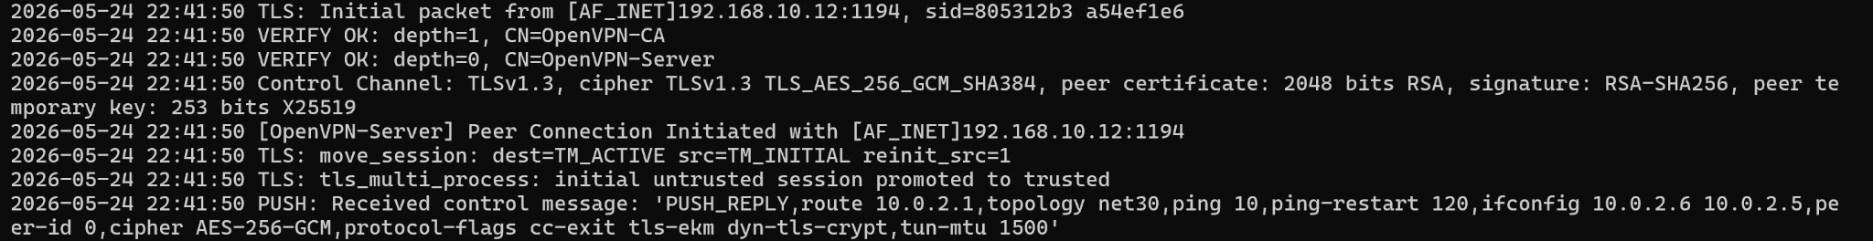
Figure 11: Connection logs showing the chronological handshake and tunnel configuration steps.
C. Why can MTU and MSS settings become problematic in OpenVPN tunnels?
MTU Limit: Physical Ethernet links enforce a Maximum Transmission Unit (MTU) limit of 1500 bytes.
Overhead: Encapsulating packets inside OpenVPN adds TLS, UDP, IP, and cryptographic headers, pushing the packet size beyond the 1500-byte physical limit.
Fragmentation & Drops: This forces intermediate routers to segment packets (degrading performance) or drop them if the Don't Fragment (DF) flag is set.
MSS Solution: Reducing the Maximum Segment Size (MSS) forces inner TCP streams to limit their initial segment size, leaving enough clearance for OpenVPN's overhead without fragmentation.

3 WireGuard vs. OpenVPN
When designing a secure network architecture, selecting the appropriate Virtual Private Network (VPN) protocol is a critical decision. WireGuard and OpenVPN represent two distinct generations of secure tunneling technology, each with unique architectural advantages. This section compares both protocols across deployment complexity, cryptographic standards, overall security, and administrative use cases.

Differences and Deployment Complexity
The most visible operational difference between the two protocols lies in their deployment workflow. WireGuard utilizes a streamlined "Cryptokey Routing" concept, where nodes are configured directly via a simple configuration file mapping internal IP addresses to static public keys. Setting up a WireGuard interface requires only generating key pairs via wg genkey and swapping the public keys between peers.
In contrast, OpenVPN relies on a traditional, heavy Public Key Infrastructure (PKI) hierarchy. Administrators must establish a Certificate Authority (CA), sign unique public certificates and private keys for both the server and the client, and manually transfer these files across nodes. Consequently, WireGuard is significantly easier and faster to set up than its legacy counterpart.

Cryptographic Foundations
The cryptographic philosophies of both protocols differ immensely. WireGuard is intentionally cryptographically opinionated; it features a fixed, hardcoded suite of cutting-edge primitives, including Curve25519 for key exchange , ChaCha20 for symmetric encryption , Poly1305 for authentication , and BLAKE2s for hashing. If any primitive is compromised, the entire protocol is updated, eliminating configuration errors.
OpenVPN, on the other hand, relies on the OpenSSL library, offering modular cryptographic agility. In standard configurations, it uses 2048-bit Diffie-Hellman parameters for key exchange , RSA for certificate validation , and AES-256-GCM for protecting data packets.

Security and Stealth Capabilities
While both protocols are highly secure when configured correctly, WireGuard offers structural security advantages. Its codebase is exceptionally compact (under 4,000 lines), making formal security auditing drastically simpler than OpenVPN’s massive legacy codebase. Furthermore, WireGuard implements an inherently stealthy "Silent Mode". It completely drops unauthorized incoming packets without sending any response, hiding the VPN server from active network scanners. OpenVPN, conversely, actively participates in initial TLS handshakes, acknowledging its existence to anyone probing the port.

Administrative Scenarios
A network administrator should choose WireGuard when raw performance, minimal CPU overhead, low latency, and ease of maintenance are the primary objectives. It is the optimal choice for modern cloud mesh architectures, containerized environments, and mobile device deployments where battery and processing power are limited.
Conversely, an administrator should choose OpenVPN when enterprise-grade flexibility or legacy compatibility is mandatory. OpenVPN is uniquely suited for bypassing restrictive network constraints because it can tunnel traffic over TCP, a capability WireGuard natively lacks due to its strict UDP-only design. OpenVPN remains preferred when integrating with legacy enterprise authentication backends or complex multi-tenant routing environments.

4 Tailscale

4.1 Installation
Tailscale was installed on all three participating devices using the automated script:
curl -fsSL https://tailscale.com/install.sh | sh
sudo tailscale up
tailscale ip

4.2 IP Address Definition
To simplify the understanding of the network mesh topology, the following unique virtual IP addresses assigned by Tailscale were defined:
- FTP Client (server1-lm223sg): 100.122.239.76
- FTP Server (server2-lm223sg): 100.121.46.10
- Local Laptop (DESKTOP-GJOONJO): 100.122.130.47

4.3 Connectivity Testing (Standard Ping)
Traditional ICMP pings were executed between all nodes to test basic reachability across the overlay network:
- From Local Laptop to Client and Server: Yielded latency averages between 47 ms and 58 ms.
- Between the Virtual Instances (Client to Server): Yielded an ultra-low latency average of 1.7 ms.
- From Virtual Instances to Local Laptop: Yielded latencies between 44 ms and 118 ms.
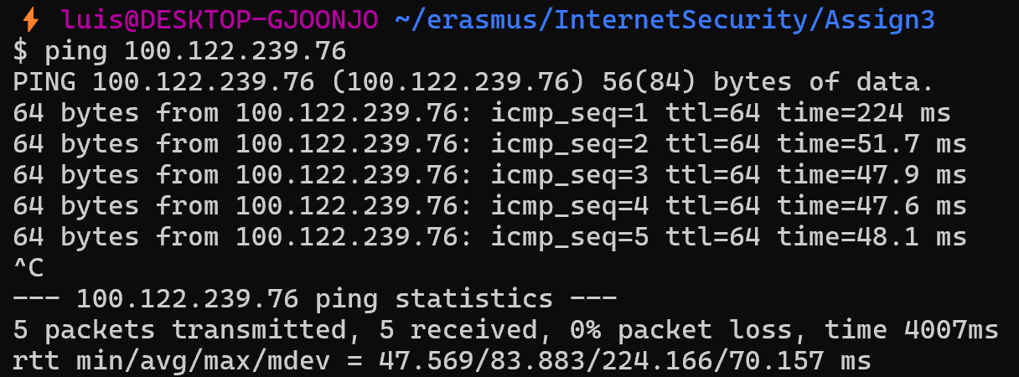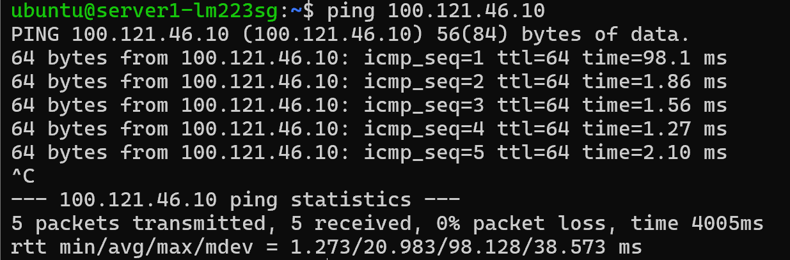
Figure 12: Standard ICMP ping test results between the mesh nodes.

4.4 Connection Diagnostics (Tailscale Ping)
The specialized diagnostic tool "tailscale ping" was used to analyze the underlying connection paths and check whether the traffic was travelling directly or via relays:
- Between Virtual Instances: Showed a direct path via local physical interfaces.
- To/From Local Laptop: Showed a relayed path via external DERP servers with "direct connection not established".
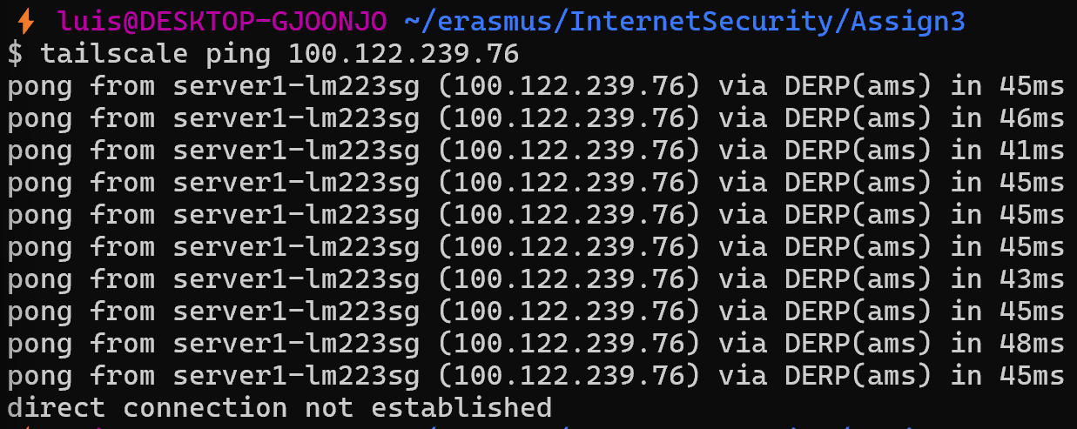Figure 14: Tailscale ping diagnostics displaying connection paths and relay status.

4.5 Connection Comparison

1. Between the virtual instances
- Result: Direct connection (Peer-to-Peer) with an ultra-low latency of 1 ms.
- Explanation: Because both virtual servers reside in the same physical local area network (LAN) of the university, Tailscale connects them directly using their local IP addresses. The traffic is encrypted but travels locally without needing to route over the public Internet.

2. From your local computer/laptop to the virtual instances
- Result: Indirect connection through DERP relay servers (Amsterdam/Frankfurt/Helsinki) with a latency of 45-50 ms (direct connection not established).
- Explanation: Strict firewalls at the university and the NAT settings of the domestic home router block incoming UDP handshakes, preventing a direct P2P connection. Tailscale resolves this obstacle by automatically and securely routing the encrypted traffic through its DERP proxy servers to guarantee connectivity.

Bibliography

[1] WireGuard Project, "WireGuard Installation Guide," wireguard.com, 2026. [Online]. Available: https://www.wireguard.com/install/

[2] OpenVPN Community, "Installing OpenVPN: Reference Manual and Community Documentation," openvpn.net, 2026. [Online]. Available: https://openvpn.net/community-docs/installing-openvpn.html

[3] Tailscale, "Download Tailscale for Linux and Setting Up the Client Daemon," tailscale.com, 2026. [Online]. Available: https://tailscale.com/download/linux

[4] J. A. Donenfeld, "WireGuard: Next Generation Kernel Network Tunnel," in Proceedings of the Network and Distributed System Security Symposium (NDSS), San Diego, CA, USA, 2017. [Online]. Available: https://www.wireguard.com/papers/wireguard.pdf

[5] O. Titz, "Why TCP Over TCP Is A Bad Idea," in Internet Engineering Task Group (IETF) Drafts & Technical Notes, 2001. [Online]. Available: https://www.rfc-editor.org/

[6] Tailscale, "How Tailscale Works: NAT Traversal and How We Establish Direct Connections," Tailscale Blog, 2020. [Online]. Available: https://tailscale.com/blog/how-tailscale-works/

