

Linnaeus University
Faculty of Technology – Department of Computer Science

2DV702 - Internet Security
Assignment 4

Student: Luis Eduardo Martín Hernández

Student ID: lm223sg@student.lnu.se

Index

CScloud Configuration Overview 3
Network Topology & Infrastructure 3
Initial Setup & Service Provisioning 3
1. SSH Reachability Configuration 3
2. FTP Daemon Installation and Setup 3
Experiment Results 4
1. ICMP Rules 4
a) Initial Connectivity Test 4
b) Directional ICMP Control (Manual / Stateless Filtering) 4
c) Other ICMP Message Types 5
2. FTP Client 5
a) Multi-Channel TCP Handling 5
b) Stateless Ruleset for Passive Mode (Client Focus) 5
c) Stateless Ruleset for Active Mode (Client Focus) 6
3. FTP Server 6
a) Server Infrastructure Requirements 6
b) & c) Server Rulesets for Passive and Active Modes (Manual) 6
4. Firewall Filtering – Part 1 7
a) Blacklisting at the Destination Perimeter 7
b) Targeted ICMP Restoration 7
c) & d) Isolated Data Channel Tests 7
e) Core Architectural Differences 7
5. Firewall Filtering – Part 2 7
a) & b) Whitelisted Rulesets for Passive and Active Modes 7
6. Stateful Filtering 8
Operational Paradigm & Comparative Evaluation 8
Intrusion Detection/Prevention Systems 9
1. Taxonomy of IDS/IPS 9
2. Suricata Rule Analysis 10
Bibliography 11

CScloud Configuration Overview
This section describes the virtual network infrastructure setup premises deployed over LNU's Cumulus cloud platform for the firewalling tasks.

Network Topology & Infrastructure
The experimental layout contains virtual compute instances running GNU/Linux arranged inside an isolated local network segment:
- Jump Machine (192.168.10.10): Functions as the single secure entry point to manage remote access into the internal network segment.
- FTP Client (192.168.10.11): An isolated terminal endpoint node inside the local network used to test connections and request files.
- FTP Server (192.168.10.12): The backend database host machine running the core file storage daemon infrastructure.
Administrative reachability to both internal compute instances is maintained via explicit remote SSH sessions routed through the Jump Machine.

Initial Setup & Service Provisioning

1. SSH Reachability Configuration
Before configuring any restrictive firewall filtering constraints, persistent SSH connectivity was verified on both compute servers. Explicit input and output configuration pathways were allocated to guarantee administrative reachability and avoid permanent network lockouts.

2. FTP Daemon Installation and Setup
The client-server FTP service was provisioned on the backend server node using the vsftpd software tool. Key behavioral configuration properties within the /etc/vsftpd.conf path were modified to govern local system authentication, enable write access, and manage the passive connection profile:
Plaintext
local_enable=YES
write_enable=YES
pasv_enable=YES
pasv_min_port=40000
pasv_max_port=40010
Restricting passive data allocations to a tight range (40000:40010) represents a secure, real-world production implementation. This limits firewall exposure to a narrow window of explicit ports rather than exposing thousands of dynamic sockets to unauthenticated external scans. Following file modifications, the underlying daemon was restarted to apply the changes

Experiment Results

1. ICMP Rules

a) Initial Connectivity Test
Before establishing any firewall constraints, baseline network connectivity was evaluated by pinging the FTP Server from the FTP Client instance.
ubuntu@server1-lm223sg:~$ ping 192.168.10.12

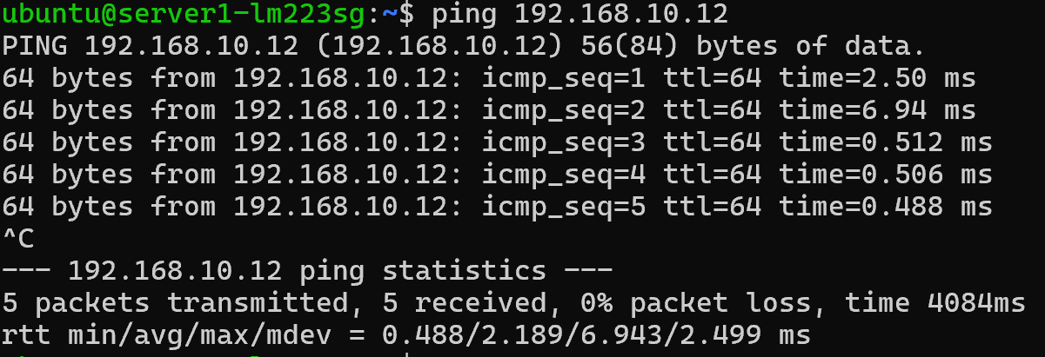
Figure 1: Client terminal showing the initial ping execution with successful responses, 0% packet loss, and the explicit round-trip time (RTT) metrics.

b) Directional ICMP Control (Manual / Stateless Filtering)
To block inbound pings without connection tracking parameters, a manual stateless drop rule was enforced directly on the server's input stream:
sudo iptables -A INPUT -p icmp --icmp-type echo-request -j DROP

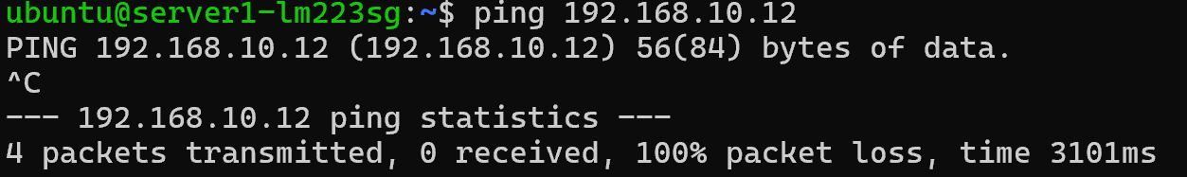
Figure 2: Network behavior showing a 100% packet loss statistic on the client terminal after applying the stateless DROP rule on the server.
To restore connectivity and ensure strict bidirectional communication manually, the blocking rule was purged and explicit rules were assigned for both request and reply paths:
sudo iptables -A INPUT -p icmp --icmp-type echo-request -j ACCEPT
sudo iptables -A OUTPUT -p icmp --icmp-type echo-reply -j ACCEPT
sudo iptables -A OUTPUT -p icmp --icmp-type echo-request -j ACCEPT
sudo iptables -A INPUT -p icmp --icmp-type echo-reply -j ACCEPT

c) Other ICMP Message Types
In production networks, alternative ICMP control subtypes are essential for network diagnostics and error reporting:
Destination Unreachable (Type 3): Used by routers or hosts to inform the sender that a destination network, host, or port cannot be reached.
sudo iptables -A INPUT -p icmp --icmp-type destination-unreachable -j ACCEPT

Time Exceeded (Type 11): Vital for diagnostic tools like traceroute to identify when a packet's Time-To-Live (TTL) counter drops to zero during transit.
sudo iptables -A INPUT -p icmp --icmp-type time-exceeded -j ACCEPT

2. FTP Client

a) Multi-Channel TCP Handling
The File Transfer Protocol (FTP) separates its operations into two distinct connection channels: the Command/Control Channel (Port 21) for authentication and instructions, and the Data Channel (Port 20 or dynamic high ports) for directory lists and file transfers.
Without stateful awareness, a stateless firewall evaluates these sessions as entirely unrelated streams. Consequently, unlocking port 21 allows a user to log in but freezes execution during file retrieval unless explicit independent rules are crafted for the subsequent data flow.

b) Stateless Ruleset for Passive Mode (Client Focus)
In Passive Mode, the client drives data initialization by launching an outbound socket toward a randomized high port broadcasted by the server. The passive port selection was restricted on the server to a deterministic range of 40000:40010.
sudo iptables -A OUTPUT -p tcp --dport 21 -j ACCEPT
sudo iptables -A INPUT -p tcp --sport 21 -j ACCEPT
sudo iptables -A OUTPUT -p tcp --dport 40000:40010 -j ACCEPT
sudo iptables -A INPUT -p tcp --sport 40000:40010 -j ACCEPT

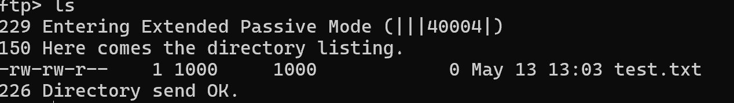
Figure 3: Client-side FTP session output showing a successful ls directory listing after entering Extended Passive Mode over an allocated port within the specified range.

c) Stateless Ruleset for Active Mode (Client Focus)
In Active Mode, the client turns off passive mechanisms and sends its listening parameters to the backend. The server then takes the initiative, establishing an inbound connection from its local port 20 back to the client's listening socket.
sudo iptables -A INPUT -p tcp --sport 20 -j ACCEPT
sudo iptables -A OUTPUT -p tcp --dport 20 -j ACCEPT

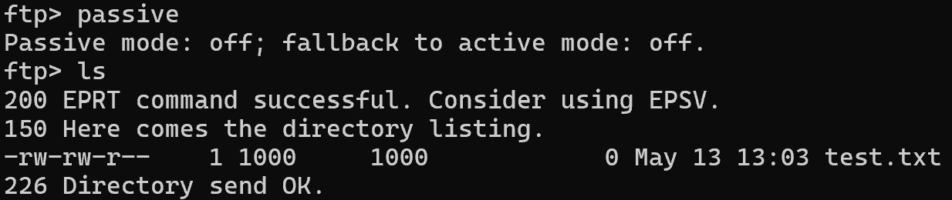
Figure 4: Client terminal showing the active mode state ("Passive mode: off") and a completed data transfer using the active EPRT command structure.

3. FTP Server

a) Server Infrastructure Requirements
To cleanly route traffic across the subnet, the parameters in /etc/vsftpd.conf were aligned to define explicit port limits:
pasv_enable=YES
pasv_min_port=40000
pasv_max_port=40010

b) & c) Server Rulesets for Passive and Active Modes (Manual)
The server ruleset must accommodate command inputs on port 21, dynamic passive ingress ports, and outbound active data triggers from port 20.
sudo iptables -A INPUT -p tcp --dport 21 -j ACCEPT
sudo iptables -A OUTPUT -p tcp --sport 21 -j ACCEPT
sudo iptables -A INPUT -p tcp --dport 40000:40010 -j ACCEPT
sudo iptables -A OUTPUT -p tcp --sport 40000:40010 -j ACCEPT
sudo iptables -A OUTPUT -p tcp --sport 20 -j ACCEPT
sudo iptables -A INPUT -p tcp --dport 20 -j ACCEPT

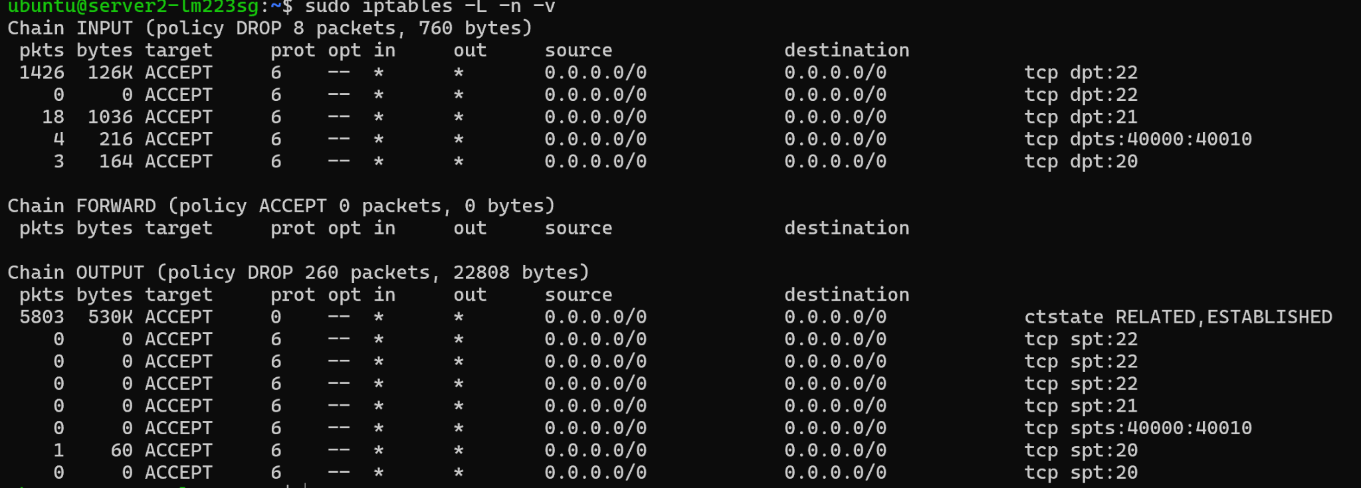

Figure 5: Inspection of the server filtering chains via sudo iptables -L -n -v, demonstrating active packet counters matching traffic across control port 21, active data port 20, and the passive port allocation range.

4. Firewall Filtering – Part 1

a) Blacklisting at the Destination Perimeter
A targeted drop rule was introduced to isolate the client machine:
sudo iptables -A INPUT -s 192.168.10.11 -j DROP
Strategic Placement Analysis: This filtering belongs on the Server side. Although blocking traffic at the client stops unauthorized packets from entering the wire, filtering at the server ensures robust application endpoint protection, safeguarding the service regardless of the client’s internal configuration state.

b) Targeted ICMP Restoration
By using high-priority inserts (-I), ICMP communication was safely carved out over the active blacklist rule without disabling the global block:
sudo iptables -I INPUT -s 192.168.10.11 -p icmp -j ACCEPT

c) & d) Isolated Data Channel Tests
Testing network states by opening only data ports (40000-40010 or 20) while keeping control port 21 closed resulted in total application failure during login attempts. This scenario highlights FTP's unique nature: without a functional command layer, endpoints cannot execute handshakes, verify permissions, or agree on operational parameters.

e) Core Architectural Differences
- Passive Integration: Requires provisioning ingress rules (INPUT) on the server to absorb inbound data links established dynamically by the remote host.
- Active Integration: Forces the server to build an outbound connection, relying entirely on egress authorization (OUTPUT) to exit port 20 toward the client.

5. Firewall Filtering – Part 2
Instead of managing complex blacklists, a rigid Whitelisting Strategy was engineered by modifying the global default policies to block all unrecognized packets.
sudo iptables -P INPUT DROP
sudo iptables -P OUTPUT DROP
sudo iptables -A INPUT -p tcp --dport 22 -j ACCEPT
sudo iptables -A OUTPUT -p tcp --sport 22 -j ACCEPT

a) & b) Whitelisted Rulesets for Passive and Active Modes
Access permissions are isolated down to the authenticated client IP, preventing unauthorized network entities from interacting with open backend sockets:
sudo iptables -A INPUT -s 192.168.10.11 -p tcp --dport 21 -j ACCEPT
sudo iptables -A OUTPUT -d 192.168.10.11 -p tcp --sport 21 -j ACCEPT
sudo iptables -A INPUT -s 192.168.10.11 -p tcp --dport 40000:40010 -j ACCEPT
sudo iptables -A OUTPUT -d 192.168.10.11 -p tcp --sport 40000:40010 -j ACCEPT
sudo iptables -A OUTPUT -d 192.168.10.11 -p tcp --sport 20 -j ACCEPT
sudo iptables -A INPUT -s 192.168.10.11 -p tcp --dport 20 -j ACCEPT

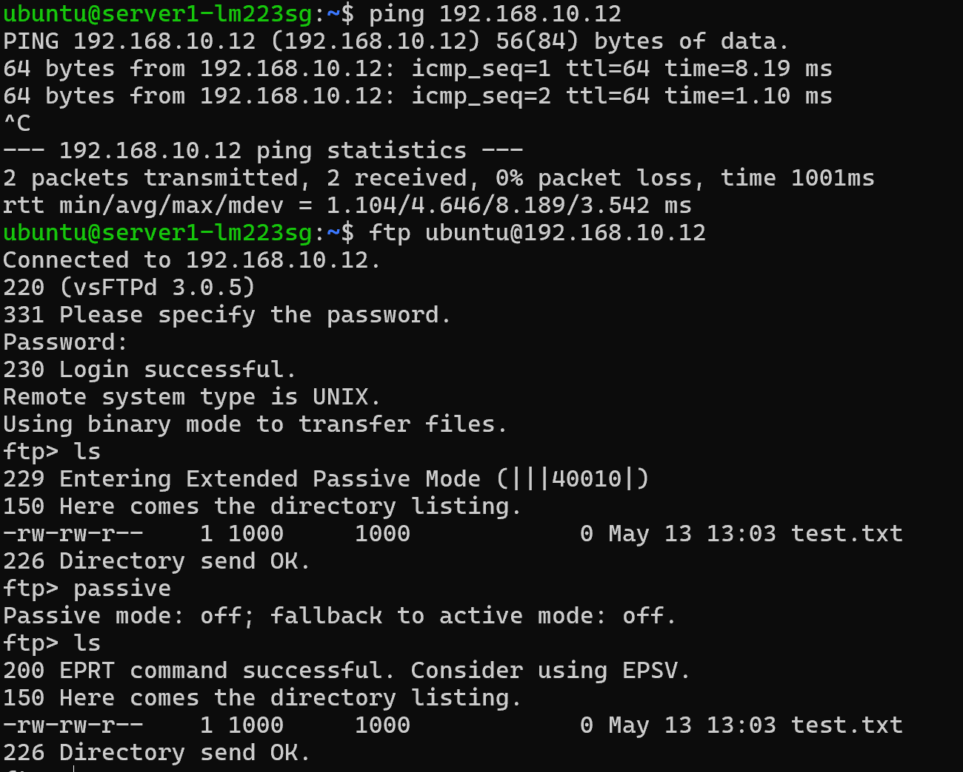


Figure 6: View of the INPUT filtering chain layout showcasing exclusive access permissions assigned explicitly to source IP 192.168.10.11 while dropping remaining ambient traffic.

6. Stateful Filtering
To complete the experiments, manual stateless mechanics were replaced with a Stateful Inspection Strategy utilizing the Netfilter conntrack subsystem.
sudo iptables -A INPUT -m conntrack --ctstate ESTABLISHED,RELATED -j ACCEPT
sudo iptables -A OUTPUT -m conntrack --ctstate ESTABLISHED,RELATED -j ACCEPT
sudo iptables -A INPUT -p tcp --dport 22 -m conntrack --ctstate NEW -j ACCEPT
sudo iptables -A INPUT -p tcp --dport 21 -m conntrack --ctstate NEW -j ACCEPT
sudo iptables -A INPUT -p tcp --dport 40000:40010 -m conntrack --ctstate NEW -j ACCEPT # NOT NECESSARY


Operational Paradigm & Comparative Evaluation
Transitioning into a stateful architecture yields substantial real-world improvements over manual approaches:
- Rule Simplification: Explicit outbound OUTPUT rules for specific services are completely eliminated. Once an incoming handshake is authorized via NEW, all return packets are handled automatically by the top-level ESTABLISHED tracking rule.
- Protocol Intelligence via RELATED: The state tracking module actively monitors the command stream on port 21. When a passive data channel transition is negotiated, the engine dynamically marks the newly requested dynamic socket connection as RELATED. This enables secure data transfers without permanently exposing open port ranges to arbitrary or untrusted network traffic.
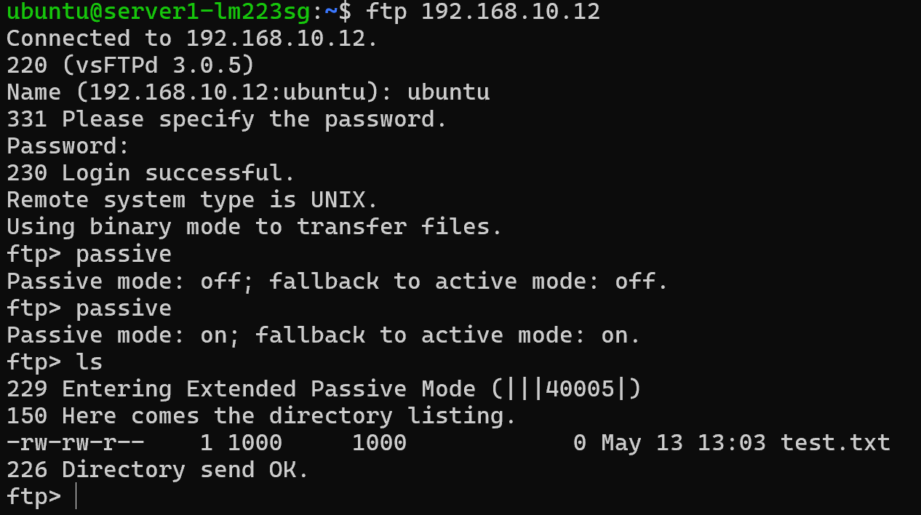
Figure 7: Verification layout displaying an active, stateful-tracked FTP connection logging in and performing a directory listing while utilizing the core ESTABLISHED,RELATED rule framework.

Intrusion Detection/Prevention Systems

1. Taxonomy of IDS/IPS
Intrusion Detection Systems (IDS) and Intrusion Prevention Systems (IPS) can be classified along two main axes: deployment location and detection method.
By deployment location:
- NIDS/NIPS (Network-based): monitors traffic at a network level, typically at chokepoints like routers or firewalls.
- HIDS/HIPS (Host-based): runs on individual endpoints, monitoring system calls, logs, and file integrity.
- Hybrid: combines both approaches for broader coverage.
By detection method:
- Signature-based (misuse detection): compares activity against known attack patterns.
- Anomaly-based: builds a baseline of normal behavior and flags deviations.
- Stateful protocol analysis: checks traffic conformance against expected protocol states.
An IDS only detects and alerts, while an IPS sits inline and can actively block or modify malicious traffic.
Well-known Methods
Log Monitoring is among the simplest forms of intrusion detection. System and application logs are parsed to identify suspicious entries — failed logins, privilege escalations, or unexpected service starts. Tools like syslog, auditd, or SIEM platforms (e.g., Splunk) automate this. It is a form of HIDS, relying on signature/rule matching against log patterns.
Signature-based detection (e.g., Snort, Suricata) matches network packets or host events against a database of known attack signatures. It is highly accurate for known threats but blind to zero-days. Belongs to both NIDS and HIDS categories.
Anomaly-based detection (e.g., machine learning models, statistical profiling) learns normal behavior and raises alerts on deviations — unusual traffic volumes, rare port usage, or atypical user behavior. More capable against novel attacks but prone to false positives. Found in both NIDS and HIDS.
Stateful protocol inspection tracks the state of network connections and validates that each packet matches the expected protocol behavior (e.g., a TCP handshake must complete before data flows). It is a NIDS/NIPS technique, effective against protocol abuse attacks.
Extrusion Detection
While traditional IDS focuses on intrusion — threats entering the network — Extrusion Detection focuses on data leaving the network without authorization. It aims to detect insider threats, data exfiltration by malware, or compromised hosts beaconing to command-and-control (C2) servers. Techniques include monitoring outbound traffic for unusual volumes, unexpected destinations, sensitive data patterns (e.g., credit card numbers via DLP), or anomalous DNS queries. It is typically implemented at the network perimeter as a NIDS/NIPS component, and complements traditional intrusion detection to form a full-spectrum monitoring posture.

2. Suricata Rule Analysis
alert tcp any any -> any ![20,21] (msg:"This should not happen!"; flow:to_server; app-layer-protocol:ftp; sid:2271004; rev:1;)
Purpose: Alerts when FTP application-layer traffic is detected on any port except 20/21. Legitimate FTP must use those ports, so this catches tunneling or evasion attempts.
- alert tcp – generate an alert on TCP traffic
- any any -> any ![20,21] – from any source to any destination port except 20 and 21 (! = negation)
- msg – human-readable label logged with the alert
- flow:to_server – only matches client→server direction
- app-layer-protocol:ftp – only fires if deep packet inspection identifies the payload as FTP
- sid:2271004; rev:1 – unique rule ID, revision 1
alert tcp any any -> any [20,21] (msg:"This should not happen!"; flow:to_server; app-layer-protocol:!ftp; sid:2271005; rev:1;)
Purpose: The mirror of Rule 1 — alerts when traffic to ports 20/21 is not FTP at the application layer. This detects non-FTP protocols tunneled through standard FTP ports to evade firewalls.
The keywords are identical to Rule 1 except:
- any [20,21] – destination is now only ports 20 or 21
- app-layer-protocol:!ftp – fires when the payload is anything but FTP
Together, these rules enforce the invariant: FTP must use ports 20/21, and ports 20/21 must carry FTP. Any violation suggests tunneling or C2 evasion.

Bibliography

[1] NIST, "Guide to Intrusion Detection and Prevention Systems (IDPS)", National Institute of Standards and Technology, Special Publication 800-94, url: https://csrc.nist.gov/pubs/sp/800/94/final

[2] Open Information Security Foundation, "Suricata User Guide - Rules Format", url: https://docs.suricata.io/en/latest/rules/intro.html

[3] Netfilter Organization, "Iptables(8) - Linux Man Page", url: https://linux.die.net/man/8/iptables

[4] J. Postel, J. Reynolds, "File Transfer Protocol (FTP)", IETF RFC 959, 1985, url: https://datatracker.ietf.org/doc/html/rfc959

[5] Pablo Neira Ayuso, "The Netfilter Connection Tracking System", 2006, url: https://www.netfilter.org/documentation/papers/networking-forum-2006.pdf

[6] Red Hat Enterprise Linux, "Securing Networks with Iptables and Connection Tracking", url: https://access.redhat.com/documentation/

