Assignment 1
1st level decomposition
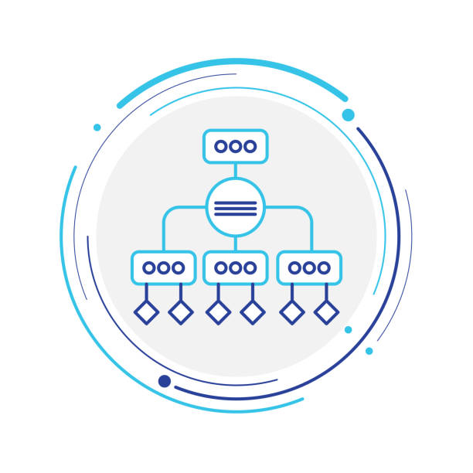
Luis Eduardo Martín Hernández lm223sg@student.lnu.se

10/02/2026

Index

Task 1. 2
List of Capabilities 2
List of Components 3
A. Product Catalog & Inventory 3
B. User Management 3
C. Sales Management 3
D. Technical Services 3
E. Order Management 3
F. Supply Chain 3
G. Performance data management 4
Task 2. 5
Product Catalog & Inventory → Sales Management, Supply Chain Management 5
User Management → Sales Management, Technical Services, Performance Data Management 5
Technical Services → Order Management 5
Sales Management → Order Management 6
Order Management → User Management 6
Order Management → Performance Data Management 6
Supply Chain Management → Product Catalog & Inventory 7
Task 3. 8
Task 4. 9
1. Deployment targets 9
2. Software deployed on each node 9
3. Communication between units 10
4. External services and dependencies 10
Task 5 11
References 12
Modeling Tools 12
Documentation and Standards 12

Task 1.
Focus on the functionalities/capabilities in the system description. Which functional components, cohesive modules with closely related responsibilities, can you identify? What responsibilities does each component have? Answer in text with component name and description of responsibilities. You may also use CRC-cards in the process and as a means of documentation.

List of Capabilities
- Browse products and services: Allow users to view the available offerings.
- Search/Filter IT products: Find items by brand, model, price, and condition.
- Maintain product catalog: Add/Edit/Remove.
- Track inventory levels: Monitor current stock.
- Identify User Roles: Distinguish between Customer, Employee, and Manager.
- Manage Profiles: Create/Modify user profiles and store information about them
- Browse and Discover Offerings: Allow customers to browse and search available products and services.
- Manage Orders: Create, update, and track customer orders throughout their lifecycle.
- Manage Service Appointments: Schedule, track, and complete IT service jobs such as repairs or configuration.
- Retrieve Order History: Provide a searchable record of past transactions for users.
- Store Supplier Information: Maintain a database of external vendors and their contact details.
- Manage Purchase Orders: Create and track requests sent to suppliers for restocking inventory.
- Monitor Supplier Status: Track the reliability and delivery timelines of external vendors.
- Generate Sales & Revenue Reports: Create performance summaries for management.
- Generate Inventory Reports: Create summaries of stock levels and turnover.
- Analyze Customer Trends: Use order data to identify purchasing patterns for business decisions.

List of Components

A. Product Catalog & Inventory
Capabilities: 1, 2, 3, 4
Responsibilities: This component is responsible for maintaining the shop’s product information and stock status. It manages the IT product catalog, including adding, updating, and removing products, as well as tracking inventory levels. It also provides functionality for browsing and searching products based on attributes such as brand, model, price, and condition.

B. User Management
Capabilities: 5, 6
Responsibilities: This component manages user identities, profiles, and roles within the system. It supports the creation and modification of customer and employee profiles and distinguishes between different user roles such as Customer, Employee, and Manager.

C. Sales Management
Capabilities: 7
Responsibilities: This component is responsible for presenting products and services to customers in a commercial context. It supports browsing and discovery of offerings and defines how products and services are exposed to customers through the system.

D. Technical Services
Capabilities: 8
Responsibilities: This component manages IT-related service offerings, including scheduling, tracking, and completion of service appointments such as repairs, system configuration, and technical support.

E. Order Management
Capabilities: 9, 10
Responsibilities: This component handles the creation, tracking, and lifecycle management of customer orders. It records orders for both products and services and provides access to order history for customers and employees.

F. Supply Chain
Capabilities: 11, 12, 13
Responsibilities: This component manages supplier-related information and procurement processes. It maintains supplier records, handles purchase orders for restocking products, and monitors supplier reliability and delivery status.

G. Performance data management
Capabilities: 14, 15, 16
Responsibilities: This component generates analytical and summary reports related to sales, inventory, and customer behavior. It supports management decision-making by producing sales and revenue reports, inventory summaries, and analyses of customer purchasing trends.

Task 2.
Analyze the dependencies between components, that is, the collaboration in CRCcards. What functions or information does each component need from other components in order to fulfill its allocated responsibilities?

Product Catalog & Inventory → Sales Management, Supply Chain Management
Provides:
- Product information
- Inventory availability and stock levels
Requires:
- Up-to-date product availability
Justification:
Sales Management requires access to product and availability information in order to correctly present offerings to customers. Supply Chain Management depends on inventory data to determine when restocking is needed and to manage procurement decisions. Product Catalog & Inventory acts as the single source of truth for product and stock data.

User Management → Sales Management, Technical Services, Performance Data Management
Provides:
- User identity
- User roles and profile information
Requires:
- Authorization and role-based user context
Justification:
Several components depend on user roles and identities to adapt their behavior. Sales Management uses role information to control access to customer-facing functionality. Technical Services requires employee information for service assignment. Performance Data Management uses user-related data to analyze customer behavior and usage patterns. User Management centralizes responsibility for user identities and permissions.

Technical Services → Order Management
Provides:
- Service appointment status
- Service execution information
Requires:
- Service-related order data
Justification:
Order Management must track both product sales and service-based orders. Technical Services provides information about scheduled and completed service appointments so that Order Management can maintain a consistent view of order status throughout its lifecycle.

Sales Management → Order Management
Provides:
- Selected products and services
Requires:
- Customer purchase selections
Justification:
Sales Management handles customer interaction and selection of products and services. Once a customer confirms a purchase, this information is passed to Order Management, which is responsible for creating and tracking the corresponding order. This separation keeps customer interaction logic distinct from order lifecycle management.

Order Management → User Management
Provides:
- Order history linked to users
Requires:
- User identity information
Justification:
Order Management associates orders with specific users and provides order history functionality. User Management supplies authoritative user identity information, while Order Management owns the order data itself. This collaboration enables retrieval of purchase history without duplicating user information.

Order Management → Performance Data Management
Provides:
- Sales and order data
- Service transaction records
Requires (by receiver):
- Historical order and transaction data
Justification:
Performance Data Management depends on accurate and complete order data to generate reports related to sales performance, revenue, and customer trends. Order Management acts as the primary source of transactional data for analytical and reporting purposes.

Supply Chain Management → Product Catalog & Inventory
Provides:
- Inventory updates based on purchase orders and deliveries
Requires (by receiver):
- Stock level updates
Justification:
When new products are procured and delivered, Supply Chain Management updates inventory levels. Product Catalog & Inventory reflects these changes to ensure that stock availability is accurate and consistent across the system.

Task 3.
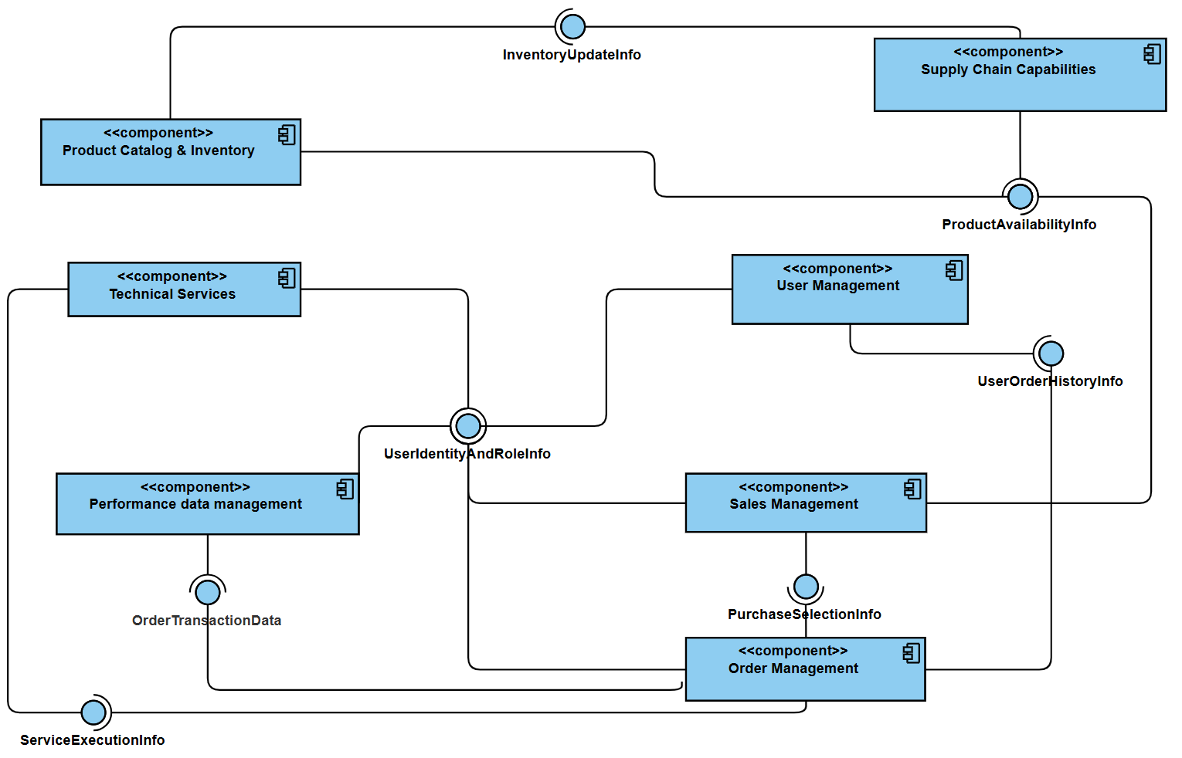
Draw a UML component diagram with the components you have identified, connect the components interfaces (use lollipop for provide-require interfaces). Make sure that your model is complete, that is, all required interfaces are provided.

Task 4.
Focus on the physical architecture (system architecture). List and briefly explain:
1. The deployment targets, that is devices or nodes.
2. The software that runs on each unit
3. How the different units communicate with each other
4. Any external services the system depends on

1. Deployment targets
The EasyShop system is deployed across the following main nodes:
- Client Devices
These include customer and employee devices such as desktop computers, laptops, or tablets running a web browser. Customers use these devices to browse products and services, place orders, and view order history, while employees and managers use them to manage products, orders, services, and reports.
- Application Server
This node hosts the core application logic of EasyShop. It executes the system’s business components and coordinates interactions between users, data storage, and external systems.
- Database Server
This node is responsible for persistent data storage. It stores all business data related to products, users, orders, services, suppliers, and performance data.
- External Supplier Systems (optional)
These represent external systems operated by suppliers that may provide inventory or delivery-related information used by the Supply Chain Management component.

2. Software deployed on each node
- Client Devices
  - EasyShop Web Interface (frontend application)
  - Provides user interaction for customers, employees, and managers
- Application Server
  - Product Catalog & Inventory
  - User Management
  - Sales Management
  - Order Management
  - Technical Services
  - Supply Chain Management
  - Performance Data Management
These components implement the system’s business logic and collaborate through well-defined interfaces as described in Tasks 2 and 3.
- Database Server
  - Product data storage
  - User and profile data storage
  - Order and order history data storage
  - Reporting and analytical data
The database server provides persistent storage but does not contain business logic.
- External Supplier Systems
  - Supplier inventory and delivery services exposed via APIs

3. Communication between units
- Client Devices ↔ Application Server
Communication takes place over standard web protocols (HTTP/HTTPS). Client devices send requests to the application server to browse products, place orders, manage services, and retrieve reports.
- Application Server ↔ Database Server
The application server communicates with the database server over an internal network using database-specific protocols (TCP/IP). This communication is not exposed externally and is used for data persistence and retrieval.
- Application Server ↔ External Supplier Systems
Communication with supplier systems occurs through API-based integration. This enables the Supply Chain Management component to exchange information related to purchase orders, deliveries, and inventory updates.

4. External services and dependencies
The EasyShop system may depend on external supplier systems to support inventory replenishment and supplier coordination. These external services are accessed via defined interfaces and are isolated from the core system to reduce coupling and allow future changes or replacements without affecting internal components.

Task 5
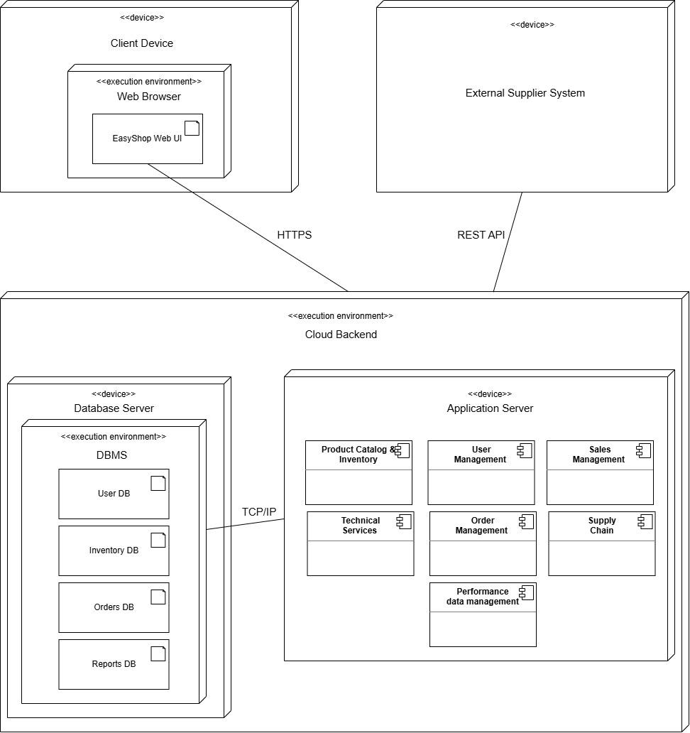
Draw a UML deployment diagram that illustrates the physical architecture described in Task 4. Show how software components are deployed on different units in the diagram.

References

Modeling Tools
- Diagrams.net (formerly Draw.io): Online diagramming software used for creating the UML Component and Deployment diagrams.
- UMLet: A free, open-source UML tool with a simple user interface, used for rapid conceptual modeling.

Documentation and Standards
- UML-Diagrams.org: A comprehensive online resource and reference guide for the Unified Modeling Language (UML) standards and notation.
- Linnaeus University Course Material: Software Architecture (2DV604) compendium and exercise solutions by Jesper Andersson and Farid Edrisi.

