RDB2RDFmb: Designing Customized RDB-to-RDF Mappings
Luís Eufrasio T. Neto¹, Vânia Maria P. Vidal¹, Marco A. Casanova², José Maria Monteiro¹
¹ Federal University of Ceará, Fortaleza, CE, Brazil
{vaniap.vidal, luis.eufrasio, jmmfilho}@gmail.com
² Department of Informatics – Pontifical Catholic University of Rio de Janeiro, RJ, Brazil
casanova@inf.puc-rio.br
Abstract. A novel approach is demonstrated that allows relational database schemas to be easily mapped to ontology schemas. Using RDB2RDFmb, naive users with no knowledge of RDB-to-RDF mapping languages (such as R2RML) and SQL can create customized mappings between heterogeneous schemas. This is accomplished by a novel RDB-to-RDF Mapping by Assertions approach where a designer can match correspondent terms of the schemas in an intuitive and user-friendly way and RDB2RDFmb generates all correspondence assertions (CA). In fact, the set of CA defines a semantic mapping that can be automatically converted to a R2RML mapping using RDB2RDFmb. Optionally, the triples resulting from the mapping can be published into a local endpoint SPARQL using an embedded D2RQ Server extension.
Keywords: Linked Data, RDB-to-RDF user interface, R2RML mappings.
- Introduction
The Linked Data initiative [2] promotes the publication of previously isolated databases as interlinked RDF triple sets, thereby creating a global scale data space, known as the Web of Data. However, the full potential of linked data depends on how easy it is to transform data stored in conventional, relational databases (RDB) into RDF triples. This process is often called RDB-to-RDF [12].
There are two main approaches for mapping RDB to RDF: direct mapping and customized mapping. The Direct mapping approach relies on automatic methods that derive ontology from a relational schema and transform data according to that schema. The customized mapping approach lets an expert create a mapping between the relational schema and an existing target ontology that is used to make the transformation into RDF.
In fact, quite a few tools that support customized mapping have been developed, such as Triplify [1], D2R Server [3, 4], and OpenLink Virtuoso [9, 10]. Early surveys of RDB-to-RDF tools [12, 14] pointed out that the tools typically adopt different and proprietary mapping languages for the mapping process and do not provide a way to easily generate customized mappings between a RDB schema and a given domain ontology.
Recently, the W3C RDB2RDF Working Group proposed a standard mapping language, called R2RML [8], to express RDB-to-RDF mappings. However, R2RML is somewhat difficult to use, which calls for the development of tools to support the definition and deployment of mappings using R2RML. This is where the current paper steps in. First, we demonstrate the use of correspondence assertions [15] for specifying the semantic mapping between a target vocabulary and a base RDB schema. Then, we execute algorithms that automatically generate R2RML mappings based on a set of correspondence assertions. We provide a demo tool that let users run these two steps in an intuitive and user-friendly way.
- Correspondence Assertions
The proposed demo uses correspondence assertions (CA) for specifying the mapping between target ontology schema and a source relational schema.
A correspondence assertion can be: (i) a class correspondence assertion (CCA), which matches a class and a relation schema; (ii) an object property correspondence assertion (OCA), which matches an object property with attributes or paths of a relation schema; or (iii) a datatype property correspondence assertion (DCA), which matches a datatype property with attributes or paths of a relation schema.
In what follows, let O=(V,Σ) be an ontology and S=(R,Ω) be a relational schema.
Definition 2.1: A class correspondence assertion (CCA) is an expression of one of following forms:
- Ψ: C ≡ R[A₁,...,A_{n}]
- Ψ: C ≡ R[A₁,...,A_{n}]σ
where Ψ is the name of the CCA, C is class of V, R is a relation name of S, A₁,...,A_{n} are attributes of R, and σ is a selection over R. We also say that Ψ matches C with R.
Definition 2.2: An object property correspondence assertion (OCA) is an expression of one of following forms:
- Ψ: O ≡ R / ϕ
- Ψ: O ≡ R / NULL
where Ψ is the name of the OCA, O is an object property of V, R is a relation name of S and ϕ is a path of R. We also say that Ψ matches O with R.
Definition 2.3: A datatype property correspondence assertion (DCA) is an expression of one of following forms:
- Ψ: P ≡ R / A
- Ψ: P ≡ R / {A₁,...,A_{n}}
- Ψ: P ≡ R / ϕ / B
- Ψ: P ≡ R / ϕ / {B₁,...,B_{n}}
where Ψ is the name of the DCA, P is a datatype property of V, R is a relation name of S, A is an attribute of R, A₁,...,A_{n} are attributes of R, ϕ is a path from R to R’, B is an attribute of R’, and B₁,...,B_{n} are attributes of R’. We also say that Ψ matches P with R.
Definition 2.4: A mapping between V and S is a set M of correspondence assertions such that:
- If M has a DCA of the form P ≡ R /ε, then M has a CCA that matches the domain of P with R;
- If M has an OCA of the form P ≡ R /ϕ, where ϕ is a path from R to R’, then M has a CCA that matches the domain of P with R, and a CCA that matches the range of P with R’.
- RDB2RDF Mapping Builder
RDB2RDFmb is a system for creation of RDB-to-RDF customized mappings. This system implements the Mapping by Assertions approach by (1) designing correspondence assertions (CAs), and (2) translating CAs into an R2RML mapping. Optionally, the result of the mapping can be published in a form of an endpoint SPARQL (3). As shown in Fig. 1, these three functions are implemented by the User Interface module (UI), the R2RML Gen module (r2rmlGEN) and the Publisher Manager module (PM).
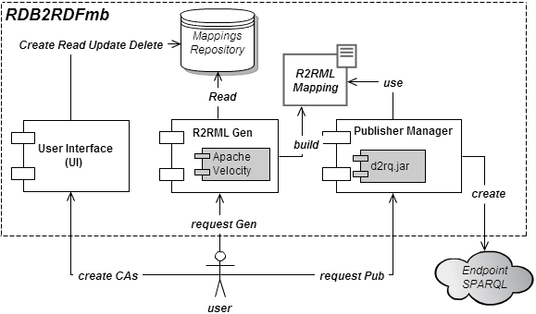
Fig. 1. RDB2RDFmb Architecture
  - The User Interface (UI)
First of all, the user defines a configuration mapping where target ontology schema and source relational database schema are chosen. This is a basic feature of UI. The assigned ontology schema can be an URL typed by the user or a local file path picked in the user’s computer/network. For source database schema, the user enters the connection parameters: URL, JDBC Driver, User and Password. The UI saves the two schemas into the mapping repository as a mapping configuration entity.
All configurations in the repository are showed by the UI in a table view descendent ordered by the creation date. When the user chooses a configuration, the UI loads its schemas into two Tree Views. Using these trees, it is possible to create associations between the vocabulary terms of the target ontology (classes, datatype properties, object properties) and the source relational concepts (tables, primary keys, attributes, foreign keys).
The associations created by the user are automatically converted to correspondence assertions and the user must save one by one in the List View component. The list of assertions is also persisted into the repository and can be retrieved by the r2rmlGEN module at a later time and translated to R2RML mapping.
  - The R2RML Mapping Generator
The correspondence assertions created are handled by r2rmlGen when the user requests the generation of the R2RML mapping. In order to translate correspondence assertions to R2RML mappings, a subject map should be defined for each CCA, a predicate object map for each DCA, and a predicate object map for each OCA with the appropriate join condition [8]. These elements of the R2RML language are combined to make up the triples maps.
Table 1. R2RML basic mapping templates
Subject Map | <#TriplesMap${className}>  rr:logicalTable [ rr:tableName "${table}" ];  rr:subjectMap [  rr:template "${classUri}/  #foreach ( $att in $atts ) {$att}/#end";  rr:class ${prefixClass}:${className};  ];
Predicate Object Map | rr:predicateObjectMap [  rr:predicate ${prefix}:${propertyName};  rr:objectMap [  #if ( ${type} == 1 )  #parse ( "datatypeMap.vm" ) ];  #else  #parse ( "objectMap.vm" ) ];  #end  ];
Datatype Map | rr:column "${columnName}"
Object Map | rr:parentTriplesMap <#TriplesMap${rangeClass}>;  #foreach ( $pair in $pairs )  rr:joinCondition [  rr:child "$pair.child";  rr:parent "$pair.parent";  ]; #end
The translation is accomplished by applying customized R2RML templates for each type of CA. As can be seen in Fig. 1, this module includes Apache Velocity as an embedded component. Velocity is used for applying templates to generate the R2RML triples map elements. Table 1 shows the templates addressed for the mapping generation task. Elements in bold are parameters whose values are extracted from a CA and passed to velocity component. For instance, the Subject Map template has the following parameters: the class name (${className}), the table name (${table}), the class base URI (${classUri}), a list of attributes (${atts}) to compose the complete class URI and the prefix class (${prefixClass}).
In order to make the transformation feasible, r2rmlGen creates a hierarchy between the CAs. CCAs are at the top of this hierarchy and DCAs and OCAs has a parent CCA associated like a tree structure. All CCAs are in first level of the tree and all DCAs/OCAs are in the second level linked to its parent CCA. This makes the transformation an easy task: the tree is traversed from top to bottom applying appropriate templates for each CCA node and its children what creates, in this way, a subject map and one or more predicate object map.
However, this task is not easy in two special cases. As seen on Section 2, DCAs and OCAs may reference foreign key (fk) paths. In case of a DCA referencing an fk path, it is not possible to use the templates Predicate Object Map and Datatype Map showed in Table 1. Because in this particular case it is necessary to create joins between tables in the fk path. The same problem occurs in case of an OCA whose fk path size is greater than one. The Object Map template in Table 1 creates join conditions for each column pair for one fk. R2RML language does not support the mapping of fk paths with more than one fk using just join conditions. Instead, it supports the use of Views. Thus, in these two cases r2rmlGen will create a SQL view to make the mapping generation achievable.
Table 2. R2RML DatatypeFkPath mapping template
Datatype Key Path Map | <#TriplesMap${propertyName}View>  rr:logicalTable [ rr:sqlQuery """  SELECT  #foreach ( $att in $subjectAtts )  ${childTable}.$att  #end  #foreach ( $att in $atts )  ${parentTable}.$att  #end  FROM  #foreach ( $table in $tables )  $table  #end  WHERE  #foreach ( $pair in $pairs )  ${pair.childTable}.${pair.child} =  ${pair.parentTable}.${pair.parent}  #end  """ ];  rr:subjectMap [  rr:template "${domainClassUri}/  #foreach ( $att in $subjectAtts)  {$att}/  #end";  ];  rr:predicateObjectMap [  rr:predicate ${prefix}:${propertyName};  rr:objectMap [  rr:template "  #foreach ( $att in $atts )  {$att}  #end";  rr:termType rr:Literal;  ];  ].
Tables 2 and 3 show the templates for DCAs and OCAs with fk paths. All of them create a special TriplesMap that refers an SQL View as logical table and defines the domain class URI as subject map. The main difference is in the predicate object map: the first one includes only the range attributes projected by the view into the rr:template term, while the second defines the URI for the range class into this term. Also note that for DCAs “rr:termType rr:Literal” was included in the object map because rr:template is used for URI definition by default [8].
Table 3. R2RML ObjectFkPath mapping template
Object  Key Path  Map | <#TriplesMap${propertyName}View>  rr:logicalTable [ rr:sqlQuery """  SELECT  #foreach ( $att in $subjectAtts )  ${childTable}.$att  #end  #foreach ( $att in $objectAtts )  ${parentTable}.$att  #end  FROM  #foreach ( $table in $tables )  $table  #end  WHERE  #foreach ( $pair in $pairs )  ${pair.childTable}.${pair.child} =  ${pair.parentTable}.${pair.parent}  #end  """ ];  rr:subjectMap [  rr:template "${domainClassUri}/  #foreach ( $att in $subjectAtts)  {$att}/  #end";  ];  rr:predicateObjectMap [  rr:predicate ${prefix}:${propertyName};  rr:objectMap [  rr:template "${rangeClassUri}/  #foreach ( $att in $objectAtts )  {$att}  #end";  ];  ].

  - The Publisher Manager (PM)
After the creation of the R2RML mapping, the creator needs to test it. PM is a special module dedicated to make the test possible. It emulates the D2RQ Server [] with some customizations. As discussed before, D2RQ has its own proprietary mapping language D2RM and until this moment there is not any production version that supports R2RML. To fill this gap, we developed a customized version of D2RQ to support the main terms of R2RML and we embedded it as a component inside RDB2RDFmb.
Internally, the original D2RQ represents the terms of D2RM language as an RDF graph. For each request of a D2RM mapping publication a new graph is created according to content of the received mapping file. This graph is passed to the D2RQ Engine that uses it to answer new requests of RDF triples via SPARQL queries for instance.
The adopted strategy to implements our customized D2RQ was firstly do not change the D2RQ engine, instead the D2RM graph is constructed based on the R2RML mapping. As a new version of D2RQ that complies with the R2RML terminology is under development and the purpose of developing this module is only permit users to query the RDF triples generated by the mapping, it is rework and a waste of time to change the complex D2RQ engine.

- The Demo
On this section we demonstrate the features of RDB2RDFmb by a running example.
Consider the creation of a Mapping Configuration where user choices the well known FOAF vocabulary as target ontology and the ISWC relational database.
Using the ontology URI and database connection parameters typed by user, the application loads the schema Trees (see Figure 2). The user is able to create term matching’s.
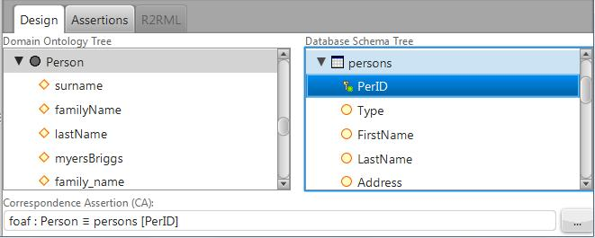
Fig. 2. Class Correspondence Assertion (CA) created matching class foaf:Person with relation persons and choosing attribute PerID to be part of class URI.
After defining a CA user must save it. When a CA is saved, the Assertions Tab is updated as visualized in Figure 3.
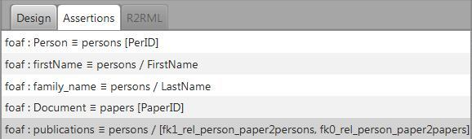
Fig. 3. Assertion Tab holds the list of assertions saved. In this example, we created two CCAs (classes Person and Document), two DCAs (datatype properties firstName and family_name) and one OCA (object property publications) that refers to an fk path.
When required, the r2rmlGen module processes the list, applying appropriate templates as explained in Section 3. Figure 4 exhibits the resulting R2RML mapping generated.
TriplesMapPerson declares the URI template for individuals of class Person and correspondent database attributes for datatype properties family_name and firstName. TriplesMapDocument declares the URI template for individuals of class Document. TriplesMapPublicationsView declares the same URI template of class Person in subject map and the same URI template of class Document in object map, but the logical table is an SQL View joining the relations persons, papers and link table rel_person_paper. This is necessary because OCA defined for object property publications refers an fk path.
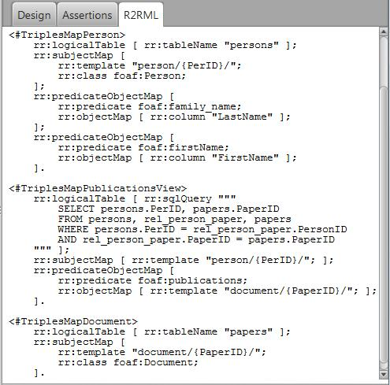
Fig. 4. The three triples map generated.
References
- Auer, S., Dietzold, S., Lehmann, J., Hellmann, S., and Aumueller, D.: Triplify - Light-Weight Linked Data Publication from Relational Databases. In Proceedings of the 18th International World Wide Web Conference (2009).
- Berners-Lee, T: Linked Data, http://www.w3.org/DesignIssues/LinkedData.html (2006).
- Bizer, C., and Cyganiak, R.: D2R Server – Publishing Relational Databases on the Semantic Web, ISWC (2006).
- Bizer, C.: D2R Map – A Database to RDF Mapping Language, World Wide Web Conference (2003).
- Casanova, M. A., Breitman, K. K., Furtado A. L., Vidal, V. M., Macedo, J. A., Gomes, R. V., Salas, P. E.: The Role of Constraints in Linked Data. OTM Conferences (2) 2011: 781-799.
- Cerbah, F.: Learning highly structured semantic repositories from relational databases. The Semantic Web: Research and Applications pp. 777–781 (2008).
- Cullot,N.,Ghawi,R.,Ye ́tongnon,K.:DB2OWL:AToolforAutomaticDatabase-to-Ontology Mapping, pp. 491–494 (2007).
- Das, S., Sundara, S., and Cyganiak, R.: R2RML: RDB to RDF Mapping Language, W3C Working Draft, http://www.w3.org/TR/r2rml/ (2012).
- Erling,O.,Mikhailov,I.:Rdfsupportinthevirtuosodbms.NetworkedKnowledge-Networked Media pp. 7–24 (2009).
- OpenLink Virtuoso. http://virtuoso.openlinksw.com
- Polfliet, S., Ichise, R.: Automated mapping generation for converting databases into linked data. Proc. of ISWC2010.
- Sahoo, S.S., Halb, W., Hellmann, S., Idehen, K., Thibodeau Jr, T., Auer, S., Sequeda, J., Ez- zat, A.: A survey of current approaches for mapping of relational databases to rdf. W3C RDB2RDF Incubator Group report (2009).
- Sequeda, J.F., Depena, R., Miranker, D.P.: Ultrawrap: Using sql views for rdb2rdf. Proc. of ISWC2009.
- Sequeda, J., Tirmizi, S., Corcho, O., Miranker, D.: DMSurvey Survey of directly mapping SQL databases to the Semantic Web (2011).
- Vidal, V. M., Araujo, V. S., Casanova, M. A.: Towards Automatic Generation of Rules for Incremental Maintenance of XML Views of Relational Data. WISE 2005: 189-202.

Velocity is a free open-source templating engine that permits the use of a simple yet powerful template language to reference objects defined in Java code. http://velocity.apache.org

