Towards Automatic Generation of R2RML Mappings

ABSTRACT
xxx
Categories and Subject Descriptors
H.2.1 [Database Management]: Logical Design – data models, normal forms, schema and subschema.
General Terms
Algorithms, Design, Experimentation, Standardization and Languages.
Keywords
RDB2RDF, Linked Data, R2RML, RDF.

INTRODUCTION
The Linked Data initiative [1] brought new opportunities for building the next generation of Web applications. Indeed, it promotes the publication of previously isolated databases as interlinked RDF triple sets, thereby creating a global-scale dataspace, known as the Web of Data. The success of the linked data initiative is partly due to the adoption of Web standards, such as URIs and HTTP, as well as Semantic Web standards, such as RDF and vocabularies. However, the full potential of linked data depends on how easy it is to transform data stored in conventional, relational databases (RDBs) into RDF triples. This process is often called RDB-to-RDF.
In fact, quite a few tools that support the RDB-to-RDF process have been developed, such as Triplify [3], D2R Server [2], and OpenLink Virtuoso. The RDB-to-RDF process can be divided into two steps: mapping generation and mapping implementation. The mapping thereby generated specifies how to represent database schema concepts in terms of RDF classes and properties. It provides the ability to view existing relational data as RDF triples, expressed in a structure and in a target vocabulary of the designer’s choice. The mapping is conceptual and enables different implementation styles. For example, it can be used to materialize the RDF view or to offer virtual access through an interface that queries the underlying database.
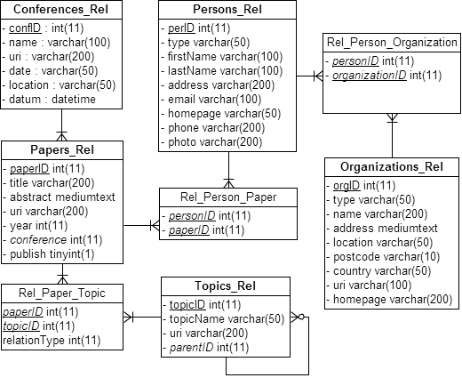
Figure 1. ISWC_REL Database Schema.
Early surveys of RDB-to-RDF tools [2, 3] pointed out that the tools typically adopt different and proprietary mapping languages for the mapping process and do not provide a way to easily generate customized mappings between a RDB schema and a given domain ontology. Recently, the W3C RDB2RDF Working Group proposed a standard mapping language, called R2RML [4], to express RDB-to-RDF mappings. However, R2RML is still somewhat difficult to use, which calls for the development of tools to support the definition and deployment of mappings using R2RML.
This paper has two major contributions. First, we propose an approach to automatically generate R2RML mappings based on a set of matching assertions which provide an intuitive way to specify mappings between relational database schemas and target ontologies (in RDF). Second, we extend the D2R Server to process R2RML mappings.
The remainder of this paper is organized as follows. Section 2 introduces the case study used throughout the paper. Section 3 presents an overview of the R2RML Mapping Language. Section 4 exposes our approach for the automatic generation of customized R2RML mappings. Section 5 proposes an extension to the D2R Server to process R2RML mappings. Section 5 contains the conclusions and directions for future work.

RUNNING EXAMPLE
In this Section, we present the relational database schema ISWC_REL and the domain ontology CONF_OWL, which are used as a case study throughout the paper. We also present a set of matching assertions which are required to begin to understand the relationship between ISWC_REL and CONF_OWL.
Relational Schema: Figure 1 depicts the database schema ISWC_REL, which represents authors and their publications, organizations which authors are affiliated to, topics referenced by publications and conferences which publications were submitted to. Each table has a distinct primary key, whose name ends with a 'ID', and which are of type integer. Tables Persons_Rel and Papers_Rel represent the main concepts. The attribute conference of table Papers_Rel is a foreign key to table Conferences_Rel. Table Rel_Person_Paper represents an N:M relationship between Persons_Rel and Papers_Rel.
Domain Ontology: Figure 2 depicts the domain ontology CONF_OWL, which reuses terms from four well-known vocabularies: FOAF (Friend of a Friend), SKOS (Knowledge Organization System) , VCARD and DC (Dublin Core). We use the prefix “conf” for the new terms defined in the CONF_OWL ontology.
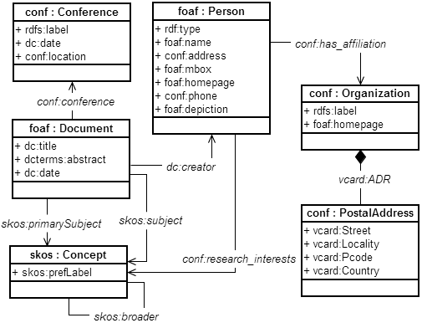Figure 2. CONF_OWL Domain Ontology.

Matching Assertions: To begin to understand the relationship between the ISWC_REL schema and CONF_OWL, we may invoke a schema matcher to generate a set of matching assertions. Alternatively, we could ask a data designer familiar with the schemas to draw arcs between elements that contain related data.
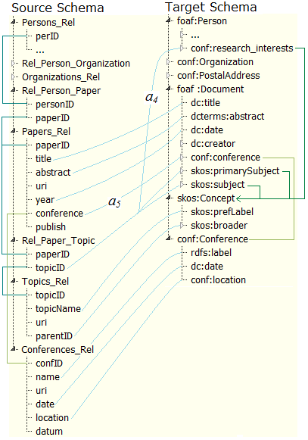Figure 4. Matching Assertions: Papers_Rel, Topics_Rel and Conferences_Rel.

Figure 3 shows a set of matching assertions from attributes of tables Persons_Rel and Organizations_Rel and Figure 4 shows a set of matching assertions from attributes of the other tables of the ISWC_Rel database. In Figure 3, assertions a₁, a₂, a₃ informally indicate:
- a₁ - column type of table Person_Rel matches the datatype property rdf:type of class foaf:Person
- a₂ - the concatenation of columns firstName and lastName matches to data property foaf:name of class foaf:Person
- a₃ - column organizationID, which is a foreign key to Organizations_Rel, matches the object property conf:has_affiliation
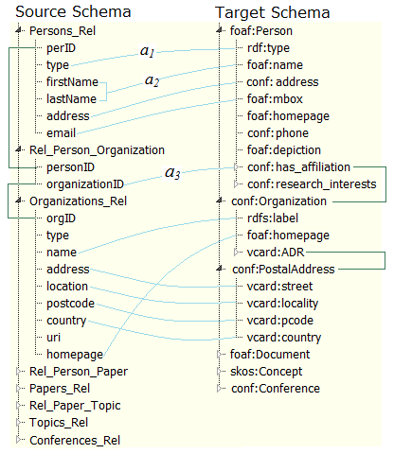Figure 3. Samples of Matching Assertions.

and, in Figure 4, assertions a₄, and a₅ informally indicate:
- a₄ - column topicID, which is a foreign key to Topics_Rel, matches the object property conf:research_interests
- a₅ - column conference that is a foreign key to Conferences_Rel matches the object property conf:Conference.
To conclude this section, we note that quite a few algorithms and tools to match database schemas and ontologies have been proposed in the literature (e.g. [31, 16]). The generation of the correspondence assertions is out of the scope of the paper.

An Overview of R2RML Mapping Language
This section briefly overviews the R2RML mapping language, followed by examples of R2RML mappings for our case study.
Table 1. Mappings for Table Persons_Rel
1 | <#PersonTriplesMap>
2 | rr:logicalTable [ rr:tableName "Persons_Rel" ];
3 | rr:subjectMap [
4 | rr:template "http://example.com/person/{perID}";
5 | rr:class foaf:Person;
6 | ];
7 | rr:predicateObjectMap [
8 | rr:predicate rdf:type;
9 | rr:objectMap [ rr:column "type" ];
10 | ];
11 | rr:predicateObjectMap [
12 | rr:predicate foaf:name;
13 | rr:objectMap [
14 | rr:template "{firstName} {lastName}"
15 | ];
16 | rr:predicateObjectMap [
17 | rr:predicate rdf:address;
18 | rr:objectMap [ rr:column "conf:address" ];
19 | ];  rr:predicateObjectMap [
20 | rr:predicate rdf:email;
21 | rr:objectMap [ rr:column "foaf:mbox" ];
22 | ];

R2RML is a language for expressing customized mappings from relational databases to RDF datasets. Such mappings provide the ability to view existing relational data in the RDF data model, expressed in a structure and in a target vocabulary of the author's choice [4].
An R2RML mapping refers to logical tables to retrieve data from the input database. A logical table can be one of the following: (i) a base table; (ii) a view; and (iii) a valid SQL query (called an “R2RML view” because it emulates an SQL view without modifying the database).
Each logical table is mapped to RDF using a triples map, which a rule to map each row in a logical table to a set of RDF triples. The rule has two main parts: a subject map and multiple predicate-object maps. The subject map generates the subject of all RDF triples that will be generated from a logical table row. The subjects are often IRIs that are generated from the primary key values. The predicate-object maps in turn consist of predicate maps and object maps (or referencing object maps). Triples are generated by combining the subject map with a predicate map or an object map, and applying these three maps to each logical table row. We note that a predicate or object mapping will be defined for each correspondence assertion (see Section 4).
Table 2. Subject map for Table Organizations_Rel
1 | <#OrgTriplesMap>
2 | rr:logicalTable [ rr:tableName "Organizations_Rel" ];
3 | rr:subjectMap [
4 | rr:template "http://example.com/org/{orgID}";
 | rr:class conf:Organization;
5 | ]  ....

The R2RML mapping in Table 1 specifies the mappings for table Persons_Rel. Each tuple in table Persons_Rel produces 5 RDF triples. Lines 3-6 declare the subject map with its IRI template and the target class Persons_Rel. Lines 7-10 declare the predicate map for the datatype property rdf:type (assertion a₁ in Figure 3). Lines 11-15 declare the predicate map for the datatype property foaf:name (assertion a₂ in Figure 3). Lines 16-18 declare the predicate map for the datatype property conf:address. Lines 17-22 declare the predicate map for the datatype property foaf:mbox.
Table 3. Mappings for Table Rel_Person_Organization
1 | <#HasAffiliationTriplesMap>
2 | rr:logicalTable [
3 | rr:tableName "Rel_Person_Organization" ];
4 | rr:subjectMap [
5 | rr:template"http://example.com/person/{perID}";  "http://example.com/person/{personID}";
6 | rr:class foaf:Person;
7 | ];
8 | rr:predicateObjectMap [
9 | rr:predicate conf:has_affiliation;
10 | rr:objectMap [
11 | rr:parentTriplesMap <#OrgTriplesMap>;
12 | rr:joinCondition [
13 | rr:child “organizationID”;
14 | rr:parent “orgID”; ]; ]; ].

Table 2 specifies the subject map for table Organizations_Rel. Table 3 specifies the subject map for table Rel_Person_Organization and the object map for the object property conf:has_affiliation (assertion a3). Table 4 specifies the subject map for table Topics_Rel.
Table 5 shows an R2RML view defined by the SQL query in lines 3-7. This RML view defines an N:M relationship between tables Person and Topics by making the joins between all the intermediary tables in WHERE clause (line 5). The object map in lines 13-16 maps tuples of the R2RML view to triples of the object property IswcResearchInterests. Note that the join condition in an objectPredicate mapping may have only one foreign key. So, in a situation where more than one foreign key is involved, the only possible solution is to create an R2RML view.

Our Strategy for R2RML Mapping Generation

Overview
In this section, we present our approach for the automatic generation of customized R2RML mappings for converting relational data to the target vocabulary of a given domain ontology.
Figure 5 illustrates the main steps of our strategy. The process inputs are:
D = (V_{D},C_{D}) - the domain ontology
S - the data source schema that must be mapped to D
A - a set of matching assertions between S and D
As shown in Figure 5, the mapping generation process consists of two main steps. The first step involves the design of the exported ontology E = (V_{E},C_{E}), which models the RDF view exported by the data source. The vocabulary V_{E} of the exported ontology is a subset of V_{D}, which can be automatically generated based on the matching assertions between the D and S [6].
The second step involves the design of: (i) a set of relational view schemas V, where V is a direct transformation for the exported ontology E; and (ii) a R2RML mapping M which maps V to E. The views schemas in V can be implemented as SQL views or R2RML views. In Section 4.2, we present an algorithm that automatically generates V and M from the process inputs.
The benefits of using relational views as a middle layer are twofold: (i) given that V is a direct transformation of E, the mapping M can be automatically generated based on V; (ii) it becomes easier to change the R2RML mappings M to accommodate changes to the database schema.
Table 4. Subject map for Table Topics_Rel
1 | <#TopicsTriplesMap>
2 | rr:logicalTable [ rr:tableName "Topics_Rel" ];
3 | rr:subjectMap [
4 | rr:template "http://example.com/topic/{topicID}";
5 | rr:class skos:Concept;
6 | ].

Table 5. iswc:research_interests Mapping
1 | <#ResearchInterestsTriplesMap>
2 | rr:logicalTable [
3 | rr:sqlQuery """
4 | SELECT  pe.perID as id,  rpt.topicID as idTopic
5 | FROM  persons_rel as pe, rel_person_paper as rpp,  papers_rel as pa, rel_paper_topic as rpt
6 | WHERE  pe.perID = rpp.personID  and rpp.paperID = pa.paperID  and pa.paperID = rpt.paperID;
7 | """.
8 | ];
9 | Rr:subjectMap [
10 | rr:template  "http://example.com/person/{id}";
11 | rr:class foaf:Person;
12 | ];
13 | rr:predicateObjectMap [
14 | rr:predicate iswc:research_interests;
15 | rr:objectMap [
16 | rr:parentTriplesMap <#TopicsTriplesMap>;
17 | rr:joinCondition [
18 | rr:child “idTopic”;
19 | rr:parent “topicID”; ]; ]; ].

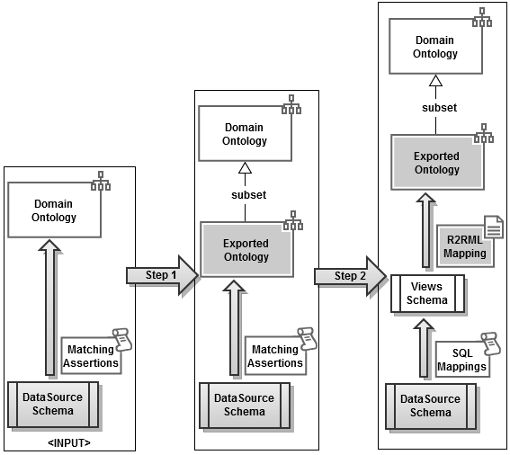Figure 5. R2RML Mapping Generation Process

Step1: Design of the Exported Ontology
The design of the exported ontology depends on what we require from the data exported by the data source. As proposed in [xx], we require the exported ontology be an open or a closed fragment of the domain ontology.
Again, let D = (V_{D},C_{D}) denote the domain ontology, and
E = (V_{E},C_{E}) denote the exported ontology.
Assume that V_{E} is a subset of V_{D}. Then, E = (V_{E},C_{E}) can be automatically generated, based on the matching assertions between the D and S [xx]. Briefly, a term T (class or property) of V_{D} is in V_{E} if and only if there is a matching assertion for T in A. The set of constraints C_{E} can also automatically constructed, when the application ontology is an open or a closed fragment of the domain ontology, as discussed in [xx].
Consider, for example, the ISWC_REL database schema in Figure 1, the CONF_OWL Domain Ontology in Figure 2 and the matching assertions in Figure 3. Figure 6 shows the exported ontology ISWC_RDF. The vocabulary of ISWC_RDF contains all the elements of the ISWC ontology that matches an element of ISWS_REL. The constraints are generated using the procedure openFragment introduced in [xx].

Step2: Design of relational view schemas and R2RML mappings
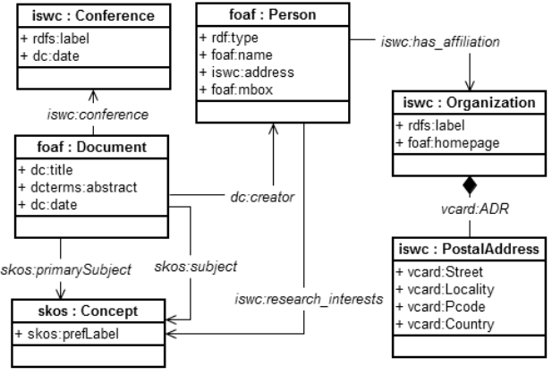Figure 6. ISWC_RDF Exported Ontology Schema.

Figure 7 shows the procedure to generate the relational view schemas and R2RML mappings. The procedure has 3 main steps…
Figure 11 depicts ISWC_Views, the relational view schemas for exported ontology ISWC_RDF, and Figure 12 contains some of the R2RML mappings for converting ISWC_Views data to the ISWC_RDF vocabulary.

Input: Exported Ontology E
Output: a set V of relational view schemas and a set M of R2RML mapping from V to E.
Step1: For each class pc : C in V_{E} do
- Create a relational view v:C;
- Create attribute ID as primary key of C;
- Create the subject map for relational view C using the template in Figure 8;
Step2: For each data property pp:P in V_{E} do
- Let pd:D be the domain class of pp:P;
- In Case of:
Case 2.1: pp:P has maxCardinality equal to 1.
- Create attribute v:P in table v:D whose type is defined according to range of pp:P;
- Create a predicate map for relational view D using the template in Figure 9;
Case 2.2: pp:P has maxCardinality greater than 1.
- Create intermediate relational view D_P;
- Create attribute ID_D in D_P defined as a foreign key to D (parent table);
- Create attribute P in D_P whose type is defined according to range of pp:P;
- Create subject and object map for relational view D_P using the template in Figure 10.
Step3: For each object property pp:P in E do
- Let pd:D and pr:R be the domain and range of pp:P, respectively;
- In case of:
Case 3.1: pp:P has maxCardinality equal to 1.
- Create attribute ID_R in table D which is a foreign key to R (parent table);
- Create an object map for relational view D using the template in Figure 11.
Case 3.2: pp:P has maxCardinality greater than 1.
- Create intermediate table D_P;
- Create attribute ID_D in D_P which is a foreign key to D;
- Create attribute ID_R in D_P which is a foreign key to R;
- Create subject and object map for relational view D using the template in Figure 12
Figure 7. Procedure to generate the relational view schemas and R2RML mappings.

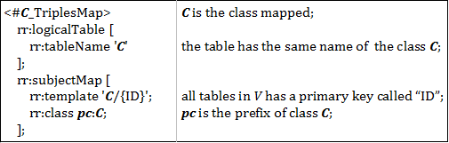
Figure 8. Template for Subject Map.
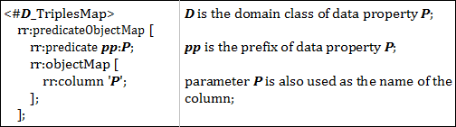
Figure 9. Predicate Map Template for Case 2.1.

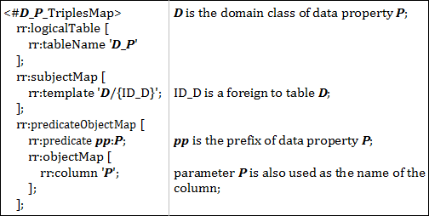
Figure10. Predicate Map Template for Case2.2.
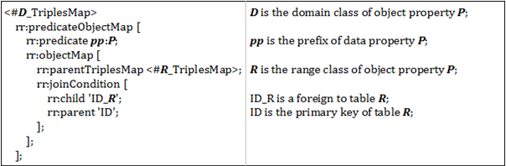
Figure 11. Object Map Template for Case 3.1.
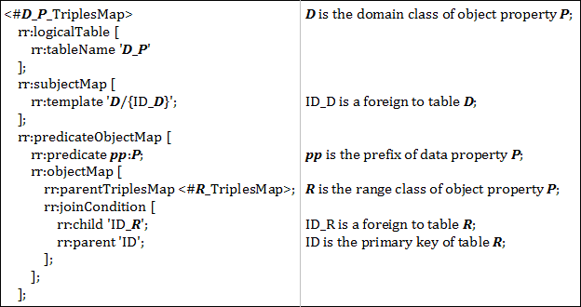
Figure 12. Object Map Template for Case 3.2.
Figure 13 depicts the relational view schemas for exported ontology ISWC_RDF and Figure 14 contains some of the R2RML mappings for converting ISWC_Views data to the ISWC_RDF vocabulary.
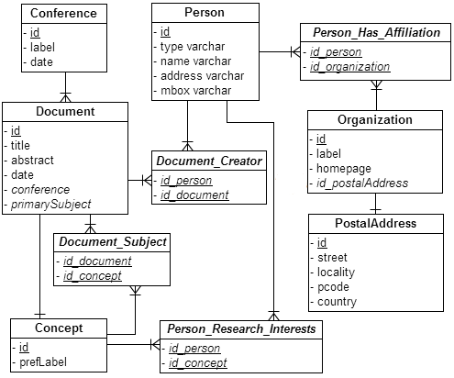
Figure 13. ISWC_Views Schema.

1 | <#PersonTriplesMap>  rr:logicalTable [ rr:tableName "Person" ];  rr:subjectMap [  rr:template "person/{id}";  rr:class foaf:Person;  ];
2 | rr:predicateObjectMap [  rr:predicate rdf:type;  rr:objectMap [ rr:column "type" ];  ];
3 | ...
4 | <#ConceptTriplesMap>  rr:logicalTable [ rr:tableName "Concept" ];  rr:subjectMap [  rr:template "concept/{id}";  rr:class skos:Concept;  ];
5 | rr:predicateObjectMap [  rr:predicate skos:prefLabel;  rr:objectMap [ rr:column "prefLabel" ];  ];
6 | ...
7 | <#Person_Research_InterestsTriplesMap>  rr:logicalTable [  rr:tableName “Person_Research_Interests”  ];  rr:subjectMap [  rr:template "person/{id_person}";  ];  rr:predicateObjectMap [  rr:predicate iswc:research_interests;  rr:objectMap [  rr:parentTriplesMap <#ConceptTriplesMap>;  rr:joinCondition [  rr:child "id_concept ";  rr:parent "id";  ];  ];  ].
Figure 14. R2RML Mapping

R2RML IMPLEMENTION

CONCLUSION AND FUTURE WORK

REFERENCES
- Berners-Lee, T. Linked Data, 2006. http://www.w3.org/DesignIssues/LinkedData.html
- Bizer, C., and Cyganiak, R. D2R Server – Publishing Relational Databases on the Semantic Web, ISWC 2006.
- Auer, S., Dietzold, S., Lehmann, J., Hellmann, S., and Aumueller, D. Triplify - Light-Weight Linked Data Publication from Relational Databases. In Proceedings of the 18th International World Wide Web Conference, 2009.
- Das, S., Sundara, S., and Cyganiak, R. R2RML: RDB to RDF Mapping Language, W3C Working Draft, 2012. http://www.w3.org/TR/r2rml/
- Bizer, C. D2R Map – A Database to RDF Mapping Language, World Wide Web Conference, 2003.
- Sacramento, E. R., Vidal, V. M., Macêdo, J. A., Lóscio, B. F., Lopes, F. L. R., Casanova, M. A., and Lemos, F. Towards automatic generation of application ontologies. In Proceeding of the 12th International Conference on Enterprise Information Systems - ICEIS, Funchal, Madeira – Portugal, 2010.
- Vidal, V. M., Casanova, M. A., and Lemos, F. Automatic Generation of XML Views of Relational Data. Federal University of Ceará, November, 2005.
- Eisenberg, A., and Melton, J. SQL/XML and the SQLX Informal Group of Companies. ACM SIGMOD Record, Volume 30, Issue 3 (September 2001), COLUMN: Standards, 2001.
- Yu, C., and Popa, L., Constraint-Based XML Query Rewriting For Data Integration. In: Proceedings of the 2004 ACM SIGMOD International Conference on Management of data, SESSION: Research sessions: Data Integration, Pages 371–382, 2004.
- Arenas, M., Bertails, A., Prud'hommeaux, E., and Sequeda, J., A Direct Mapping of Relational Data to RDF, W3C Working Draft, 2012. http://www.w3.org/TR/rdb-direct-mapping/
- Bizer, C., Cyganiak, R., and Heath, T. How to publish linked data on the web. Retrieved August 24, 2012, from www4.wiwiss.fuberlin.de/bizer/pub/LinkedDataTutorial/ (2007)
- Hass, L., Hernández, M., Ho, H., Popa, L., Roth, M. Clio Grows Up: From Research Prototype to Industrial Tool.

Columns on Last Page Should Be Made As Close As Possible to Equal Length

http://virtuoso.openlinksw.com
http://www.foaf-project.org/
http://www.w3.org/TR/skos-reference/
http://www.w3.org/TR/vcard-rdf/
http://dublincore.org/
http://www.ietf.org/rfc/rfc3987.txt

