Luis Miguel Flores
2015-01835
CS 180 MP4-5 Documentation
Note that I resized my dataset such that half of the input node size is 1288
1. Performance on Training Set = 100%, Performance on Testing Set = 87.5%
2. I used 250 as my increment value, and a cap at input node size 2576.
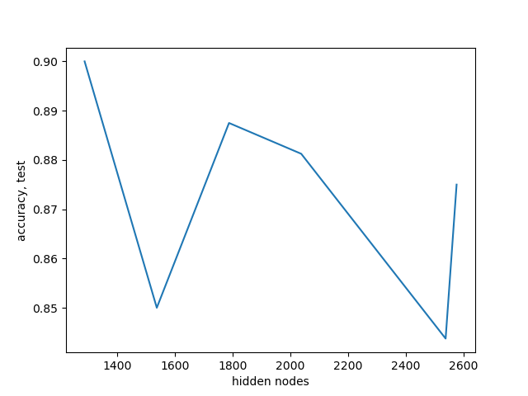

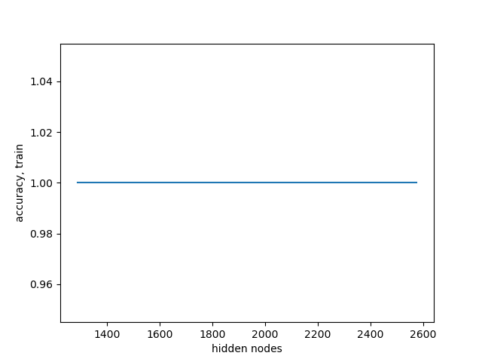

3. Performance on Training Set = 100%, Performance on Testing Set = 1.875% Drastic decrease in performance on the test set. However, faster training time.
4. Performance on Training Set = 100%, Performance on Testing Set = 55%

5.
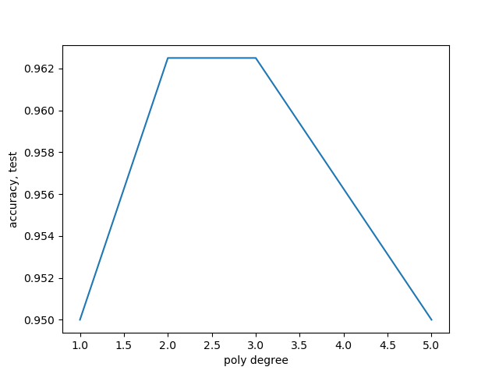
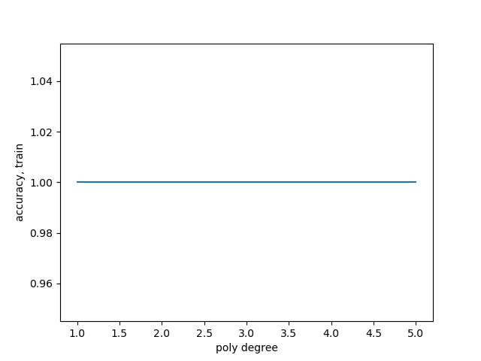
6.
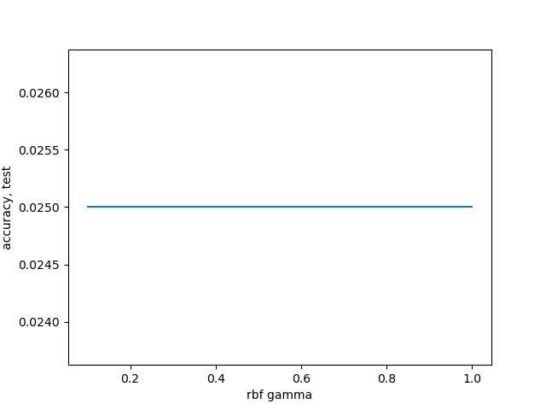
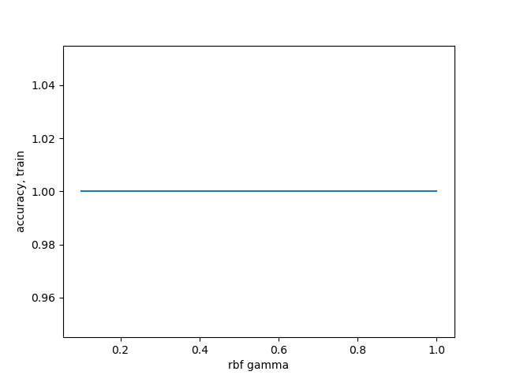

7. In terms of training time, SVM took less time to train. Parameters for SVM were easier to tune and understand. SVM using Polynomials was also the most accurate and consistent. However, ANN was more accurate against SVM using rbf.

