**GitHub Username**: luisfnicolau

**Askkui**

# Description

In Brazil we have a huge problem with corruption and misinformation in politics. This app is made to help you to choose the best candidate in elections. It will provide you a description about all candidates and their proposal. You gonna have chance to see what other people think about them and show your thoughts.

# Intended User

The voters, or people that are deciding if gonna vote. (In Brazil the vote is mandatory. You only can choose to vote if you have 16 or 17 years old or more than 70, so this app is for everyone with more than 15 years old).

# Features

* Gather information about candidates like their description and proposals
* Like/Not Like and Comments feature so you can manifest your feelings about that candidate
* Rating option for proposals like “I like”, “Don’t like”, “Maybe good”, “Poor explained / Too much vague”
* Profile feature so you can show who you are and what are your opinions (only if you want it).

# User Interface Mocks

These can be created by hand (take a photo of your drawings and insert them in this flow), or using a program like Photoshop or Balsamiq.

## Screen 1

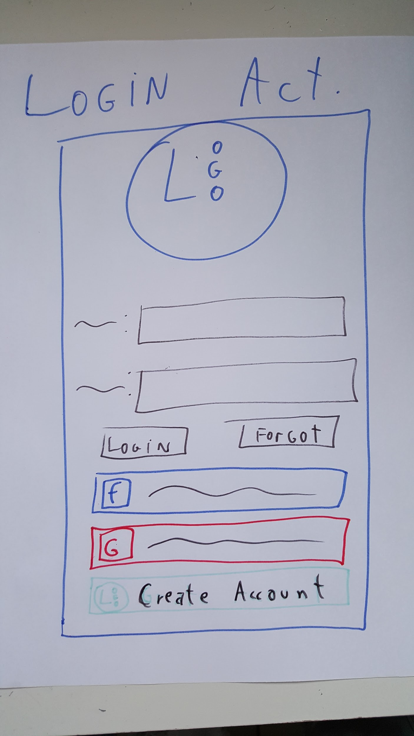

Login Activity where you can Login/Register with Facebook, Google+ or direct by Askkui

## Screen 2

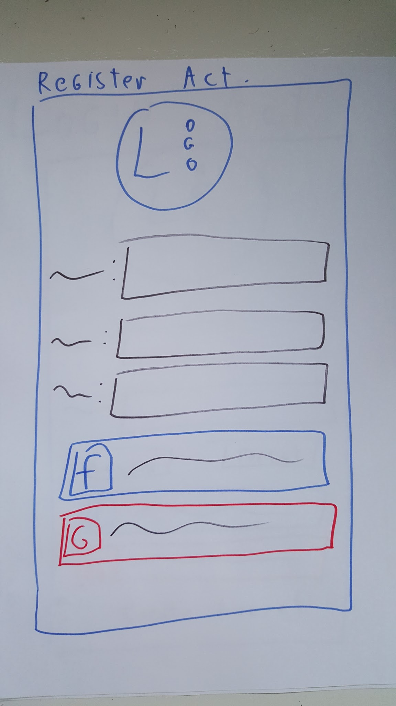

Register Activity where you can put your information or fetch the info from facebook or google+

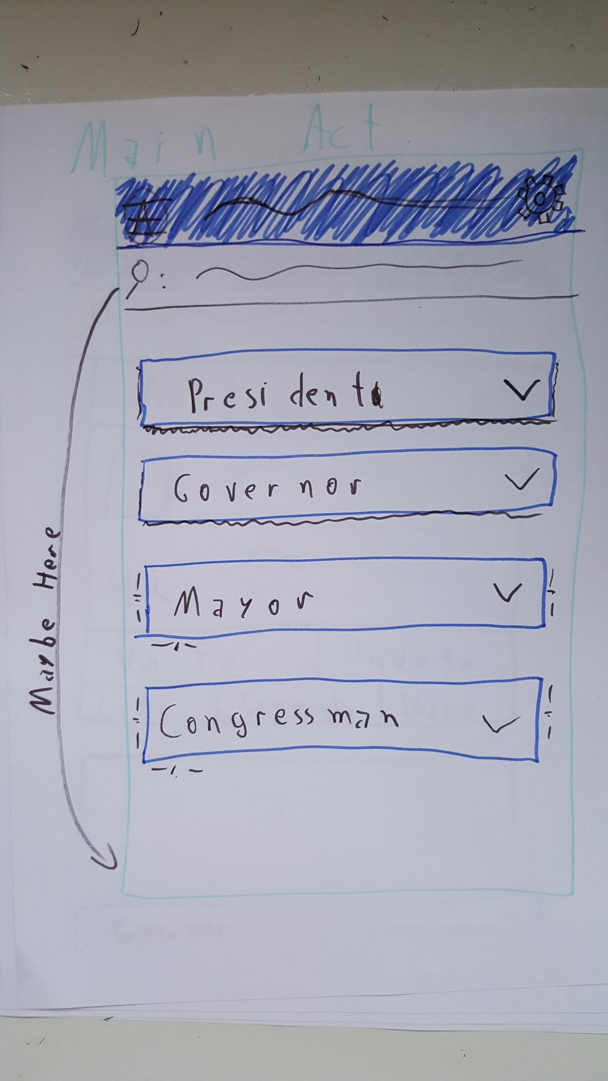

Main Activity where there’s a search bar to search for candidates and the candidates are divided by their role

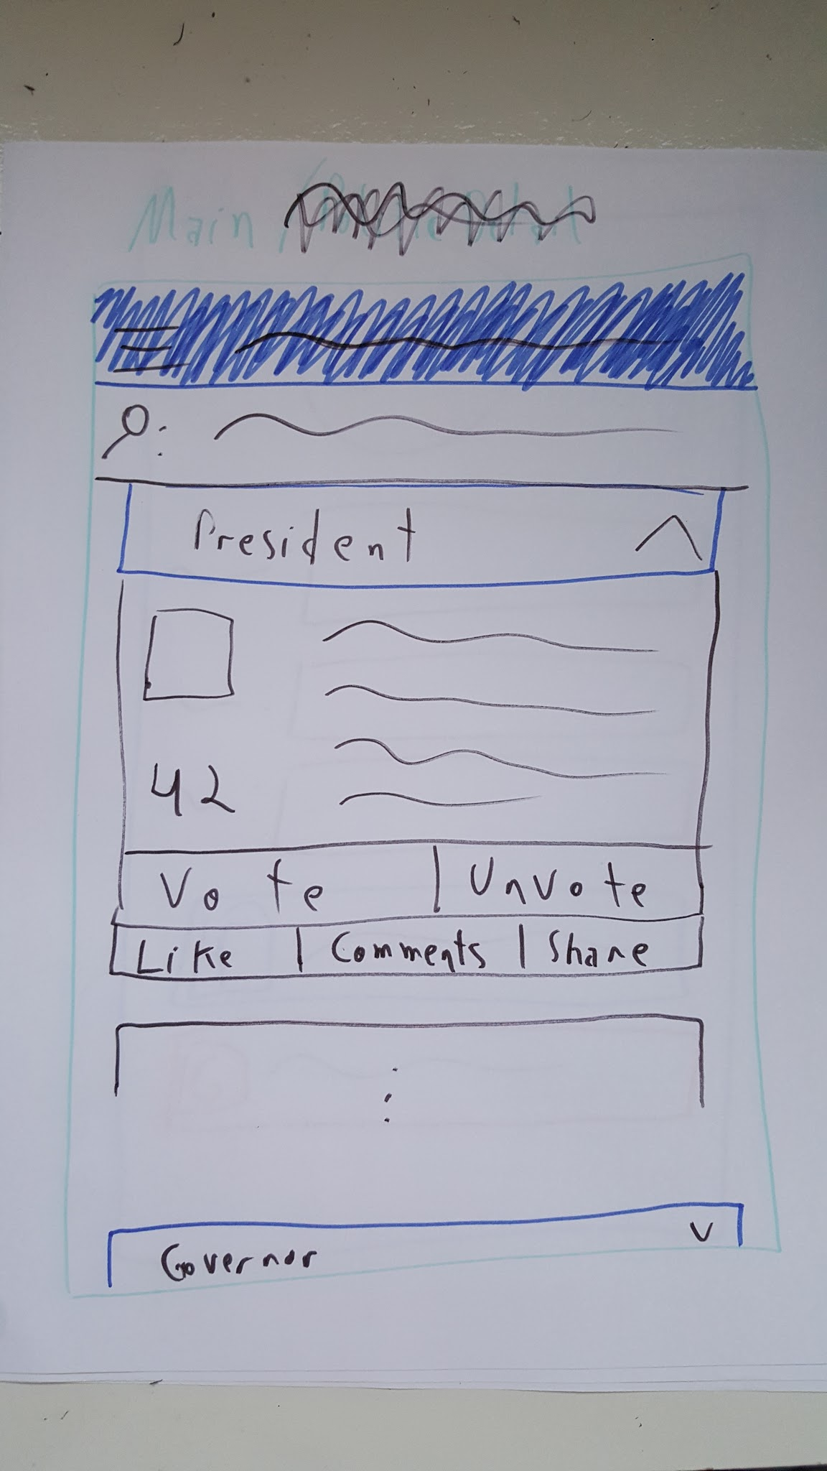

Main activity described above with a role tab opened showing the cards with candidate information

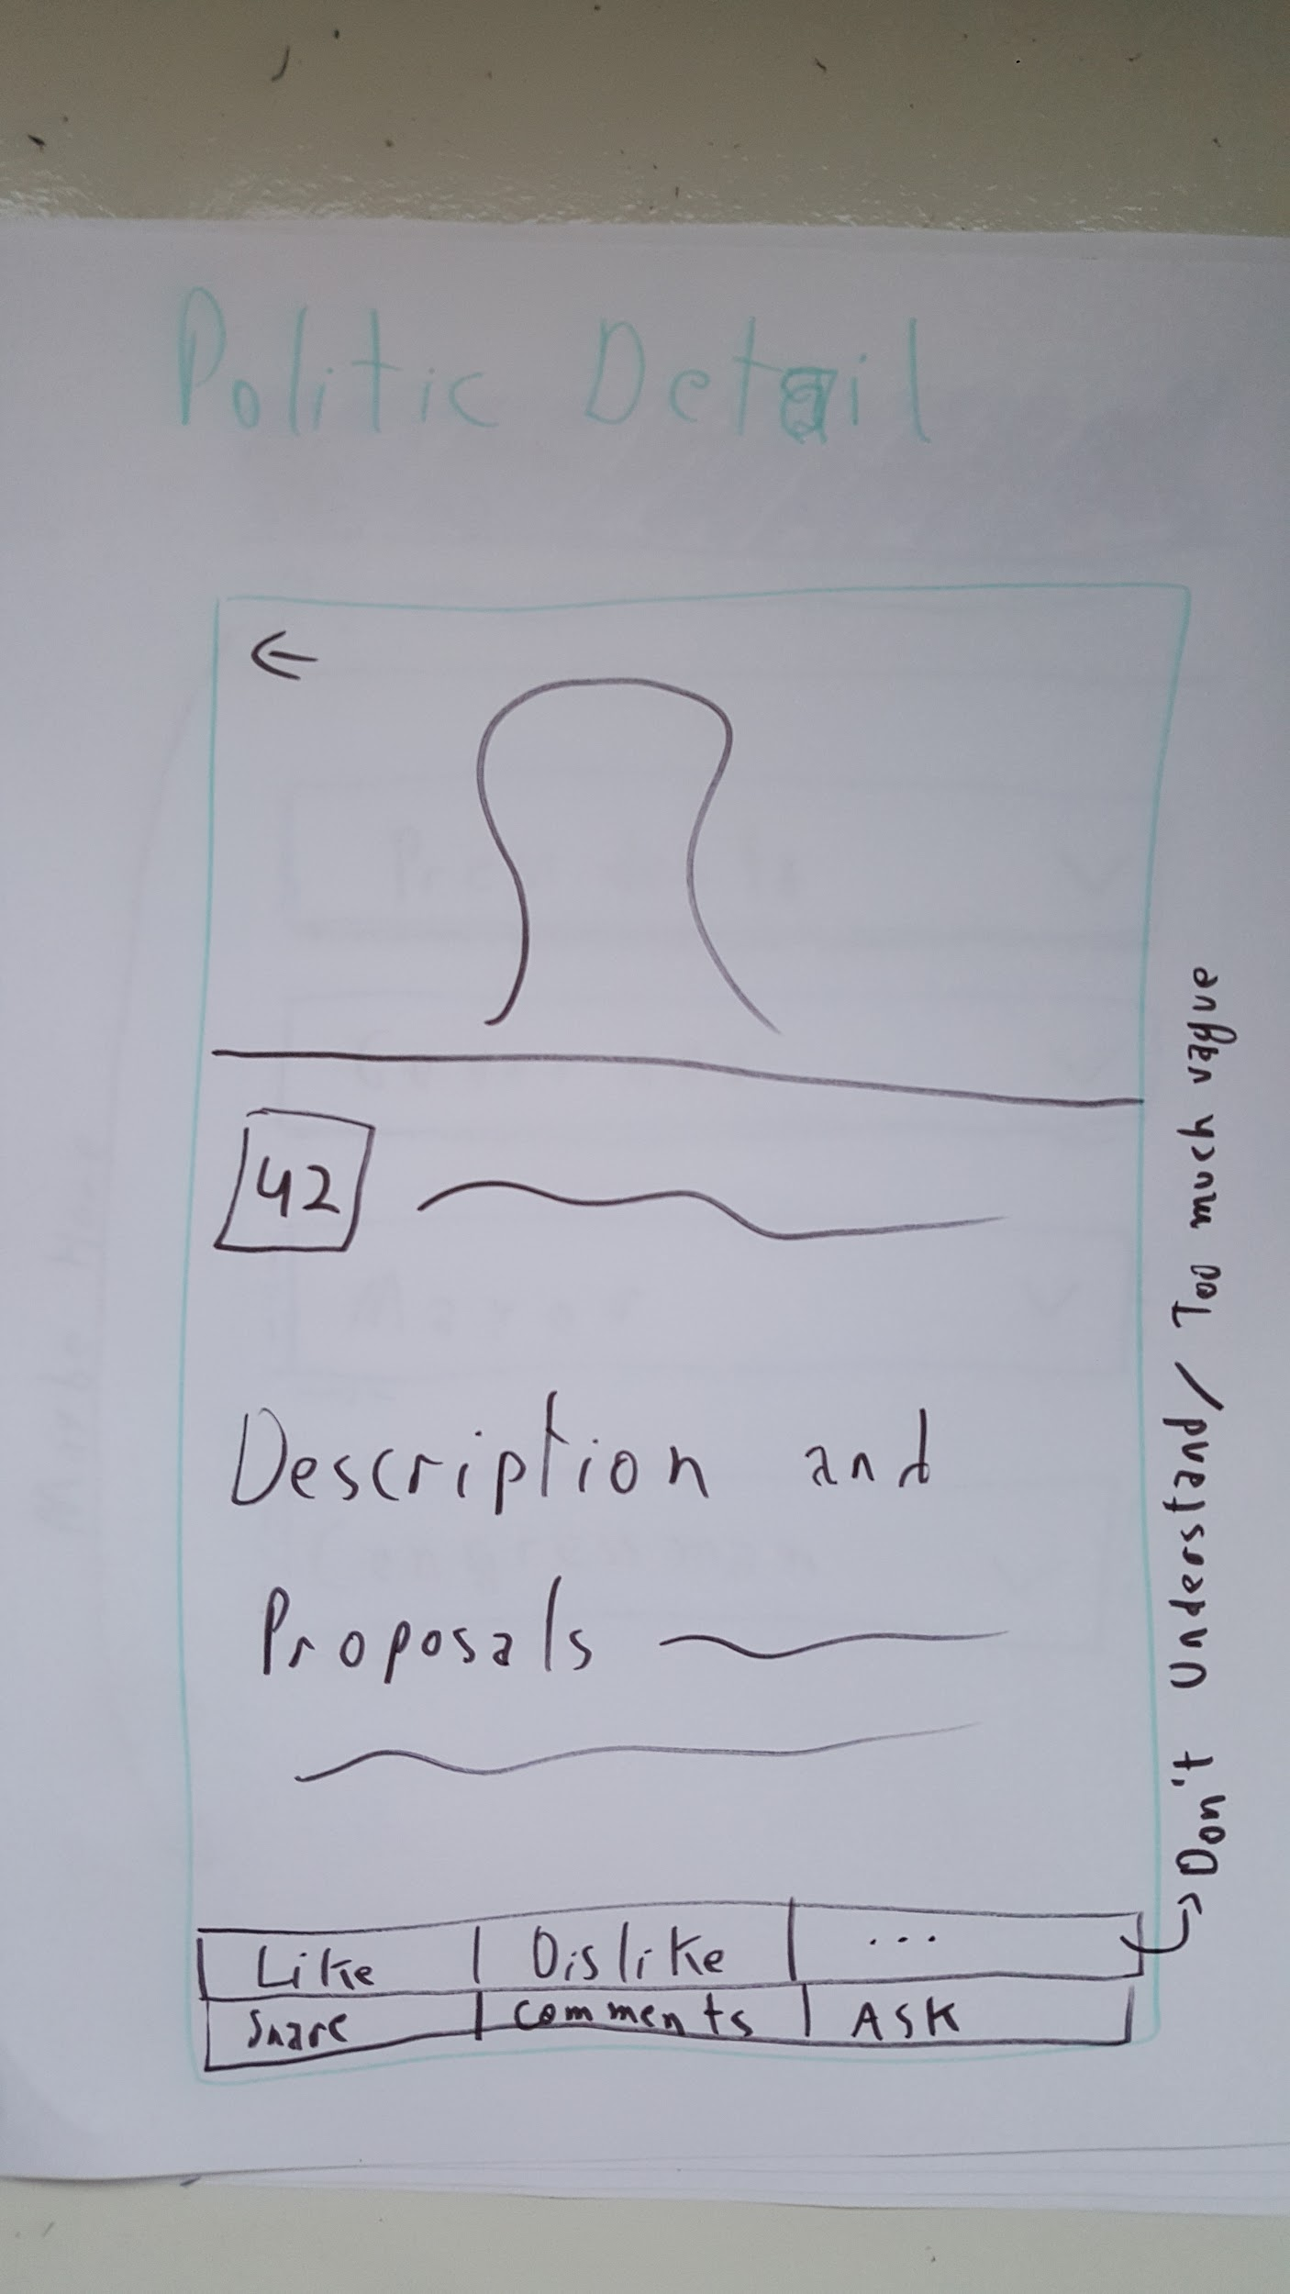

The Politic Activity that is shown if you press on candidates name or photo with more information and their proposals.

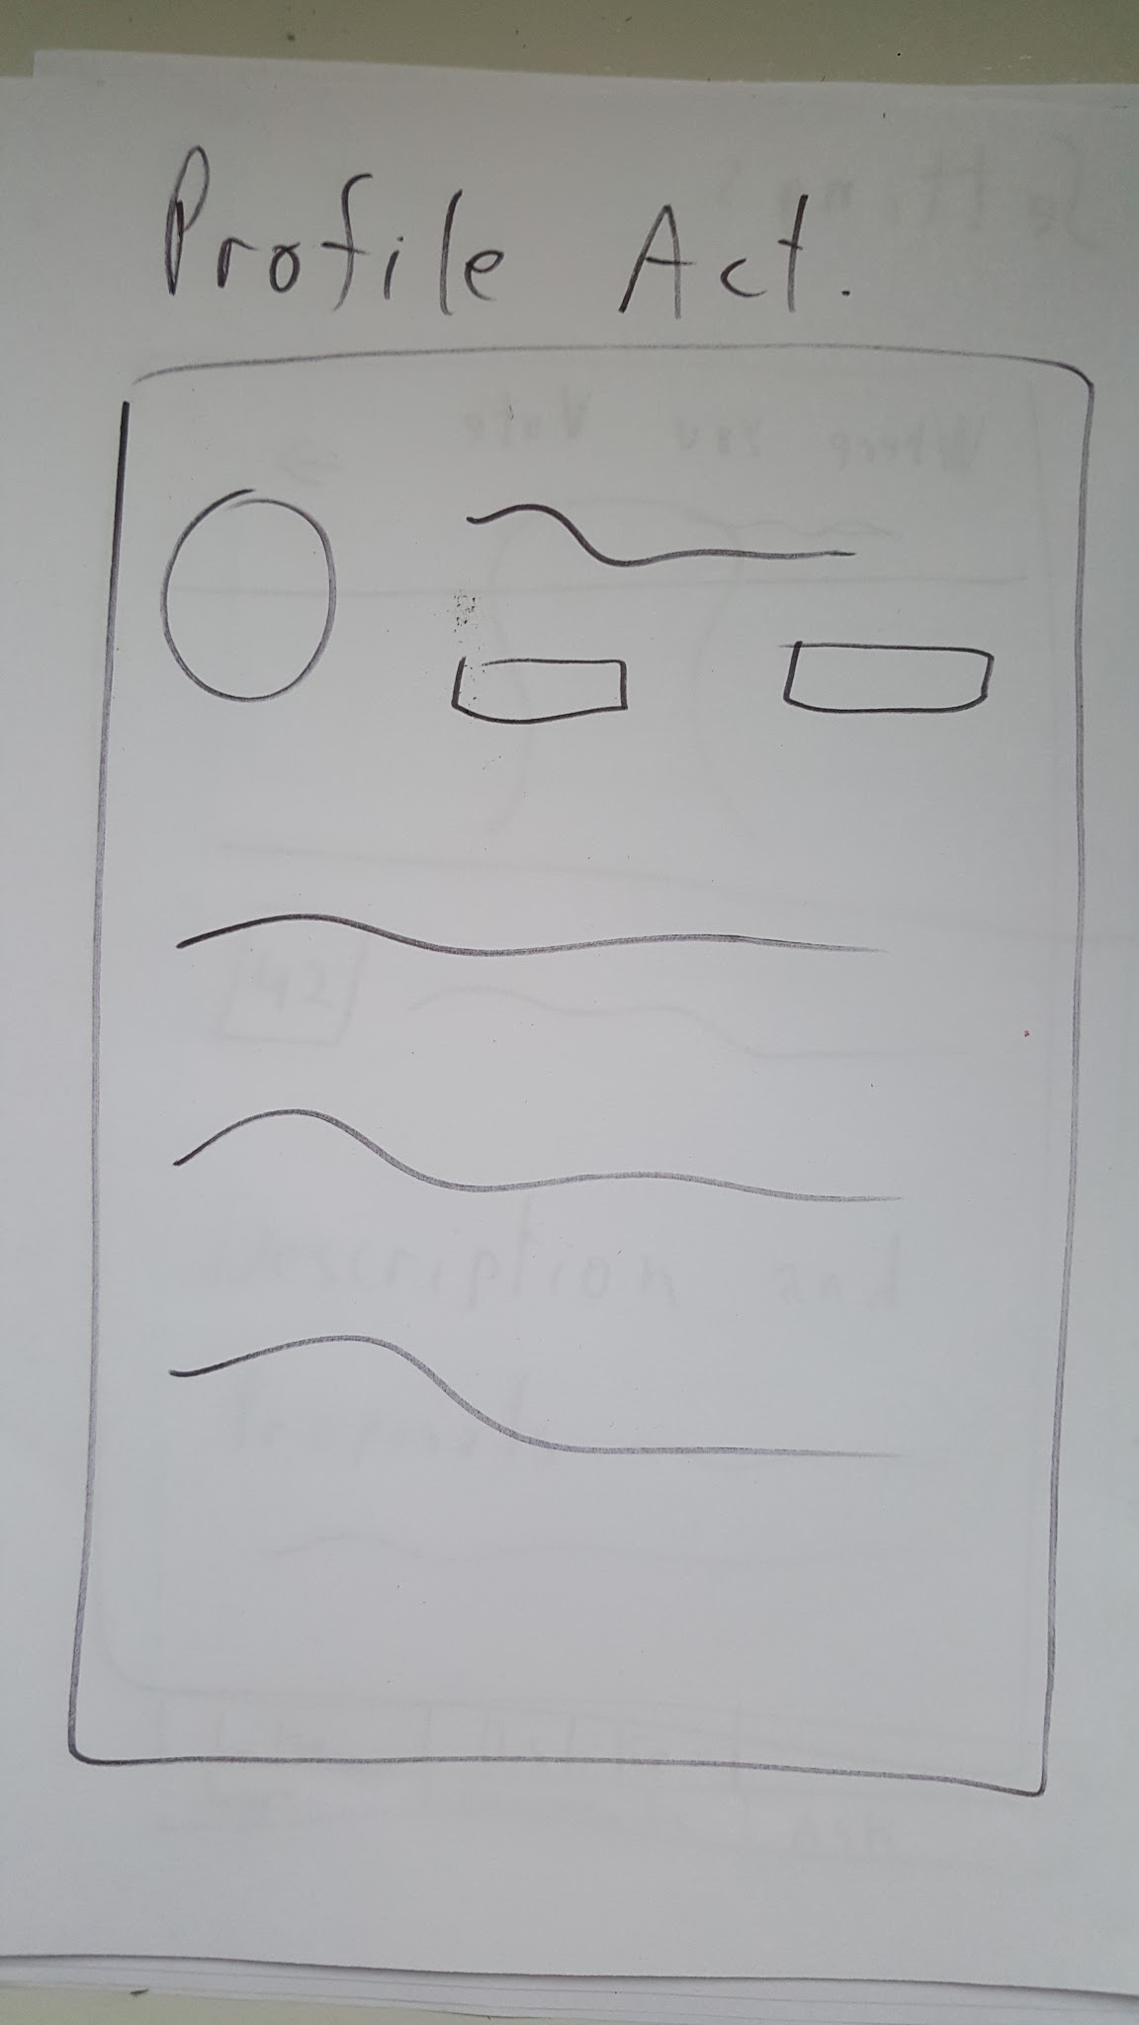

Profile Activity gathering the user info

# 

# Key Considerations

### How will your app handle data persistence?

Yes. This app will have a Content Provider that will be uploaded to a server with the user info and their preferences.

It will download a Database from a server too with the updated info.

### Describe any corner cases in the UX.

The app will save login information about the user in a token (with user’s permission) so it can skip the login activity.

Implement a Sync Adapter so the app will be up to date when opened. (Pay full attention on that to not set a sync time that will running every minute if the app start to became popular)

### Describe any libraries you’ll be using and share your reasoning for including them.

Google Play Services.

Google Api Client

Planning to use Google Cloud as the server for that app because it is available and affordable to me now.

Picasso to fetch candidates images from server.

# Next Steps: Required Tasks

This is the section where you can take the main features of your app (declared above) and decompose them into tangible technical tasks that you can complete incrementally until you have a finished app.

## Task 1: Project Setup

Set up the Google Cloud Endpoint

Configure Login Token

Set variables that will be passed between Main and Detail Activity

## Task 2: Implement UI for Each Activity and Fragment

On that order:

Build UI for MainActivity

Build UI for DetailActivity

Build SettingsActivity

Build UI for Login and Register Activity

## Task 3: Implement Data

Implement Main activity and Detail

Configure Content Provider

Configure Sync Adapter

## Task 4: Implement Server

Implement Google Cloud Endpoint

Add as many tasks as you need to complete your app.

**Submission Instructions**

1. After you’ve completed all the sections, download this document as a PDF [ File → Download as PDF ]
2. Create a new GitHub repo for the capstone. Name it “**Capstone Project**”
3. Add this document to your repo. Make sure it’s named “**Capstone_Stage1.pdf**”