**SUPPORTING INFORMATION**

**Molecular dynamics investigations of structural and functional changes in Bcl-2 induced by the novel antagonist BDA-366**

Tao Lia,b,c# Yinglu Cuia#, Bian Wua*

a *CAS Key Laboratory of Microbial Physiological and Metabolic Engineering, State Key Laboratory of Microbial Resources, Institute of Microbiology, Chinese Academy of Sciences, Beijing 100101, PR China*

*b University of Chinese Academy of Sciences, PR China*

*c State Key Laboratory of Transducer Technology, Chinese Academy of Sciences, PR China*

\**Corresponding author:* Bian Wu

Email: wub@im.ac.cn

Telephone: +8610-64806035

Fax: +8610-64806035

ORCID: 0000-0002-6524-2049

# Tao Li and Yinglu Cui contributed equally to this work.

**Contents:**

**Figure S1.** Plot of RMSD of Bcl-2 binding with BDA-366 (red), Bid (green), or both (blue) over 500 ns aMD simulations.

**Figure S2.** Plot of RMSD of Bcl-2 binding with BDA-366 over 1000 ns aMD simulations.

**Figure S3.** Two-dimensional free energy profiles of the first and second principal components in Bcl-2-BDA-366 complex simulated for 1000 ns aMD and Bcl-2-Bid complex simulated for 500 ns aMD.

**Table S1.** Decomposition of binding free energy (kcal·mol-1) on per-residue basis for Bcl-2-BDA-366.

**Table S2.** Decomposition of binding free energy (kcal· mol-1) on per-residue basis for Bcl-2-Bid-BDA-366.

**Table S3.** Decomposition of binding free energy (kcal·mol-1) on per-residue basis for Bcl-2-Bid.

**Table S4**. Decomposition of binding free energy (kcal·mol-1) on per-residue basis for Bcl-2-BDA-366-Bid.

**Movie 1:** The animated cartoon simulates the process of BDA-366 binding and inducing the α3 region rearrangement. These motions constituted an “open-semiclosed-closed” transition pathway of the hydrophobic binding site in Bcl-2.

**File 1.** The mol2 files of the ligand BDA-366 after Gaussian optimization.

**File 2.** The prmtop file of ligand BDA-366 calculated by Antechamber module using the optimized mol2 file.

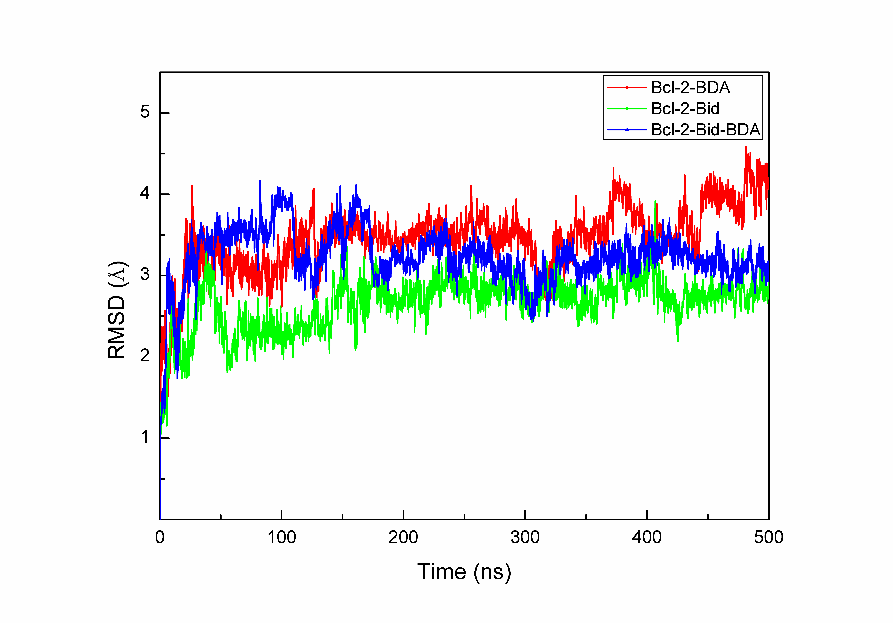

**Figure S1.** Plot of RMSD of Bcl-2 binding with BDA-366 (red), Bid (green), or both (blue) over 500 ns aMD simulations.

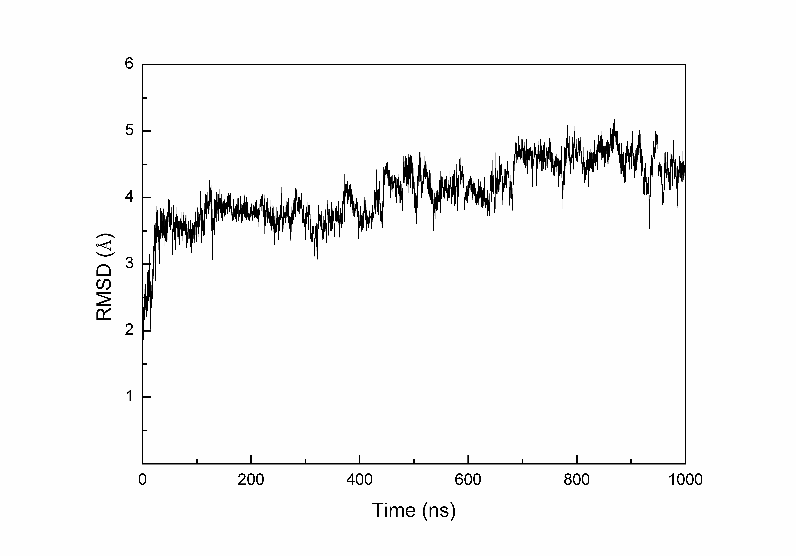

**Figure S2.** Plot of RMSD of Bcl-2 binding with BDA-366 over 1000 ns aMD simulations.

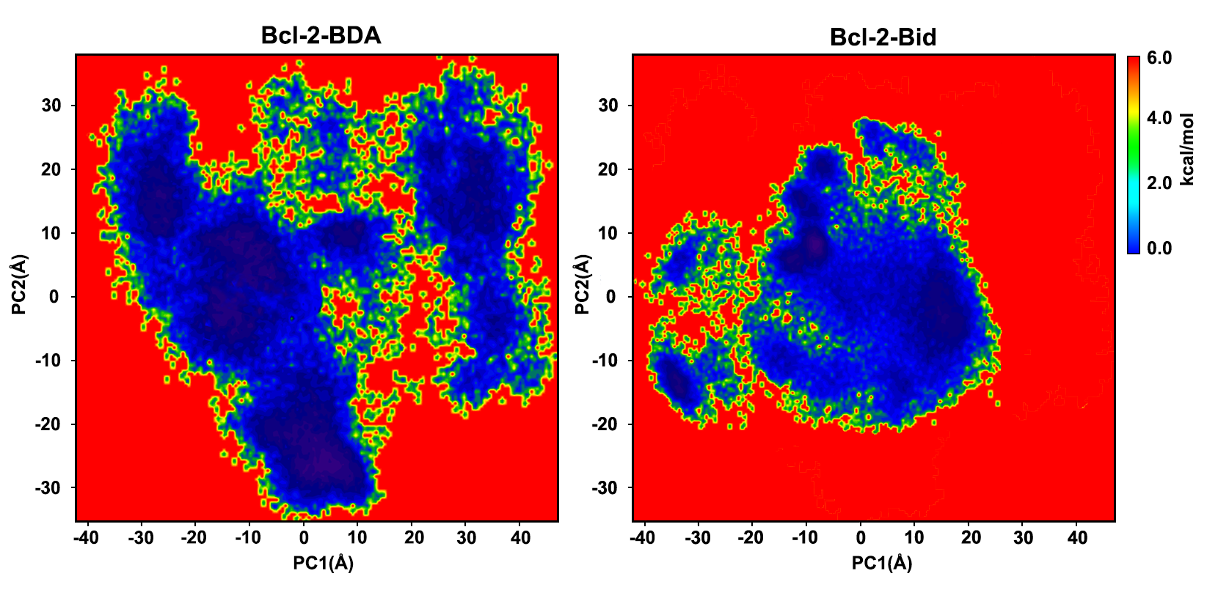

**Figure S3.** Two-dimensional free energy profiles of the first and second principal components in Bcl-2-BDA-366 complex simulated for 1000 ns aMD and Bcl-2-Bid complex simulated for 500 ns aMD.

**Table S1.** Decomposition of binding free energy (kcal·mol-1) on per-residue basis for Bcl-2-BDA.

|  |  |  |  |  |  |  |
| --- | --- | --- | --- | --- | --- | --- |
| Residues | Δ*E*int | Δ*E*vdw | Δ*E*ele | Δ*E*GB | Δ*ESASA* | ΔEbind |
| Trp30 | 1.46 | -3.35 | -2.29 | 0.46 | -0.17 | -3.89 |
| Asp10 | -0.56 | -1.71 | -3.62 | 2.99 | -0.22 | -3.12 |
| Asn11 | 2.09 | -2.62 | -8.48 | 6.66 | -0.6 | -2.95 |
| Arg40 | 0.65 | -1.23 | -6.24 | 4.25 | -0.21 | -2.78 |
| Tyr28 | -0.44 | -1.03 | -0.31 | -0.34 | -0.08 | -2.2 |
| Thr7 | -0.51 | -2.09 | -3.14 | 3.82 | -0.1 | -2.02 |
| Arg12 | 0.77 | 1.04 | -8.04 | 4.41 | -0.12 | -1.94 |
| Val129 | -0.7 | -0.99 | 0.11 | -0.28 | -0.01 | -1.87 |
| Ser126 | 1.08 | -1.43 | -4.43 | 3.3 | -0.34 | -1.82 |
| Val121 | 0.06 | -1.15 | -1.82 | 1.26 | -0.06 | -1.71 |
| Asp31 | 1.76 | -0.87 | -7.43 | 5.12 | -0.24 | -1.66 |
| Pro127 | -0.30 | -0.84 | 1.33 | -1.73 | -0.02 | -1.56 |
| Tyr21 | -0.17 | -2.39 | -3.34 | 4.54 | -0.08 | -1.44 |
| Lys22 | -0.83 | 0.53 | -4.78 | 3.71 | 0.08 | -1.29 |

**Table S2.** Decomposition of binding free energy (kcal·mol-1) on per-residue basis for Bcl-2-Bid-BDA.

|  |  |  |  |  |  |  |
| --- | --- | --- | --- | --- | --- | --- |
| Residues | Δ*E*int | Δ*E*vdw | Δ*E*ele | Δ*E*GB | Δ*ESASA* | ΔEbind |
| Trp30 | -0.31 | -2.14 | -2.13 | 1.99 | 0.12 | -2.47 |
| Tyr28 | -0.23 | -1.18 | -1.76 | 1.55 | -0.22 | -1.84 |
| Arg40 | 0.68 | -1.39 | -5.15 | 4.54 | -0.38 | -1.70 |
| Thr7 | 0.98 | 0.73 | -5.68 | 2.47 | -0.17 | -1.67 |
| Val129 | -0.6 | -0.94 | -0.08 | -0.04 | -0.01 | -1.67 |
| Pro127 | -1.69 | -1.89 | 2.64 | -0.44 | -0.27 | -1.65 |
| Ser126 | 0.9 | -1.44 | -3.12 | 2.34 | -0.25 | -1.57 |
| Val36 | 0.45 | -1.79 | -1.35 | 1.54 | -0.38 | -1.53 |
| Val121 | -0.88 | -0.56 | 0.42 | -0.36 | -0.08 | -1.46 |
| Asp31 | -0.37 | 0.93 | -13.93 | 11.81 | 0.16 | -1.40 |
| Asp10 | -2.92 | -0.25 | 14.88 | -13.07 | -0.02 | -1.38 |
| Asn11 | -0.64 | 0.76 | -1.73 | 0.39 | -0.01 | -1.23 |
| Tyr21 | -0.95 | 0.06 | 0.51 | -0.79 | -0.05 | -1.22 |
| Arg12 | 0.34 | 0.32 | -8.36 | 6.54 | 0.09 | -1.07 |

**Table S3.** Decomposition of binding free energy (kcal·mol-1) on per-residue basis for Bcl-2-Bid.

|  |  |  |  |  |  |  |
| --- | --- | --- | --- | --- | --- | --- |
| Residues | Δ*E*int | Δ*E*vdw | Δ*E*ele | Δ*E*GB | Δ*ESASA* | ΔEbind |
| Glu95 | -1.05 | -1.49 | -19.83 | 17.89 | -0.31 | -4.79 |
| Arg105 | -0.03 | -1.64 | -18.24 | 15.42 | -0.22 | -4.71 |
| Glu94 | -1.28 | -1.30 | -17.89 | 16.16 | -0.16 | -4.47 |
| Asn102 | -1.40 | -1.18 | -8.27 | 6.89 | -0.18 | -4.14 |
| Asp99 | -1.17 | -1.09 | -3.69 | 2.03 | -0.07 | -3.99 |
| Leu80 | 1.76 | -2.7 | -3.67 | 2.37 | -0.50 | -2.74 |
| Leu96 | -0.18 | -1.33 | -0.82 | 0.21 | -0.20 | -2.32 |
| Arg88 | 0.76 | -1.88 | -11.06 | 10.48 | -0.31 | -2.01 |
| Phe63 | -0.11 | -1.01 | -0.37 | -0.41 | -0.09 | -1.99 |
| Trp135 | 1.47 | -0.75 | -3.11 | 0.60 | -0.08 | -1.87 |
| Leu160 | -2.09 | -1.40 | 0.09 | 1.95 | -0.27 | -1.72 |
| Trp103 | 0.17 | -1.17 | -2.90 | 2.52 | -0.09 | -1.47 |
| Leu78 | -2.12 | 0.24 | -0.53 | 1.16 | -0.03 | -1.28 |
| Gly104 | 0.31 | -1.14 | -3.47 | 3.17 | -0.09 | -1.22 |
| Val92 | 0.25 | -1.34 | -0.64 | 0.74 | -0.19 | -1.18 |
| Phe112 | -0.09 | -0.65 | -0.11 | -0.25 | -0.06 | -1.16 |

**Table S4**. Decomposition of binding free energy (kcal·mol-1) on per-residue basis for Bcl-2-BDA-Bid.

|  |  |  |  |  |  |  |
| --- | --- | --- | --- | --- | --- | --- |
| Residues | Δ*E*int | Δ*E*vdw | Δ*E*ele | Δ*E*GB | Δ*ESASA* | ΔEbind |
| Arg105 | -0.81 | -1.12 | -15.98 | 14.56 | -0.38 | -3.73 |
| Asn102 | -1.42 | -1.17 | -6.62 | 6.24 | -0.25 | -3.22 |
| Arg88 | -0.51 | -1.79 | -14.02 | 13.46 | -0.18 | -3.04 |
| Tyr161 | -1.03 | -1.09 | -1.71 | 1.41 | -0.19 | -2.61 |
| Tyr67 | -0.89 | -3.44 | 0.17 | 2.23 | -0.11 | -2.04 |
| Asp99 | -2.11 | 1.66 | -11.44 | 10.15 | -0.15 | -1.89 |
| Leu80 | -0.24 | -1.50 | -2.40 | 2.63 | -0.25 | -1.76 |
| Glu95 | -0.55 | -1.18 | -8.70 | 8.82 | -0.07 | -1.68 |
| Arg66 | -1.17 | -1.80 | -6.41 | 7.98 | -0.24 | -1.64 |
| Leu160 | -2.88 | -1.88 | -1.63 | 5.36 | -0.48 | -1.51 |
| Phe63 | -1.06 | -1.24 | -1.68 | 2.74 | -0.19 | -1.43 |
| Leu96 | 1.38 | -1.13 | -1.49 | -0.10 | -0.08 | -1.42 |
| Gly104 | -0.34 | -0.68 | -6.20 | 5.96 | -0.04 | -1.30 |
| Phe112 | -0.75 | 0.07 | -1.02 | 0.54 | -0.02 | -1.18 |

**Movie 1.** The animated cartoon simulates the process of BDA-366 binding and inducing the α3 region rearrangement. These motions constituted an “open-semiclosed-closed” transition pathway of the hydrophobic binding site in Bcl-2.

**File 1.** The mol2 files of the ligand BDA-366 after Gaussian optimization.

**BDA-366.mol2:**

@<TRIPOS>MOLECULE

MOL

60 63 1 0 0

SMALL

resp

@<TRIPOS>ATOM

1 O1 6.6900 -2.2700 0.7810 os 1 MOL -0.281083

2 C1 5.4740 -2.8380 0.2710 cx 1 MOL 0.039262

3 C2 6.7240 -3.6130 0.2750 cx 1 MOL -0.146191

4 C3 4.9300 -2.2230 -1.0070 c3 1 MOL -0.092268

5 H1 4.7350 -3.0460 1.0470 h1 1 MOL 0.121430

6 H2 7.2830 -3.7400 -0.6530 h1 1 MOL 0.130023

7 H3 6.8810 -4.3880 1.0250 h1 1 MOL 0.130023

8 N1 4.1460 -1.0220 -0.7950 nh 1 MOL -0.533909

9 H4 5.7780 -1.9500 -1.6440 h1 1 MOL 0.103578

10 H5 4.3450 -2.9710 -1.5580 h1 1 MOL 0.103578

11 C4 2.8250 -0.9690 -0.4500 ca 1 MOL 0.465359

12 H6 4.6100 -0.1140 -0.8190 hn 1 MOL 0.423472

13 C5 2.1480 0.2660 -0.2240 ca 1 MOL -0.348642

14 C6 2.0700 -2.1690 -0.3090 ca 1 MOL -0.255805

15 C7 0.7440 0.2780 0.1120 ca 1 MOL -0.121641

16 C8 2.8920 1.5260 -0.3420 c 1 MOL 0.497212

17 C9 0.0160 -0.9460 0.2120 ca 1 MOL 0.167446

18 C10 0.0490 1.5480 0.3490 c 1 MOL 0.386851

19 N2 -1.3170 -0.9900 0.4900 nh 1 MOL -0.231093

20 C11 0.7360 -2.1590 0.0030 ca 1 MOL -0.160236

21 H7 2.5580 -3.1290 -0.4410 ha 1 MOL 0.157071

22 O2 4.1040 1.5680 -0.6420 o 1 MOL -0.581471

23 C12 2.1790 2.8040 -0.0960 ca 1 MOL -0.003906

24 H8 0.2220 -3.1070 0.1090 ha 1 MOL 0.134374

25 O3 -1.1630 1.6060 0.6450 o 1 MOL -0.508037

26 C13 0.8140 2.8150 0.2360 ca 1 MOL -0.001066

27 C14 2.8810 4.0160 -0.1960 ca 1 MOL -0.121039

28 C15 0.1630 4.0360 0.4680 ca 1 MOL -0.113609

29 C16 2.2290 5.2230 0.0340 ca 1 MOL -0.133877

30 H9 3.9350 3.9830 -0.4540 ha 1 MOL 0.141396

31 C17 0.8660 5.2330 0.3670 ca 1 MOL -0.117993

32 H10 -0.8900 4.0190 0.7270 ha 1 MOL 0.126529

33 H11 2.7770 6.1590 -0.0440 ha 1 MOL 0.128217

34 H12 0.3580 6.1770 0.5480 ha 1 MOL 0.125602

35 C18 -2.0990 -2.1990 0.6520 c3 1 MOL -0.019349

36 H13 -1.7270 -0.1060 0.7890 hn 1 MOL 0.306825

37 C19 -3.5950 -1.8800 0.7060 c3 1 MOL 0.277404

38 H14 -1.8230 -2.7370 1.5730 h1 1 MOL 0.032182

39 H15 -1.9270 -2.8820 -0.1920 h1 1 MOL 0.032182

40 O4 -3.8210 -0.9830 1.7820 oh 1 MOL -0.642272

41 C20 -4.1300 -1.2650 -0.6110 c3 1 MOL 0.141141

42 H16 -4.1150 -2.8310 0.9040 h1 1 MOL 0.004472

43 N3 -5.4150 -0.5780 -0.3910 n3 1 MOL -0.308986

44 H17 -4.2160 -2.0490 -1.3800 h1 1 MOL -0.031374

45 H18 -3.3960 -0.5400 -0.9760 h1 1 MOL -0.031374

46 H19 -4.6770 -0.5560 1.5670 ho 1 MOL 0.357871

47 C21 -5.4150 0.8100 -0.8970 c3 1 MOL 0.130819

48 C22 -6.5750 -1.3440 -0.8710 c3 1 MOL 0.130819

49 C23 -6.4900 1.6990 -0.2670 c3 1 MOL -0.197880

50 H20 -4.4370 1.2400 -0.6610 h1 1 MOL 0.015875

51 H21 -5.5150 0.8260 -2.0000 h1 1 MOL 0.015875

52 C24 -6.8130 -2.6600 -0.1290 c3 1 MOL -0.197880

53 H22 -7.4620 -0.7160 -0.7470 h1 1 MOL 0.015875

54 H23 -6.4780 -1.5440 -1.9570 h1 1 MOL 0.015875

55 H24 -6.3980 1.7000 0.8260 hc 1 MOL 0.053724

56 H25 -7.5080 1.3880 -0.5240 hc 1 MOL 0.053724

57 H26 -6.3650 2.7290 -0.6200 hc 1 MOL 0.053724

58 H27 -6.0080 -3.3840 -0.2950 hc 1 MOL 0.053724

59 H28 -7.7430 -3.1190 -0.4850 hc 1 MOL 0.053724

60 H29 -6.9060 -2.4910 0.9500 hc 1 MOL 0.053724

@<TRIPOS>BOND

1 1 2 1

2 1 3 1

3 2 3 1

4 2 4 1

5 2 5 1

6 3 6 1

7 3 7 1

8 4 8 1

9 4 9 1

10 4 10 1

11 8 11 1

12 8 12 1

13 11 13 ar

14 11 14 ar

15 13 15 ar

16 13 16 1

17 14 20 ar

18 14 21 1

19 15 17 ar

20 15 18 1

21 16 22 2

22 16 23 1

23 17 19 1

24 17 20 ar

25 18 25 2

26 18 26 1

27 19 35 1

28 19 36 1

29 20 24 1

30 23 26 ar

31 23 27 ar

32 26 28 ar

33 27 29 ar

34 27 30 1

35 28 31 ar

36 28 32 1

37 29 31 ar

38 29 33 1

39 31 34 1

40 35 37 1

41 35 38 1

42 35 39 1

43 37 40 1

44 37 41 1

45 37 42 1

46 40 46 1

47 41 43 1

48 41 44 1

49 41 45 1

50 43 47 1

51 43 48 1

52 47 49 1

53 47 50 1

54 47 51 1

55 48 52 1

56 48 53 1

57 48 54 1

58 49 55 1

59 49 56 1

60 49 57 1

61 52 58 1

62 52 59 1

63 52 60 1

@<TRIPOS>SUBSTRUCTURE

1 MOL 1 TEMP 0 **** **** 0 ROOT

**File 2.** The prmtop file of ligand BDA-366 calculated by Antechamber module using the optimized mol2 file.

**BDA-366.promtop：**

%FLAG TITLE

%FORMAT(20a4)

MOL

%FLAG POINTERS

%FORMAT(10I8)

60 11 29 34 65 48 114 78 0 0

324 1 34 48 78 17 32 15 14 0

0 0 0 0 0 0 0 0 60 0

0

%FLAG ATOM_NAME

%FORMAT(20a4)

O1 C1 C2 C3 H1 H2 H3 N1 H4 H5 C4 H6 C5 C6 C7 C8 C9 C10 N2 C11

H7 O2 C12 H8 O3 C13 C14 C15 C16 H9 C17 H10 H11 H12 C18 H13 C19 H14 H15 O4 C20 H16 N3 H17 H18 H19 C21 C22 C23 H20 H21 C24 H22 H23 H24 H25 H26 H27 H28 H29

%FLAG CHARGE

%FORMAT(5E16.8)

-5.12197875E+00 7.15443943E-01 -2.66393626E+00 -1.68133518E+00 2.21273389E+00

2.36931811E+00 2.36931811E+00 -9.72904997E+00 1.88742939E+00 1.88742939E+00

8.47991131E+00 7.71663383E+00 -6.35305912E+00 -4.66135545E+00

-2.21657879E+00

9.06034623E+00 3.05125125E+00 7.04931498E+00 -4.21104597E+00

-2.91986846E+00

2.86219488E+00 -1.05957390E+01 -7.11763038E-02 2.44860334E+00

-9.25760263E+00

-1.94249718E-02 -2.20560897E+00 -2.07021728E+00 -2.43954686E+00 2.57656033E+00

-2.15010384E+00 2.30564940E+00 2.33640864E+00 2.28875732E+00

-3.52583283E-01

5.59105720E+00 5.05493891E+00 5.86430059E-01 5.86430059E-01

-1.17036731E+01

2.57191364E+00 8.14901256E-02 -5.63043559E+00 -5.71706440E-01

-5.71706440E-01

6.52123272E+00 2.38382306E+00 2.38382306E+00 -3.60582872E+00 2.89279012E-01

2.89279012E-01 -3.60582872E+00 2.89279012E-01 2.89279012E-01 9.78974845E-01

9.78974845E-01 9.78974845E-01 9.78974845E-01 9.78974845E-01 9.78974845E-01

%FLAG ATOMIC_NUMBER

%FORMAT(10I8)

8 6 6 6 1 1 1 7 1 1

6 1 6 6 6 6 6 6 7 6

1 8 6 1 8 6 6 6 6 1

6 1 1 1 6 1 6 1 1 8

6 1 7 1 1 1 6 6 6 1

1 6 1 1 1 1 1 1 1 1

%FLAG MASS

%FORMAT(5E16.8)

1.60000000E+01 1.20100000E+01 1.20100000E+01 1.20100000E+01 1.00800000E+00

1.00800000E+00 1.00800000E+00 1.40100000E+01 1.00800000E+00 1.00800000E+00

1.20100000E+01 1.00800000E+00 1.20100000E+01 1.20100000E+01 1.20100000E+01

1.20100000E+01 1.20100000E+01 1.20100000E+01 1.40100000E+01 1.20100000E+01

1.00800000E+00 1.60000000E+01 1.20100000E+01 1.00800000E+00 1.60000000E+01

1.20100000E+01 1.20100000E+01 1.20100000E+01 1.20100000E+01 1.00800000E+00

1.20100000E+01 1.00800000E+00 1.00800000E+00 1.00800000E+00 1.20100000E+01

1.00800000E+00 1.20100000E+01 1.00800000E+00 1.00800000E+00 1.60000000E+01

1.20100000E+01 1.00800000E+00 1.40100000E+01 1.00800000E+00 1.00800000E+00

1.00800000E+00 1.20100000E+01 1.20100000E+01 1.20100000E+01 1.00800000E+00

1.00800000E+00 1.20100000E+01 1.00800000E+00 1.00800000E+00 1.00800000E+00

1.00800000E+00 1.00800000E+00 1.00800000E+00 1.00800000E+00 1.00800000E+00

%FLAG ATOM_TYPE_INDEX

%FORMAT(10I8)

1 2 2 3 4 4 4 5 4 4

2 6 2 2 2 2 2 2 5 2

7 8 2 7 8 2 2 2 2 7

2 7 7 7 3 6 3 4 4 9

3 4 5 4 4 10 3 3 3 4

4 3 4 4 11 11 11 11 11 11

%FLAG NUMBER_EXCLUDED_ATOMS

%FORMAT(10I8)

9 10 7 10 5 1 1 10 3 2

12 2 13 7 13 9 12 9 10 4

1 3 9 1 2 7 6 5 5 2

3 1 1 1 11 3 11 4 3 6

13 4 16 3 2 1 10 9 5 4

3 5 4 3 2 1 1 2 1 1

%FLAG NONBONDED_PARM_INDEX

%FORMAT(10I8)

1 2 4 7 11 16 22 29 37 46

56 2 3 5 8 12 17 23 30 38

47 57 4 5 6 9 13 18 24 31

39 48 58 7 8 9 10 14 19 25

32 40 49 59 11 12 13 14 15 20

26 33 41 50 60 16 17 18 19 20

21 27 34 42 51 61 22 23 24 25

26 27 28 35 43 52 62 29 30 31

32 33 34 35 36 44 53 63 37 38

39 40 41 42 43 44 45 54 64 46

47 48 49 50 51 52 53 54 55 65

56 57 58 59 60 61 62 63 64 65

66

%FLAG RESIDUE_LABEL

%FORMAT(20a4)

MOL

%FLAG RESIDUE_POINTER

%FORMAT(10I8)

1

%FLAG BOND_FORCE_CONSTANT

%FORMAT(5E16.8)

3.03600000E+02 3.32200000E+02 3.18300000E+02 3.41500000E+02 3.26600000E+02

3.30600000E+02 4.17900000E+02 4.04600000E+02 4.61100000E+02 3.45900000E+02

3.45800000E+02 6.37700000E+02 3.00900000E+02 3.16700000E+02 3.71400000E+02

3.25900000E+02 3.30600000E+02

%FLAG BOND_EQUIL_VALUE

%FORMAT(5E16.8)

1.43680000E+00 1.50410000E+00 1.51840000E+00 1.08900000E+00 1.46400000E+00

1.09690000E+00 1.38590000E+00 1.01210000E+00 1.39840000E+00 1.49060000E+00

1.08600000E+00 1.21830000E+00 1.53750000E+00 1.42330000E+00 9.73000000E-01

1.46470000E+00 1.09690000E+00

%FLAG ANGLE_FORCE_CONSTANT

%FORMAT(5E16.8)

9.29400000E+01 6.60700000E+01 4.95600000E+01 8.43000000E+01 4.54900000E+01

6.87600000E+01 4.68900000E+01 6.16200000E+01 4.57600000E+01 6.33900000E+01

4.60700000E+01 3.83100000E+01 4.95700000E+01 6.82900000E+01 3.92400000E+01

4.84200000E+01 6.66200000E+01 6.42800000E+01 4.81800000E+01 6.87200000E+01

6.30000000E+01 6.62100000E+01 6.74700000E+01 6.28600000E+01 4.63900000E+01

4.73800000E+01 6.60200000E+01 5.09300000E+01 6.38200000E+01 4.95300000E+01

4.63400000E+01 3.94000000E+01

%FLAG ANGLE_EQUIL_VALUE

%FORMAT(5E16.8)

1.03131550E+00 2.01899774E+00 2.00590777E+00 1.07826487E+00 2.07170671E+00

1.81269974E+00 1.91427794E+00 2.09614133E+00 2.01271456E+00 2.09404693E+00

2.02440827E+00 2.01515802E+00 1.91619781E+00 2.11097664E+00 1.89298492E+00

2.02580453E+00 2.09474507E+00 2.10015559E+00 2.09230160E+00 2.13977458E+00

2.06140926E+00 1.92789152E+00 1.92317913E+00 1.94621748E+00 1.91218355E+00

1.87204096E+00 1.93801443E+00 1.92440086E+00 1.96087826E+00 1.91776860E+00

1.91637234E+00 1.87762601E+00

%FLAG DIHEDRAL_FORCE_CONSTANT

%FORMAT(5E16.8)

1.55555556E-01 1.56000000E-01 2.50000000E-01 0.00000000E+00 3.83000000E-01

0.00000000E+00 1.05000000E+00 3.62500000E+00 1.00000000E+00 1.60000000E-01

4.80000000E-01 3.00000000E-01 1.66666667E-01 1.10000000E+00 1.05000000E+01

%FLAG DIHEDRAL_PERIODICITY

%FORMAT(5E16.8)

3.00000000E+00 3.00000000E+00 1.00000000E+00 3.00000000E+00 3.00000000E+00

2.00000000E+00 2.00000000E+00 2.00000000E+00 2.00000000E+00 3.00000000E+00

2.00000000E+00 3.00000000E+00 3.00000000E+00 2.00000000E+00 2.00000000E+00

%FLAG DIHEDRAL_PHASE

%FORMAT(5E16.8)

0.00000000E+00 0.00000000E+00 0.00000000E+00 0.00000000E+00 0.00000000E+00

0.00000000E+00 3.14159400E+00 3.14159400E+00 3.14159400E+00 0.00000000E+00

3.14159400E+00 0.00000000E+00 0.00000000E+00 3.14159400E+00 3.14159400E+00

%FLAG SCEE_SCALE_FACTOR

%FORMAT(5E16.8)

1.20000000E+00 1.20000000E+00 1.20000000E+00 1.20000000E+00 1.20000000E+00

1.20000000E+00 1.20000000E+00 1.20000000E+00 1.20000000E+00 1.20000000E+00

1.20000000E+00 1.20000000E+00 1.20000000E+00 0.00000000E+00 0.00000000E+00

%FLAG SCNB_SCALE_FACTOR

%FORMAT(5E16.8)

2.00000000E+00 2.00000000E+00 2.00000000E+00 2.00000000E+00 2.00000000E+00

2.00000000E+00 2.00000000E+00 2.00000000E+00 2.00000000E+00 2.00000000E+00

2.00000000E+00 2.00000000E+00 2.00000000E+00 0.00000000E+00 0.00000000E+00

%FLAG SOLTY

%FORMAT(5E16.8)

0.00000000E+00 0.00000000E+00 0.00000000E+00 0.00000000E+00 0.00000000E+00

0.00000000E+00 0.00000000E+00 0.00000000E+00 0.00000000E+00 0.00000000E+00

0.00000000E+00 0.00000000E+00 0.00000000E+00 0.00000000E+00

%FLAG LENNARD_JONES_ACOEF

%FORMAT(5E16.8)

3.61397723E+05 5.57281136E+05 8.19971662E+05 6.28541240E+05 9.24822270E+05

1.04308023E+06 3.63097246E+04 6.01816484E+04 6.78771368E+04 3.25969625E+03

5.89818288E+05 8.82619071E+05 9.95480466E+05 6.20665997E+04 9.44293233E+05

1.03954408E+03 2.27577561E+03 2.56678134E+03 5.94667300E+01 2.12601181E+03

1.39982777E-01 4.68711055E+04 7.62451550E+04 8.59947003E+04 4.33325458E+03

7.91627154E+04 8.90987508E+01 5.71629601E+03 3.70622491E+05 5.74393458E+05

6.47841731E+05 3.69471530E+04 6.06829342E+05 1.02595236E+03 4.77908183E+04

3.79876399E+05 4.58874091E+05 7.01803794E+05 7.91544157E+05 4.66922514E+04

7.44975864E+05 1.40467023E+03 6.00750218E+04 4.71003287E+05 5.81803229E+05

0.00000000E+00 0.00000000E+00 0.00000000E+00 0.00000000E+00 0.00000000E+00

0.00000000E+00 0.00000000E+00 0.00000000E+00 0.00000000E+00 0.00000000E+00

5.33379252E+04 8.61541883E+04 9.71708117E+04 4.98586848E+03 8.96776989E+04

1.07193646E+02 6.55825601E+03 5.44261042E+04 6.82786631E+04 0.00000000E+00

7.51607703E+03

%FLAG LENNARD_JONES_BCOEF

%FORMAT(5E16.8)

4.95732238E+02 5.19163331E+02 5.31102864E+02 5.85549272E+02 5.99015525E+02

6.75612247E+02 8.66220817E+01 9.40505980E+01 1.06076943E+02 1.43076527E+01

6.33305958E+02 6.53361429E+02 7.36907417E+02 1.13252061E+02 8.01323529E+02

1.46567808E+01 1.82891803E+01 2.06278363E+01 1.93248820E+00 2.09604198E+01

9.37598976E-02 9.73010751E+01 1.04660679E+02 1.18043746E+02 1.63092814E+01

1.26451907E+02 2.33864085E+00 1.85196588E+01 5.29252520E+02 5.55666448E+02

6.26720080E+02 9.21192136E+01 6.77220874E+02 1.53505284E+01 1.03580945E+02

5.64885984E+02 5.89183300E+02 6.14502845E+02 6.93079947E+02 1.03606917E+02

7.50714425E+02 1.79702257E+01 1.16187983E+02 6.29300710E+02 6.99746810E+02

0.00000000E+00 0.00000000E+00 0.00000000E+00 0.00000000E+00 0.00000000E+00

0.00000000E+00 0.00000000E+00 0.00000000E+00 0.00000000E+00 0.00000000E+00

1.04986921E+02 1.12529845E+02 1.26919150E+02 1.76949863E+01 1.36131731E+02

2.59456373E+00 2.00642027E+01 1.11805549E+02 1.25287818E+02 0.00000000E+00

2.17257828E+01

%FLAG BONDS_INC_HYDROGEN

%FORMAT(10I8)

3 12 4 6 15 4 6 18 4 9

24 6 9 27 6 21 33 8 39 60

11 54 105 8 57 69 11 78 87 11

81 93 11 84 96 11 90 99 11 102

111 6 102 114 6 108 123 6 117 135

15 120 129 6 120 132 6 138 147 6

138 150 6 141 156 6 141 159 6 144

162 17 144 165 17 144 168 17 153 171

17 153 174 17 153 177 17

%FLAG BONDS_WITHOUT_HYDROGEN

%FORMAT(10I8)

0 3 1 0 6 1 3 6 2 3

9 3 9 21 5 21 30 7 30 36

9 30 39 9 36 42 9 36 45 10

39 57 9 42 48 9 42 51 10 45

63 12 45 66 10 48 54 7 48 57

9 51 72 12 51 75 10 54 102 5

66 75 9 66 78 9 75 81 9 78

84 9 81 90 9 84 90 9 102 108

13 108 117 14 108 120 13 120 126 16

126 138 16 126 141 16 138 144 13 141

153 13

%FLAG ANGLES_INC_HYDROGEN

%FORMAT(10I8)

0 3 12 3 0 6 15 3 0 6

18 3 3 6 15 5 3 6 18 5

3 9 24 7 3 9 27 7 6 3

12 5 9 3 12 9 9 21 33 11

15 6 18 12 21 9 24 13 21 9

27 13 24 9 27 15 30 21 33 16

30 39 60 19 39 57 69 19 48 54

105 16 48 57 69 19 54 102 111 13

54 102 114 13 57 39 60 19 66 78

87 19 75 81 93 19 78 84 96 19

81 90 99 19 84 78 87 19 84 90

99 19 90 81 93 19 90 84 96 19

102 54 105 11 102 108 123 25 108 102

111 25 108 102 114 25 108 117 135 26

108 120 129 25 108 120 132 25 111 102

114 15 117 108 123 28 120 108 123 25

126 120 129 30 126 120 132 30 126 138

147 30 126 138 150 30 126 141 156 30

126 141 159 30 129 120 132 15 138 144

162 31 138 144 165 31 138 144 168 31

141 153 171 31 141 153 174 31 141 153

177 31 144 138 147 25 144 138 150 25

147 138 150 15 153 141 156 25 153 141

159 25 156 141 159 15 162 144 165 32

162 144 168 32 165 144 168 32 171 153

174 32 171 153 177 32 174 153 177 32

%FLAG ANGLES_WITHOUT_HYDROGEN

%FORMAT(10I8)

0 3 6 1 0 3 9 2 0 6

3 1 3 0 6 4 3 9 21 6

6 3 9 8 9 21 30 10 21 30

36 14 21 30 39 14 30 36 42 17

30 36 45 18 30 39 57 17 36 30

39 17 36 42 48 17 36 42 51 18

36 45 63 20 36 45 66 21 39 57

48 17 42 36 45 18 42 48 54 14

42 48 57 17 42 51 72 20 42 51

75 21 45 66 75 18 45 66 78 18

48 42 51 18 48 54 102 10 51 75

66 18 51 75 81 18 54 48 57 14

54 102 108 22 63 45 66 20 66 75

81 17 66 78 84 17 72 51 75 20

75 66 78 17 75 81 90 17 78 84

90 17 81 90 84 17 102 108 117 23

102 108 120 24 108 120 126 27 117 108

120 23 120 126 138 29 120 126 141 29

126 138 144 27 126 141 153 27 138 126

141 29

%FLAG DIHEDRALS_INC_HYDROGEN

%FORMAT(10I8)

0 3 -6 15 1 0 3 -6 18 1

0 3 9 24 3 0 3 -9 24 4

0 3 9 27 3 0 3 -9 27 4

0 6 -3 12 1 3 0 -6 15 5

3 0 -6 18 5 3 9 21 33 6

6 0 -3 12 5 6 3 9 24 2

6 3 9 27 2 9 3 6 15 1

9 3 6 18 1 12 3 6 15 1

12 3 6 18 1 12 3 9 21 2

12 3 9 24 2 12 3 9 27 2

21 30 39 60 8 24 9 21 30 6

24 9 21 33 6 27 9 21 30 6

27 9 21 33 6 30 39 57 69 8

33 21 30 36 7 33 21 30 39 7

36 30 39 60 8 42 48 54 105 7

42 48 57 69 8 45 66 78 87 8

48 54 102 111 6 48 54 102 114 6

48 57 39 60 8 51 75 81 93 8

54 48 57 69 8 54 102 108 123 1

57 48 54 105 7 60 39 57 69 8

66 75 81 93 8 66 78 84 96 8

75 66 78 87 8 75 81 90 99 8

78 84 90 99 8 81 90 84 96 8

84 90 81 93 8 87 78 84 90 8

87 78 84 96 8 93 81 90 99 8

96 84 90 99 8 102 108 117 135 3

102 108 -117 135 10 102 108 120 129 1

102 108 120 132 1 105 54 102 108 6

105 54 102 111 6 105 54 102 114 6

111 102 108 117 3 111 102 -108 117 4

111 102 108 120 1 111 102 108 123 1

114 102 108 117 3 114 102 -108 117 4

114 102 108 120 1 114 102 108 123 1

117 108 120 129 3 117 108 -120 129 4

117 108 120 132 3 117 108 -120 132 4

120 108 117 135 3 120 108 -117 135 10

120 126 138 147 12 120 126 138 150 12

120 126 141 156 12 120 126 141 159 12

123 108 117 135 13 123 108 120 126 1

123 108 120 129 1 123 108 120 132 1

126 138 144 162 1 126 138 144 165 1

126 138 144 168 1 126 141 153 171 1

126 141 153 174 1 126 141 153 177 1

129 120 126 138 12 129 120 126 141 12

132 120 126 138 12 132 120 126 141 12

138 126 141 156 12 138 126 141 159 12

141 126 138 147 12 141 126 138 150 12

147 138 144 162 1 147 138 144 165 1

147 138 144 168 1 150 138 144 162 1

150 138 144 165 1 150 138 144 168 1

156 141 153 171 1 156 141 153 174 1

156 141 153 177 1 159 141 153 171 1

159 141 153 174 1 159 141 153 177 1

9 30 -21 -33 14 30 57 -39 -60 14

102 48 -54 -105 14 39 48 -57 -69 14

66 84 -78 -87 14 75 90 -81 -93 14

78 90 -84 -96 14 81 84 -90 -99 14

%FLAG DIHEDRALS_WITHOUT_HYDROGEN

%FORMAT(10I8)

0 3 9 21 2 0 6 -3 9 1

3 9 21 30 6 6 0 -3 9 5

6 3 9 21 2 9 21 30 36 7

9 21 30 39 7 21 30 36 42 8

21 30 36 45 8 21 30 39 57 8

30 36 42 48 8 30 36 42 51 8

30 36 45 63 9 30 36 45 66 9

30 39 -57 48 8 36 30 39 57 8

36 42 48 54 8 36 42 -48 57 8

36 42 51 72 9 36 42 51 75 9

36 45 -66 75 9 36 45 66 78 9

39 30 36 42 8 39 30 36 45 8

39 57 -48 42 8 39 57 48 54 8

42 36 45 63 9 42 36 45 66 9

42 48 54 102 7 42 51 -75 66 9

42 51 75 81 9 45 36 42 48 8

45 36 42 51 8 45 66 -75 51 8

45 66 75 81 8 45 66 78 84 8

48 42 51 72 9 48 42 51 75 9

48 54 102 108 6 51 42 48 54 8

51 42 48 57 8 51 75 66 78 8

51 75 81 90 8 54 102 108 117 1

54 102 108 120 1 57 48 54 102 7

63 45 66 75 9 63 45 66 78 9

66 75 51 72 9 66 75 81 90 8

66 78 -84 90 8 72 51 75 81 9

75 66 78 84 8 75 81 -90 84 8

78 66 75 81 8 78 84 -90 81 8

102 108 120 126 1 108 120 126 138 11

108 120 -126 138 12 108 120 126 141 11

108 120 -126 141 12 117 108 120 126 1

120 126 138 144 11 120 126 -138 144 12

120 126 141 153 11 120 126 -141 153 12

138 126 141 153 11 138 126 -141 153 12

141 126 138 144 11 141 126 -138 144 12

36 39 -30 -21 14 45 30 -36 -42 14

51 36 -42 -48 14 36 66 -45 -63 15

42 57 -48 -54 14 42 75 -51 -72 15

45 75 -66 -78 14 51 66 -75 -81 14

%FLAG EXCLUDED_ATOMS_LIST

%FORMAT(10I8)

2 3 4 5 6 7 8 9 10 3

4 5 6 7 8 9 10 11 12 4

5 6 7 8 9 10 5 6 7 8

9 10 11 12 13 14 6 7 8 9

10 7 0 9 10 11 12 13 14 15

16 20 21 10 11 12 11 12 12 13

14 15 16 17 18 20 21 22 23 24

13 14 14 15 16 17 18 19 20 21

22 23 25 26 27 15 16 17 19 20

21 24 16 17 18 19 20 22 23 24

25 26 28 35 36 17 18 22 23 26

27 28 29 30 18 19 20 21 24 25

26 35 36 37 38 39 19 20 23 25

26 27 28 31 32 20 24 35 36 37

38 39 40 41 42 21 24 35 36 24

23 26 27 25 26 27 28 29 30 31

32 33 0 26 28 27 28 29 30 31

32 34 28 29 30 31 33 34 29 31

32 33 34 30 31 32 33 34 31 33

32 33 34 34 34 0 36 37 38 39

40 41 42 43 44 45 46 37 38 39

38 39 40 41 42 43 44 45 46 47

48 39 40 41 42 40 41 42 41 42

43 44 45 46 42 43 44 45 46 47

48 49 50 51 52 53 54 43 44 45

46 44 45 47 48 49 50 51 52 53

54 55 56 57 58 59 60 45 47 48

47 48 0 48 49 50 51 52 53 54

55 56 57 49 50 51 52 53 54 58

59 60 50 51 55 56 57 51 55 56

57 55 56 57 53 54 58 59 60 54

58 59 60 58 59 60 56 57 57 0

59 60 60 0

%FLAG HBOND_ACOEF

%FORMAT(5E16.8)

%FLAG HBOND_BCOEF

%FORMAT(5E16.8)

%FLAG HBCUT

%FORMAT(5E16.8)

%FLAG AMBER_ATOM_TYPE

%FORMAT(20a4)

os cx cx c3 h1 h1 h1 nh h1 h1 ca hn ca ca ca c ca c nh ca

ha o ca ha o ca ca ca ca ha ca ha ha ha c3 hn c3 h1 h1 oh

c3 h1 n3 h1 h1 ho c3 c3 c3 h1 h1 c3 h1 h1 hc hc hc hc hc hc

%FLAG TREE_CHAIN_CLASSIFICATION

%FORMAT(20a4)

BLA BLA BLA BLA BLA BLA BLA BLA BLA BLA BLA BLA BLA BLA BLA BLA BLA BLA BLA BLA

BLA BLA BLA BLA BLA BLA BLA BLA BLA BLA BLA BLA BLA BLA BLA BLA BLA BLA BLA BLA

BLA BLA BLA BLA BLA BLA BLA BLA BLA BLA BLA BLA BLA BLA BLA BLA BLA BLA BLA BLA

%FLAG JOIN_ARRAY

%FORMAT(10I8)

0 0 0 0 0 0 0 0 0 0

0 0 0 0 0 0 0 0 0 0

0 0 0 0 0 0 0 0 0 0

0 0 0 0 0 0 0 0 0 0

0 0 0 0 0 0 0 0 0 0

0 0 0 0 0 0 0 0 0 0

%FLAG IROTAT

%FORMAT(10I8)

0 0 0 0 0 0 0 0 0 0

0 0 0 0 0 0 0 0 0 0

0 0 0 0 0 0 0 0 0 0

0 0 0 0 0 0 0 0 0 0

0 0 0 0 0 0 0 0 0 0

0 0 0 0 0 0 0 0 0 0

%FLAG RADIUS_SET

%FORMAT(1a80)

modified Bondi radii (mbondi)

%FLAG RADII

%FORMAT(5E16.8)

1.50000000E+00 1.70000000E+00 1.70000000E+00 1.70000000E+00 1.30000000E+00

1.30000000E+00 1.30000000E+00 1.55000000E+00 1.30000000E+00 1.30000000E+00

1.70000000E+00 1.30000000E+00 1.70000000E+00 1.70000000E+00 1.70000000E+00

1.70000000E+00 1.70000000E+00 1.70000000E+00 1.55000000E+00 1.70000000E+00

1.30000000E+00 1.50000000E+00 1.70000000E+00 1.30000000E+00 1.50000000E+00

1.70000000E+00 1.70000000E+00 1.70000000E+00 1.70000000E+00 1.30000000E+00

1.70000000E+00 1.30000000E+00 1.30000000E+00 1.30000000E+00 1.70000000E+00

1.30000000E+00 1.70000000E+00 1.30000000E+00 1.30000000E+00 1.50000000E+00

1.70000000E+00 1.30000000E+00 1.55000000E+00 1.30000000E+00 1.30000000E+00

8.00000000E-01 1.70000000E+00 1.70000000E+00 1.70000000E+00 1.30000000E+00

1.30000000E+00 1.70000000E+00 1.30000000E+00 1.30000000E+00 1.30000000E+00

1.30000000E+00 1.30000000E+00 1.30000000E+00 1.30000000E+00 1.30000000E+00

%FLAG SCREEN

%FORMAT(5E16.8)

8.50000000E-01 7.20000000E-01 7.20000000E-01 7.20000000E-01 8.50000000E-01

8.50000000E-01 8.50000000E-01 7.90000000E-01 8.50000000E-01 8.50000000E-01

7.20000000E-01 8.50000000E-01 7.20000000E-01 7.20000000E-01 7.20000000E-01

7.20000000E-01 7.20000000E-01 7.20000000E-01 7.90000000E-01 7.20000000E-01

8.50000000E-01 8.50000000E-01 7.20000000E-01 8.50000000E-01 8.50000000E-01

7.20000000E-01 7.20000000E-01 7.20000000E-01 7.20000000E-01 8.50000000E-01

7.20000000E-01 8.50000000E-01 8.50000000E-01 8.50000000E-01 7.20000000E-01

8.50000000E-01 7.20000000E-01 8.50000000E-01 8.50000000E-01 8.50000000E-01

7.20000000E-01 8.50000000E-01 7.90000000E-01 8.50000000E-01 8.50000000E-01

8.50000000E-01 7.20000000E-01 7.20000000E-01 7.20000000E-01 8.50000000E-01

8.50000000E-01 7.20000000E-01 8.50000000E-01 8.50000000E-01 8.50000000E-01

8.50000000E-01 8.50000000E-01 8.50000000E-01 8.50000000E-01 8.50000000E-01

%FLAG IPOL

%FORMAT(1I8)

0