**3.2.1. Isothermal Binary Mixing**

The following verification case tests the ability to handle flows with large density ratios similar to those found in fires or in combustion systems. An exact solution to the one dimensional mixing of two fluids with different molecular weights is presented. The mixing occurs at constant temperature and constant pressure conditions. Next, a measure of the global

Discretization error is obtained on a series of different meshes and the error is computed on each mesh. This information yields the spatial order of accuracy of the code. If the discrete solution is second order in space, then the RMS error, ||*L2*|| will decrease by a factor of 4 for every halving of the grid cell size. In this case, the normalized global error is defined as:

$$\left|\left|L_{2}\right|\right|=\sqrt{\frac{1}{N}\sum{{\left(u_{j}-U_{j}\right)}^{2}}}$$

where *uj* is the exact solution and *Uj* the discrete solution. $| this case, theobal error y of the code. If the discrete solution is second order in space, then the RMS errorted. The mixing$

**3.2.1.1 Governing Equations**

An exact solution for the binary mixing problem is found for the density field which directly couples the mixture fraction scalar and lateral component of velocity. The solution has the characteristic of being a transient mass-density diffusion equation satisfying, $\frac{∂ρ}{∂t}=D\frac{∂^{2}ρ}{∂y^{2}}$. The density field solution has the following form:

$$ρ\left(y,t\right)={ ρ}_{2}+({ ρ}_{1}-{ ρ}_{2})\frac{δ_{0}}{\sqrt{4πD(t+t_{0})}}e^{\frac{{-y}^{2}}{4D(t+t_{0})}}$$

Where the density values are assigned through molecular weights of heavy and light fluids through an equation of state (EOS) and $δ_{0}$ represents a characteristic mixing length scale. The mixture fraction field for the first scalar is now defined as,

$$Z\left(y,t\right)=\frac{\frac{1}{ρ(y,t)}-\frac{1}{ρ_{2}}}{\frac{1}{ρ_{1}}-\frac{1}{ρ_{2}}}$$

Using the one-dimensional continuity equation with transient and lateral velocity terms gives the vertical component of velocity as,

$$v\left(y,t\right)=\frac{({ ρ}_{1}-{ ρ}_{2})}{ρ(y,t)}\frac{δ_{0}}{\sqrt{4πD(t+t_{0})}}{\left(\frac{y}{2(t+t_{0})}\right)e}^{\frac{-y^{2}}{4D(t+t_{0})}}$$

It should be noted that all the above solutions have a singularity at time (*t =0*), thus an offset time, $t_{0}$, is added based on diffusion time scales to avoid an unphysical solution. The analysis of this problem begins at $t_{0}$ =10. Also note that the reference density fields corresponding to isothermal light and heavy fluid mixing in air $\left(ρ_{1}, ρ_{2}\right)$ are defined through the use of the equation of state (Table 1). The species fraction of oxygen and nitrogen in air are: $Y_{{0_{2}}_{air}}=02.33$ and $Y_{{N_{2}}_{air}}=1-Y_{{0_{2}}_{air}}$ are utilized to calculate the molecular weight of the mixture (air),

$$MW_{mix}=\frac{1}{\left(\frac{Y_{0_{2}}}{MW_{0_{2}}}+\frac{Y_{N_{2}}}{MW_{N_{2} }}\right)}$$

$$ρ_{1}=\frac{MW_{mix}}{MW_{1}}$$

$$ρ_{2}=\frac{MW_{mix}}{MW_{2}}$$

The verification task begins by initializing the code with the above equations at an offset time, $t_{0}$ =10. The domain is selected as *(Lx, Ly, Lz) = (10,30,5.0)* with double periodic conditions in *Lx* and *Lz*. Grid design procedures are followed in order to resolve the characteristic mixing layer, this has a minimum length-scale of 2 and increases to 20 by the end of the simulation. Adequate resolution will ensure to have at least 30-40 points inside the minimum mixing layer set by the initial conditions. The running time is selected based on a parametric study of density ratios (Figure 1) where a peak density ratio value was found at initial offset time ($\frac{ρ_{2}}{ρ_{1}}=19$) and decreased exponentially to nearly 1 at an approximate time of 400 time units. The density ratio values are graphically compared to the reference density field ($ρ_{1}$) showing that a running time of t = 100 captures the transient dynamics of interest. This is shown by the following figures where the history of peak density ratios are evaluated at the bottom of the domain.

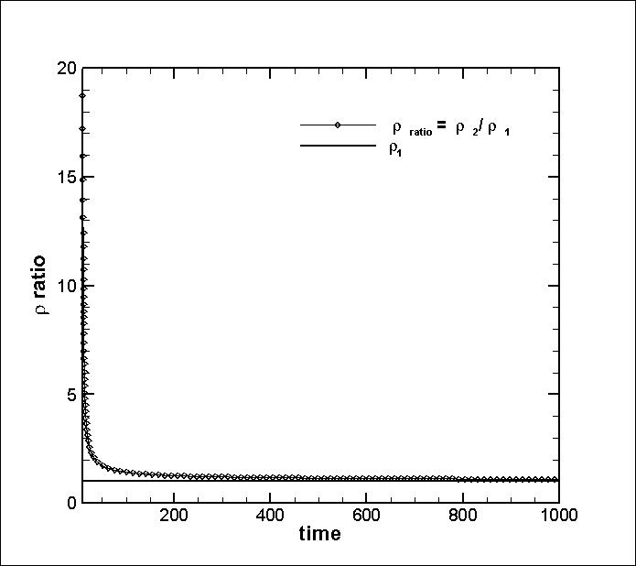

|  |  |  |  |  |
| --- | --- | --- | --- | --- |
| $$ν_{inf}*$$ | $$Pr=\frac{c_{p}μ}{k}$$ | $$ρ_{1}^{*}$$ | $$ρ_{2}^{*}$$ | $$t_{0}$$**(off-set time)** |
| $$0.02$$ | $$0.75$$ | $$\frac{MW_{mix}}{MW_{1}}=0.0097$$ | $$\frac{MW_{mix}}{MW_{2}}=1$$ | 10 |
| $$δ_{0}$$**(characteristic lengthscale)** | $$Re_{ref}$$ | $$T_{inf}(K)$$ |  |  |
| $$2$$ | 50 |  |  |  |

|  |  |  |
| --- | --- | --- |
|  |  |  |
| (10,30,5) | (10,2400,4) | Uniform grid in x, z, y |
| **Initial Conditions** | **Specific Enthalpy model** | $$farfield boundary$$ |
| $$u_{init}=0, w_{init}=0$$ $$v_{init}=v_{exact}\left(t=t_{0}\right)$$ $$Z_{init}=Z_{exact}\left(t=t_{0}\right)$$ $$h_{init}=h^{*}(Z_{init}, T_{amb})$$ | CHEMKIN coefficient data base w/  enthalpy polynomial: $$h^{*}=a_{6}+a_{1}T+\frac{c_{2}T^{2}}{2}+\frac{c_{3}T^{3}}{3}+\frac{c_{4}T^{4}}{4}+\frac{c_{5}T^{5}}{5}$$ | $$u_{farfield}=0$$ $$\frac{dv}{dy}= 0,\frac{dw}{dy}=0$$ $$\frac{dh}{dy}= 0,\frac{dZ}{dy}=0$$ |
| $$wall boundary$$ | $$Scalar Discretization Option$$ | $$Periodicity$$ |
| $${u_{i}}_{wall}=No slip$$ $$T_{wall}=T_{inf}$$ | QUICK | Spanwise, Streamwise |

