|  |  |  |  |  |
| --- | --- | --- | --- | --- |
| $$ν_{inf}(m/s^{2})$$ | $$Pr=\frac{c_{p}μ}{k}$$ | $$ν_{wall} (m/s^{2})$$ | $$k_{inf}(m/s^{2})$$ | $$k_{wall }(m/s^{2})$$ |
| $$0.02$$ | $$0.71$$ | $$ν_{inf}{\left({T_{w}}/{T_{a}}\right)}^{1.6}=0.0383$$ | $$\frac{{c_{p}ν}_{inf}ρ_{inf} }{Pr}=0.0539$$ | $$\frac{{c_{p}ν}_{wall}ρ_{wall} }{Pr}=0.05685$$ |
| $$L_{0}-L_{z}$$ | $$Re$$ | $$δ^{*}\left(z=L_{0}\right) \left(m\right)$$ | $$δ\left(z=L_{0}\right) \left(m\right)$$ | $$T_{wall} \left(K\right)$$ |
| $$16.84 -200 m$$ |  | $$1$$ | 3 | 450K |
| $$U_{ref}\left(\frac{m}{s}\right)$$ | $$δ^{*} \left(m\right)$$ | $$ν_{ref}\left(\frac{m}{s^{2}}\right)$$ | $$Re_{ref}=\frac{u_{ref}L_{ref}}{ν_{ref}}$$ |  |
| 1.0 | 1.0 | 0.02 | 50 |  |

|  |  |  |  |
| --- | --- | --- | --- |
|  |  |  | |
| (200,60,4) | (128,96,4) | * Wall –normal hyperbolic   ($α$ = 2.75)   * Uniform grid in x, z | |
| $$Inflow boundary$$ | $$outflow boundary$$ | $$freestream boundary$$ | |
| $$u=u_{blasius}, \\ v=v_{blasius},$$ $$w=0$$ $$T=T_{wall}$$ | $$Orlansky$$ $$\frac{∂u_{i}}{∂t}+U_{c}\frac{∂u_{i}}{∂x_{i}}=0$$ $$\frac{∂h}{∂t}+U_{c}\frac{∂h}{∂x_{i}}=0$$ $$U_{c}=\frac{1}{L_{y}}\int{u_{outflow}dy}$$ | $$\frac{du_{i}}{dy}= 0$$ $$\frac{dh}{dy}= 0$$ | *(Option) $$\frac{du}{dy}=0,\frac{dw}{dy}=0$$ $$v=v_{blasius}$$ $$\frac{dh}{dy}= 0$$* |
| $$wall boundary$$ | $$Scalar Discretization Option$$ | $$Periodicity$$ | |
| $${u_{i}}_{wall}=No slip$$ $$T_{wall}=450K$$ | QUICK | Spanwise | |

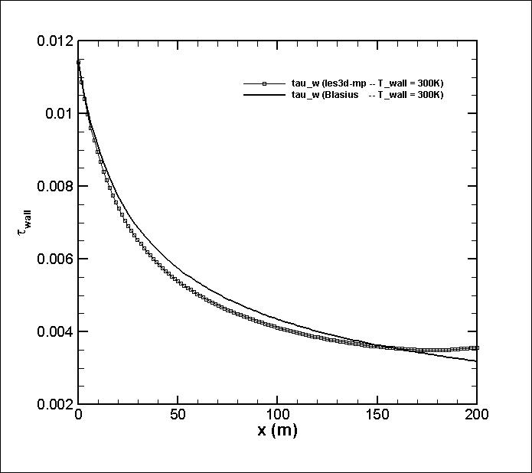

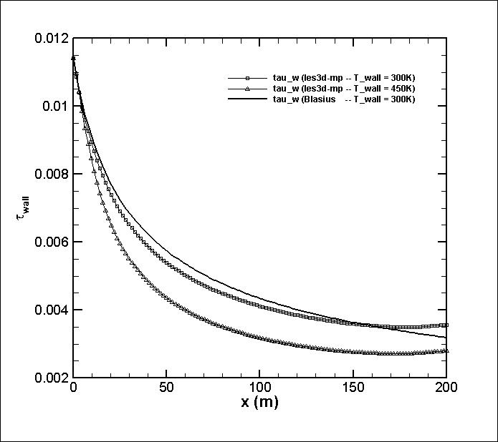

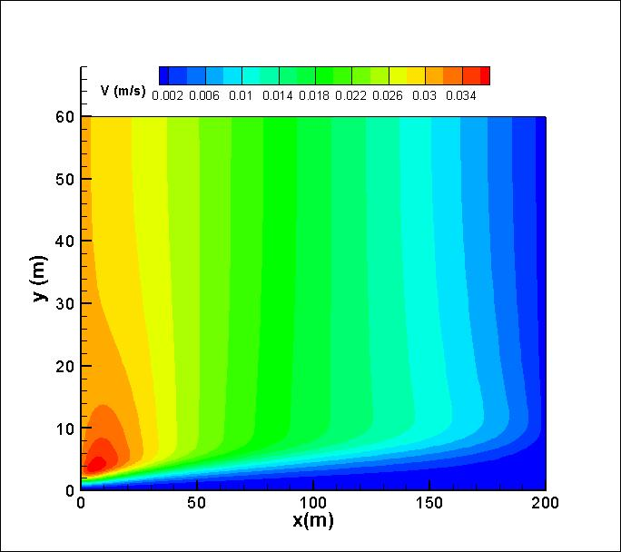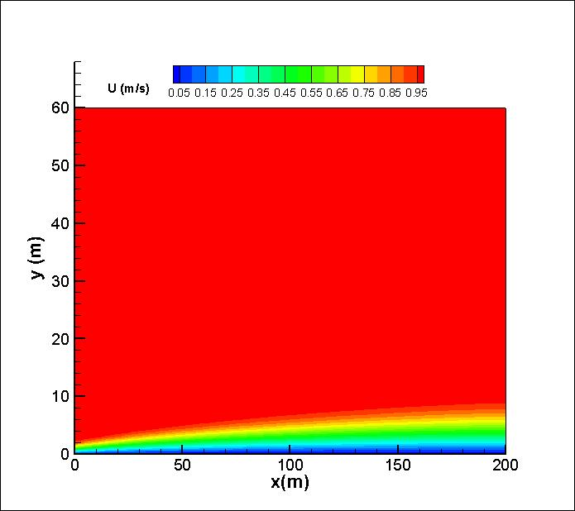ddd

