Time Advancement

Runge-Kutta:
Stage rk advances the solution from time 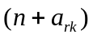 to time 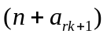, with (a₁, a₂, a₃, a₄) = (0,8/15,2/3,1) (assuming substeps = 3)

STEP 1: INITIALIZATION (before start of iterative loop)
- Initial guess (iter = 0) of mass density:
If rk = 1,
or 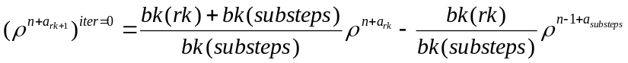
If rk > 1,
or 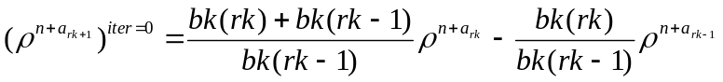
- Store previous values of various quantities required for advancing the solution: 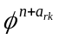, 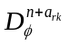, 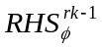, 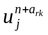, 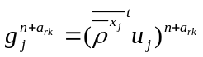, 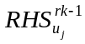

STEP 2: SCALAR EQUATIONS (start of iterative loop, from (iter-1) to iter)
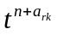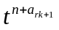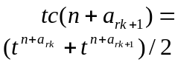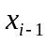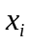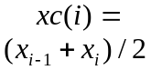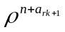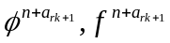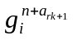
NB: The RHS of the scalar equation is evaluated at the center of the spatio-temporal cell, identified by a black dot.
- Calculate: 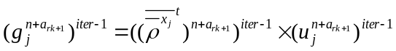, 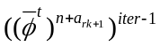, 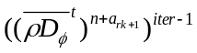
- Initialize scalar fields: 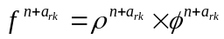
- Solve scalar equations: 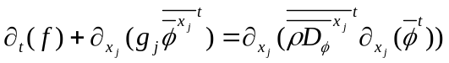, where 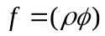 and 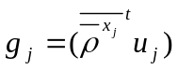, and provide 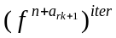, 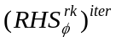
- Calculate intermediate value
- Impose boundary conditions

STEP 3: EQUATION OF STATE
- Calculate 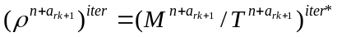

STEP 4: UPDATE SCALAR FIELDS
- Calculate 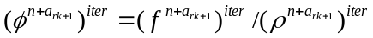
- Impose boundary conditions

STEP 5: MOMENTUM EQUATIONS
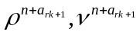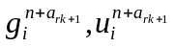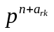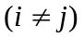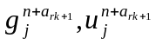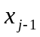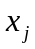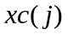
NB: The RHS of the momentum equation is evaluated at the bottom right edge of the spatio-temporal cell, identified by a black dot.
- Calculate: 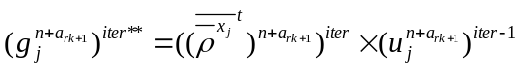, 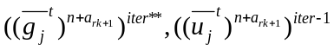
- Initialize momentum field: 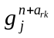
- Solve momentum equations: 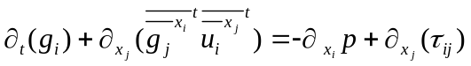, where 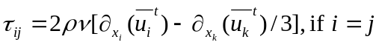, and 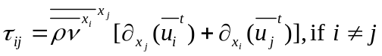, and provide 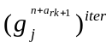, 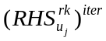
- Calculate intermediate velocity 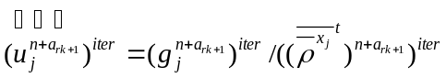
- Impose boundary conditions
- Calculate intermediate momentum field 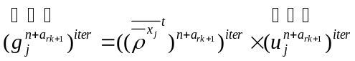

STEP 6: PRESSURE EQUATION
- Solve pressure equation: 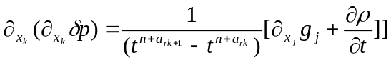 or 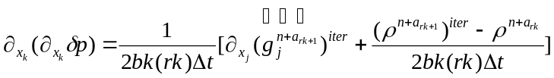, and provide 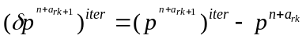

STEP 7: UPDATE VELOCITY AND PRESSURE (end of iterative loop)
- Calculate:
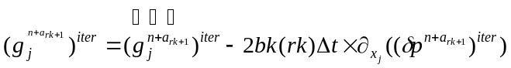, 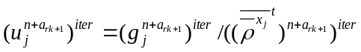
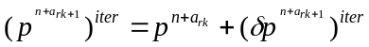
- Impose boundary conditions

- Prepare for next Runge-Kutta stage and update values of 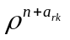 and 