Here is a fuller explanation of the scoring. The game ends when the board is full of stones or when both players pass. For experienced players, the game will nearly always end with both players passing. An example of a board after both players have passed is below.

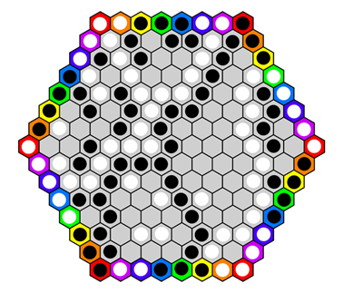

So, now it’s time to score. Let’s look at White’s score. The first step is to identify White’s groups, that is, the different groups of white stones connected to each other. Start with White’s biggest group. I’ve marked the stones in this group with a red dot below:

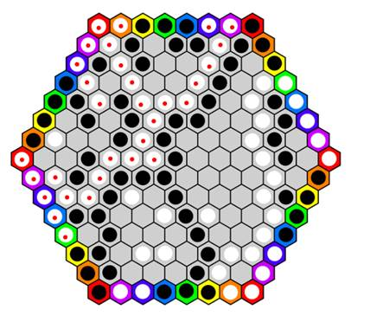

Now, what is this group’s score? The score is equal to the number of border stones it contains, that is, the number of stones on a colored cell. (It doesn’t matter what colors are occupied; all that matters is that the cell has some color, that is, is not gray.) Also note that it doesn’t matter how many stones total are in a group. Stones on gray cells count for nothing toward a group’s score.

The group marked in the picture above has 11 stones on colored cells. So, that group’s score is 11.

White of course has other groups besides this one. Here is one other White group, marked with green. Its score is 9 since 9 of its stones occupy colored cells:

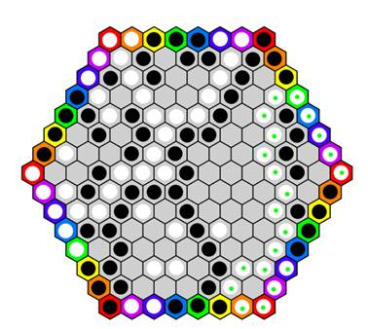

White has one more scoring group, marked in blue below. It scores just 2 since it has two stones in colored cells:

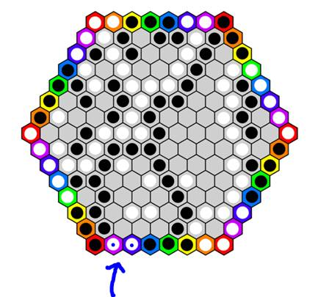

White has some other groups in the interior (a single stone here and there, and a pair of stones) but these score 0 since they do not have any stones occupying colored cells.

So in summary, White has three scoring groups, with scores as follows: 11, 9, and 2.

Let’s do the same for Black.

Here’s Black’s biggest group, marked in red. It scores 9 since 9 of its stones occupy colored cells.

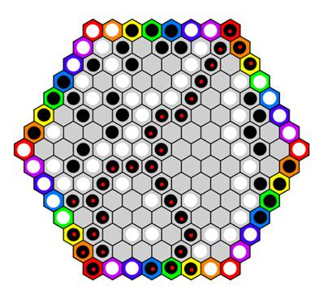

Here are all of Black’s other groups, marked in distinct colors. The green-marked group scores 4. The yellow-marked group scores 4. The blue-marked group scores 3.

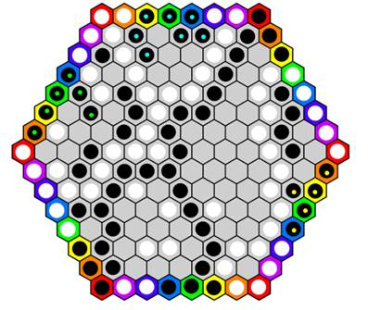

So, in total Black has four scoring groups. Their scores are 9, 4, 4, 3.

Now, who has won the game? The answer = the player with the highest scoring group. So, you look at only the highest scoring group. The scores of the other groups are irrelevant (unless the highest scores are tied). It’s also irrelevant how many scoring groups a player has. For instance, in the game above, White has three scoring groups and Black has four scoring groups. That doesn’t matter. What matters is the single group with the highest score.

So in the current game, White’s highest scoring single group is 11, compared to Black’s highest scoring single group, which is 9. So, it’s 11 versus 9, and White wins!

Now, what if the players’ highest scoring groups had been tied? For instance, suppose that White had groups with scores of 9, 8, and 2, and suppose that Black had groups with scores of 9, 7, 4, 3. What then?

The answer is that you set the highest scoring groups aside and compare the players remaining groups. So, the two groups of 9 are set aside, and you compare White’s remaining groups (8,2) with Black’s remaining groups (7,4,3). Take just the highest scoring single group of these. So, it’s 8 vs 7. White wins on the tie break!

But suppose that THESE groups had had the same score too. For instance suppose the scoring groups are as follows:

White: 9, 7, 3

Black: 9, 7, 4, 3

In this case you’d set aside both the 9s and the 7s and compare the remaining groups. Thus, you compare 3 with 4,3. Take the highest scoring group from these, namely, 3 for White and 4 for Black. 4 beats 3, so Black wins.

In summary, you compare highest scores, working down the line if scores are tied, until you come to a non-tied pair of scores. Of the non-tied pair, the owner of the higher scoring group wins the whole game.

I hope that clears it up. This explanation makes the idea sound more complex than it really is. Once you get the idea, it becomes simple to use in practice.

I’m writing with a follow up to my first email.  This new email is just to recommend that you start on smaller boards than the board in my graphics in my previous email.  That board is a “hexhex” board of size 8.  (A *hexhex board* is a hexagonal-shaped board made of hexagonal cells.  The board in my graphics in the previous email is “size 8” since each side of the board has 8 cells.)

You can certainly play Iris on boards of sizes 6 or 7.  I think you could even have viable game of Iris on a hexhex board of size 5.  The bigger the board, the more complicated the board is to “read.”  So, smaller boards are much better for beginners.

If you use smaller boards, then just be sure to get the colors of the border cells right.  Sorry, I don’t have time to make board images via a graphics editor, but the text “images” below give you the idea.  The letters in the border cells stand for colors that the cells are filled with:  R = red, O=orange, Y=yellow, G=Green, B=blue, P=purple.   The dots are of course gray-colored cells.

Hexhex5:

     R O Y G R

    G . . . . O

   Y . . . . . Y

  O . . . . . . G

R . . . . . . . R

  G . . . . . . O

   Y . . . . . Y

    O . . . . G

     R G Y O R

Hexhex6:

         R O Y G B R

        B . . . . . O

       G . . . . . . Y

      Y . . . . . . . G

     O . . . . . . . . B

    R . . . . . . . . . R

     B . . . . . . . . O

      G . . . . . . . Y

       Y . . . . . . G

        O . . . . . B

         R B G Y O R

Hexhex7:

         R O Y G B P R

        P . . . . . . O

       B . . . . . . . Y

      G . . . . . . . . G

     Y . . . . . . . . . B

    O . . . . . . . . . . P

   R . . . . . . . . . . . R

    P . . . . . . . . . . O

     B . . . . . . . . . Y

      G . . . . . . . . G

       Y . . . . . . . B

        O . . . . . . P

         R P B G Y O R

By the way, just in case it is not clear from the rules, let me clarify the placement rules for playing stones on colored cells.

For instance, suppose you wish to play on the following yellow cell (on the hexhex8 size board):

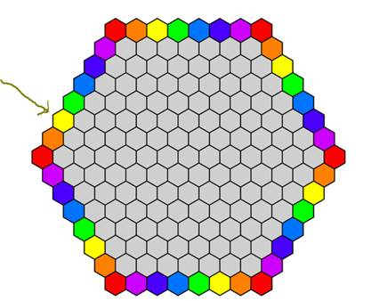

Then the rules require you to play your second stone in the yellow cell on *the opposite side* of the board:

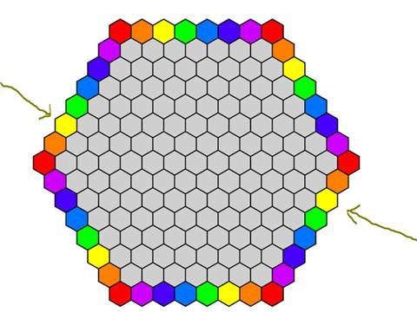

You have no choice about this.  Playing the same-colored cell on the opposite side of the board is REQUIRED.

Another example: if you play in a red corner cell, then you must play your second stone in the opposite corner cell.  For instance:

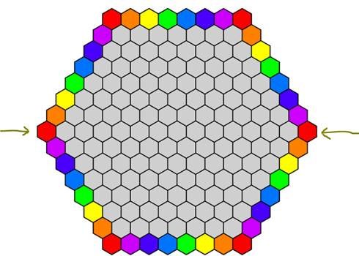

By the way, it’s an interesting feature of Iris that, despite the fact that there is always an even total number of colored cells (no matter what the board size is), the game of Iris CANNOT end in a tie.  You cannot have two sets of groups (one set for White, the other set for Black) which are mirror images of each other.  So, say, it can never happen that White’s scores are 9,7,3,2 and Black’s scores are also 9,7,3,2.  In other words, draws are impossible in Iris.

And just to be extra clear, here are the rules for playing stones on gray cells (that is, interior cells, as opposed to colored border cells).  Suppose I place a black stone in the following gray cell:

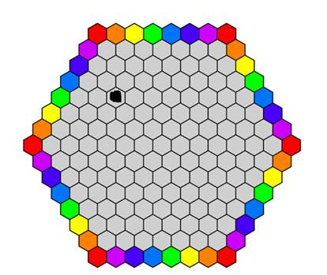

In that case my second stone can be played in ANY empty gray cell except those gray cells that are neighbors with the first stone.  So, I can play my second stone in any gray cell below EXCEPT the cells marked with a red dot.  Those red-dot cells are off-limits:

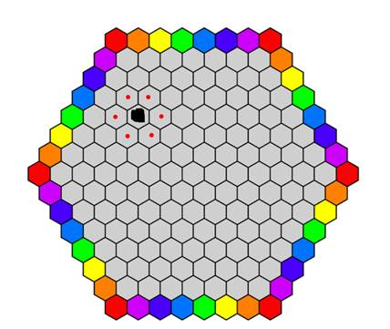

CAUTION:  the above example is made-up.  In real play there would be other stones already in the board.  Note that the first player to play a stone (that is, play a stone to the empty board) only gets to place ONE stone on his first turn (and he must place it on a gray interior cell).  Thereafter, each player gets to place TWO stones on each of his turns (on either two gray cells, or on two colored cells, according to the rules just described).  So, Player 2 on his very first turn gets to place TWO stones.  Then Player 1 on his second turn gets to place TWO stones – and so on for the rest of the game.

The reason for the rule that Player 1 only gets one stone to place on his very first turn is the following.  In most abstract strategy games, the first player to play in the game has a significant advantage.  This is the case in Chess and Go for instance; both games have a first player advantage.    The idea in Iris of having two stones per turn normally, but just one stone for Player 1 on his first turn, is that this temporary one-turn disadvantage offsets the first player advantage for Player 1, and in doing so balances the game.  That is, the hope is that two expert and evenly-matched Iris players would in the long run have win rates very near 50/50, regardless of whether they play as Player 1 or Player 2.