Context Diagram
System Context Diagrams are diagrams used in systems design to represent the more important external factors that interact with the system at hand. It shows the interactions between a system and other actors with which the system is designed to interface.
The objective of a system context diagram is to focus attention on external factors and events that should be considered in developing a complete set of system requirements and constraints.

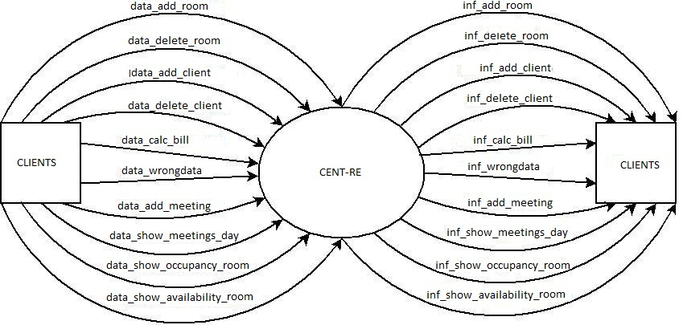
The External entity is the client that want to make reservation of one meeting room.
The context diagram has the next in data flow:
- data_add_room
- data_delete_room
- data_add_client
- data_delete_client
- data_calc_bill
- data_wrongData
- data_add_meeting
- data_show_meetings_day
- data_show_occupancy_room
- data_show_availability_room

it has the next out data flow:
- inf_add_room
- inf_delete_room
- inf_add_client
- inf_delete_client
- inf_calc_bill
- inf_wrongData
- inf_add_meeting
- inf_show_meetings_day
- inf_show_occupancy_room
- inf_show_availability_room

Event list
The event list are the external events to which the system must respond.
- add_room
- delete_room
- add_client
- delete_client
- calc_bill
- wrongData
- add_meeting
- show_meetings_day
- show_occupancy_room
- show_availability_room

