Project Specification
We want to develop a informtic system called CENT-RE wich manages a center for meetengs, including meeting rooms, and meeting customers. This should be handled the following information:
- Meeting room: storing the name, capacity (maximum number of persons) and hourly rate.
- Client: storing identification number, name and billing address.
- Meeting: storing a name, a number of attendees, a start date, a time beginning, an end date and end time.

Team organisation and responsibilities
We are a team of three and we decide the roles in base of our knowledges.
The roles are:
- Janina Lissete Moscoso León → Manager
- Luis Ildefonso Gómez Solana → Designer
- Ana Escrich Acero → Planner

Requirements
- Add a meeting room, given all data. It is not allowed rooms take the same name.
- Delete a meeting room, given its name. Rooms may not be removed if are reserved for a meeting.
- Add a client, given all the personal data. There may be no two customers with the same ID number.
- Remove a client, given their ID number. Deleting a client will remove all its meetings and the reservation of facilities associated.
- Add a meeting, given your data and customer NIF. As a customer can not be add two meetings with the same name. By adding a meeting the system must locate and assign a room that is available and has adequate capacity to accommodate the number of meeting attendees. That room will be scheduled from the beginning of the meeting (date and start time) until the end of it (date and time of order). If no no room available the system can not discharge the meeting.
- Show day meetings: The user requests to know all the meetings that take place one day when the user provides. The system will return a list with information about the day's meetings.

- Show occupancy of a room in a month: The user requests to know the meetings that take place in a room that you specify in a month also specified by the user. The system will return a list of all meetings held in the room for each day of the month.

- Show the availability of rooms in a period of time: The user requests to know the rooms that are fully available in time to facilitate a start date and an ending. The system will return a list of rooms that are available in the period of time.
- Calculate bill a client: The user requests to know a customer's bill making it easier to NIF for a month and a year concrete also provided by the user. The system returns a list of client meetings ending in the given month, giving the total hours and total cost.

Schedule

Context Diagram
System Context Diagrams are diagrams used in systems design to represent the more important external factors that interact with the system at hand. It shows the interactions between a system and other actors with which the system is designed to interface.
The objective of a system context diagram is to focus attention on external factors and events that should be considered in developing a complete set of system requirements and constraints.

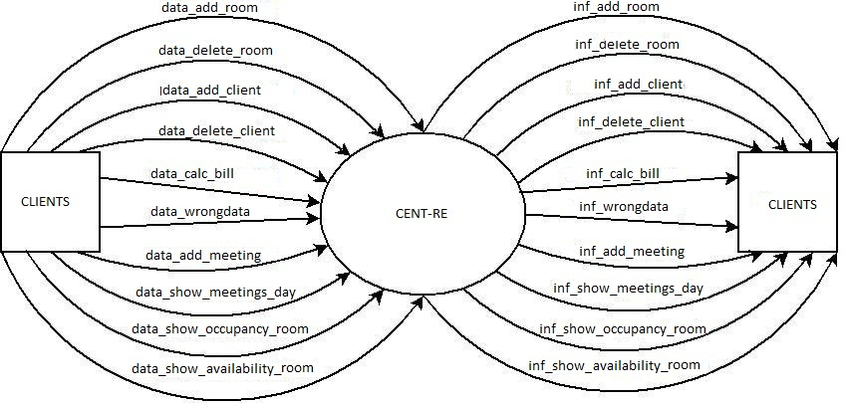
The External entity is the client that want to make reservation of one meeting room.
The context diagram has the next in data flow:
- data_add_room
- data_delete_room
- data_add_client
- data_delete_client
- data_calc_bill
- data_wrongData
- data_add_meeting
- data_show_meetings_day
- data_show_occupancy_room
- data_show_availability_room

it has the next out data flow:
- inf_add_room
- inf_delete_room
- inf_add_client
- inf_delete_client
- inf_calc_bill
- inf_wrongData
- inf_add_meeting
- inf_show_meetings_day
- inf_show_occupancy_room
- inf_show_availability_room

Event list
The event list are the external events to which the system must respond.
- add_room
- delete_room
- add_client
- delete_client
- calc_bill
- wrongData
- add_meeting
- show_meetings_day
- show_occupancy_room
- show_availability_room

Use Case
