Modelling

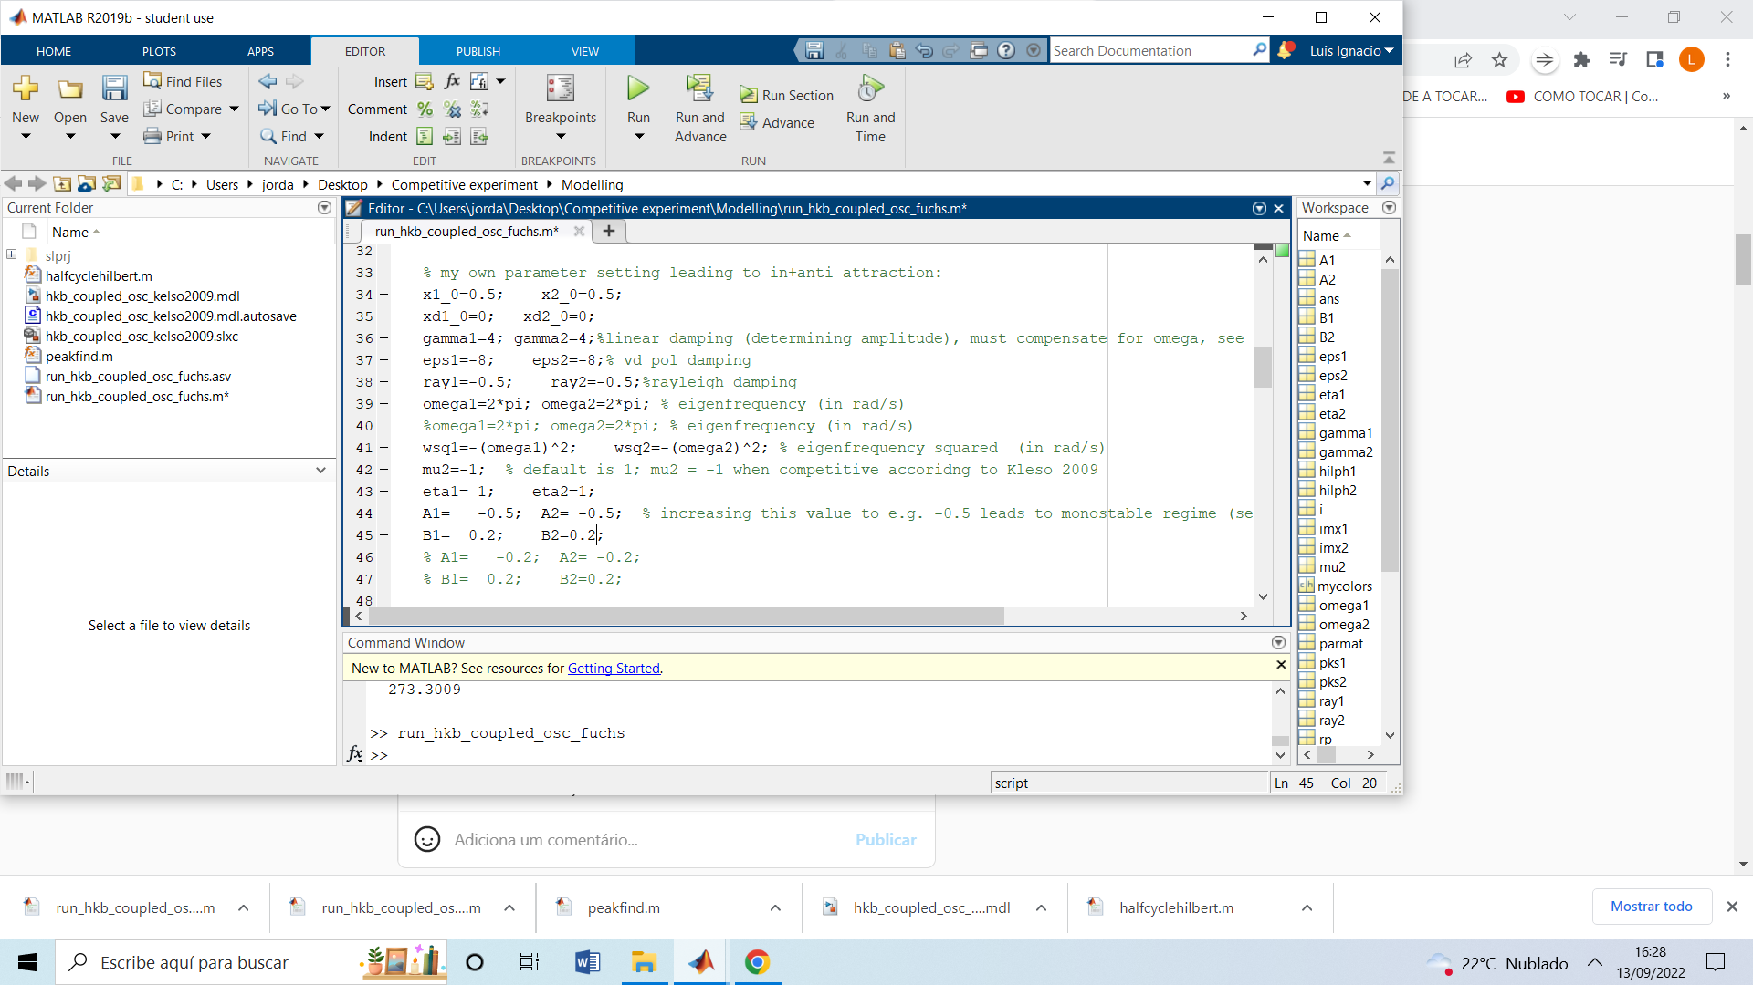

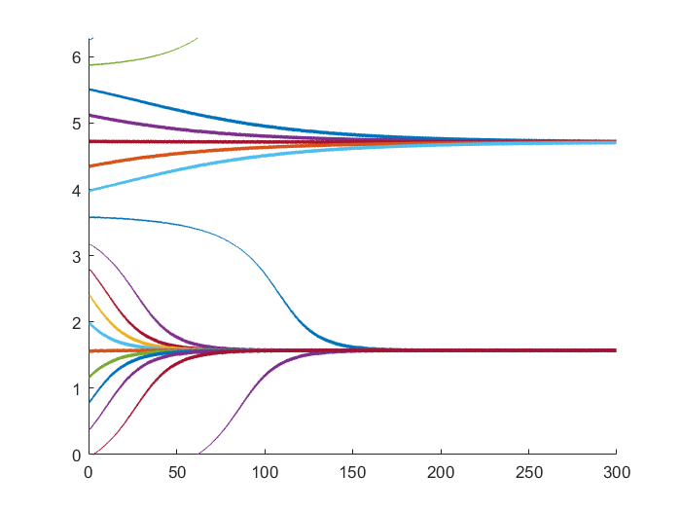

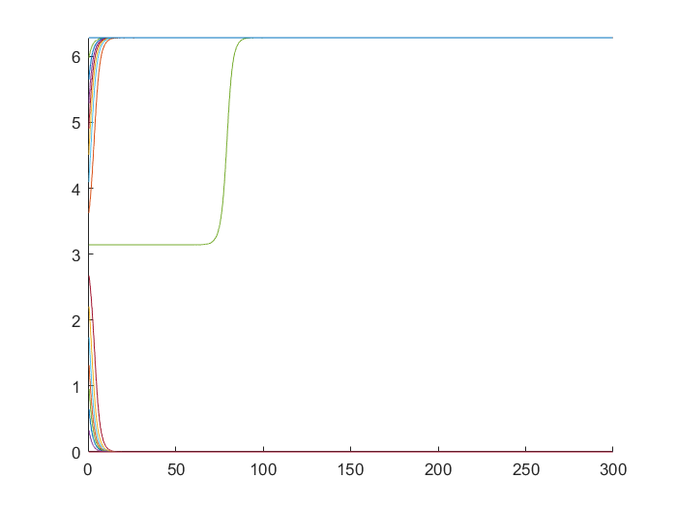

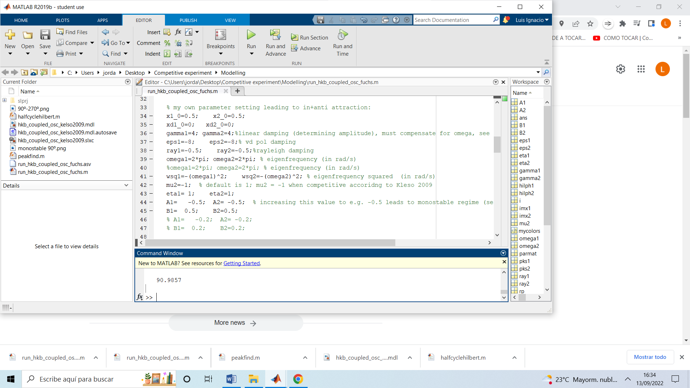

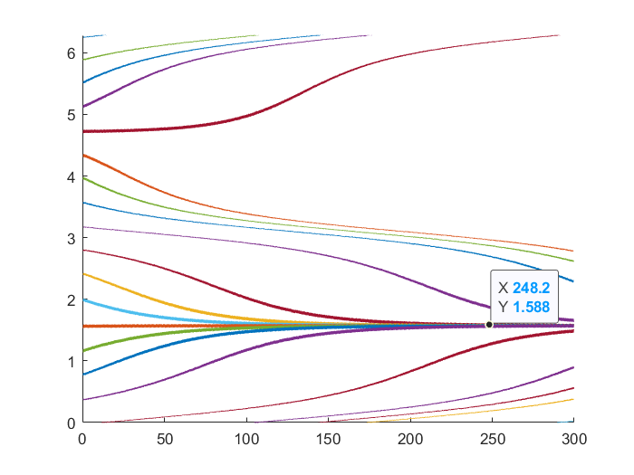

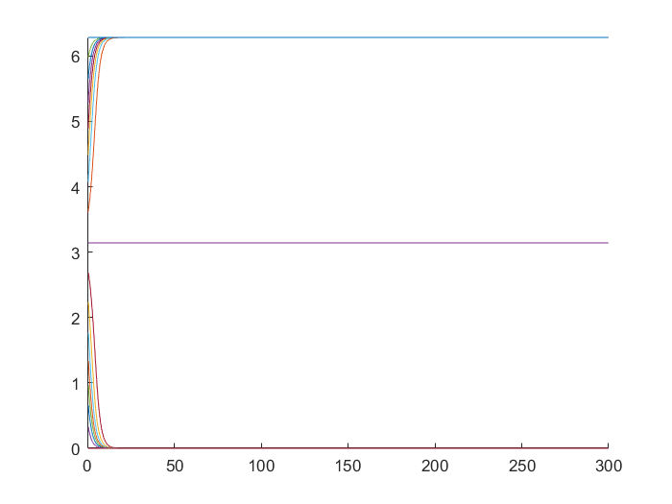

I found a bunch of results like the one bellow by growing differences in gamma with defender leading, from 330º (-30º) for small differences in gamma, to 285º before the system stops been stable (gamma1=9). Then there is a breaking point gamma1=10 and gamma2=4 where the system enters a state of metastability with an ghost attractor around 290º. If you look to our results, an attractor around the space between 0º and -90º (or 0º and 90º) will explain our results quite nicely.

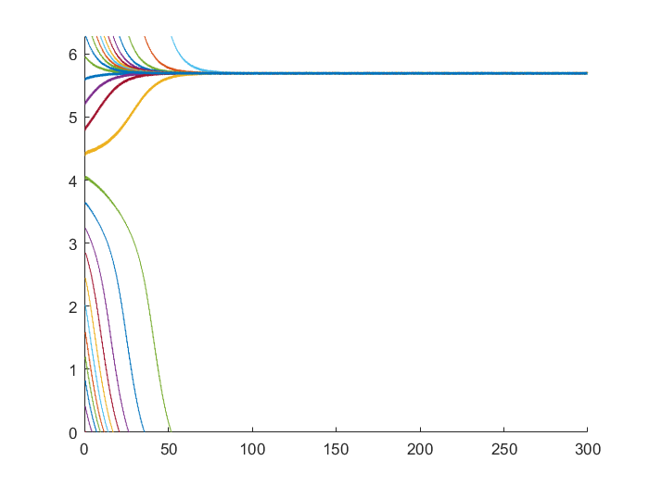

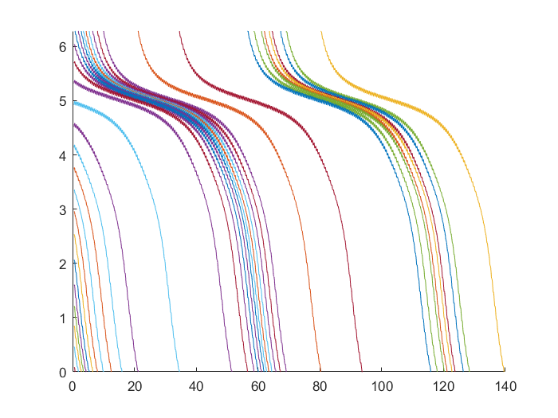

Another interesting effect. By reducing the repulsive force mu=-0.5 the attractor around 90º disappears and the system is stable around 0º. With the attacker leading. Interestingly enough, and consistent with the educated guess that the antiphase instruction (attacker) is the one with repulsive force, we found that the antiphase is stable with mu=-2, two times the attractive force. If we assume the strength of the force (repulsive or attractive) as a raw measure of skill, these results could explain the 180º high results for one of the conditions, as in some couples maybe one of the performers was clearly more skilled than the other one.

Less repulsive force

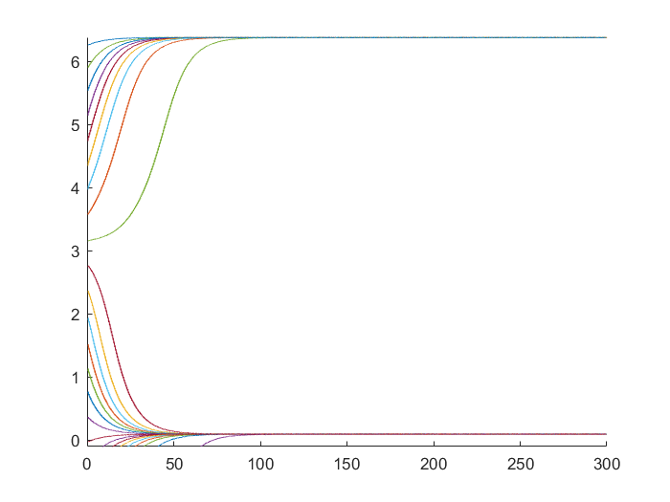

More repulsive force.

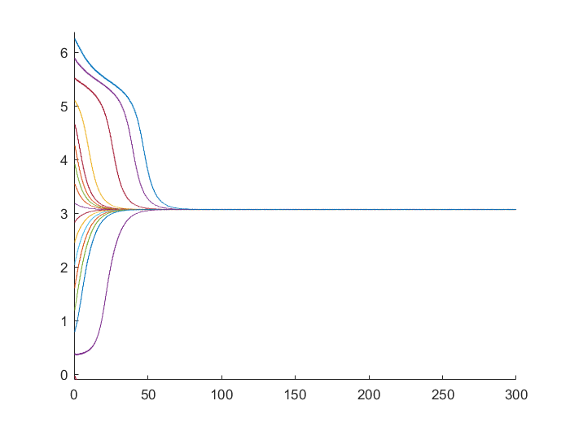

Interestingly enough keeping this asymmetric strength of the forces we found that with growing dissimilarities in amplitude (growing the amplitude of the attacker) the results are similar than before. The one with smaller amplitudes is leading until it stops been stable. Surprisingly it is more resistant to amplitude differences with asymmetries in the strength of coupling. Before in gamma1=10, for gamma2=4 it stopped been stable. In this case for less repulsive force gamma1=10 is still stable, and for more repulsive force gamma2=12 is still stable.

Less repulsive force

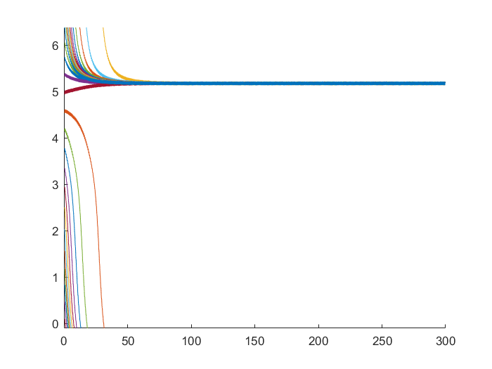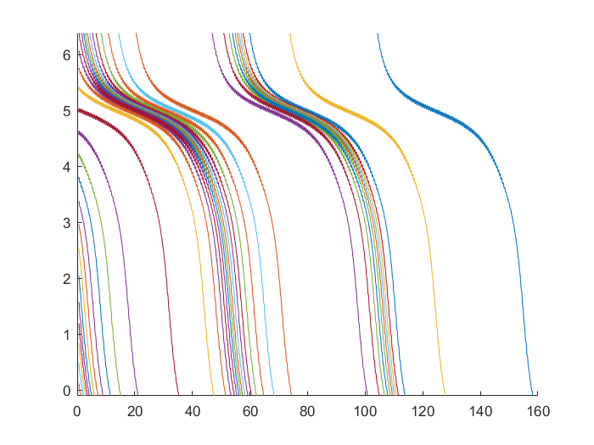

More repulsive force

