ITSupport247: Deploying Missing OS Patches by Policy
Version 1.0 | Luis Lazo | IT Intern - CMIT Solutions of Sandy
Date: February 10, 2026

📋 Table of Contents
- Prerequisites
- Step-by-Step Instructions
- Best Practices
- Expected Results
- Troubleshooting

🔧 Prerequisites
- ConnectWise Account with ITSupport247 RMM access
- Administrative permissions for patch management
- Target devices online and agent-connected

📖 Step-by-Step Instructions

Step 1: Access ITSupport247 Dashboard
text
1. Log in to ConnectWise
2. Click **"Asio"** in the main menu
3. ITSupport247 dashboard loads automatically
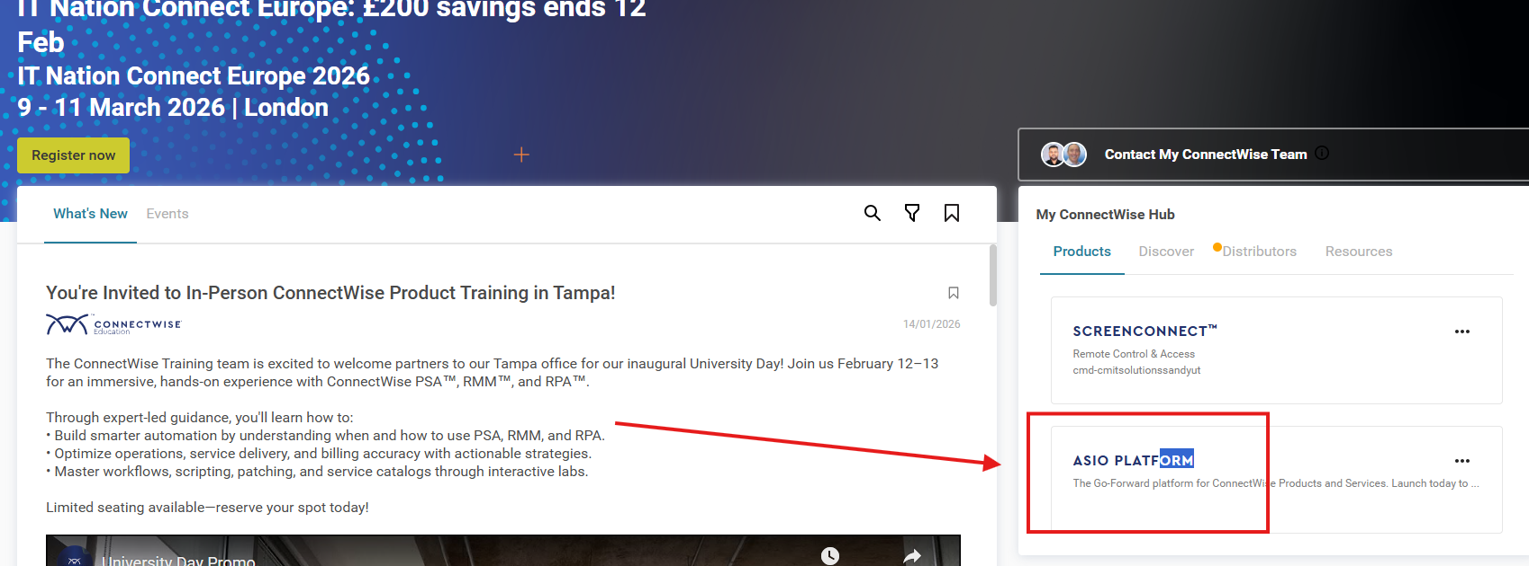

Step 2: Navigate to Automation Module
text
1. Main Dashboard → Locate **"Automation"** section
2. Click **Automation** to expand options

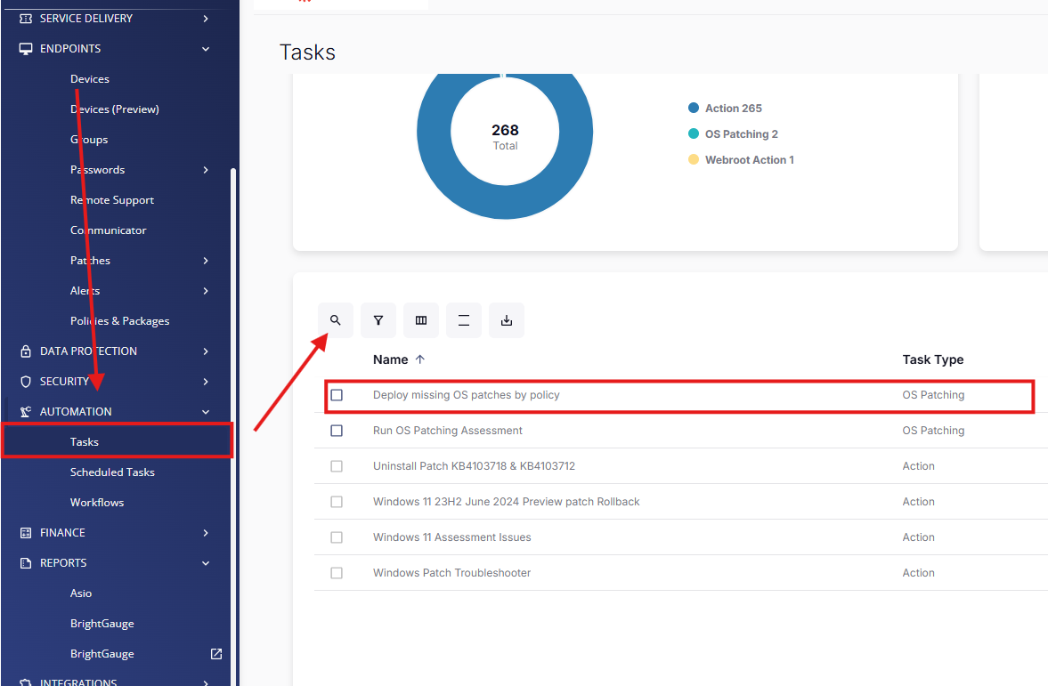Step 3: Configure Patch Deployment
text
1. **Right panel** → Hover over **⏰ Clock icon** → Click
2. **Deployment Options:**
| Option | Description |
|--------|-------------|
| **Run Now** | Immediate deployment |
| **Schedule** | Set date/time for deployment |

3. **Select Targets:**
| Target Type | Selection Method |
|-------------|------------------|
| Devices | Individual selection |
| Groups | Policy-based groups |
| All Systems | Organization-wide |

4. Click **"Run"** → **Task scheduled successfully**
Screenshot placeholder: [Clock icon → Deployment scheduler]

Step 4: Verify Deployment Status
text
1. **Automation History** → View scheduled tasks
2. **Real-time Status:** Pending | Running | Completed
3. **Compliance Reports** → Success/Failure rates

✅ Best Practices
text
🔥 **CRITICAL PATCHES:** Deploy within 72 hours
📅 **ROUTINE PATCHES:** Weekly (Patch Tuesday aligned)
⏰ **OFF-PEAK:** Schedule 2:00 AM - 6:00 AM local time
📊 **MONITOR:** Post-deployment compliance reports

🆘 Troubleshooting
text
❌ **"No targets found":** Verify agent connectivity
❌ **"Deployment failed":** Check policy permissions
❌ **"Patches not detected":** Run OSPatchment Assessment first
ℹ️ **Support:** control.itsupport247.net → Tickets

Author Contact: Luis Lazo - CMIT Solutions Santiago

