Sample DOCX Document

# Introduction

This is a comprehensive sample DOCX document that demonstrates various document elements including text formatting, images, structured tables, and unstructured tables with merged cells.

Generated on: 2025-06-13 21:47:32

## Sample Image

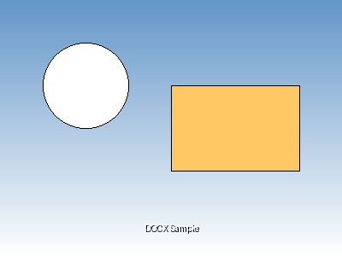

## Structured Table

This is a normal structured table with consistent formatting:

|  |  |  |  |
| --- | --- | --- | --- |
| **Product** | **Category** | **Price** | **Stock** |
| Laptop | Electronics | $999.99 | 25 |
| Smartphone | Electronics | $699.99 | 50 |
| Desk Chair | Furniture | $199.99 | 15 |
| Coffee Mug | Kitchen | $12.99 | 100 |

## Unstructured Table (Merged Cells)

This table demonstrates both horizontal and vertical cell merging:

|  |  |  |  |
| --- | --- | --- | --- |
| Department | Q1 | Q2 | Q3 |
| Sales | $10,000 | $12,000 | $15,000 |
| Marketing | $5,000 | $6,000 | $7,000 |
| Total | $15,000 | $18,000 | $22,000 |
| Grand Total (All Quarters) | | | $55,000 |

## Additional Text Content

This document serves as a comprehensive example for testing document processing capabilities. It includes various formatting styles, different types of content, and complex table structures that are commonly found in business documents.

* Key features demonstrated:
* Rich text formatting
* Image embedding
* Structured data tables
* Complex merged cell layouts