Sample DOCX Document

Introduction
This is a comprehensive sample DOCX document that demonstrates various document elements including text formatting, images, structured tables, and unstructured tables with merged cells.
Generated on: 2025-06-13 21:47:32

Sample Image
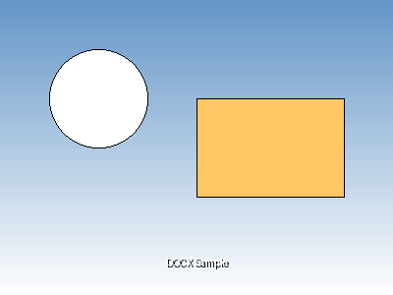

Structured Table
This is a normal structured table with consistent formatting:
Product | Category | Price | Stock
Laptop | Electronics | $999.99 | 25
Smartphone | Electronics | $699.99 | 50
Desk Chair | Furniture | $199.99 | 15
Coffee Mug | Kitchen | $12.99 | 100

Unstructured Table (Merged Cells)
This table demonstrates both horizontal and vertical cell merging:
Department | Q1 | Q2 | Q3
Sales | $10,000 | $12,000 | $15,000
Marketing | $5,000 | $6,000 | $7,000
Total | $15,000 | $18,000 | $22,000
Grand Total (All Quarters) |  |  | $55,000

Additional Text Content
This document serves as a comprehensive example for testing document processing capabilities. It includes various formatting styles, different types of content, and complex table structures that are commonly found in business documents.
- Key features demonstrated:
- Rich text formatting
- Image embedding
- Structured data tables
- Complex merged cell layouts

