|  |  |  |  |  |
| --- | --- | --- | --- | --- |
| Fecha | Versión | Incidencias | Entrega | Comentario |
| 21/03/2023 | 1 | 7 | 16/03/2023 | Datos incorrectos en los parámetros al buscar y error al generar el informe. |
|  |  |  |  |  |
|  |  |  |  |  |

**Histórico de Cambios**

1. Si se incluye un código de modelo y se pulsa la lupa, ese código no se está trasladando a la pantalla de búsqueda. Además, al no hacerlo, si el código es único, no se está devolviendo automáticamente la información del modelo. Este funcionamiento es el mismo siempre con la búsqueda de modelos.
2. No se están actualizando correctamente los registros del listado. Tras seleccionar modelo e incluir filtros y pulsar buscar, no se está visualizando ningún resultado en el listado pese a que si los hay. Si se cambia el tamaño de la pantalla, aparecen los registros. Este comportamiento ocurría en otras pantallas similares. Además, si una vez mostrados los resultados realizamos una consulta que no devuelve nada, el listado se queda con scroll y las filas anteriores en blanco.

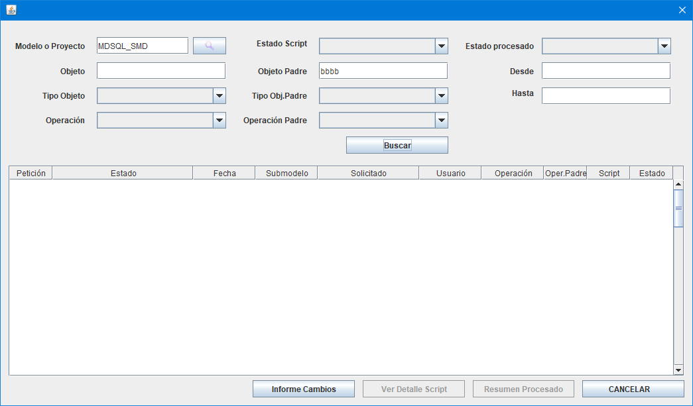

1. Si se realiza una búsqueda (que devuelve resultados) y se pulsa el botón de Informe Cambios se produce el siguiente error (la pila del error solo sale en la ventana de CMD, no se escribe en el fichero de log):

12:53:08.511 [AWT-EventQueue-0] INFO c.m.b.service.impl.ServiceSupport - {call SM2_K_LD_MDSQL_MARIPAM.P_INFORME_CAMBIOS(?,?,?,?,?,?)}

12:53:08.511 [AWT-EventQueue-0] INFO c.m.b.service.impl.ServiceSupport - Parßmetros de entrada:

MDSQL_SMD

NULL

NULL

Exception in thread "AWT-EventQueue-0" java.lang.NullPointerException

at com.mdsql.bussiness.service.impl.ExcelGeneratorServiceImpl.createRowInforme(ExcelGeneratorServiceImpl.java:154)

at com.mdsql.bussiness.service.impl.ExcelGeneratorServiceImpl.generarExcelHistoricoCambios(ExcelGeneratorServiceImpl.java:46)

at com.mdsql.ui.listener.PantallaHistoricoCambiosListener.informeCambios(PantallaHistoricoCambiosListener.java:122)

at com.mdsql.ui.listener.PantallaHistoricoCambiosListener.actionPerformed(PantallaHistoricoCambiosListener.java:58)

at javax.swing.AbstractButton.fireActionPerformed(Unknown Source)

at javax.swing.AbstractButton$Handler.actionPerformed(Unknown Source)

at javax.swing.DefaultButtonModel.fireActionPerformed(Unknown Source)

at javax.swing.DefaultButtonModel.setPressed(Unknown Source)

at javax.swing.plaf.basic.BasicButtonListener.mouseReleased(Unknown Source)

at java.awt.Component.processMouseEvent(Unknown Source)

at javax.swing.JComponent.processMouseEvent(Unknown Source)

at java.awt.Component.processEvent(Unknown Source)

at java.awt.Container.processEvent(Unknown Source)

at java.awt.Component.dispatchEventImpl(Unknown Source)

at java.awt.Container.dispatchEventImpl(Unknown Source)

at java.awt.Component.dispatchEvent(Unknown Source)

at java.awt.LightweightDispatcher.retargetMouseEvent(Unknown Source)

at java.awt.LightweightDispatcher.processMouseEvent(Unknown Source)

at java.awt.LightweightDispatcher.dispatchEvent(Unknown Source)

at java.awt.Container.dispatchEventImpl(Unknown Source)

at java.awt.Window.dispatchEventImpl(Unknown Source)

at java.awt.Component.dispatchEvent(Unknown Source)

at java.awt.EventQueue.dispatchEventImpl(Unknown Source)

at java.awt.EventQueue.access$500(Unknown Source)

at java.awt.EventQueue$3.run(Unknown Source)

at java.awt.EventQueue$3.run(Unknown Source)

at java.security.AccessController.doPrivileged(Native Method)

at java.security.ProtectionDomain$JavaSecurityAccessImpl.doIntersectionPrivilege(Unknown Source)

at java.security.ProtectionDomain$JavaSecurityAccessImpl.doIntersectionPrivilege(Unknown Source)

at java.awt.EventQueue$4.run(Unknown Source)

at java.awt.EventQueue$4.run(Unknown Source)

at java.security.AccessController.doPrivileged(Native Method)

at java.security.ProtectionDomain$JavaSecurityAccessImpl.doIntersectionPrivilege(Unknown Source)

at java.awt.EventQueue.dispatchEvent(Unknown Source)

at java.awt.EventDispatchThread.pumpOneEventForFilters(Unknown Source)

at java.awt.EventDispatchThread.pumpEventsForFilter(Unknown Source)

at java.awt.EventDispatchThread.pumpEventsForFilter(Unknown Source)

at java.awt.WaitDispatchSupport$2.run(Unknown Source)

at java.awt.WaitDispatchSupport$4.run(Unknown Source)

at java.awt.WaitDispatchSupport$4.run(Unknown Source)

at java.security.AccessController.doPrivileged(Native Method)

at java.awt.WaitDispatchSupport.enter(Unknown Source)

at java.awt.Dialog.show(Unknown Source)

at java.awt.Component.show(Unknown Source)

at java.awt.Component.setVisible(Unknown Source)

at java.awt.Window.setVisible(Unknown Source)

at java.awt.Dialog.setVisible(Unknown Source)

at com.mdval.ui.utils.UIHelper.show(UIHelper.java:63)

at com.mdsql.ui.listener.MenuListener.actionPerformed(MenuListener.java:37)

at javax.swing.AbstractButton.fireActionPerformed(Unknown Source)

at javax.swing.AbstractButton$Handler.actionPerformed(Unknown Source)

at javax.swing.DefaultButtonModel.fireActionPerformed(Unknown Source)

at javax.swing.DefaultButtonModel.setPressed(Unknown Source)

at javax.swing.AbstractButton.doClick(Unknown Source)

at javax.swing.plaf.basic.BasicMenuItemUI.doClick(Unknown Source)

at javax.swing.plaf.basic.BasicMenuItemUI$Handler.mouseReleased(Unknown Source)

at java.awt.Component.processMouseEvent(Unknown Source)

at javax.swing.JComponent.processMouseEvent(Unknown Source)

at java.awt.Component.processEvent(Unknown Source)

at java.awt.Container.processEvent(Unknown Source)

at java.awt.Component.dispatchEventImpl(Unknown Source)

at java.awt.Container.dispatchEventImpl(Unknown Source)

at java.awt.Component.dispatchEvent(Unknown Source)

at java.awt.LightweightDispatcher.retargetMouseEvent(Unknown Source)

at java.awt.LightweightDispatcher.processMouseEvent(Unknown Source)

at java.awt.LightweightDispatcher.dispatchEvent(Unknown Source)

at java.awt.Container.dispatchEventImpl(Unknown Source)

at java.awt.Window.dispatchEventImpl(Unknown Source)

at java.awt.Component.dispatchEvent(Unknown Source)

at java.awt.EventQueue.dispatchEventImpl(Unknown Source)

at java.awt.EventQueue.access$500(Unknown Source)

at java.awt.EventQueue$3.run(Unknown Source)

at java.awt.EventQueue$3.run(Unknown Source)

at java.security.AccessController.doPrivileged(Native Method)

at java.security.ProtectionDomain$JavaSecurityAccessImpl.doIntersectionPrivilege(Unknown Source)

at java.security.ProtectionDomain$JavaSecurityAccessImpl.doIntersectionPrivilege(Unknown Source)

at java.awt.EventQueue$4.run(Unknown Source)

at java.awt.EventQueue$4.run(Unknown Source)

at java.security.AccessController.doPrivileged(Native Method)

at java.security.ProtectionDomain$JavaSecurityAccessImpl.doIntersectionPrivilege(Unknown Source)

at java.awt.EventQueue.dispatchEvent(Unknown Source)

at java.awt.EventDispatchThread.pumpOneEventForFilters(Unknown Source)

at java.awt.EventDispatchThread.pumpEventsForFilter(Unknown Source)

at java.awt.EventDispatchThread.pumpEventsForHierarchy(Unknown Source)

at java.awt.EventDispatchThread.pumpEvents(Unknown Source)

at java.awt.EventDispatchThread.pumpEvents(Unknown Source)

at java.awt.EventDispatchThread.run(Unknown Source)

1. Los combos de opciones deben permitir no seleccionar ningún valor. En el momento que seleccionas uno no te permite dejar de nuevo sin valor, lo que hace que se tenga que salir de la pantalla y volver a entrar para no aplicar ese filtro.
2. Se están pasando las descripciones en vez de los códigos de los valores de los combos. En un email del 05/10/2022, se indicaban los procesdimientos para estos combos:

Se añaden estos procedimientos para que podáis usarlos en los combos de la pantalla Histórico de Cambios (devuelven código/descripción de la tabla maestra de BD):

p_con_tipos_objeto

p_con_estados_proc

p_con_estados_scrip

p_con_operaciones

Estructuras asociadas:

t_r_tip_objeto, t_t_tip_objeto

t_r_estado, t_t_estado

t_r_operacion, t_t_operacion

13:16:47.106 [AWT-EventQueue-0] INFO c.m.b.service.impl.ServiceSupport - {call SM2_K_LD_MDSQL_MARIPAM.P_CON_HISTORICO_OBJETO(?,?,?,?,?,?,?,?,?,?,?,?,?,?)}

13:16:47.106 [AWT-EventQueue-0] INFO c.m.b.service.impl.ServiceSupport - Parßmetros de entrada:

MDSQL_SMD

aaa

Sin¾nimo

Creaci¾n

NULL

Sin¾nimo

Creaci¾n

Mon Nov 21 00:00:00 CET 2022

Thu Feb 16 00:00:00 CET 2023

NULL

NULL

1. Falta el título de la pantalla.
2. Ajustar los tamaños de las columnas del listado:

