|  |  |  |  |  |
| --- | --- | --- | --- | --- |
| Fecha | Versión | Incidencias | Entrega | Comentario |
| 21/03/2023 | 1 | 4 | 16/03/2023 | No se ha podido probar por el error indicado. |
|  |  |  |  |  |
|  |  |  |  |  |

**Consulta de Peticiones**

1. No se están actualizando correctamente los registros del listado. Tras seleccionar modelo e incluir filtros y pulsar buscar, no se está visualizando ningún resultado en el listado pese a que si los hay. Si se cambia el tamaño de la pantalla, aparece el siguiente error:

Exception in thread "AWT-EventQueue-0" java.lang.NullPointerException

at com.mdsql.ui.model.ConsultaPeticionesTableModel.getValueAt(ConsultaPeticionesTableModel.java:54)

at javax.swing.JTable.getValueAt(Unknown Source)

at javax.swing.JTable.prepareRenderer(Unknown Source)

at javax.swing.plaf.basic.BasicTableUI.paintCell(Unknown Source)

at javax.swing.plaf.basic.BasicTableUI.paintCells(Unknown Source)

at javax.swing.plaf.basic.BasicTableUI.paint(Unknown Source)

at javax.swing.plaf.ComponentUI.update(Unknown Source)

at javax.swing.JComponent.paintComponent(Unknown Source)

at javax.swing.JComponent.paint(Unknown Source)

at javax.swing.JComponent.paintChildren(Unknown Source)

at javax.swing.JComponent.paint(Unknown Source)

at javax.swing.JViewport.paint(Unknown Source)

at javax.swing.JComponent.paintChildren(Unknown Source)

at javax.swing.JComponent.paint(Unknown Source)

at javax.swing.JComponent.paintChildren(Unknown Source)

at javax.swing.JComponent.paint(Unknown Source)

at javax.swing.JComponent.paintChildren(Unknown Source)

at javax.swing.JComponent.paint(Unknown Source)

at javax.swing.JLayeredPane.paint(Unknown Source)

at javax.swing.JComponent.paintChildren(Unknown Source)

at javax.swing.JComponent.paintToOffscreen(Unknown Source)

at javax.swing.RepaintManager$PaintManager.paintDoubleBuffered(Unknown Source)

at javax.swing.RepaintManager$PaintManager.paint(Unknown Source)

at javax.swing.RepaintManager.paint(Unknown Source)

at javax.swing.JComponent.paint(Unknown Source)

at java.awt.GraphicsCallback$PaintCallback.run(Unknown Source)

at sun.awt.SunGraphicsCallback.runOneComponent(Unknown Source)

at sun.awt.SunGraphicsCallback.runComponents(Unknown Source)

at java.awt.Container.paint(Unknown Source)

at java.awt.Window.paint(Unknown Source)

at javax.swing.RepaintManager$4.run(Unknown Source)

at javax.swing.RepaintManager$4.run(Unknown Source)

at java.security.AccessController.doPrivileged(Native Method)

at java.security.ProtectionDomain$JavaSecurityAccessImpl.doIntersectionPrivilege(Unknown Source)

at javax.swing.RepaintManager.paintDirtyRegions(Unknown Source)

at javax.swing.RepaintManager.paintDirtyRegions(Unknown Source)

at javax.swing.RepaintManager.prePaintDirtyRegions(Unknown Source)

at javax.swing.RepaintManager.access$1200(Unknown Source)

at javax.swing.RepaintManager$ProcessingRunnable.run(Unknown Source)

at java.awt.event.InvocationEvent.dispatch(Unknown Source)

at java.awt.EventQueue.dispatchEventImpl(Unknown Source)

at java.awt.EventQueue.access$500(Unknown Source)

at java.awt.EventQueue$3.run(Unknown Source)

at java.awt.EventQueue$3.run(Unknown Source)

at java.security.AccessController.doPrivileged(Native Method)

at java.security.ProtectionDomain$JavaSecurityAccessImpl.doIntersectionPrivilege(Unknown Source)

at java.awt.EventQueue.dispatchEvent(Unknown Source)

at java.awt.EventDispatchThread.pumpOneEventForFilters(Unknown Source)

at java.awt.EventDispatchThread.pumpEventsForFilter(Unknown Source)

at java.awt.EventDispatchThread.pumpEventsForFilter(Unknown Source)

at java.awt.WaitDispatchSupport$2.run(Unknown Source)

at java.awt.WaitDispatchSupport$4.run(Unknown Source)

at java.awt.WaitDispatchSupport$4.run(Unknown Source)

at java.security.AccessController.doPrivileged(Native Method)

at java.awt.WaitDispatchSupport.enter(Unknown Source)

at java.awt.Dialog.show(Unknown Source)

at java.awt.Component.show(Unknown Source)

at java.awt.Component.setVisible(Unknown Source)

at java.awt.Window.setVisible(Unknown Source)

at java.awt.Dialog.setVisible(Unknown Source)

at com.mdval.ui.utils.UIHelper.show(UIHelper.java:63)

at com.mdsql.ui.listener.MenuListener.actionPerformed(MenuListener.java:37)

at javax.swing.AbstractButton.fireActionPerformed(Unknown Source)

at javax.swing.AbstractButton$Handler.actionPerformed(Unknown Source)

at javax.swing.DefaultButtonModel.fireActionPerformed(Unknown Source)

at javax.swing.DefaultButtonModel.setPressed(Unknown Source)

at javax.swing.AbstractButton.doClick(Unknown Source)

at javax.swing.plaf.basic.BasicMenuItemUI.doClick(Unknown Source)

at javax.swing.plaf.basic.BasicMenuItemUI$Handler.mouseReleased(Unknown Source)

at java.awt.Component.processMouseEvent(Unknown Source)

at javax.swing.JComponent.processMouseEvent(Unknown Source)

at java.awt.Component.processEvent(Unknown Source)

at java.awt.Container.processEvent(Unknown Source)

at java.awt.Component.dispatchEventImpl(Unknown Source)

at java.awt.Container.dispatchEventImpl(Unknown Source)

at java.awt.Component.dispatchEvent(Unknown Source)

at java.awt.LightweightDispatcher.retargetMouseEvent(Unknown Source)

at java.awt.LightweightDispatcher.processMouseEvent(Unknown Source)

at java.awt.LightweightDispatcher.dispatchEvent(Unknown Source)

at java.awt.Container.dispatchEventImpl(Unknown Source)

at java.awt.Window.dispatchEventImpl(Unknown Source)

at java.awt.Component.dispatchEvent(Unknown Source)

at java.awt.EventQueue.dispatchEventImpl(Unknown Source)

at java.awt.EventQueue.access$500(Unknown Source)

at java.awt.EventQueue$3.run(Unknown Source)

at java.awt.EventQueue$3.run(Unknown Source)

at java.security.AccessController.doPrivileged(Native Method)

at java.security.ProtectionDomain$JavaSecurityAccessImpl.doIntersectionPrivilege(Unknown Source)

at java.security.ProtectionDomain$JavaSecurityAccessImpl.doIntersectionPrivilege(Unknown Source)

at java.awt.EventQueue$4.run(Unknown Source)

at java.awt.EventQueue$4.run(Unknown Source)

at java.security.AccessController.doPrivileged(Native Method)

at java.security.ProtectionDomain$JavaSecurityAccessImpl.doIntersectionPrivilege(Unknown Source)

at java.awt.EventQueue.dispatchEvent(Unknown Source)

at java.awt.EventDispatchThread.pumpOneEventForFilters(Unknown Source)

at java.awt.EventDispatchThread.pumpEventsForFilter(Unknown Source)

at java.awt.EventDispatchThread.pumpEventsForHierarchy(Unknown Source)

at java.awt.EventDispatchThread.pumpEvents(Unknown Source)

at java.awt.EventDispatchThread.pumpEvents(Unknown Source)

at java.awt.EventDispatchThread.run(Unknown Source)

Exception in thread "AWT-EventQueue-0" java.lang.NullPointerException

at com.mdsql.ui.model.ConsultaPeticionesTableModel.getValueAt(ConsultaPeticionesTableModel.java:54)

at javax.swing.JTable.getValueAt(Unknown Source)

at javax.swing.JTable.prepareRenderer(Unknown Source)

at javax.swing.plaf.basic.BasicTableUI.paintCell(Unknown Source)

at javax.swing.plaf.basic.BasicTableUI.paintCells(Unknown Source)

at javax.swing.plaf.basic.BasicTableUI.paint(Unknown Source)

at javax.swing.plaf.ComponentUI.update(Unknown Source)

at javax.swing.JComponent.paintComponent(Unknown Source)

at javax.swing.JComponent.paint(Unknown Source)

at javax.swing.JComponent.paintChildren(Unknown Source)

at javax.swing.JComponent.paint(Unknown Source)

at javax.swing.JViewport.paint(Unknown Source)

at javax.swing.JComponent.paintChildren(Unknown Source)

at javax.swing.JComponent.paint(Unknown Source)

at javax.swing.JComponent.paintChildren(Unknown Source)

at javax.swing.JComponent.paint(Unknown Source)

at javax.swing.JComponent.paintChildren(Unknown Source)

at javax.swing.JComponent.paint(Unknown Source)

at javax.swing.JLayeredPane.paint(Unknown Source)

at javax.swing.JComponent.paintChildren(Unknown Source)

at javax.swing.JComponent.paintToOffscreen(Unknown Source)

at javax.swing.RepaintManager$PaintManager.paintDoubleBuffered(Unknown Source)

at javax.swing.RepaintManager$PaintManager.paint(Unknown Source)

at javax.swing.RepaintManager.paint(Unknown Source)

at javax.swing.JComponent.paint(Unknown Source)

at java.awt.GraphicsCallback$PaintCallback.run(Unknown Source)

at sun.awt.SunGraphicsCallback.runOneComponent(Unknown Source)

at sun.awt.SunGraphicsCallback.runComponents(Unknown Source)

at java.awt.Container.paint(Unknown Source)

at java.awt.Window.paint(Unknown Source)

at javax.swing.RepaintManager$4.run(Unknown Source)

at javax.swing.RepaintManager$4.run(Unknown Source)

at java.security.AccessController.doPrivileged(Native Method)

at java.security.ProtectionDomain$JavaSecurityAccessImpl.doIntersectionPrivilege(Unknown Source)

at javax.swing.RepaintManager.paintDirtyRegions(Unknown Source)

at javax.swing.RepaintManager.paintDirtyRegions(Unknown Source)

at javax.swing.RepaintManager.prePaintDirtyRegions(Unknown Source)

at javax.swing.RepaintManager.access$1200(Unknown Source)

at javax.swing.RepaintManager$ProcessingRunnable.run(Unknown Source)

at java.awt.event.InvocationEvent.dispatch(Unknown Source)

at java.awt.EventQueue.dispatchEventImpl(Unknown Source)

at java.awt.EventQueue.access$500(Unknown Source)

at java.awt.EventQueue$3.run(Unknown Source)

at java.awt.EventQueue$3.run(Unknown Source)

at java.security.AccessController.doPrivileged(Native Method)

at java.security.ProtectionDomain$JavaSecurityAccessImpl.doIntersectionPrivilege(Unknown Source)

at java.awt.EventQueue.dispatchEvent(Unknown Source)

at java.awt.EventDispatchThread.pumpOneEventForFilters(Unknown Source)

at java.awt.EventDispatchThread.pumpEventsForFilter(Unknown Source)

at java.awt.EventDispatchThread.pumpEventsForFilter(Unknown Source)

at java.awt.WaitDispatchSupport$2.run(Unknown Source)

at java.awt.WaitDispatchSupport$4.run(Unknown Source)

at java.awt.WaitDispatchSupport$4.run(Unknown Source)

at java.security.AccessController.doPrivileged(Native Method)

at java.awt.WaitDispatchSupport.enter(Unknown Source)

at java.awt.Dialog.show(Unknown Source)

at java.awt.Component.show(Unknown Source)

at java.awt.Component.setVisible(Unknown Source)

at java.awt.Window.setVisible(Unknown Source)

at java.awt.Dialog.setVisible(Unknown Source)

at com.mdval.ui.utils.UIHelper.show(UIHelper.java:63)

at com.mdsql.ui.listener.MenuListener.actionPerformed(MenuListener.java:37)

at javax.swing.AbstractButton.fireActionPerformed(Unknown Source)

at javax.swing.AbstractButton$Handler.actionPerformed(Unknown Source)

at javax.swing.DefaultButtonModel.fireActionPerformed(Unknown Source)

at javax.swing.DefaultButtonModel.setPressed(Unknown Source)

at javax.swing.AbstractButton.doClick(Unknown Source)

at javax.swing.plaf.basic.BasicMenuItemUI.doClick(Unknown Source)

at javax.swing.plaf.basic.BasicMenuItemUI$Handler.mouseReleased(Unknown Source)

at java.awt.Component.processMouseEvent(Unknown Source)

at javax.swing.JComponent.processMouseEvent(Unknown Source)

at java.awt.Component.processEvent(Unknown Source)

at java.awt.Container.processEvent(Unknown Source)

at java.awt.Component.dispatchEventImpl(Unknown Source)

at java.awt.Container.dispatchEventImpl(Unknown Source)

at java.awt.Component.dispatchEvent(Unknown Source)

at java.awt.LightweightDispatcher.retargetMouseEvent(Unknown Source)

at java.awt.LightweightDispatcher.processMouseEvent(Unknown Source)

at java.awt.LightweightDispatcher.dispatchEvent(Unknown Source)

at java.awt.Container.dispatchEventImpl(Unknown Source)

at java.awt.Window.dispatchEventImpl(Unknown Source)

at java.awt.Component.dispatchEvent(Unknown Source)

at java.awt.EventQueue.dispatchEventImpl(Unknown Source)

at java.awt.EventQueue.access$500(Unknown Source)

at java.awt.EventQueue$3.run(Unknown Source)

at java.awt.EventQueue$3.run(Unknown Source)

at java.security.AccessController.doPrivileged(Native Method)

at java.security.ProtectionDomain$JavaSecurityAccessImpl.doIntersectionPrivilege(Unknown Source)

at java.security.ProtectionDomain$JavaSecurityAccessImpl.doIntersectionPrivilege(Unknown Source)

at java.awt.EventQueue$4.run(Unknown Source)

at java.awt.EventQueue$4.run(Unknown Source)

at java.security.AccessController.doPrivileged(Native Method)

at java.security.ProtectionDomain$JavaSecurityAccessImpl.doIntersectionPrivilege(Unknown Source)

at java.awt.EventQueue.dispatchEvent(Unknown Source)

at java.awt.EventDispatchThread.pumpOneEventForFilters(Unknown Source)

at java.awt.EventDispatchThread.pumpEventsForFilter(Unknown Source)

at java.awt.EventDispatchThread.pumpEventsForHierarchy(Unknown Source)

at java.awt.EventDispatchThread.pumpEvents(Unknown Source)

at java.awt.EventDispatchThread.pumpEvents(Unknown Source)

at java.awt.EventDispatchThread.run(Unknown Source)

Además, tras el error, la pantalla se queda bloqueada y desparecen la mayoría de los campos:

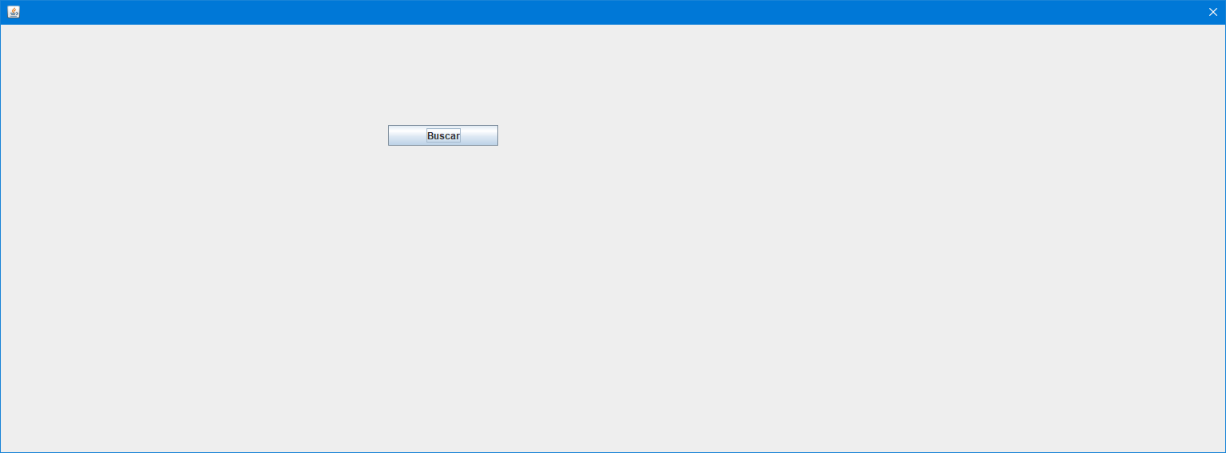

1. El botón de cancelar aparece cortado al abrir la pantalla.

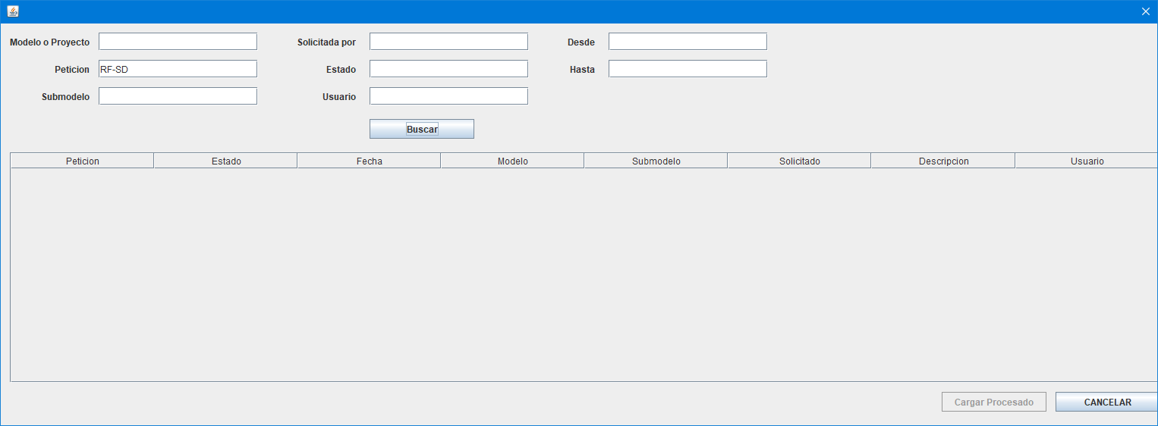

1. Falta el título de la pantalla.
2. Ajustar los tamaños de las columnas del listado:

