Accelerated growth of the scleractinian coral Orbicella faveolata under turbid and polluted water conditions

Luis Lizcano-Sandoval^{a,b,c,*}, Angela Marulanda-Gómez^{d,e}, Mateo López-Victoria^{d}, Alberto Rodriguez-Ramirez^{f,g}

ªPosgrado de Ciencias del Mar y Limnología, Universidad Nacional Autónoma de México, Puerto Morelos, Mexico
^{b}College of Marine Science, University of South Florida, St. Petersburg, FL, USA
^{c}Environmental Mapping Team, Spatial Informatics Group, Pleasanton, CA, USA
^{d}Department of Natural Sciences and Mathematics, Pontificia Universidad Javeriana Cali, Cali, Colombia
^{e}Institute of Biology and Chemistry of the Marine Environment (ICBM), Carl von Ossietzky University of Oldenburg, Oldenburg, Germany (current affiliation)
^{f}Global Change Institute, The University of Queensland, St Lucia, QLD 4072, Australia. ^{g}School of Biological Sciences, The University of Queensland, St Lucia, QLD 4072, Australia
*Correspondence author: lsandoval@sig-gis.com

Abstract
Cartagena Bay (Colombia), has experienced historical changes in water quality mainly due to dredging and channelization of the Canal del Dique, which connects the bay with the Magdalena River. In this bay, the coral reef of Varadero depicts high coral diversity and large coral colonies, showing apparent signs of a healthy ecosystem, under highly turbid and polluted waters. Here, we evaluated the potential effects of historical environmental variables on the coral skeletal growth of Orbicella faveolata, including an analysis of before and after the major dredging events in the Canal del Dique in 1981. We obtained coral growth information from 65 years in the period 1951–2015, corresponding to four coral specimens. Overall, mean coral skeletal density was 0.73 g cm⁻³, linear extension 1.02 cm yr⁻¹, and calcification 0.74 g cm⁻² yr⁻¹. After 1981, significant changes in coral growth and luminescence were found: skeletal density decreased (-9.9%), linear extension increased (+6.6%), and skeletal luminescence was less intense (-1.6%). The Atlantic Multidecadal Oscillation (AMO) explained changes in skeletal density (8–10%) and linear extension (7–19%). Air temperature explained changes in skeletal luminescence (22–45%). Water flow of the Canal del Dique showed continuous increases since 1981, but it did not contribute significantly to coral skeletal growth and skeletal luminescence. The growth of O. faveolata in Varadero Reef was characterized by low-density skeletons and an accelerated linear extension, especially after the dredging events of 1981. Further research is required to understand coral growth responses and resilience to the conditions of high turbidity, pollution, and low light in Cartagena Bay.
Keywords: coral skeletal growth, coral skeletal luminescence, water quality, Varadero Reef, Cartagena Bay, Canal del Dique

Introduction
Coral reefs are increasingly affected by a mixture of local and global stressors such as rising temperatures, disease outbreaks, eutrophication, acidification, and overexploitation that jeopardize their stability and persistence (Sully et al. 2019; Guan et al. 2020; Davis et al. 2021; Burke et al. 2023). In particular, water quality has been declining over time due to intensified human impacts on oceans and coastal areas (Halpern et al. 2019), which has exposed fringing coral reefs to higher levels of turbidity and pollution (Zweifler et al. 2021). While most coral reefs typically thrive in tropical and oligotrophic waters, ranging from shallow to mesophotic depths (Kahng et al. 2010; Guan et al. 2015), a fraction (12%) of the world’s coral reefs is found in moderately turbid waters (0.080–0.127 K_{d}490) (Sully and van Woesik 2020). Further, evidence shows that some corals can survive under highly turbid and reduced light conditions (Camp et al. 2018; Burt et al. 2020; Zweifler et al. 2021) by finding refugia from thermal stress (Sully and van Woesik 2020), shifting from autotrophy to heterotrophy (Anthony and Fabricius 2000; Travaglione et al. 2023), reducing lipid content (Jones et al. 2020), photoacclimating to low light exposure (Jones et al. 2020; López-Londoño et al. 2021), and increasing their number of pigments per cell (Jones et al. 2020).
Despite these challenges, evidence shows that some coral reefs survive under highly turbid conditions (Camp et al. 2018; Burt et al. 2020; Zweifler et al. 2021). The coral reef facing the most extreme turbidity reported to date in the Caribbean is Varadero Reef, Colombia (Fig. 1) (López-Victoria et al. 2015; Zweifler et al. 2021). This well-developed reef exhibits typical signs of a healthy ecosystem, including high coral diversity, 45% coral cover, and large colonies of the massive coral Orbicella faveolata (López-Victoria et al. 2015; Pizarro et al. 2017). Varadero Reef exists in a light-limited environment, influenced by freshwater discharge and industrial wastewater flowing into Cartagena Bay (Fig. 1). Several parameters exceed threshold values that are not optimal for biotic health or sustaining life. Elevated concentrations of heavy metals, such as cadmium, lead, mercury, chromium, copper, and nickel have been found in the water (Tosic et al. 2019), sediments (Cogua et al. 2012), and organisms (Alonso et al. 2000; Manjarrez et al. 2008). Cartagena Bay presents seasonal increases in nutrient levels and decreases in dissolved oxygen, occasionally reaching hypoxic conditions (Tuchkovenko and Lonin 2003; Tosic et al. 2019). Organic matter and high coliform counts have also been observed (Garay and Giraldo 1997; Tuchkovenko and Rendón 2002; Tosic et al. 2019). Domestic sewage and industrial wastewaters contribute pollutants to the bay, but it is the Canal del Dique that has caused significant declines in water quality (Tosic et al. 2018). Water discharge from the Canal del Dique is correlated to the seasonal and spatial variability of the water quality in the bay (Tosic et al. 2019) (Fig. S1).

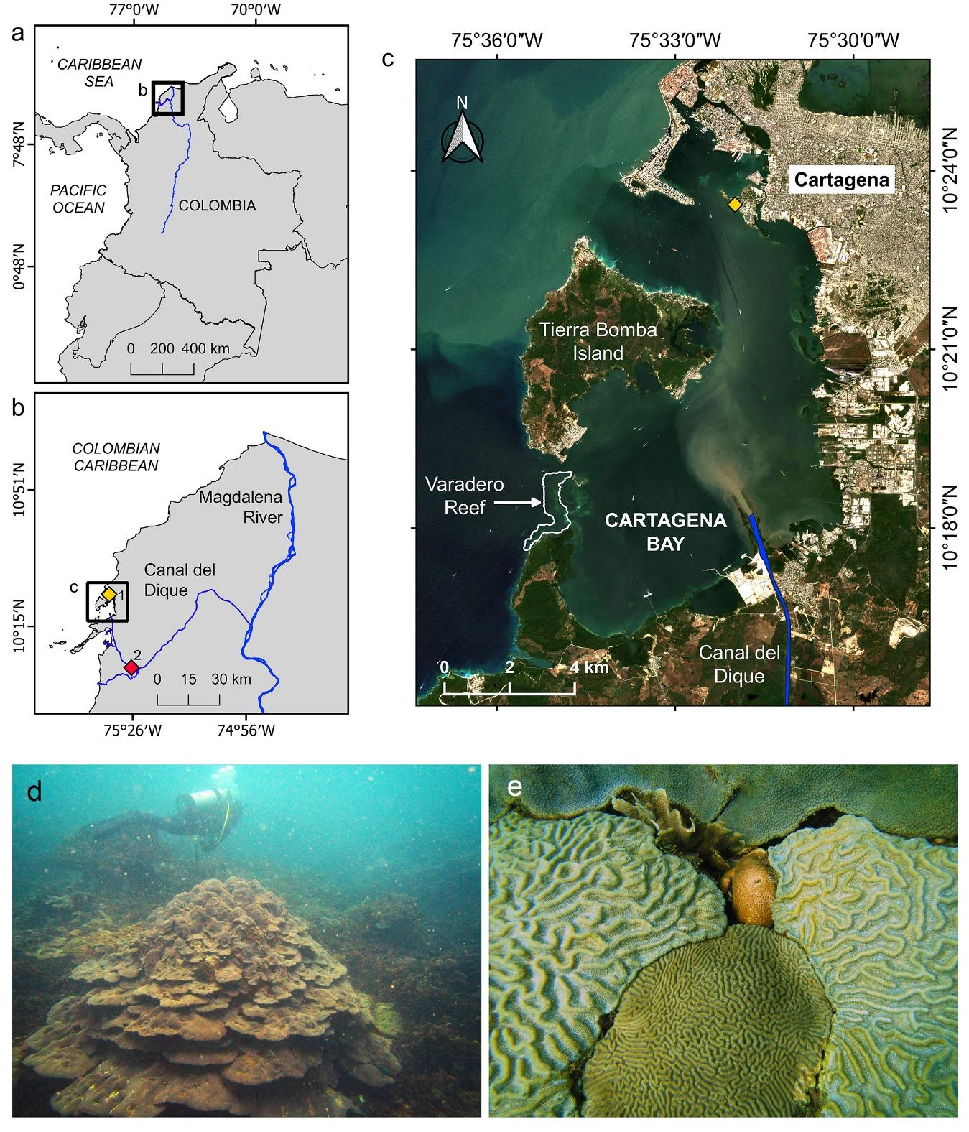
Figure 1. Geographic location of Varadero Reef in the Colombian Caribbean. (a-b) The connection between the Canal del Dique and the Magdalena River, and (c) location of Varadero Reef within Cartagena Bay. Environmental stations are indicated by diamonds: 1. Air temperature (yellow), and 2. Water flow (red). (d) Orbicella faveolata colonies growing in plate-like forms at 4 m depth with the presence of marine snow. (e) Corals competing for substrate in less than 1 m²: Colpophyllia natans, Pseudodiploria clivosa, Agaricia tenuifolia, Siderastrea siderea and O. faveolata.

The Canal del Dique has connected the Magdalena River and Cartagena Bay since 1934, and it is a navigable channel of 115 km length (Mogollón 2002, 2013) (Fig. 1). It was fully channelized between 1950 and 1952, leading to the transformation of Cartagena Bay’s clear waters into turbid waters due to freshwater discharge (Mogollón 2013). Between 1981 and 1984, the Canal del Dique was rectified and expanded in both depth and width. During this period, nearly 47% of the soil and sediments dredged throughout the 20th century were removed (Mogollón 2013). Annual maintenance is required to remove accumulated sediments, a practice that continues today. Between 1984 and 2010, the Canal del Dique increased water discharge by 28% and sediment load by 48%, contributing approximately 52 Mt of sediment to Cartagena Bay (Restrepo et al. 2018). While sedimentary evidence suggests that Cartagena Bay had a significant presence of scleractinian corals and seagrasses during the late Holocene (Martínez et al. 2010), recent changes in water quality have adversely affected these ecosystems. Seagrass cover in the bay declined by about 92% between 1935 and 2001 (Díaz and Gómez 2003), with no recent data available. Coral reefs here were once thought to be nonexistent until 2014 (López-Victoria et al. 2015).
Coral communities surviving under marginal conditions (e.g., high turbidity) have shown resilience to climate change impacts (Zweifler et al. 2021), and their corals can provide critical information to support coral reef conservation strategies. Thus, a better understanding of the responses of such corals to recent changes in the environment and climate is pivotal to preserving the existence of these turbid reefs, managing the future resilience for other coral reef environments, and developing effective conservation strategies (McClanahan et al. 2012). Massive corals respond to environmental changes by modulating their calcification rates and skeletal microstructure (e.g., exothecal dissepiments thickness), recording these variations in their skeleton (Barnes and Lough 1993; Carricart-Ganivet 2004; Dávalos-Dehullu et al. 2008). In corals of the genus Orbicella, seasonal temperature variations are recorded as changes in skeletal density bands, with low-density bands corresponding to cooler seasons and high-density bands indicating warmer seasons (Hudson et al. 1976; Carricart-Ganivet 2011). Each pair of bands represents one year of coral growth. Changes in skeletal luminescence also serve as a proxy for humic acid and sediment concentrations in the water (Grove et al. 2010; Tanzil et al. 2016). The ability of coral skeletons to record environmental responses provides an opportunity to track coral growth and reconstruct potential past disturbances.
The purpose of this study was to document growth responses from the coral Orbicella faveolata to high turbidity and pollution in Varadero Reef, Colombia (Fig. 1). We measured coral growth parameters (skeletal density, linear extension, calcification rates) and skeletal luminescence, in O. faveolata to assess the effects of historical environmental changes and perturbations in Cartagena Bay on coral growth, including any potential impacts of the Canal del Dique dredging in 1981.

Material and methods
Study area
Varadero Reef is located within Cartagena Bay, Colombian Caribbean (Fig. 1). Covering an area of approximately 1 km², the reef presents up to 80% live coral cover, dominated by massive colonies of O. faveolata that can exceed 3 m in diameter (López-Victoria et al. 2015; Pizarro et al. 2017). The range of maximum coral cover is 2–6 m depth, but live corals have been observed up to 15 m depth (Pizarro et al. 2017). This is a reef developing in limited conditions for coral settlement and growth, and exhibiting high coral species richness and density (Fig. 1e).
This coral reef is influenced by the turbid and polluted waters from the Canal del Dique, an extension of the Magdalena River (Fig. 1d, Fig. S1). In Varadero Reef, the reported annual mean (min-max) values of water quality parameters at surface between 2014 and 2015 were: salinity of 26 (~14–34), temperature of 30°C (~28–33°C), total suspended sediment of 17,000 mg m⁻³ (~9,000–60,000 mg m⁻³), turbidity of 5 NTU (~3–10 NTU), nitrates of 59 mg m⁻³ (~10–210 mg m⁻³), phosphates of 17 mg m⁻³ (~12–60 mg m⁻³), chlorophyll-a of 3 mg m⁻³ (~1.8–5 mg m⁻³), phenolics of 500 mg m⁻³ (~0–2,000 mg m⁻³), fecal coliforms of 126 MPN 100 ml⁻¹ (~0.3–3.1 MPN 100 ml⁻¹), and enterococcus of 26 CFU 100 ml⁻¹ (~0–120 CFU 100 ml⁻¹) (Tosic et al. 2019). Air temperatures can be as cool as 26.9°C ± 0.5°C between October and April, and as warm as 28.3°C ± 0.4°C between May and September (Fig. S2).
Coral growth parameters
A single core of 6 cm diameter was extracted along the growth axis from four massive O. faveolata colonies at 3–4 m depth by scuba diving using a pneumatic drill. Coral density was estimated using a CT-scan (ADD REF), but one of the cores was cut, and density could only be estimated using the X-ray method (ADD REF).
One coral core (VAR1) was sliced using a circular saw into several slabs of 6 mm thick (prior to using the CT-scan method for coral density estimation). One of the slabs was radiographed using a conventional X-ray machine, and coral density was estimated following Carricart-Ganivet and Barnes (2007). Radiation effects on the radiograph were corrected following Duprey (2012). The remaining three coral cores (VAR2, VAR3, VAR4) were imaged using a General Electric LightSpeed VCT 64 CT-scan as described by Lizcano-Sandoval et al. (2019). The skeletal density of all four coral specimens was calibrated using aragonite density standards obtained from the shell of the giant clam Tridacna maxima (Lizcano-Sandoval et al. 2019).
For scanned coral cores, the best planes for observing the density banding pattern were selected by inspecting multi-planar reconstructions. For each core, one sagittal and one coronal image were chosen, and a single transect was drawn along the coral growth axis in each image to extract optical density values in Hounsfield units (HU). The HU values from both transects were averaged for each core. These averaged HU values were then converted to skeletal density (Lizcano-Sandoval et al. 2019). The CT-scan images were visualized and analyzed using RadiAnt DICOM Viewer 4.0. The coral cores were cut into slabs of 6 mm thick after scanning.
The annual skeletal density pattern (Fig. 2) for orbicellid corals is characterized by a high-density band formed during the warm season and a low-density band formed during the cold season (Carricart-Ganivet et al. 2000; Carricart-Ganivet 2004). Here, we matched the highest and lowest density peaks along the coral skeleton to late June and February, respectively, to be consistent with the climatology of Cartagena Bay (Fig. S2). The dates of density measurements among the respective maximum and minimum peaks of every year were interpolated. For both CT-scan and X-ray images, coral years were counted retrospectively. Skeletal density (g cm⁻³), linear extension (cm yr⁻¹), and calcification rates (g cm⁻² yr⁻¹) were estimated annually. Linear extension was calculated from early January to late December of each year, while calcification was determined as the product of skeletal density and linear extension.

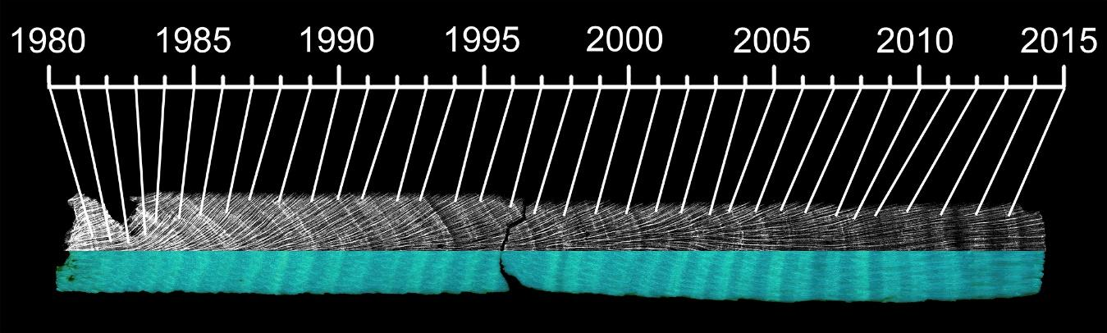
Figure 2. Coral growth banding patterns along an O. faveolata slab. The upper and lower halves of the coral slab show the skeletal density and luminescence banding patterns, respectively.

Since the aragonite standards used for estimating coral skeletal density in both X-ray and CT-scan methods were the same, we included X-ray-derived coral density in the global coral growth analysis, assuming minimal error between both methods. The mean skeletal density of core VAR1 fell within the range of the densities measured for cores VAR2, VAR3, and VAR4 over the period of 1981–2015, suggesting that density estimates were comparable between the two methods (See Results section).
The potential relationship between growth parameters and skeletal microstructure of the corals was evaluated by counting the number of annual exothecal dissepiments and measuring their thickness and spacing (Dodge et al. 1992; Dávalos-Dehullu et al. 2008). The number of dissepiments per year is represented by the average of dissepiments counted within the average linear extension of each coral core, in portions where a continuous corallite exotheca trajectory in the vertical axis was observed. We selected 40 random dissepiments to measure the average thickness and spacing for each coral specimen. The skeletal microstructure measurements were performed on digitalized images of the cores.
Skeletal luminescence
All of the 6 mm thick coral slabs were treated with 13% reagent-grade NaOCl for 24 h (Nagtegaal et al. 2012). After treatment, the slabs were rinsed several times with distilled water and oven-dried at 60°C for 24 h. The luminescence banding patterns of the coral slabs were visualized and photographed under UV-A light (Opalux blacklight bulb T8 20W, λ ≈ 365 nm), in a darkened room (Fig. 2). The red, green and blue (RGB) values were extracted from 5 mm wide tracks (~62 pixels) along the coral growth axis for each digital photograph using ImageJ 1.51. The green/blue (G/B) ratio was used as a measure of luminescence intensity in coral skeleton (hereafter skeletal luminescence). The G/B ratio reflects the influence of humic acid/aragonite ratios within the coral skeleton (Grove et al. 2010), with higher G/B intensities indicating higher freshwater discharge and sediment load (Tanzil et al. 2016). Consequently, the highest and lowest annual luminescence peaks were aligned with the months of highest (late December) and lowest (late March) water flow records, respectively (Fig. S2).
Environmental data
Water flow data (1981‒2015) were obtained from the Instituto de Hidrología, Metereología y Estudios Ambientales (IDEAM) monitoring station (Fig. 1b). The water flow station, located 28 km from the mouth of the Canal del Dique, provided the best available data to describe the flow into Cartagena Bay. Sea surface temperature data were not available at the temporal and spatial scales required (e.g., >50 years of data and <1 km resolution); thus, air temperature data (1954‒2013) were obtained from another IDEAM’s station in Cartagena (Escuela Naval ‒ 14015030) (Fig. 1b). Air temperature time series was completed until 2015 by extrapolating data from a proximate monitoring station (Rafael Nuñez Airport ‒ 14015080). Air temperature data were used as an indicator of potential patterns and variations of sea surface temperature over time.
The Southern Oscillation Index (SOI) and Atlantic Multidecadal Oscillation (AMO) data were used to test potential effects on the coral skeletal growth and luminescence. SOI data (1954–2015) were obtained from the National Oceanic and Atmospheric Administration (NOAA) (https://www.ncdc.noaa.gov/teleconnections/enso/indicators/soi/). Negative and positive values of this index indicate El Niño and La Niña events, respectively. The AMO data (1954–2015) were sourced from the Kaplan SST dataset (Enfield et al. 2001).
Data treatment and analyses
Time series were obtained for skeletal density, linear extension, calcification, and luminescence of each coral specimen. Pearson correlations were performed between skeletal density, linear extension, and calcification rates to evaluate growth strategies. Linear regressions were used to detect significant trends over the time series of coral skeletal growth and environmental data. The point at which the time series presented any abrupt change in their statistical properties (i.e., mean, variance) was detected with a change point detection analysis (Aminikhanghahi and Cook 2017; Truong et al. 2020). We employed the PELT algorithm for point change detection, which has been demonstrated to be more efficient and accurate than other methods (Killick et al. 2012). Additionally, and compared the coral skeletal growth and skeletal luminescence between the periods before (1951–1981) and after (1981–2015) the major dredging events that began in 1981, using a two-tailed t-test, assuming unequal variances, and an alpha level of 0.05.
The effects of environmental variables on coral growth and skeletal luminescence were tested for two periods. The first period included the environmental data available for 1954–2015 (i.e., air temperature, AMO, and SOI). The second period, 1981–2015, included both variables from the first period and the water flow data available after 1981. The purpose of analyzing these two periods was to 1) understand the long-term effects of available environmental variables on the complete coral growth record, and 2) evaluate the effects of environmental variables, including the water flow, on coral growth after the dredging of 1981. A model selection procedure was conducted to identify the best-performing predictor variables for use in a multiple linear regression, using the Akaike Information Criterion with a stepwise selection approach (Table S1; Table S3) (Quinn and Keough 2002). If none of the predictor variables outperformed a null model, the analysis was omitted (e.g., with calcification in Table S2). However, the model selection did not identify more than one predictor variable to support running a multiple linear regression (Table S2; Table S4). As a result, simple linear regressions were performed. The data of response variables were centered, and predictors were transformed into z-scores to standardize the data before performing the regressions, resulting in intercepts of zero values. The model selection was conducted using the Fathom package in Matlab vR2022a, while plots and additional analyses were completed using Python. The point change detection analysis utilized the ruptures Python package (Truong et al. 2020).

Results
Coral growth parameters
The overall mean and standard deviation of the skeletal density, linear extension, and calcification were 0.72 ± 0.07 g cm⁻³, 1.03 ± 0.13 cm yr⁻¹, and 0.74 ± 0.10 g cm⁻² yr⁻¹, respectively, corresponding to the period 1951–2015 (Table 1). The linear extension was negatively correlated to skeletal density (r = -0.29; p = 0.02; Pearson) and positively correlated to calcification rates (r = 0.69; p < 0.01; Pearson). The skeletal density was positively correlated to calcification (r = 0.46, p < 0.01; Pearson). The mean number of dissepiments per year along the coral slabs was 21.3 ± 1.3, while dissepiment thickness and spacing were 0.13 ± 0.01 mm and 0.57 ± 0.06 mm, respectively. No signs of mortality were observed along the coral cores.

Table 1. Coral growth means and standard deviations from four specimens of the coral O. faveolata in Varadero Reef.
Core | Time span | n | Density  (g cm⁻³) | Extension  (cm yr⁻¹) | Calcification  (g cm⁻² yr⁻¹)
VAR1 | 1982–2015 | 34 | 0.69 ± 0.08 | 1.33 ± 0.35 | 0.91 ± 0.24
VAR2 | 1951–2015 | 65 | 0.73 ± 0.14 | 1.04 ± 0.20 | 0.77 ± 0.22
VAR3 | 1942–2015 | 74 | 0.80 ± 0.12 | 0.91 ± 0.22 | 0.74 ± 0.23
VAR4 | 1950–2015 | 66 | 0.67 ± 0.13 | 1.02 ± 0.20 | 0.67 ± 0.15
Mean | 1951–2015 | 65 | 0.73 ± 0.07 | 1.02 ± 0.13 | 0.74 ± 0.10

Table 2. Linear regression results of coral skeletal growth, skeletal luminescence, and environmental time series data. The slopes are significantly different from zero at p < 0.05.
Variable | Period | n | Intercept | Slope | R² | F | p
Density (g cm⁻³) | 1951–2015 | 65 | 4.31 | -0.002 | 0.22 | 18 | <0.01
Extension (cm yr⁻¹) | 1951–2015 | 65 | -1.22 | 0.001 | 0.03 | 1.7 | 0.20
Calcification (g cm⁻² yr⁻¹) | 1951–2015 | 65 | 3.48 | -0.001 | 0.06 | 4.3 | 0.04
Luminescence | 1951–2015 | 65 | 2.21 | -0.001 | 0.45 | 52 | <0.01
Water flow (m³ s⁻¹) | 1981–2015 | 35 | -8115 | 4.240 | 0.20 | 8.0 | <0.01
Air temperature (°C) | 1954–2015 | 62 | 20.37 | 0.004 | 0.04 | 2.8 | 0.10
AMO | 1954–2015 | 62 | -6.10 | 0.003 | 0.09 | 6.0 | 0.02
SOI | 1954–2015 | 62 | 5.41 | -0.003 | 0.01 | 0.4 | 0.53

Time series analysis
The trends of the overall recorded coral growth data (1951–2015) showed significant declines in skeletal density, calcification rate, and skeletal luminescence (Table 2; Fig. 3). Abrupt changes in time series data were detected in 1982 for skeletal density; in 1966 and 1986 for linear extension; in 1961 for calcification rate; and in 1956, 1996, 2001, and 2011 for skeletal luminescence (Fig. 3). After 1986, linear extension exhibited greater variability among coral specimens (Fig. 3).
Significant increases in water flow (1981–2015) and the AMO (1954–2015) were detected (Table 2; Fig. 3). Significant changes in the time series record of air temperature, SOI, and AMO occurred concurrently between 1971 and 1976 (Fig. 3), characterized by decreases in air temperature and the AMO, and increases in the SOI. Both SOI and AMO showed apparent increasing trends after 1996, while air temperature data showed increases after 2001. Water flow data also depicted an important increase between 2006 and 2011 (Fig. 3).
The comparison of coral skeletal growth and luminescence between the periods before and after the events of 1981 indicated several differences. The mean skeletal density and luminescence values recorded in 1981–2015 were significantly lower than those observed in 1951–1981 (t-test: p < 0.001) (Fig. 4). The mean values for linear extension were significantly higher in 1981–2015 (t-test: p = 0.049). Calcification rates were lower in 1981-2015, but they did not indicate a significant difference (t-test: p = 0.131) (Fig. 4). In average, skeletal density was -9.9% lower, linear extension was +6.6% higher, and skeletal luminescence -1.6% less intense during 1981–2015, in comparison to the period 1951–1981.

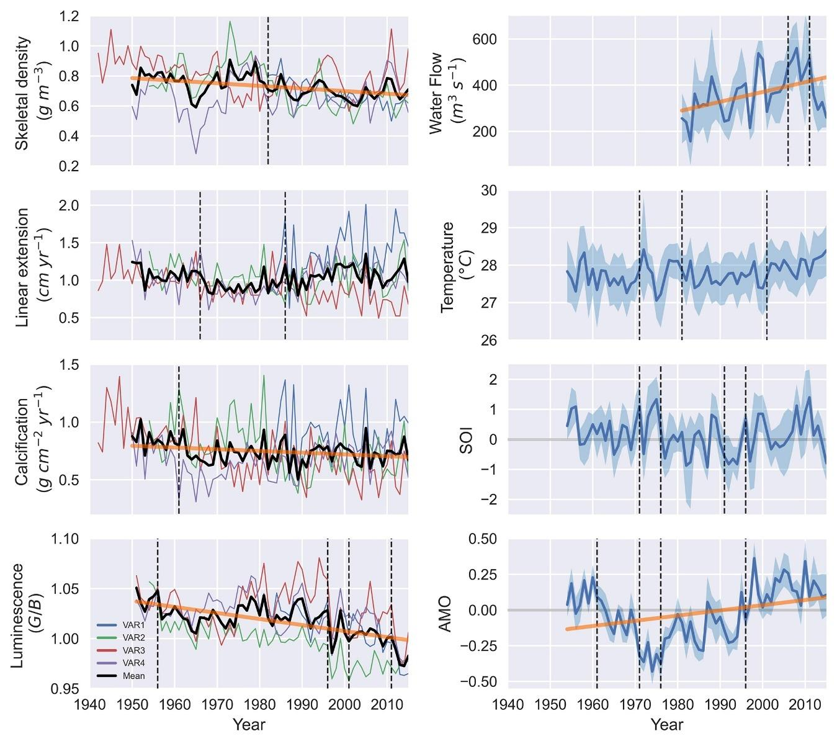
Figure 3. Time series of coral growth, coral luminescence, and environmental data (shaded area indicates annual standard deviations). The legend of coral cores corresponds to the left subplots. Significant trends over time are indicated by bold orange lines (linear regression: p < 0.05). Vertical dashed lines mark points of change in the time series.

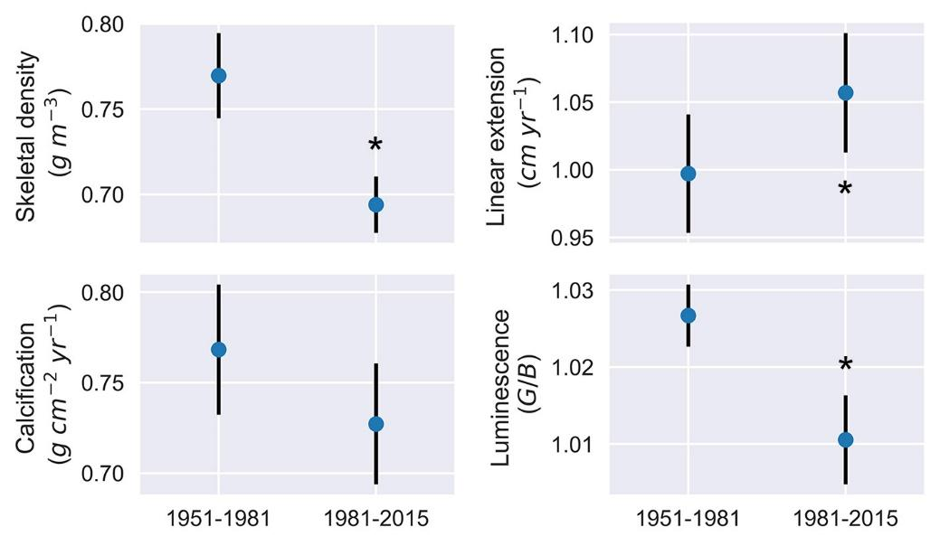
Figure 4. Coral growth and skeletal luminescence (mean ± confidence interval 95%) before (1951–1981) and after (1981–2015) the major dredging of 1981 in the Canal del Dique. The asterisks indicate significant differences in respective variables between the two periods (t-test: p < 0.05).

Coral growth responses to environmental variables
The model selection procedure indicated that predictor variables such as AMO, SOI, and air temperature were the most adequate for linear regression analysis in both periods 1954–2015 and 1981–2015 (Table S2; Table S4). Water flow data did not show significant contributions to variability on any coral growth and luminescence variables (R² ˂ 0.03), and it was not selected for linear regression for the period 1981–2015 (Table S3; Table S4). The AMO explained 8% of the decrease and 19% of the increase in skeletal density and linear extension over 1954–2015, respectively (Table 3). Air temperature explained 22% of the decrease in luminescence over the same period. In the period 1981–2015, the air temperature significantly explained 45% of the decrease in skeletal luminescence (Table 4).

Table 3. Linear regression results for annual coral growth and luminescence variables against environmental predictors for the period 1954–2015. All regressions have an intercept set to zero. Significant slopes are identified with a p-value of < 0.05 (bold values)
Variable/Predictor | Slope | R² | p-value
Density
AMO | -0.11 | 0.08 | 0.025
Extension
AMO | 0.30 | 0.19 | 0.001
Calcification
SOI | 0.04 | 0.06 | 0.069
Luminescence
Air temperature | -0.03 | 0.22 | 0.001

Table 4. Linear regression results for annual coral growth and luminescence variables against environmental predictors for the period 1981–2015. All regressions have intercept set to zero. Significant slopes are identified with a p-value of < 0.05 (bold values)
Variable/Predictor | Slope | R² | p-value
Density
AMO | -0.32 | 0.10 | 0.061
Extension
AMO | 0.26 | 0.07 | 0.144
Luminescence
Air temperature | -0.67 | 0.45 | 0.001

Discussion
Coral growth characteristics
The coral colonies of O. faveolata in Varadero Reef exhibit low skeletal density and calcification rates, while their linear extension remains relatively stable over time. The average skeletal density and calcification rates observed are the lowest reported for this species at 4 m depth , despite maintaining relatively high linear extension rates (Table 5). These corals grow under low-light conditions caused by high water turbidity, resulting in plate-like colony shapes typical of those found in light-limited environments (Pizarro et al. 2017; López-Londoño et al. 2021). The light availability and physiology of O. faveolata at 4 m depth in Varadero Reef are similar to those observed in O. faveolata colonies at 12 m depth in reefs of the Rosario Islands (Colombian Caribbean), where the quality of the optical properties of water is better (López-Londoño et al. 2021). In response to reduced light availability with increasing depth, orbicellid corals typically increase skeletal density while decreasing linear extension and calcification rates (Baker and Weber 1975; Dustan 1975; Bosscher 1993). However, the skeletal growth characteristics of O. faveolata in Varadero Reef deviate from expected patterns for corals growing under low-light conditions. Correlations between the growth variables suggest that the observed growth strategy of O. faveolata focuses on utilizing calcification products to achieve faster vertical growth with less dense skeletons, contrary to previous findings for orbicellid corals (Carricart-Ganivet and Merino 2001). The benefits of faster growth in the shallow suboptimal conditions of Varadero Reef (~2–6 m depth for O. faveolata) require further research.
Skeletal microstructure characteristics
The mean number of dissepiments per year (21.3 ± 1.3) was nearly double that observed in other studies. O. faveolata specimens from Mahahual, Mexico and La Parguera, Puerto Rico recorded annual averages of 13.6 ± 0.9 (Dávalos-Dehullu et al. 2008) and 11.8 ± 1.6 (Winter and Sammarco 2010) exothecal dissepiments, respectively. The dissepiment spacing observed in this study (0.57 ± 0.06 mm) was similar to that found by Dávalos-Dehullu et al. (2008), but the dissepiments in Varadero were almost twice as thick (0.13 ± 0.01 mm). The high number of dissepiments formed annually could explain the low skeletal density observed. The decline in skeletal luminescence intensity after 1981 may be related to the decrease in skeletal density, as skeletal microstructure contributes a small proportion to luminescence (Barnes and Taylor 2005). However, the causes of variations in skeletal microstructure remain unclear. Some studies suggest that these variations are due to seasonal changes in tissue thickness and calcification rates, which affect coral density banding patterns (Barnes and Lough 1993; Cruz-Piñón et al. 2003; Dávalos-Dehullu et al. 2008).

Table 5. Linear extension, skeletal density, and calcification rates of O. faveolata over relatively long periods and different depths in the Caribbean Sea.
Location | Period | Depth (m) | Number of cores | Extension (cm yr⁻¹) | Density  (g cm⁻³) | Calcification (g cm⁻² yr⁻¹) | Reference
Veracruz Reef, Mexico | 1835–2002 |  | 1 | 1.12 ± 0.23 |  |  | (Horta-Puga and Carriquiry 2014)
Upper Florida Keys, USA | 1937–1996 |  | 7 | 0.79 ± 0.07 | 1.18 ± 0.06 | 0.91 ± 0.06 | (Helmle et al. 2011)
Turneffe Islands, Belize | 1954–1996 | 2 | 1 | 0.88 ± 0.07 | 0.98 ± 0.05 | 0.83 ± 0.11 | (Zoppe and Gischler 2024)
Glovers Reef, Belize | 1899–2005 | 4 | 1 | 0.95 ± 0.09 | 1.13 ± 0.06 | 1.07 ± 0.11 | (Zoppe and Gischler 2024)
Varadero Reef, Colombia | 1951–2015 | 4 | 4 | 1.02 ± 0.13 | 0.73 ± 0.07 | 0.74 ± 0.10 | This study
Cheeca Rocks Reef, USA | 2004–2013 | 4–5 | 11 | 0.89 ± 0.07 | 1.25 ± 0.03 | 1.10 ± 0.08 | (Manzello et al. 2015)
Barrier reef, Belize | 1942–1999 | 4.8 | 1 | 1.20 ± 0.01 | 0.99 ± 0.05 | 1.19 ± 0.10 | (Zoppe and Gischler 2024)
Little Conch Reef, USA | 2004–2013 | 5–6 | 12 | 0.73 ± 0.03 | 1.34 ± 0.01 | 0.97 ± 0.03 | (Manzello et al. 2015)
Serrana Cay, Colombia | 1963–2015 | 4–9 | 5 | 0.96 ± 0.11 | 1.08 ± 0.08 | 1.02 ± 0.12 | (Lizcano-Sandoval et al. 2019)
Cayo Arenas, Mexico | 1992–2016 | 7–12 | 5 | 0.82 ± 0.08 | 1.04 ± 0.30 | 0.85 ± 0.18 | (Sánchez-Pelcastre et al. 2023)
Flower Garden Banks, USA | 1970–2014 | 19 | 10 | 0.71 ± 0.04 | 1.42 ± 0.03 | 0.99 ± 0.05 | (Manzello et al. 2021)

Lunar cycles have been proposed as a trigger for dissepiment formation, with one dissepiment forming per full moon on average (~12 annually) (Dávalos-Dehullu et al. 2008; Winter and Sammarco 2010). Corals can respond to lunar cycles by detecting the blue portion of lunar irradiance (Gorbunov and Falkowski 2002), but in Varadero Reef, the optical properties of the water are variable and suboptimal, particularly in the blue light spectrum (López-Londoño et al. 2021). If irradiance at 4 m depth in Varadero Reef represent between 20% and 30% of surface irradiance (Pizarro et al. 2017; López-Londoño et al. 2021), then moon light irradiance may range between 6 x 10⁻⁴ and 9 x 10⁻⁴ µmol quanta m⁻² s⁻¹, assuming zenith moon light irradiance at the surface is ~3 x 10⁻³ µmol quanta m⁻² s⁻¹ (Winter and Sammarco 2010). This hypothetical moonlight irradiance at 4 m depth is below the coral photoreception sensitivity threshold of ~2 x 10⁻³ µmol quanta m⁻² s⁻¹ (Gorbunov and Falkowski 2002). However, daily variations in water quality can cause large fluctuations in light attenuation coefficients (K_{d}) in Varadero Reef (López-Londoño et al. 2021), which may temporarily enable corals to respond to light. The causes of variation in skeletal microstructure for O. faveolata in Varadero Reef are likely multifaceted. Further investigation into the effects of light on coral skeletal microstructure is needed.
Growth responses to environmental variables
Air temperature explained 22% of the variation in skeletal luminescence in 1954–2015 and 45% in the period 1981–2015. The AMO significatively accounted for 19% of the variation in linear extension over the period 1954–2015. These responses to the air temperature and the AMO suggest that corals in Varadero Reef have been vulnerable to those variations in different periods of time. The growth of O. faveolata has shown to be related to the AMO to some extent, though the patterns may vary. Our results are comparable to those from the remote reefs of Serrana Cay, Colombian Caribbean, where the AMO showed long-term (1963–2015) influence in the skeletal growth of O. faveolata (Lizcano-Sandoval et al. 2019). However, contrasting patterns were found in O. faveolata corals from Belize and Florida, where linear extension and skeletal density were negatively and positively correlated to the AMO, respectively (Helmle et al. 2011; Zoppe and Gischler 2024).
Water flow did not contribute significantly to variations in coral skeletal growth and skeletal luminescence after 1981 (Table S3), yet abrupt changes in the time series of skeletal density and linear extension were detected in 1982 and 1986, respectively (Fig. 3). The mean values of skeletal density, linear extension, and luminescence in the period 1981–2015 were significantly different from those of the period 1951–1981 (Fig. 4), suggesting a likely response of O. faveolata to decreased water quality due to dredging activities between 1981 and 1984, which removed 18.8 million m³ of soil and sediments (Mogollón 2013). The points of change detected in the skeletal luminescence time series are apparently related to El Niño from 1997–1998 and La Niña from 1998–2001, which coincided with low and high-water flow during those periods, respectively (Fig. 3). The air temperature data showed a decrease that coincided with La Niña from 1973–1976, along with slight increases in skeletal density and luminescence, and decreases in linear extension.
The corals in Varadero Reef are exposed to multiple stressors that can affect their skeletal density, linear extension, and calcification rates. Limited photosynthetic potential, combined with the presence of organic matter in the water column, can cause a shift towards increased heterotrophy to meet energetic requirements. For some tropical corals, heterotrophy can contribute 15% to 35% of daily energy requirements (Houlbrèque and Ferrier‐Pagès 2009). Under heterotrophic conditions, linear extension may double, skeletal density can decrease, and skeletal mass may increase (Ferrier-Pagès et al. 2003; Fabricius 2005). Cartagena Bay also experiences seasonal hypoxic conditions, with low dissolved oxygen levels (<4 mg m⁻³) occurring between 10 and 20 m depth, but during May-August these levels can be found at 5–10 m depth (Tosic et al. 2019). Prolonged exposure to hypoxia can lead to coral bleaching, tissue loss, or a reduction in calcification rates (Pezner et al. 2023). Additionally, heavy metal concentrations (e.g., As, Zn, Cu, Ni, Cr, Mn, Fe, Pb) in Cartagena Bay often exceed acceptable standards (Restrepo et al. 2016; Tosic et al. 2019). Also, concentrations of total suspended solids (6,000–72,000 mg m⁻³), nitrates (5–389 mg m⁻³), and phosphates (17–140 mg m⁻³) surpass thresholds considered healthy for coral ecosystems (suspended solids <50,000 mg m⁻³, nitrate <62 mg m⁻³, phosphate <95 mg m⁻³) (Fabricius 2005; Tosic et al. 2019). A potential threat to coral growth in Varadero Reef that may require more attention is sea-level rise. Cartagena presents one of the largest sea-level rise rates in the Caribbean, which has accelerated between 2000 and 2019, with a rate of 7.02 mm yr⁻¹ (Restrepo-Ángel et al. 2021).
The absence of signs of mortality in any of the coral cores raises the question of how these corals have survived and apparently thrived for over 65 years under the influence of the Canal del Dique. However, the constant increase in water flow suggests a decline in water quality, which poses an ongoing threat to coral health and survival in Varadero Reef. The reason for an accelerated linear extension might be a response to the particular conditions of light and pollution, but further research is required to understand coral growth and responses to these conditions in Cartagena Bay. A more frequent and comprehensive water quality monitoring program is needed to assess the effects of the multiple stressors on coral growth, and conservation efforts should be implemented in the bay to protect Varadero Reef.

Acknowledgements
Financial support for the research visit of L. Lizcano-Sandoval to Colombia was provided by the Posgrado en Ciencias del Mar y Limnologia, Universidad Nacional Autonoma de Mexico.
Author contributions

References
Alonso D, Pineda P, Olivero J, González H, Campos N (2000) Mercury levels in muscle of two fish species and sediments from the Cartagena Bay and the Cienaga Grande de Santa Marta, Colombia. Environ Pollut 109:157–163
Aminikhanghahi S, Cook DJ (2017) A survey of methods for time series change point detection. Knowl Inf Syst 51:339–367
Anthony KRN, Fabricius KE (2000) Shifting roles of heterotrophy and autotrophy in coral energetics under varying turbidity. J Exp Mar Biol Ecol 252:221–253
Baker PA, Weber JN (1975) Coral growth rate: Variation with depth. Earth Planet Sci Lett 27:57–61
Barnes DJ, Lough JM (1993) On the nature and causes of density banding in massive coral skeletons. J Exp Mar Biol Ecol 167:91–108
Barnes DJ, Taylor RB (2005) On the nature and causes of luminescent lines and bands in coral skeletons: II. Contribution of skeletal crystals. J Exp Mar Biol Ecol 322:135–142
Bosscher H (1993) Computerized tomography and skeletal density of coral skeletons. Coral Reefs 12:97–103
Burke S, Pottier P, Lagisz M, Macartney EL, Ainsworth T, Drobniak SM, Nakagawa S (2023) The impact of rising temperatures on the prevalence of coral diseases and its predictability: A global meta‐analysis. Ecol Lett 26:1466–1481
Burt JA, Camp EF, Enochs IC, Johansen JL, Morgan KM, Riegl B, Hoey AS (2020) Insights from extreme coral reefs in a changing world. Coral Reefs 39:495–507
Camp EF, Schoepf V, Mumby PJ, Hardtke LA, Rodolfo-Metalpa R, Smith DJ, Suggett DJ (2018) The future of coral reefs subject to rapid climate change: Lessons from natural extreme environments. Front Mar Sci 5:4
Carricart-Ganivet JP (2004) Sea surface temperature and the growth of the West Atlantic reef-building coral Montastraea annularis. J Exp Mar Biol Ecol 302:249–260
Carricart-Ganivet JP (2011) Coral skeletal extension rate: An environmental signal or a subject to inaccuracies? J Exp Mar Biol Ecol 405:73–79
Carricart-Ganivet JP, Barnes DJ (2007) Densitometry from digitized images of X-radiographs: Methodology for measurement of coral skeletal density. J Exp Mar Biol Ecol 344:67–72
Carricart-Ganivet JP, Beltrán-Torres AU, Merino M, Ruiz-Zárate MA (2000) Skeletal extension, density and calcification rate of the reef building coral Montastraea annularis (Ellis and Solander) in the Mexican Caribbean. Bull Mar Sci 66:215–224
Carricart-Ganivet JP, Merino M (2001) Growth responses of the reef-building coral Montastraea annularis along a gradient of continental influence in the southern Gulf of Mexico. Bull Mar Sci 68:133–146
Cogua P, Campos-Campos H, Duque G (2012) Concentración de mercurio total y metilmercurio en sedimento y seston de la Bahía de Cartagena, Caribe Colombiano. Bol Invest Mar Cost 41:267–285
Cruz-Piñón G, Carricart-Ganivet JP, Espinoza-Avalos J (2003) Monthly skeletal extension rates of the hermatypic corals Montastraea annularis and Montastraea faveolata: Biological and environmental controls. Mar Biol 143:491–500
Dávalos-Dehullu E, Hernández-Arana H, Carricart-Ganivet JP (2008) On the causes of density banding in skeletons of corals of the genus Montastraea. J Exp Mar Biol Ecol 365:142–147
Davis KL, Colefax AP, Tucker JP, Kelaher BP, Santos IR (2021) Global coral reef ecosystems exhibit declining calcification and increasing primary productivity. Commun Earth Environ 2:105
Díaz JM, Gómez DI (2003) Cambios históricos en la distribución y abundancia de praderas de pastos marinos en la Bahía de Cartagena y areas aledañas (Colombia). Bol Invest Mar Cost 32:57–74
Dodge RE, Szmant AM, Garcia R, Swart PK, Forester A, Leder JJ (1992) Skeletal structural basis of density banding in the reef coral Montastrea annularis. Proceedings of the 7th International Coral Reef Symposium 1:186–195
Duprey N, Boucher H, Jiménez C (2012) Digital correction of computed X-radiographs for coral densitometry. J Exp Mar Biol Ecol 438:84–92
Dustan P (1975) Growth and form in the reef-building coral Montastrea annularis. Mar Biol 33:101–107
Enfield DB, Mestas-Nuñez AM, Trimble PJ (2001) The Atlantic multidecadal oscillation and its relationship to rainfall and river flows in the continental U.S. Geophys Res Lett 28:2077–2080
Fabricius KE (2005) Effects of terrestrial runoff on the ecology of corals and coral reefs: review and synthesis. Mar Pollut Bull 50:125–146
Ferrier-Pagès C, Witting J, Tambuttè E, Sebens KP (2003) Effect of natural zooplankton feeding on the tissue and skeletal growth of the scleractinian coral Stylophora pistillata. Coral Reefs 22:229–240
Garay JA, Giraldo LN (1997) Influencia de los aportes de materia orgánica externa y autóctona en el decrecimiento de los niveles de oxigeno disuelto en la Bahía de Cartagena, Colombia. Bol Cient CIOH 18:1–13
Gorbunov MY, Falkowski PG (2002) Photoreceptors in the cnidarian hosts allow symbiotic corals to sense blue moonlight. Limnol Oceanogr 47:309–315
Grove CA, Nagtegaal R, Zinke J, Scheufen T, Koster B, Kasper S, McCulloch MT, van den Bergh G, Brummer GJA (2010) River runoff reconstructions from novel spectral luminescence scanning of massive coral skeletons. Coral Reefs 29:579–591
Guan Y, Hohn S, Merico A (2015) Suitable environmental ranges for potential coral reef habitats in the tropical ocean. PLoS ONE 10:e0128831
Guan Y, Hohn S, Wild C, Merico A (2020) Vulnerability of global coral reef habitat suitability to ocean warming, acidification and eutrophication. Glob Change Biol 26:5646–5660
Halpern BS, Frazier M, Afflerbach J, Lowndes JS, Micheli F, O’Hara C, Scarborough C, Selkoe KA (2019) Recent pace of change in human impact on the world’s ocean. Sci Rep 9:1–8
Helmle KP, Dodge RE, Swart PK, Gledhill DK, Eakin CM (2011) Growth rates of Florida corals from 1937 to 1996 and their response to climate change. Nat Commun 2:215
Horta-Puga G, Carriquiry JD (2014) The last two centuries of lead pollution in the southern Gulf of Mexico recorded in the annual bands of the scleractinian coral Orbicella faveolata. Bull Environ Contam Toxicol 92:567–573
Houlbrèque F, Ferrier‐Pagès C (2009) Heterotrophy in Tropical scleractinian corals. Biol Rev 84:1–17
Hudson JH, Shinn EA, Halley RB, Lidz B (1976) Sclerochronology: A tool for interpreting past environments. Geology 4:361–364
Jones R, Giofre N, Luter HM, Neoh TL, Fisher R, Duckworth A (2020) Responses of corals to chronic turbidity. Sci Rep 10:4762
Kahng SE, Garcia-Sais JR, Spalding HL, Brokovich E, Wagner D, Weil E, Hinderstein L, Toonen RJ (2010) Community ecology of mesophotic coral reef ecosystems. Coral Reefs 1–21
Killick R, Fearnhead P, Eckley IA (2012) Optimal detection of changepoints with a linear computational cost. J Am Stat Assoc 107:1590–1598
Lizcano-Sandoval LD, Marulanda-Gómez Á, López-Victoria M, Rodriguez-Ramirez A (2019) Climate change and Atlantic multidecadal oscillation as drivers of recent declines in coral growth rates in the Southwestern Caribbean. Front Mar Sci 6:38
López-Londoño T, Galindo-Martínez CT, Gómez-Campo K, González-Guerrero LA, Roitman S, Pollock FJ, Pizarro V, López-Victoria M, Medina M, Iglesias-Prieto R (2021) Physiological and ecological consequences of the water optical properties degradation on reef corals. Coral Reefs 40:1243–1256
López-Victoria M, Rodríguez-Moreno M, Zapata FA (2015) A paradoxical reef from Varadero, Cartagena Bay, Colombia. Coral Reefs 34:231
Manjarrez G, Castro I, Utria L (2008) Bioacumulación de cadmio en ostras de la Bahía de Cartagena. Rev Ing Univ Medellín 7:11–20
Manzello DP, Enochs IC, Kolodziej G, Carlton RR (2015) Recent decade of growth and calcification of Orbicella faveolata in the Florida Keys: An inshore-offshore comparison. Mar Ecol Prog Ser 521:81–89
Manzello DP, Kolodziej G, Kirkland A, Besemer N, Enochs IC (2021) Increasing coral calcification in Orbicella faveolata and Pseudodiploria strigosa at Flower Garden Banks, Gulf of Mexico. Coral Reefs 40:1097–1111
Martínez JI, Yokoyama Y, Gomez A, Delgado A, Matsuzaki H, Rendon E (2010) Late Holocene marine terraces of the Cartagena region, southern Caribbean: The product of neotectonism or a former high stand in sea-level? J South Am Earth Sci 29:214–224
McClanahan TR, Donner SD, Maynard JA, MacNeil MA, Graham NAJ, Maina J, Baker AC, Alemu I. JB, Beger M, Campbell SJ, Darling ES, Eakin CM, Heron SF, Jupiter SD, Lundquist CJ, McLeod E, Mumby PJ, Paddack MJ, Selig ER, van Woesik R (2012) Prioritizing key resilience indicators to support coral reef management in a changing climate. PLoS ONE 7:e42884
Mogollón JV (2002) Aproximación a la historia geomorfológica del área de influencia del Canal del Dique. Revista ANDI 66–82
Mogollón JV (2013) El Canal del Dique: Historia de un Desastre Ambiental. El Áncora Editores, Bogotá, Colombia
Nagtegaal R, Grove CA, Kasper S, Zinke J, Boer W, Brummer GJA (2012) Spectral luminescence and geochemistry of coral aragonite: Effects of whole-core treatment. Chem Geol 318–319:6–15
Pezner AK, Courtney TA, Barkley HC, Chou W-C, Chu H-C, Clements SM, Cyronak T, DeGrandpre MD, Kekuewa SAH, Kline DI, Liang Y-B, Martz TR, Mitarai S, Page HN, Rintoul MS, Smith JE, Soong K, Takeshita Y, Tresguerres M, Wei Y, Yates KK, Andersson AJ (2023) Increasing hypoxia on global coral reefs under ocean warming. Nat Clim Chang 13:403–409
Pizarro V, Rodríguez SC, López-Victoria M, Zapata FA, Zea S, Galindo-Martínez CT, Iglesias-Prieto R, Pollock J, Medina M (2017) Unraveling the structure and composition of Varadero Reef, an improbable and imperiled coral reef in the Colombian Caribbean. PeerJ 5:e4119
Quinn GP, Keough MJ (2002) Experimental design and data analysis for biologists. Cambridge University Press, Cambridge, UK
Restrepo JD, Escobar R, Tosic M (2018) Fluvial fluxes from the Magdalena River into Cartagena Bay, Caribbean Colombia: Trends, future scenarios, and connections with upstream human impacts. Geomorphology 302:92–105
Restrepo JD, Park E, Aquino S, Latrubesse EM (2016) Coral reefs chronically exposed to river sediment plumes in the southwestern Caribbean: Rosario Islands, Colombia. Sci Total Environ 553:316–329
Restrepo-Ángel JD, Mora-Páez H, Díaz F, Govorcin M, Wdowinski S, Giraldo-Londoño L, Tosic M, Fernández I, Paniagua-Arroyave JF, Duque-Trujillo JF (2021) Coastal subsidence increases vulnerability to sea level rise over twenty first century in Cartagena, Caribbean Colombia. Sci Rep 11:18873
Sánchez-Pelcastre DW, Tortolero-Langarica JJA, Alvarez-Filip L, Cruz-Ortega I, Carricart-Ganivet JP (2023) Sclerochronological characteristics of Orbicella faveolata in Cayo Arenas, a remote coral reef from the Gulf of Mexico. PLoS ONE 18:e0293802
Sully S, Burkepile DE, Donovan MK, Hodgson G, van Woesik R (2019) A global analysis of coral bleaching over the past two decades. Nat Commun 10:1264
Sully S, van Woesik R (2020) Turbid reefs moderate coral bleaching under climate‐related temperature stress. Glob Change Biol 26:1367–1373
Tanzil JTI, Lee JN, Brown BE, Quax R, Kaandorp JA, Lough JM, Todd PA (2016) Luminescence and density banding patterns in massive Porites corals around the Thai-Malay Peninsula, Southeast Asia. Limnol Oceanogr 61:2003–2025
Tosic M, Restrepo JD, Izquierdo A, Lonin S, Martins F, Escobar R (2018) An integrated approach for the assessment of land-based pollution loads in the coastal zone. Estuar Coast Shelf Sci 211:217–226
Tosic M, Restrepo JD, Lonin S, Izquierdo A, Martins F (2019) Water and sediment quality in Cartagena Bay, Colombia: Seasonal variability and potential impacts of pollution. Estuar Coast Shelf Sci 216:187–203
Travaglione N, Evans R, Moustaka M, Cuttler M, Thomson DP, Tweedley J, Wilson S (2023) Scleractinian corals rely on heterotrophy in highly turbid environments. Coral Reefs 42:997–1010
Truong C, Oudre L, Vayatis N (2020) Selective review of offline change point detection methods. Signal Process 167:107299
Tuchkovenko YS, Lonin SA (2003) Mathematical model of the oxygen regime of Cartagena Bay. Ecol Model 165:91–106
Tuchkovenko YS, Rendón SR (2002) Estudio del comportamiento de la contaminación bacteriana en la Bahía de Cartagena. Bol Cient CIOH 20:56–67
Winter A, Sammarco PW (2010) Lunar banding in the scleractinian coral Montastraea faveolata: Fine-scale structure and influence of temperature. J Geophys Res 115:1–12
Zoppe SF, Gischler E (2024) Reef‐wide and long‐term skeletal growth records of the mountainous star coral (Orbicella faveolata) from Belize barrier and atoll reefs (Central America). J Quat Sci 39:145–162
Zweifler A, O’Leary M, Morgan K, Browne NK (2021) Turbid coral reefs: Past, present and future—A review. Diversity 13:251

