Supplementary Information

Accelerated growth of the scleractinian coral Orbicella faveolata under turbid and polluted water conditions
Luis Lizcano-Sandoval, Angela Marulanda-Gómez, Mateo López-Victoria, Alberto Rodriguez-Ramirez

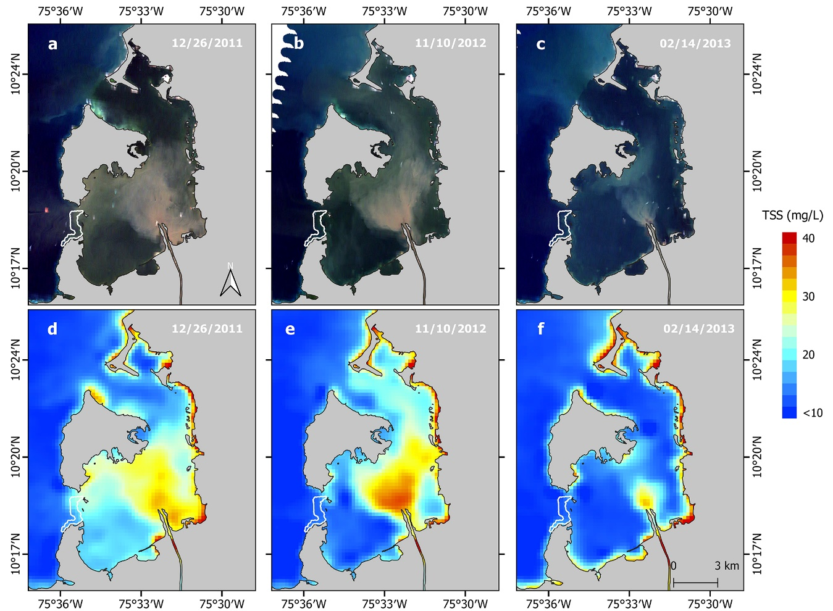
Figure S1. Total suspended sediments (TSS) within Cartagena Bay according to three water flow rates recorded upstream the Canal del Dique (Santa Helena Station): high (632 m³ s⁻¹) on December 26, 2011, intermediate (378 m³ s⁻¹) on November 10, 2012, and low (158 m³ s⁻¹) on February 14, 2013. True-color satellite imagery showing different levels of suspended sediments in Cartagena Bay (a-c). MODIS Terra (MOD09GQ; band 1) satellite imagery calibrated for TSS following the model by Restrepo et al. (2016) (d-f). The Varadero coral reef is outlined by a white-bordered polygon.
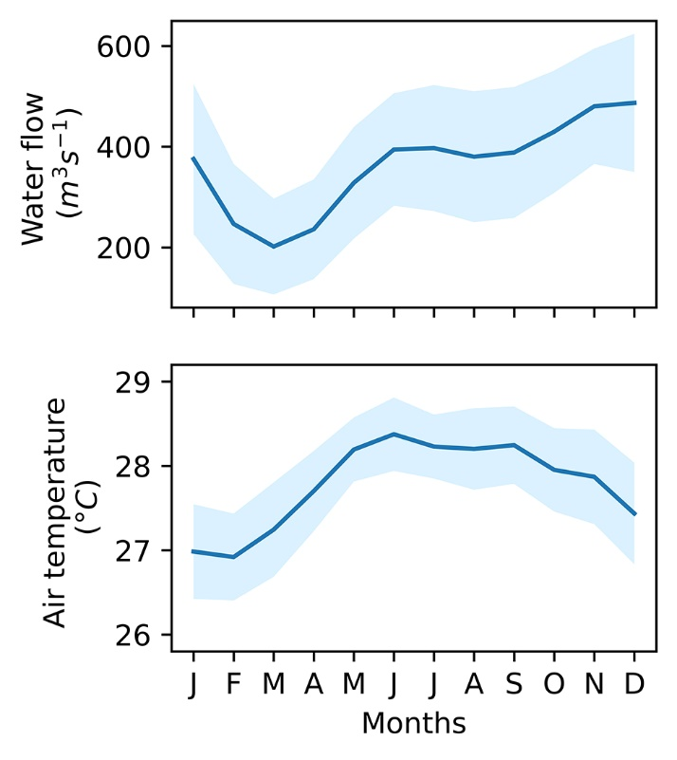
Figure S2. Climatology of water flow (1981–2015) and air temperature (1954–2015) from the Canal del Dique and Cartagena Bay, respectively. The data sources are detailed in the methods section.

The model selection is a procedure that first runs marginal (independent) tests on each variable, including a test with no variables (null model). The best variables are selected based on the Akaike Information Criterion (AIC), weights and ratio values. The weight indicates the probability that the respective variable is the best one to be included in a model. The ratios compare each variable against the best (first) variable, indicating how many times it is better than the others. Then, conditional tests are performed with the variables that indicated to be better than the null model. If a null model is better than any other model then the procedure is stopped (e.g., no conditional tests are required for calcification after the results in Table S3). The conditional tests are the last step to select the predictor variables to include in the optimized multiple linear regression analysis.

Table S1. Results of the marginal tests (independent) with AIC on environmental predictors for coral growth parameters and luminescence (period 1954-2015). Sum of squares residuals (RSS) are additive.
Variable | RSS | R² | AIC | ΔAIC | Weights | Ratio
Density
AMO | 0.29 | 0.08 | -329.1 | 0.0 | 0.7 | 1.0
SOI | 0.30 | 0.04 | -326.2 | 2.9 | 0.2 | 4.3
None | 0.31 |  | -326.1 | 3.0 | 0.1 | 4.5
Air temperature | 0.31 | 0.00 | -324.0 | 5.1 | 0.1 | 12.8
Extension
AMO | 0.84 | 0.19 | -262.8 | 0.0 | 1.0 | 1.0
None | 1.03 |  | -252.2 | 10.6 | 0.0 | 204
SOI | 1.02 | 0.01 | -250.6 | 12.3 | 0.0 | 462
Air temperature | 1.02 | 0.01 | -250.5 | 12.3 | 0.0 | 465
Calcification
SOI | 0.55 | 0.06 | -288.8 | 0.0 | 0.6 | 1.0
None | 0.58 |  | -287.1 | 1.7 | 0.2 | 2.3
AMO | 0.58 | 0.01 | -285.8 | 3.0 | 0.1 | 4.5
Air temperature | 0.58 | 0.00 | -285.0 | 3.8 | 0.1 | 6.8
Luminescence
Air temperature | 0.01 | 0.22 | -520.5 | 0.0 | 1.0 | 1.0
AMO | 0.01 | 0.11 | -512.3 | 8.2 | 0.0 | 61
SOI | 0.02 | 0.04 | -507.2 | 13.3 | 0.0 | 769
None | 0.02 |  | -507.0 | 13.5 | 0.0 | 840

Table S2. Results of the conditional tests with AIC on environmental predictors for coral growth parameters and luminescence (period 1954-2015). Sum of squares residuals (RSS) are additive.
Variable | RSS | R² | AIC | ΔAIC | Weights
Density
AMO | 0.29 | 0.08 | -329.1 | 3.0 | 0.7
None | 0.29 |  | -329.1 | 0.5 | 0.3
Extension
AMO | 0.84 | 0.19 | -262.8 | 10.6 | 1.0
None | 0.84 |  | -262.8 | 0.0 | 0.5
Calcification
SOI | 0.55 | 0.06 | -288.8 | 1.7 | 0.6
None | 0.55 |  | -288.8 | 0.0 | 0.4
Luminescence
Air temperature | 0.01 | 0.22 | -520.5 | 13.5 | 1.0
None | 0.01 |  | -520.5 | 0.2 | 0.4

Table S3. Results of the marginal tests (independent) with AIC on environmental predictors for coral growth parameters and luminescence (period 1981-2015). Sum of squares residuals (RSS) are additive.
Variable | RSS | R² | AIC | ΔAIC | Weights | Ratio
Density
AMO | 30.5 | 0.10 | -0.4 | 0.0 | 0.5 | 1.0
None | 34.0 |  | 1.1 | 1.5 | 0.2 | 2.1
Air temperature | 33.6 | 0.01 | 3.0 | 3.4 | 0.1 | 5.4
Water Flow | 33.9 | 0.00 | 3.2 | 3.6 | 0.1 | 6.1
SOI | 34.0 | 0.00 | 3.4 | 3.7 | 0.1 | 6.5
Extension
AMO | 31.7 | 0.07 | 0.9 | 0.0 | 0.3 | 1.0
None | 34.0 |  | 1.1 | 0.2 | 0.3 | 1.1
SOI | 32.4 | 0.05 | 1.7 | 0.8 | 0.2 | 1.5
Water Flow | 32.8 | 0.03 | 2.1 | 1.2 | 0.2 | 1.9
Air temperature | 33.2 | 0.02 | 2.5 | 1.6 | 0.1 | 2.3
Calcification
None | 34.0 |  | 3.0 | 1.9 | 0.4 | 1.0
SOI | 32.6 | 0.04 | 3.4 | 2.3 | 0.3 | 1.5
Water Flow | 33.7 | 0.01 | 1.9 | 0.8 | 0.1 | 2.6
AMO | 34.0 | 0.00 | 3.3 | 2.2 | 0.1 | 3.0
Air temperature | 34.0 | 0.00 | 1.1 | 0.0 | 0.1 | 3.1
Luminescence
Air temperature | 18.59 | 0.45 | -17.8 | 0.0 | 1.0 | 1.0
AMO | 25.43 | 0.25 | -6.8 | 11.0 | 0.0 | 241.4
None | 34.00 |  | 1.1 | 18.9 | 0.0 | 12609.0
SOI | 33.86 | 0.00 | 3.2 | 21.0 | 0.0 | 36153.0
Water Flow | 33.96 | 0.00 | 3.3 | 21.1 | 0.0 | 38081.0

Table S4. Results of the conditional tests with AIC on environmental predictors for coral growth parameters and luminescence (period 1981-2015). Sum of squares residuals (RSS) are additive. Tests for calcification were skipped according to marginal tests results.
Variable | RSS | R² | AIC | ΔAIC | Weights
Density
AMO | 0.1 | 0.07 | 0.5 | 1.5 | 0.5
None |  |  | 0.4 | 0.0 | 0.4
Extension
AMO | 31.7 | 0.07 | 0.9 | 0.3 | 0.2
None | 31.7 |  | 0.9 | 0.3 | 0.0
Luminescence
Air temperature | 18.6 | 0.45 | -17.8 | 1.0 | 18.9
None | 18.6 |  | -17.8 | 0.4 | 0.0

