Present in “Method in neuronal modeling” page 10.
name: “cable equation”

the book presents a partial differential equation

- They also provide the information that is the voltage difference across the membrane. Moreover, is posed as deviation from the resting value . represent distance along the axis of the membrane cylinder, and is the length constant of the core conductor. is the membrane time constant and is time.

Ok, so what the hell is a partial derivative.

Take a function , then the partial derivate is the partial derivative with respect to .
The definition is the rate of change of the function with respect to , keeping constant.

I’m trying to visualize the partial derivate, if I consider a derivate is easier, because I have only one point that changes, so the derivate is the rate of change. So to understand the partial derivate I’m going with thinking of a derivative while holding the other variables constant.

Ok, let’s dive into the partial equation.

First , what gets my attention is “voltage signal decays along the neurite”.
Think of a hose with tiny holes along its length, if you inject water at one end, the water pressure will be highest at the point. As you move further down the hose, the water pressure will decrease because some water is leaking out through the holes. is then the space constant, and is the distance where the “water pressure” drops to about 37%.

To understand this 37%.

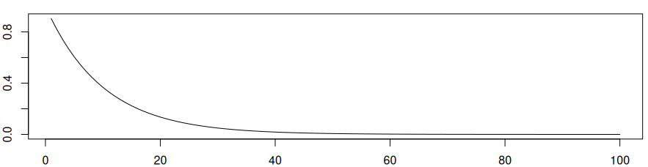
this was done in R, with and .

Follow then the following specification. , then equation becomes , ohh and then , we understand this as the evaluation of the equation at one space constant.

