|  |  |  |
| --- | --- | --- |
|  | **IT Department**  **Examination: September 7th, 2018**  Web applications development  Course ID: TC2026 Group: 1  **Estado de México** | |
| Professor: Eduardo Aguirre Bermúdez | Grade: _______________ | |
| Student name: Luis Ángel Lucatero Villanueva | | Student ID: A01020507 |

**Instructions: You have to create a webpage according to the images and specifications below. Please attach your html and style files as a zip file in classroom. Please READ CAREFULLY the specifications, ask the professor if you have any doubts. Always use the best practices you have learned on the course. You don’t have to use the same images, colors or fonts, be creative.**

All image backgrounds are fixed.

The upper menu is composed by links. On mouseover the style of the links change (see the image for details).

The upper menu is always fixed to the top.

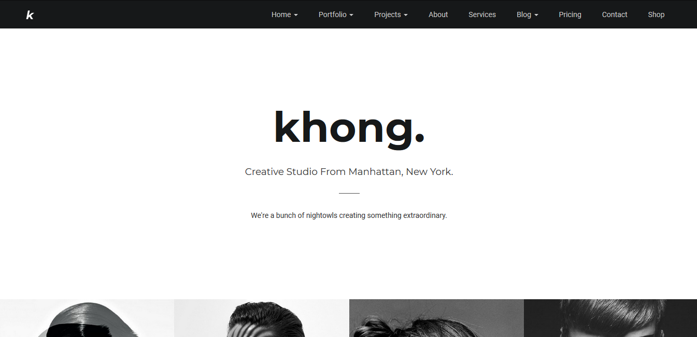

There are some images. On mouseover on any one of them: a filter is applied, and a text appears in the middle of the image (see the image for details).

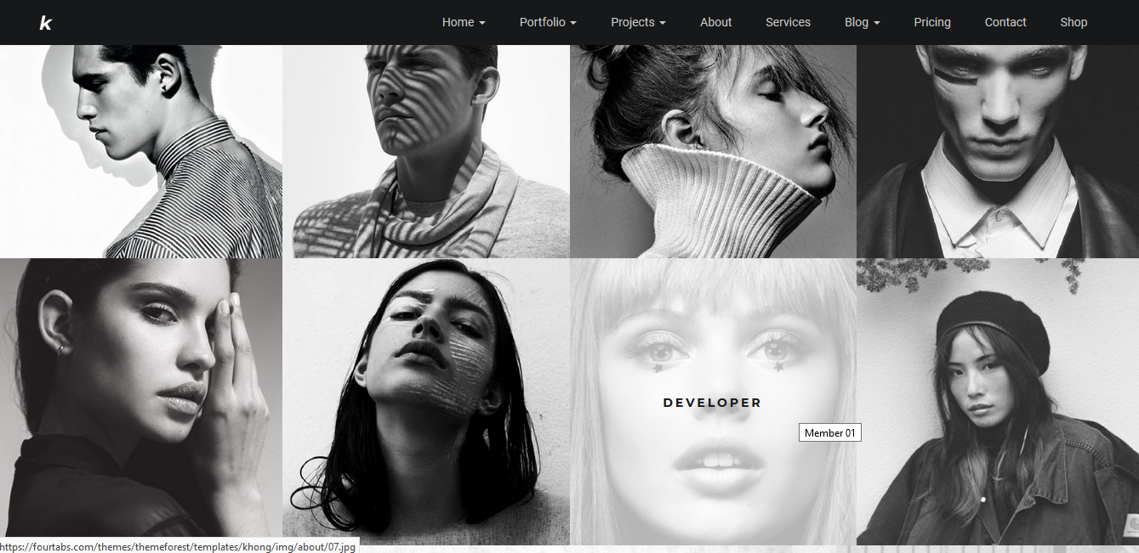

There is a button. On mouseover the button changes its style (change the style to any style you want).

Use Font Awesome through a CDN for any icon you find in the webpage (use any icon).

