GCP-Snow Alerts to Ticket integration

Here is a model ticket that would be created in snow if an alert is triggered in GCP. The below fields are fixed.

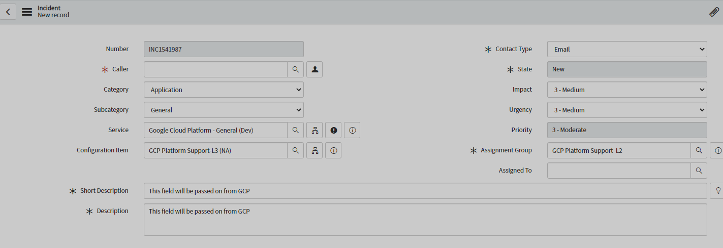

There are 2 dynamic fields that would be passed by gcp to snow.

**Short Description** ---it will be taken from DisplayName (see below)

**Description**—it will be a union of the following keys: resource_name,project_id,documentation,summary

This is the information that is going to be passed to snow.

{"incident": {"incident_id": "0.m55o3icuzx1c", "resource_id": "", "**resource_name**": "mck-esit-prod-ec3b gke-esit-cluster-pro-esit-flex-np-pro-4ecc334c-1lgh", "resource": {"type": "gce_instance", "labels": {"instance_id": "5835124713064873471", "**project_id**": "mck-esit-prod-ec3b", "zone": "us-west1-b"}}, "resource_display_name": "gke-esit-cluster-pro-esit-flex-np-pro-4ecc334c-1lgh", "resource_type_display_name": "VM Instance", "metric": {"type": "compute.googleapis.com/guest/cpu/load_1m", "displayName": "CPU load average (1m)"}, "started_at": 1626913223, "policy_name": "fake alert", "condition_name": "CPU load average (1m) [MEAN]", "condition": {"name": "projects/cops-cloudmonus-prod-b71c/alertPolicies/14022155012417054955/conditions/14022155012417056230", "**displayName**": "CPU load average (1m) [MEAN]", "conditionThreshold": {"filter": "metric.type=\"compute.googleapis.com/guest/cpu/load_1m\" resource.type=\"gce_instance\"", "aggregations": [{"alignmentPeriod": "60s", "perSeriesAligner": "ALIGN_MEAN"}], "comparison": "COMPARISON_GT", "thresholdValue": 0.1, "duration": "0s", "trigger": {"count": 1}}}, "url": "https://console.cloud.google.com/monitoring/alerting/incidents/0.m55o3icuzx1c?project=cops-cloudmonus-prod-b71c", "**documentation**": {"content": "This is an alert for high cpu please contact the customer to check on this", "mime_type": "text/markdown"}, "state": "open", "ended_at": null, "**summary**": "CPU load average (1m) for mck-esit-prod-ec3b gke-esit-cluster-pro-esit-flex-np-pro-4ecc334c-1lgh with metric labels {instance_name=gke-esit-cluster-pro-esit-flex-np-pro-4ecc334c-1lgh} is above the threshold of 0.100 with a value of 0.120."}, "version": "1.2"}

From a GCP cloud function we would invoke a snow api .The code would be similar to this one:

Snow team has to provide the exact url and the authentication method.

 url = "https://demo.service-now.com/api/now/table/incident"

        auth = ("username", "password")

        data = {"caller_id" : "xxxxxxxxxxxxxxxxxxxxxxx",

                "category" : "Fault",

                "subcategory" : "Issues",

                "cmdb_ci" : "xxxxxxxxxxxxxxxxxxxxxxx",

                "short_description" : "google cloud testing",

                "description" : "Testing Google-cloud service - Cloud router is down",

                "assignment_group": "test group",

                }

        #data = json.dumps(data)

        headers = {"Content-type" : "application/json", "Accept" : "application/json"}

        r = requests.post(url, auth = auth, headers = headers, json = data)

        scode = r.status_code

