MODULE 1: Introduction

Welcome

Course Introduction
You will apply your data science skills as a Data scientist for a private space launch company in this project.
As a starting point of almost all data science projects, you need to collect data, as much and relevant as possible.
You will be collecting data from various sources. After your raw data has been collected, you will need to improve the quality by performing data wrangling.
Then you can start exploring the processed data. We will be your guide as we explore some really interesting real-world datasets together. You'll get to practice your SQL skills as we query the data and gather insights.
You'll gain further insights into the data by applying some basic statistical analysis and data visualization, you'll be able to see directly how variables might be related to each other.
We'll drill down into finer levels of detail by splitting the data into groups defined by categorical variables or factors in your data.
You will be guided to build, evaluate, and refine predictive models for discovering more exciting insights.
The final task of this capstone project is to create a presentation that will be developed into stories of all your analysis.

Capstone Introduction and Understanding the Datasets

Project scenario and Overview
The commercial space age is here, companies are making space travel affordable for everyone.
- Virgin Galactic is providing suborbital spaceflights.
- Rocket Lab is a small satellite provider.
- Blue Origin manufactures sub-orbital and orbital reusable rockets.
- SpaceX’s accomplishments include:
Sending spacecraft to the International Space Station.
Starlink, a satellite internet constellation providing satellite Internet access. Sending manned missions to Space.
One reason SpaceX can do this is the rocket launches are relatively inexpensive.
SpaceX advertises Falcon 9 rocket launches on its website with a cost of 62 million dollars; other providers cost upwards of 165 million dollars each, much of the savings is because SpaceX can reuse the first stage. Therefore, if we can determine if the first stage will land, we can determine the cost of a launch.
Spaces X’s Falcon 9 launch like regular rockets. To help us understand the scale of the Falcon 9, we are going to use these diagrams from Forest Katsch, at zlsadesign.com. He is a 3D artist and software engineer. He makes infographics on spaceflight and spacecraft art. He also makes software.
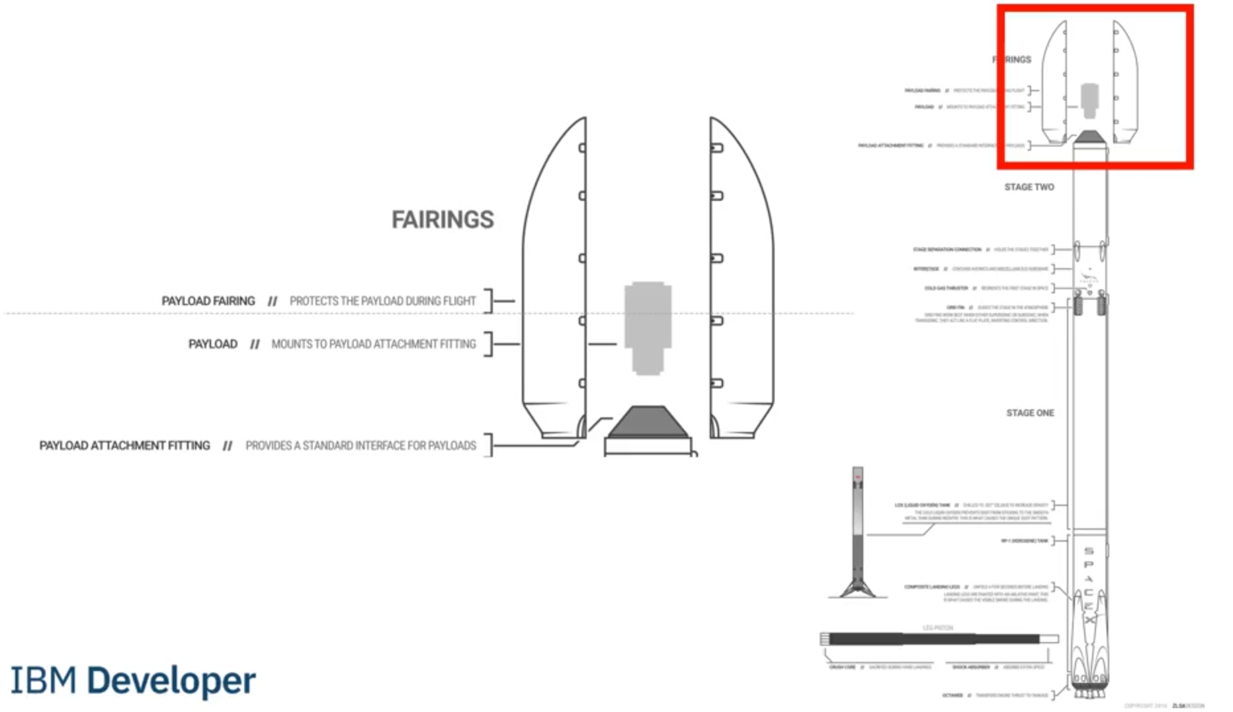 The payload is enclosed in the fairings. Stage two, or the second stage, helps bring the payload to orbit, but most of the work is done by the first stage. The first stage is shown here. This stage does most of the work and is much larger than the second stage.
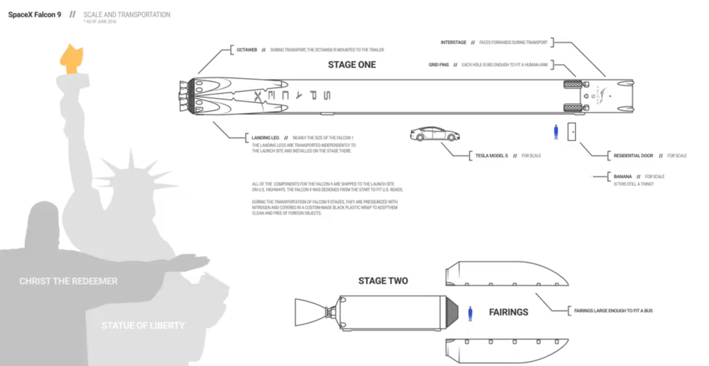
Here we see the first stage next to a person and several other landmarks. This stage is quite large and expensive. Unlike other rocket providers, SpaceX's Falcon 9 Can recover the first stage. Sometimes the first stage does not land. Sometimes it will crash as shown in this clip. Other times, Space X will sacrifice the first stage due to the mission parameters like payload, orbit, and customer.
In this capstone, you will take the role of a data scientist working for a new rocket company. Space Y that would like to compete with SpaceX founded by Billionaire industrialist Allon Musk.
Your job is to determine the price of each launch. You will do this by gathering information about Space X and creating dashboards for your team. You will also determine if SpaceX will reuse the first stage.
Instead of using rocket science to determine if the first stage will land successfully, you will train a machine learning model and use public information to predict if SpaceX will reuse the first stage.

Getting Started with GitHub

Collecting the data

Data Collection Overview
SpaceX Rest API
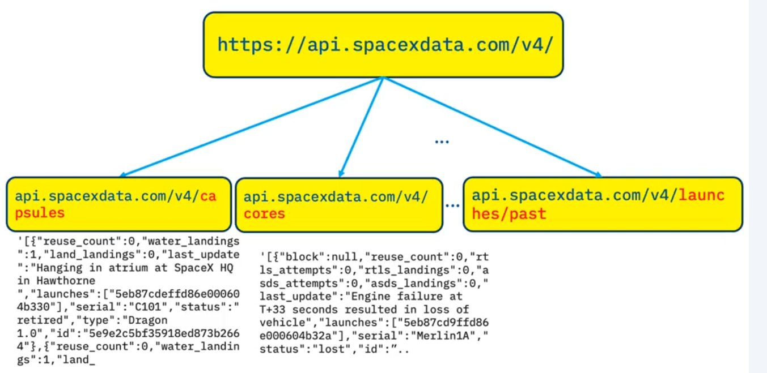

API returns a list of JSON Objects, representing each a launch.
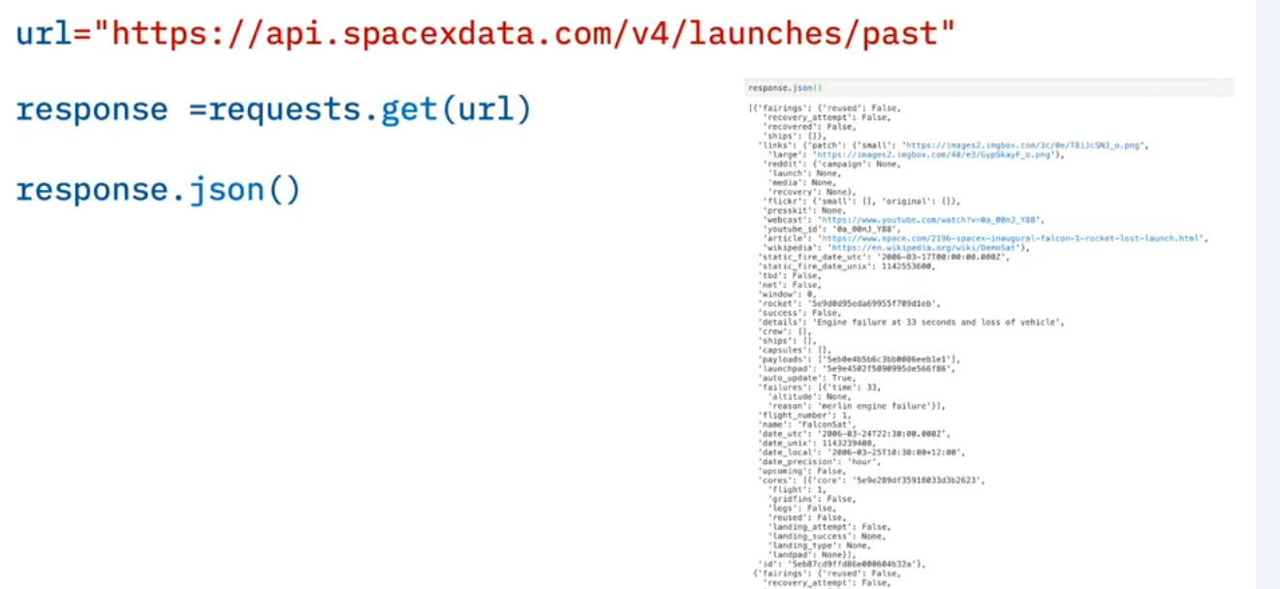
We convert the JSON objects list into a Data Frame with Json_normalize()
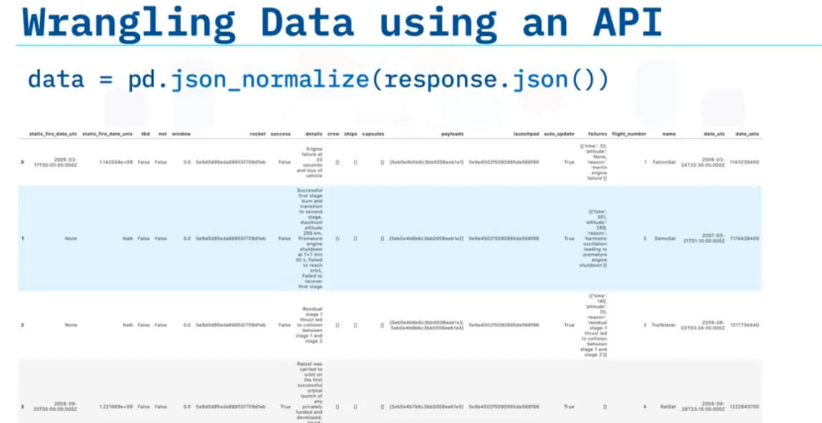
Asid using API is it possible webscrap with BeautifulSoup to get data from HTML tables
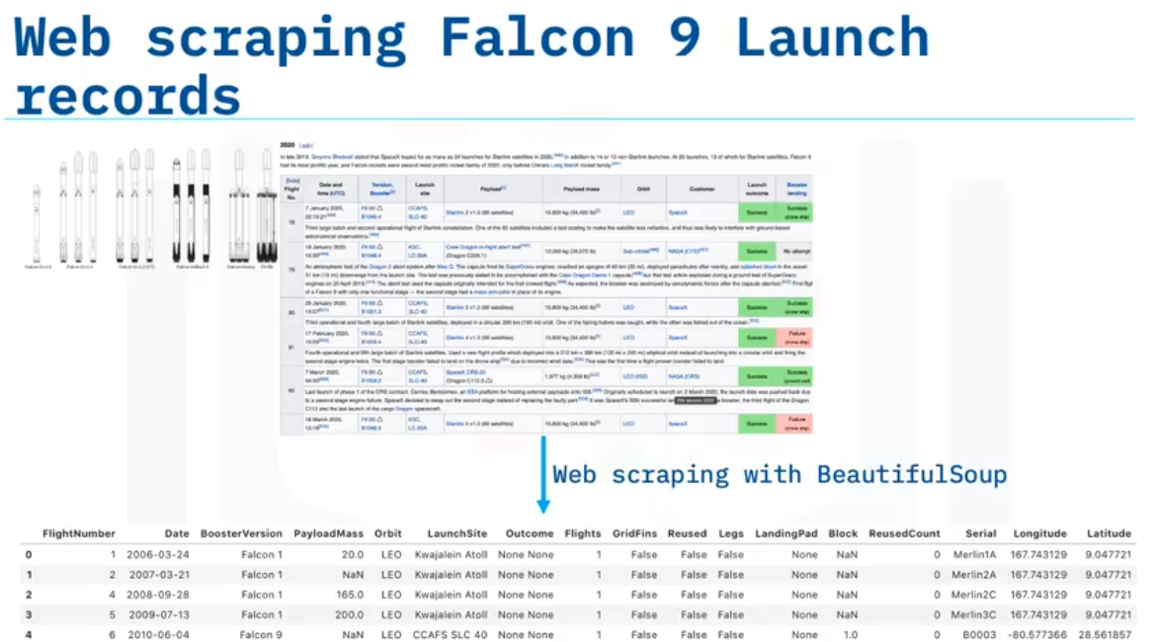

We want to transform this raw data into a clean dataset which provides meaningful data on the situation we are trying to address: Wrangling Data using an API, Sampling Data, and Dealing with Nulls.
You will notice, in some of the columns, like rocket, we have an identification number, not actual data. This means we will need to use the API again targeting another endpoint to gather specific data for each ID number.
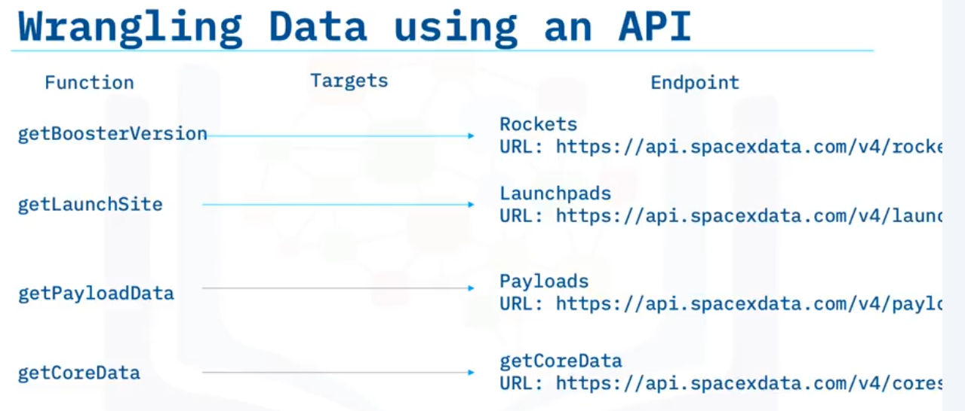
These functions are already created for you, and will use the following: Booster, Launchpad, payload, and core. The data will be stored in lists and will be used to create our dataset.
Another issue we have is that the launch data we have includes data for the Falcon 1 booster whereas we only want falcon 9.
In this lab, you will need to figure out how to filter/sample the data to remove Falcon 1 launches.
Finally, not all gathered data is perfect. We may end up with data that contains NULL values.
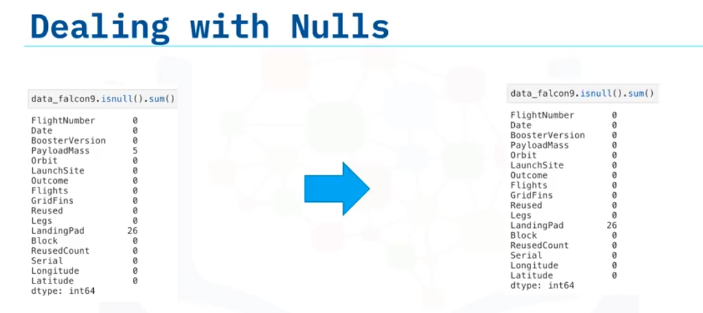
We must sometimes deal with these null values in order to make the dataset viable for analysis.
In this case, we will deal with the NULL values inside the PayloadMass. In this lab, you must figure out a way to calculate the mean of the PayloadMass data and then replace the null values in PayloadMass with the mean.
We will leave the column LandingPad with NULL values, as it is represented when a landing pad is not used. This will be dealt with using one hot encoding later on.

Lab: Complete the data collection API Lab
Data_falcon9 has a shape of 90,17.

Lab: Complete the data collection with data Webscraping

Check Point: Data collection Api

Graded Quiz: Data Collection API With Webscraping

Data Wrangling

Data Wrangling Overview

Lab: Data Wrangling

Check Point : Data Wrangling

Graded Quiz: Data Wrangling

MODULE 2: Exploratory Data Analysis (EDA)

Exploratory Data Analysis Using SQL

Exploratory Data Analysis Using Pandas and Matplotlib

MODULE 3: Interactive Visual Analytics and Dashboard

Interactive Visual Analytics and Dashboard

Interactive Visual Analytics and Dashboard

Lab: Interactive Visual Analytics and Dashboard with Folium

Lab: Interactive Visual Analytics and Dashboard with Dash

Check Point: Interactive Visual Analytics and Dashboard

Graded Quiz: Interactive Visual Analytics and Dashboard

MODULE 4: Predictive Analysis (Classification)

Predictive Analysis (Classification)

Predictive Analysis Overview

Lab: Complete the Machine Learning Prediciton Lab

Check Point: Predictive Analysis

Graded Quiz: Predictive Analysis

MODULE 5: Present Your Data-Driven Insights

How to present your findings

Elements of a Succesful Data findings Report
While finding and cleaning data is an important first step in data analysis, a concept can be lost if you are not able to organize and represent the findings effectively to your audience.
In this video, you will learn how to represent your findings by focusing on specific elements to create successful data findings report. After the data has been collected, cleaned, and organized the work of interpretation begins. You are now able to obtain a complete view of the data and hopefully, answer the questions that were formed before starting the analysis. Now, you typically begin to compose a findings report that explains what was learned. Depending on the stakeholders and how they receive the information, your report could vary in form. This could include a paper style report, a slideshow presentation, or maybe even both.
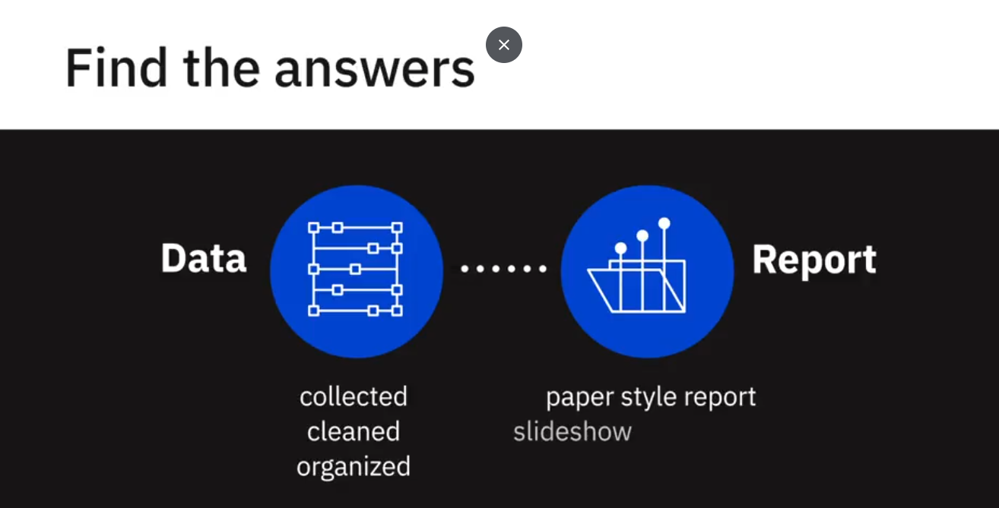
The findings report is a crucial part of data analysis, as it conveys what was discovered. When beginning this process, the collected data and information may seem a little overwhelming. The best way to get through this block is to begin by creating an outline. By completing an outline, you can then get a complete picture and begin to write in a precise but simple manner. While there are many different formats for creating a data-driven presentation, we have created a simple outline that is easy to follow yet effective. When creating your outline always remember to structure it towards your audience and create a presentation that is appropriate for your situation.
You first begin with your cover page.
This beginning section will have the title of your presentation, your name, and then the date.
The next section in your outline will be an executive summary and then the table of contents. The table of contents will contain the sections and subsections of your report in order to give your audience an overview of the contents. This also enables readers to go directly to a specific section that may be more important to them. Continue your presentation with the introduction, methodology, results, discussion, conclusion, and finally the appendix. Please note the depth and length for each element may vary depending on the audience and format of report.
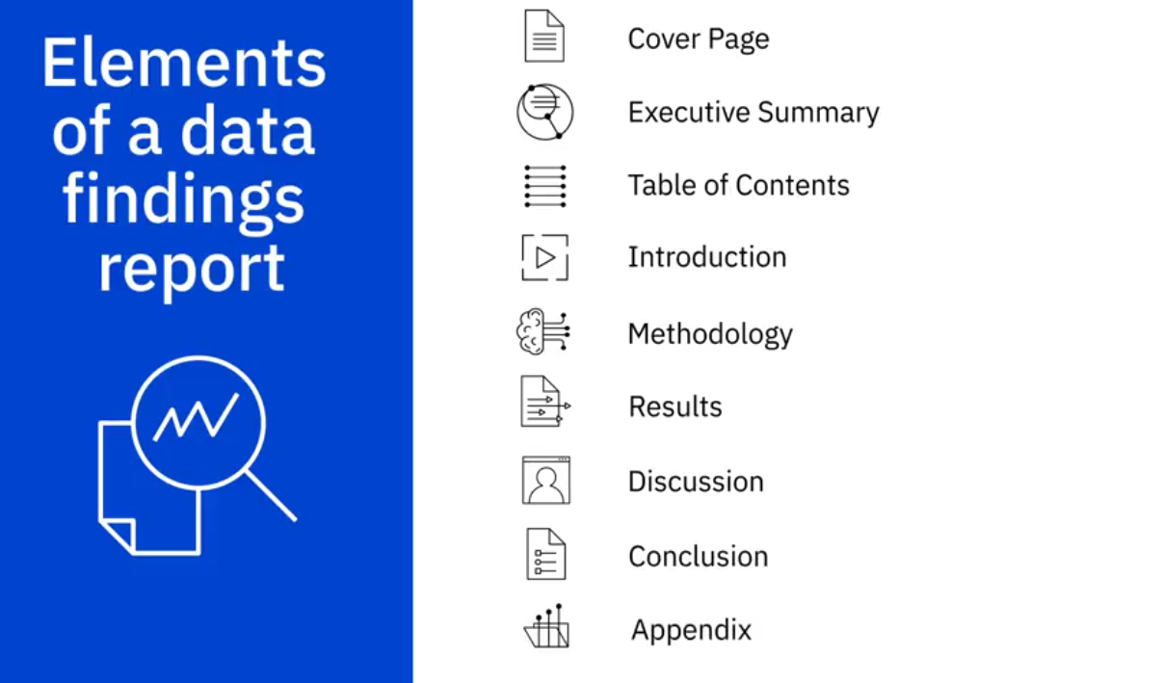

Executive summary.
This summary will briefly explain the details of the project and should be considered a stand-alone document. This information is taken from the main points of your report and while it is acceptable to repeat information, no new information is presented.
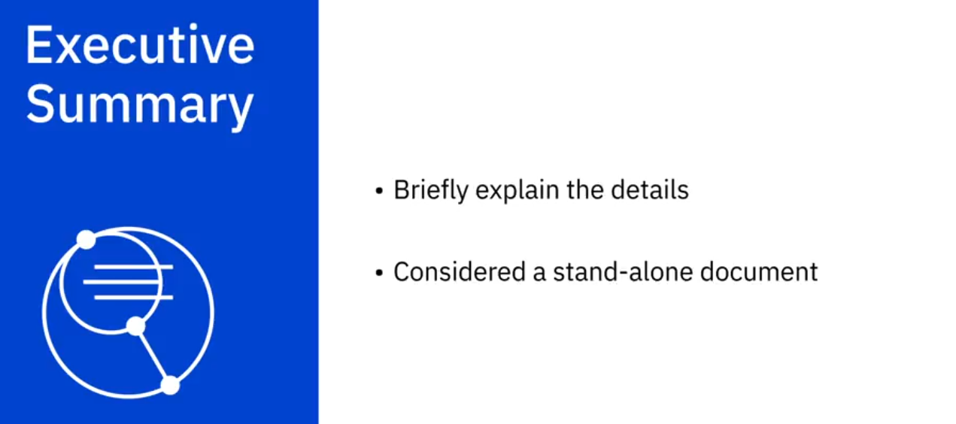

Introduction
The introduction explains the nature of the analysis, states the problem, and gives the questions that were to be answered by performing the analysis.
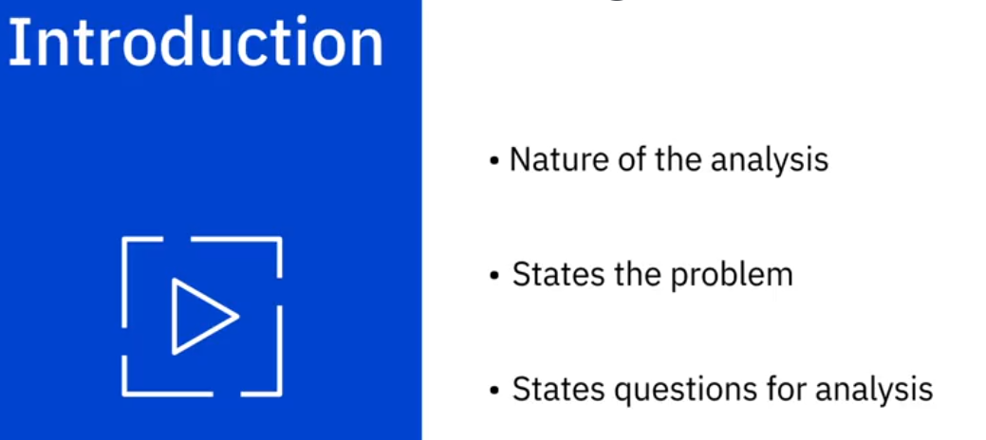

Methodology
Methodology explains the data sources that were used in the analysis and outlines the plan for the collected data. For example, was the cluster or regression method used to analyze the data?
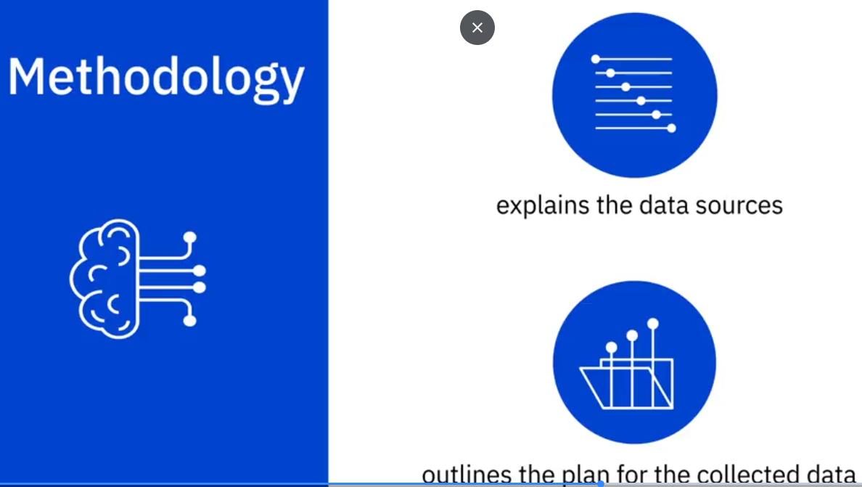

Results
Next, we have the results section. This section goes into the detail of the data collection, how it was organized, and how it was analyzed. This portion would also contain the charts and graphs that would substantiate the results and call attention to the more complex or crucial findings. By providing this interpretation of data, you are able to give a detailed explanation to the audience and convey how it relates to the problem that was stated in the introduction.

Discussion
Next is the discussion of the report findings and implications. For this section you would begin to engage the audience with a discussion of your implications that were drawn from the research. For example, let’s say you were conducting research for top programming languages for college graduates. Would you find they need to learn multiple languages to remain competitive in the job market, or would one language always reign supreme?

Conclusion
We have now reached the conclusion of the report’s findings. This final section should reiterate the problem given in the introduction and gives an overall summary of the findings. It would also state the outcome of the analysis and if any other steps are taken in the future.

Appendix
Lastly, we have the appendix. This section would contain information that really didn’t fit in the main body of the report, but you deemed it was still important enough to include. This type of information could include locations where the raw data was collected or other details such as resources, acknowledgements or references.
In this video, we learned about the important elements in creating successful data findings report. In the next video, we will learn the best practices when presenting your findings.

Reading: Structure of a Report
The Report Structure
Before starting the analysis, think about the structure of the report. Will it be a brief report of five or fewer pages, or will it be a longer document running more than 100 pages in length? The structure of the report depends on the length of the document. A brief report is more to the point and presents a summary of key findings. A detailed report incrementally builds the argument and contains details about other relevant works, research methodology, data sources, and intermediate findings along with the main results.
I have reviewed reports by leading consultants including Deloitte and McKinsey. I found that the length of the reports varied depending largely on the purpose of the report. Brief reports were drafted as commentaries on current trends and developments that attracted public or media attention. Detailed and comprehensive reports offered a critical review of the subject with extensive data analysis and commentary. Often, detailed reports collected new data or interviewed industry experts to answer the research questions.
Even if you expect the report to be brief, sporting five or fewer pages, I recommend that the deliverable follows a prescribed format including the cover page, table of contents, executive summary, detailed contents, acknowledgments, references, and appendices (if needed).
I often find the cover page to be missing in documents. It is not the inexperience of undergraduate students that is reflected in submissions that usually miss the cover page. In fact, doctoral candidates also require an explicit reminder to include an informative cover page. I hasten to mention that the business world sleuths are hardly any better. Just search the Internet for reports and you will find plenty of reports from reputed firms that are missing the cover page.
At a minimum, the cover page should include the title of the report, names of authors, their affiliations, and contacts, the name of the institutional publisher (if any), and the date of publication. I have seen numerous reports missing the date of publication, making it impossible to cite them without the year and month of publication. Also, from a business point of view, authors should make it easier for the reader to reach out to them. Having contact details at the front makes the task easier.
"A table of contents (ToC)" is like a map needed for a trip never taken before. You need to have a sense of the journey before embarking on it. A map provides a visual proxy for the actual travel with details about the landmarks that you will pass by in your trip. The ToC with main headings and lists of tables and figures offers a glimpse of what lies ahead in the document. Never shy away from including a ToC, especially if your document, excluding cover page, table of contents, and references, is five or more pages in length.
Even for a short document, I recommend an "abstract" or an "executive summary". Nothing is more powerful than explaining the crux of your arguments in three paragraphs or less. Of course, for larger documents running a few hundred pages, the executive summary could be longer.
An "introductory section" is always helpful in setting up the problem for the reader who might be new to the topic and who might need to be gently introduced to the subject matter before being immersed in intricate details. A good follow-up to the introductory section is a review of available relevant research on the subject matter. The length of the literature review section depends upon how contested the subject matter is. In instances where the vast majority of researchers have concluded in one direction, the literature review could be brief with citations for only the most influential authors on the subject. On the other hand, if the arguments are more nuanced with caveats aplenty, then you must cite the relevant research to offer adequate context before you embark on your analysis. You might use the literature review to highlight gaps in the existing knowledge, which your analysis will try to fill. This is where you formally introduce your research questions and hypothesis.
In the "methodology" section, you introduce the research methods and data sources you used for the analysis. If you have collected new data, explain the data collection exercise in some detail. You will refer to the literature review to bolster your choice for variables, data, and methods and how they will help you answer your research questions.
The results section is where you present your empirical findings. Starting with descriptive statistics (see Chapter 4, "Serving Tables") and illustrative graphics (see Chapter S, "Graphic Details" for plots and Chapter 10, "Spatial Data Analytics" for maps), you will move toward formally testing your hypothesis (see Chapter 6, "Hypothetically Speaking").
In case you need to run statistical models, you might turn to regression models (see Chapter 7, "Why Tall Parents Don't Have Even Taller Children") or categorical analysis (see Chapters 8, "To Be or Not to Be" and 2., "Categorically Speaking About Categorical Data"). If you are working with time-series data, you can turn to Chapter 11, Doing Serious Time with Time Series. You can also report results from other empirical techniques that fall under the general rubric of data mining (see Chapter 12, "Data Mining for Gold"). Note that many reports in the business sector present results in a more palatable fashion by holding back the statistical details and relying on illustrative graphics to summarize the results.
The results section is followed by the discussion section, where you craft your main arguments by building on the results you have presented earlier.
The "discussion section" is where you rely on the power of narrative to enable numbers to communicate your thesis to your readers. You refer the reader to the research question and the knowledge gaps you identified earlier. You highlight how your findings provide the ultimate missing piece to the puzzle.
Of course, not all analytics return a smoking gun. At times, more frequently than I would like to acknowledge, the results provide only a partial answer to the question and that, too, with a long list of caveats.
In the "conclusion" section, you generalize your specific findings and take on a rather marketing approach to promote your findings so that the reader does not remain stuck in the caveats that you have voluntarily outlined earlier. You might also identify future possible developments in research and applications that could result from your research.
What remains is housekeeping, including a list of references, the acknowledgment section (acknowledging the support of those who have enabled your work is always good), and "appendices", if needed.
Have You Done Your Job as a Writer?
As a data scientist, you are expected to do thorough analysis with the appropriate data, deploying the appropriate tools. As a writer, you are responsible for communicating your findings to the readers. Transport Policy, a leading research publication in transportation planning, offers a checklist for authors interested in publishing with the journal. The checklist is a series of questions authors are expected to consider before submitting their manuscripts to the journal. I believe the checklist is useful for budding data scientists and, therefore, I have reproduced it verbatim for their benefit.
- Have you told readers, at the outset, what they might gain by reading your paper?
- Have you made the aim of your work clear?
- Have you explained the significance of your contribution?
- Have you set your work in the appropriate context by giving sufficient background (including a complete set of relevant references) to your work?
- Have you addressed the question of practicality and usefulness?
- Have you identified future developments that might result from your work?
- Have you structured your paper in a clear and logical fashion?

Best Practices for presenting your finding
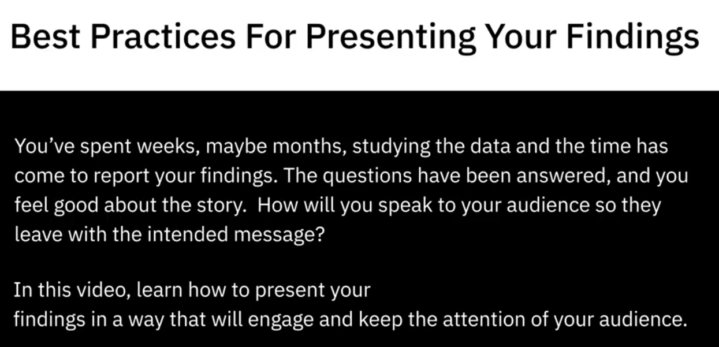
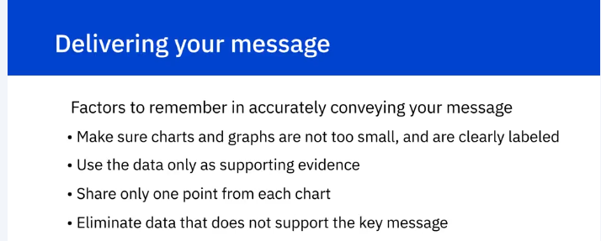
Have you ever sat through a presentation and the information being presented was difficult to read or understand?
While this may seem apparent, small charts and labels can be easily overlooked. Make sure to test the visualizations by sitting at different distances, similar to your audience, and if the data cannot be seen clearly then maybe a redesign should be considered.
When preparing the report, you may feel the only way to explain the findings is to pack the slides with data. While this may seem sensible as a data analyst, your audience will probably not appreciate the intricacies of the data and just see a pile of numbers. To resolve this issue, begin by forming the key messages that need to be conveyed to the audience and build the story around these messages. After forming the outline, go back and insert the data to support your findings. By not relying heavily on the data and using this method to create the presentation, you will create a story that is engaging and interesting to your audience.
Presenting your data using charts and graphs is the best way to get your message across, however, if you are supplying too much information it can be confusing. For example, looking at this pie chart, can you decipher what the key message is, and what the presenter is trying to convey? In the example, the chart has so much information it is hard to determine what point the presenter is trying to make and what the focus should be for the audience. By sticking with one idea and not summarizing multiple points into one visualization, you are able to accurately convey the idea to the audience and avoid any confusion. Data analysts can spend months researching data, however, some items that seem interesting to the analyst may not be relevant to the project. Trying to explain every little detail to your audience and not recognizing irrelevant data could damage the key message. By eliminating this unnecessary data and highlighting only data points that support your key ideas, you will keep the presentation clear and concise.
In this video, we learned about creating a data-driven presentation that will keep the audience engaged and how to deliver a clear and concise message.
Lab: Power Poitn for the web

Final Presentation

Credits and Acknowledges

