What makes data science interesting.
What a data science methodology is
Why data scientists need a data science methodology.

Next, you’ll gain more in-depth knowledge of the first two data science methodology stages: Business Understanding and Analytic Approach. You’ll discover how to identify considerations and steps needed to define the data requirements for decision tree classification during the Data Requirements stage.

Next, learn about the processes and techniques data scientists use to assess data content, quality, and initial insights and how data scientists manage data gaps.

Practical hands-on experience learning how to approach the Business Understanding and the Analytic Approach stage tasks and the Data Requirements and Collection stage tasks for any data science problem.

Learning Objectives

- Apply the first four phases of the data science methodology to a case study.
- Compose clearly defined questions that address a business problem.
- Analyze a case study to determine data requirements.
- Apply the data science methodology to a case study.
- Determine data content, data formats, and data sources prior to data collection and data preparation phases.
- Create a decision tree to classify outcomes in a case study.
- Identify appropriate data sources to address a business problem.

Module 1: From Problem to Approach and From Requirements to Collection

Welcome to the course
Explain how your understanding of a question resulted in an answer that changed how something was done.
Gain in-depth insights into data science methodologies.
Describe how data scientists apply structured approach to solve business problems.
Creating your own data science methodology stories.
In each lesson within each module, you'll explore two foundational data science methodology stages.
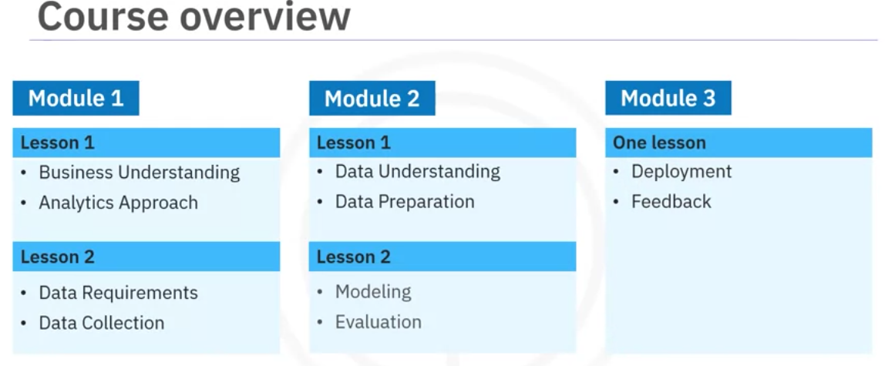
The case study in the course highlights how to apply data science methodology in the following real world scenario. A healthcare facility has a limited budget to properly address a patient's condition before their initial discharge. The core question is what is the best way to allocate these funds to maximize their use to provide quality care?

Problem to Approach

Data Science Methodology overview
we often don't understand the questions being asked or know how to apply the data correctly to address the problem at hand.
Using a methodology helps resolve those issues.

What is a methodology?
A system of methods used in a particular area of study.
A guideline for the decisions researchers must make during the scientific process.
A structured approach that guides data scientists in solving complex problems and making data-driven decisions.

Data science methodology also includes:
- Data collection forms,
- Measurement strategies.
- Comparisons of data analysis methods relative to different research goals and situations.

Using a methodology provides the practical guidance needed to conduct scientific research efficiently. There's often a
Temptation to bypass methodology and jump directly to solutions.
Jumping to solutions hinders our best intentions for solving problems.

Data science methodology by John Rollins
It consists of the following 10 stages.
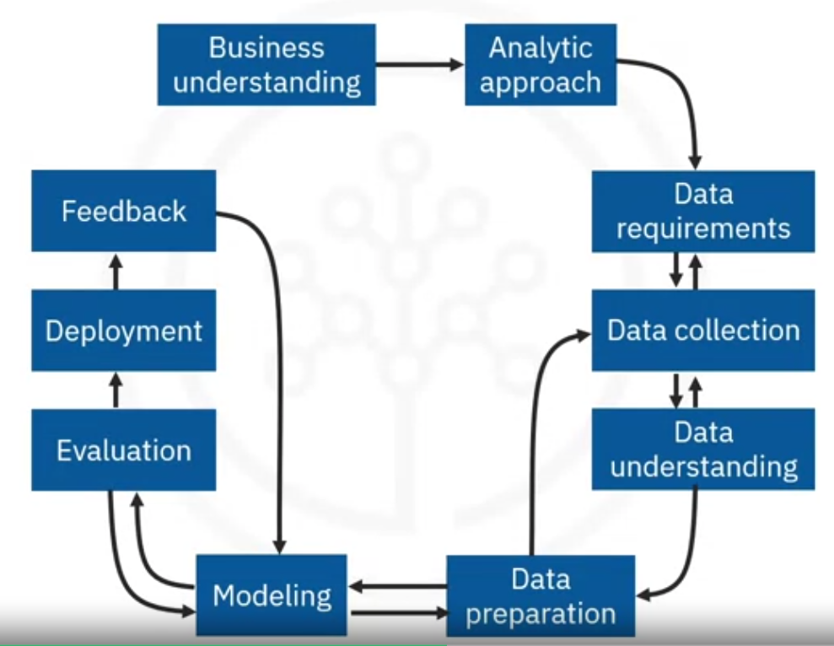

Asking questions is the cornerstone of success in data science.
Questions drive every stage of data science methodology.
Data science methodology aims to answer the following 10 basic questions which align with the data methodology questions.
1.-Define the issue and determine what approach to use.
- What is the problem that you're trying to solve? (BUSINESS UNDERSTANDIG)
- How can you use data to answer the question? (ANALYTIC APPROACH)
2.- Organized around the data.
- What data do you need to answer the question? (DATA REQUIREMENTS)
- Where's the data source from? (DATA COLLECTION)
- How will you receive the data? (DATA COLLECTION)
- Does the data you collect represent the problem to be solved? (DATA UNDERSTANDING)
- What additional work is required to manipulate and work with the data? (DATA PREPARATION)

3.- Validate your approach and final design of the data for ongoing analysis.
- When you apply data visualizations, do you see answers that address the business problem? (MODELING)
- Does the data model answer the initial business question or must you adjust the data? (EVALUATION)
- Can you put the model into practice? (DEPLOYMENT)
- Can you get constructive feedback from the data and the stakeholder to answer the business question? (FEEDBACK)

Analytic Approach Based on the Question Type
When choosing an analytic approach for a problem, the type of question you’re trying to answer greatly influences the methodology. Here are five common types of questions and corresponding analytic approaches:

1. Descriptive Questions: “What is the current status?”
Approach: Descriptive Analytics
Question: "What is the current status of our sales?"
Techniques:
- Data aggregation: Combining data from various sources into a unified view.
- Data mining: Extracting useful information from large datasets.
- Data visualization: Using visual tools to present data in an easily understandable format.
Examples:
- Summarizing sales data
- Creating dashboards
- Generating reports

2. Diagnostic Questions: “Why did it happen?”
Approach: Diagnostic Analytics
Question: "Why did our sales decline in the last quarter?"
Techniques:
- Drill-down: Exploring detailed data to find underlying causes.
- Data discovery: Identifying patterns and relationships in data.
- Correlation analysis: Assessing the relationship between different variables.
Examples:
- Identifying root causes of sales decline
- Analyzing customer complaints
- Understanding failure points in a process

3. Predictive Questions: “What is likely to happen?”
Approach: Predictive Analytics
Question: "What is our sales forecast for the next year?"
Techniques:
- Regression analysis: Predicting outcomes based on relationships between variables.
- Time series forecasting: Predicting future values based on past trends.
- Machine learning models: Using algorithms to predict future outcomes based on historical data.
Examples:
- Forecasting sales
- Predicting customer churn
- Estimating future demand

4. Prescriptive Questions: “What should we do?”
Approach: Prescriptive Analytics
Question: "What should we do to increase website traffic?"
Techniques:
- Optimization models: Finding the best solution from a set of alternatives.
- Simulation: Modeling scenarios to predict outcomes.
- Decision analysis: Evaluating and comparing different decisions.
Examples:
- Recommending inventory levels
- Optimizing marketing campaigns
- Determining pricing strategies

5. Classification Questions: “Which category does this belong to?”
Approach: Classification (Supervised Learning)
Question: "Which category does this data point belong to?"
Techniques:
- Logistic regression: Predicting the probability of a categorical outcome.
- Decision trees: Splitting data into branches to classify it.
- Support vector machines: Finding the best boundary to separate categories.
- Neural networks: Using interconnected nodes to classify data.
Examples:
- Email spam detection
- Image classification
- Disease diagnosis
Understanding these different types of questions and the corresponding analytic approaches can help you unlock your data's true potential.

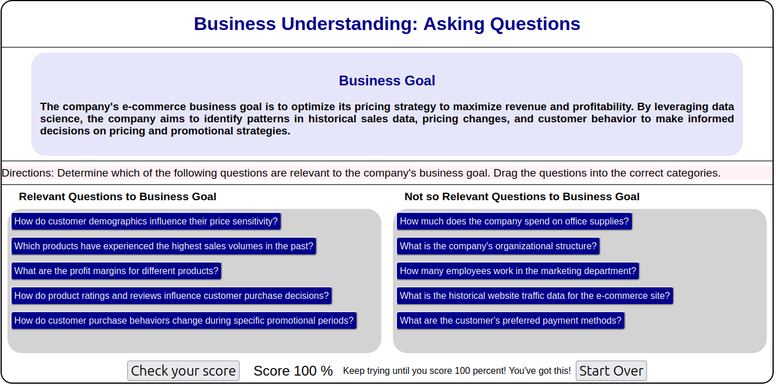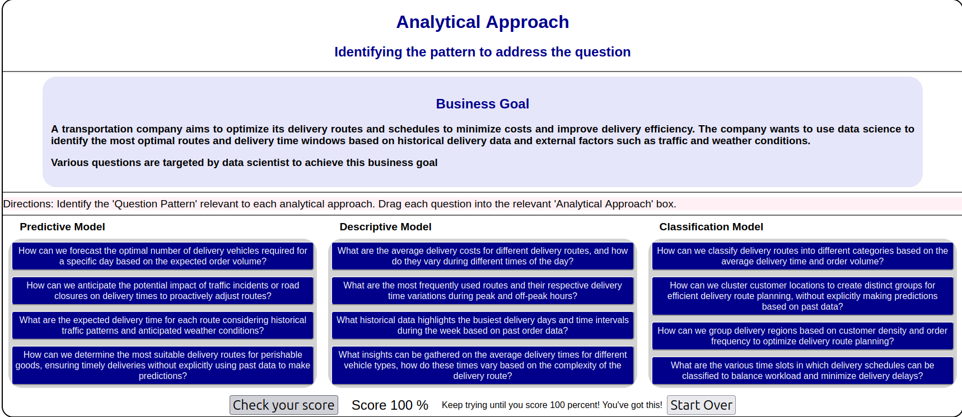
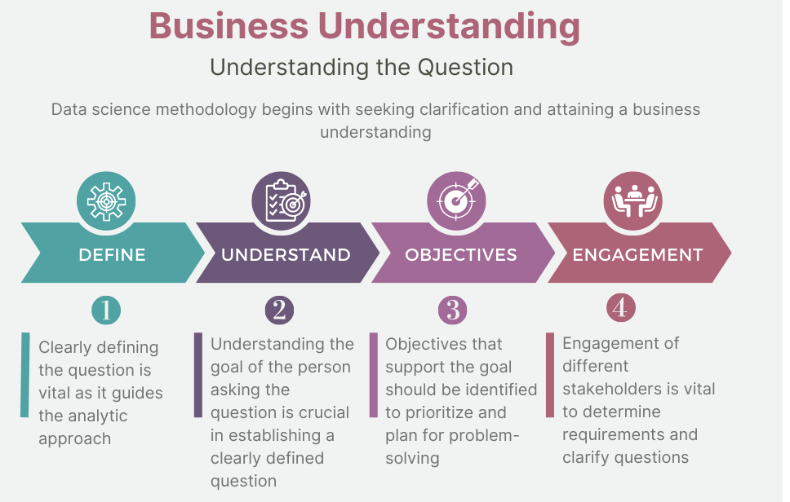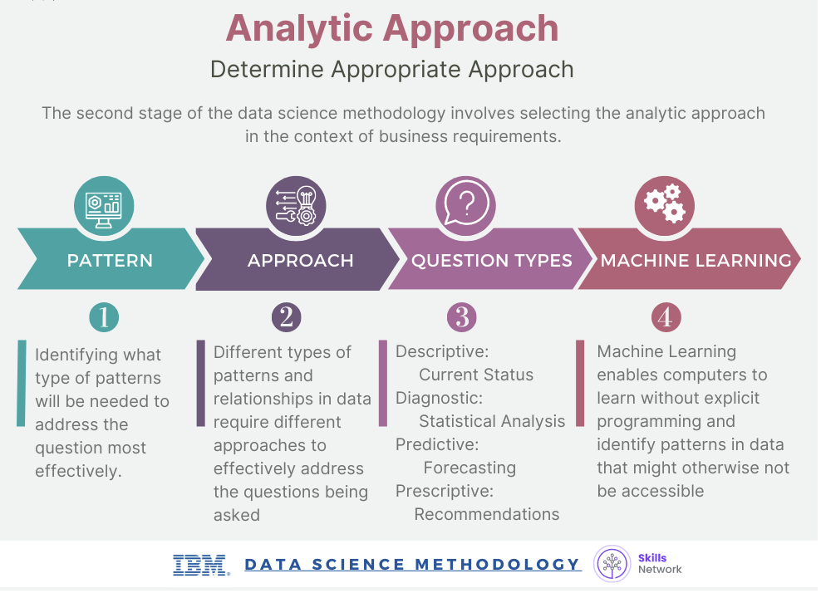

Business Understanding

Analytic Approach

Analytic Approach based on the question type

From Requirements to Collection

Data Requirements
The data scientist needs to identify:
- Which data are required.
- How to source or to collect them.
- How to understand or work with them.
- How to prepare the data to meet the desired outcome.

Building on the understanding of the problem at hand, and then using the analytical approach selected, the Data Scientist is ready to get started.
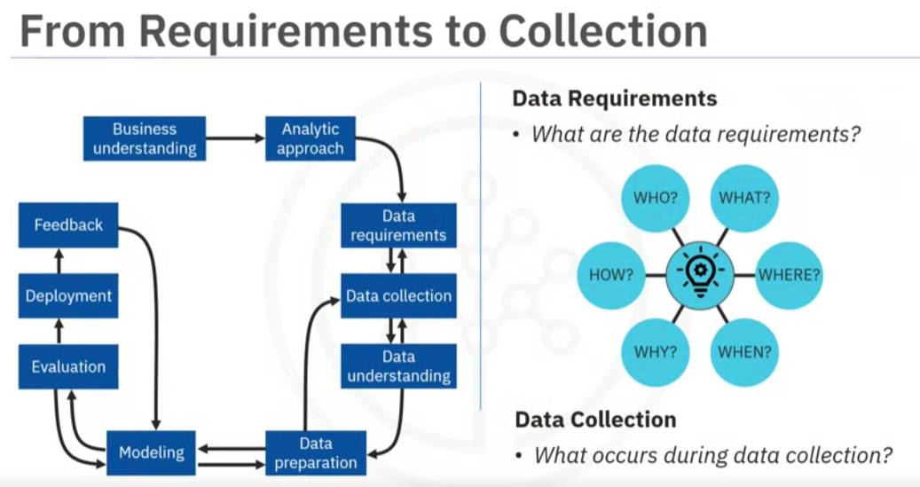

Example:

Define the data requirements for decision-tree classification:

1.-Identifying the necessary data content, formats and sources for initial data collection.

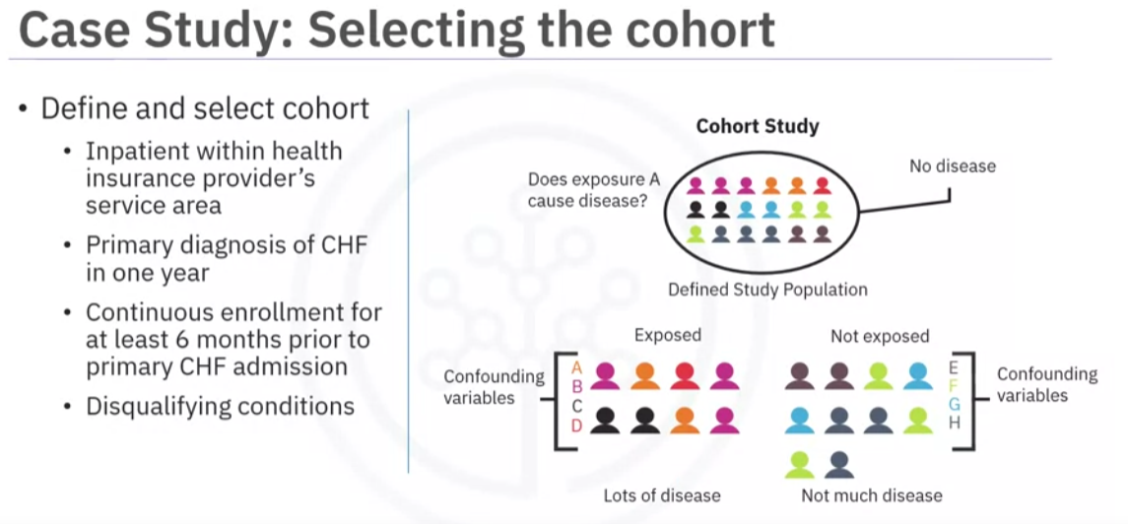
Selecting a suitable patient cohort from the health insurance providers member base.
Three criteria were identified:
- To be admitted as in-patient within the provider service area, (access to his/her information).
- Primary diagnosis of congestive heart failure during one full year.
- Continuous enrollment for at least six months, prior to the primary admission for congestive heart failure, (complete medical history).

Congestive heart failure patients who also had been diagnosed as having other significant
medical conditions, were excluded from the cohort because those conditions would cause
higher-than-average re-admission rates and, thus, could skew the results.

Then the content, format, and representations of the data needed for decision tree classification were defined.
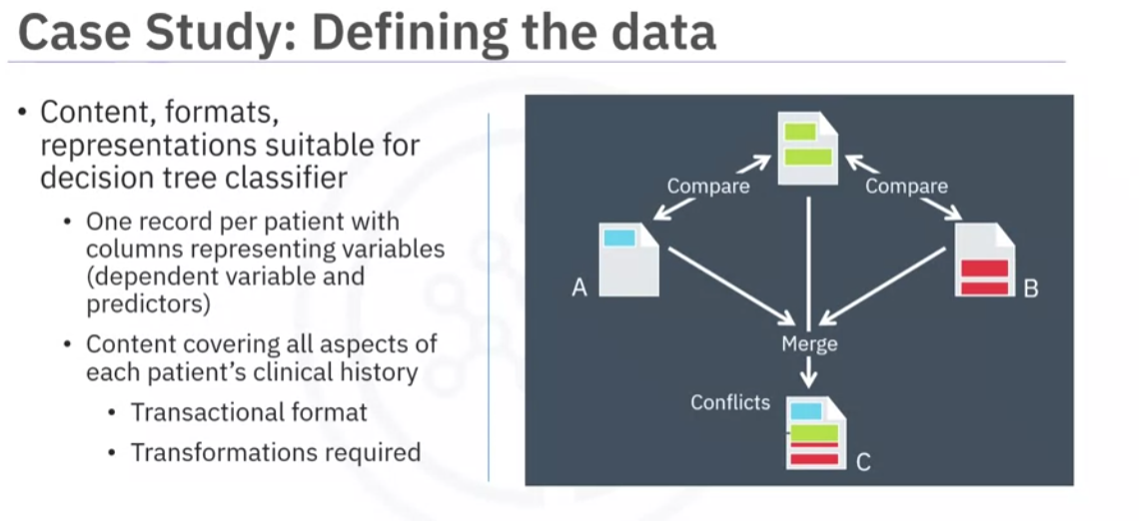
This modeling technique requires one record per patient, with columns representing the variables in the model.
To model the readmission outcome, there needed to be data covering all aspects of the patient's clinical history.
This content would include admissions, primary, secondary, and tertiary diagnoses, procedures, prescriptions, and other services provided either during hospitalization or throughout patient/doctor visits.
Thus, a particular patient could have thousands of records, representing all their related
attributes.
To get to the one record per patient format, the data scientists rolled up the transactional
records to the patient level, creating a number of new variables to represent that information.
This was a job for the data preparation stage, so thinking ahead and anticipating subsequent stages is important.

Data Collection
After the initial data collection is performed, an assessment by the data scientist takes
place to determine whether or not they have what they need.

The data requirements are revised, and decisions are made as to whether or not the collection requires more or less data.

In the data collection stage, the data scientist will have a good understanding of what they will be working with.

Techniques such as descriptive statistics and visualization can be applied to the data
set, to assess the content, quality, and initial insights about the data.
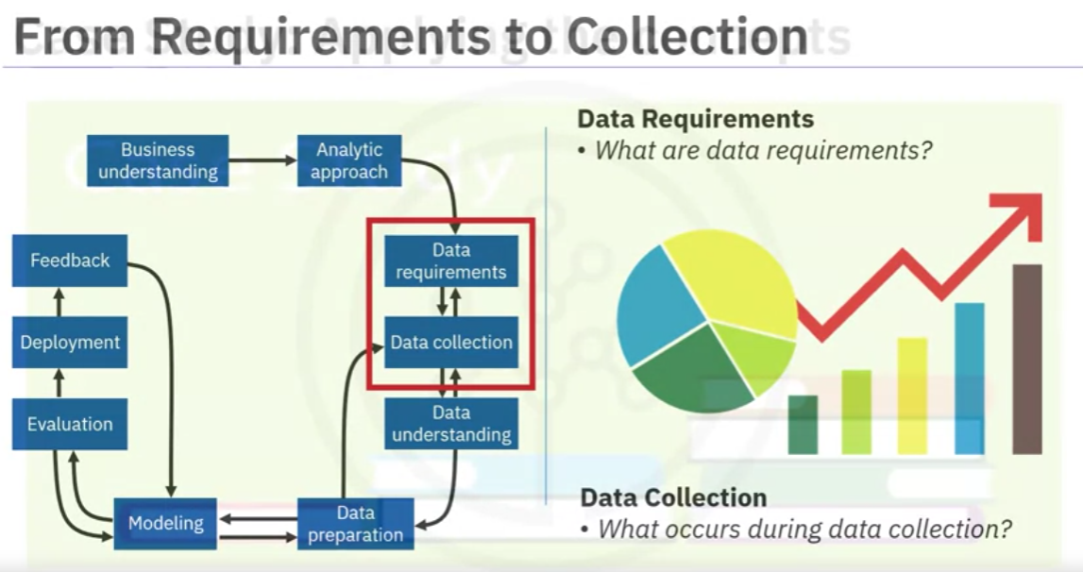

Gaps in data will be identified and plans to either fill or make substitutions will have to be made.

The data collection stage follow-up to the data requirements stage. It requires that you know the source or, know where to find the data elements that are needed.
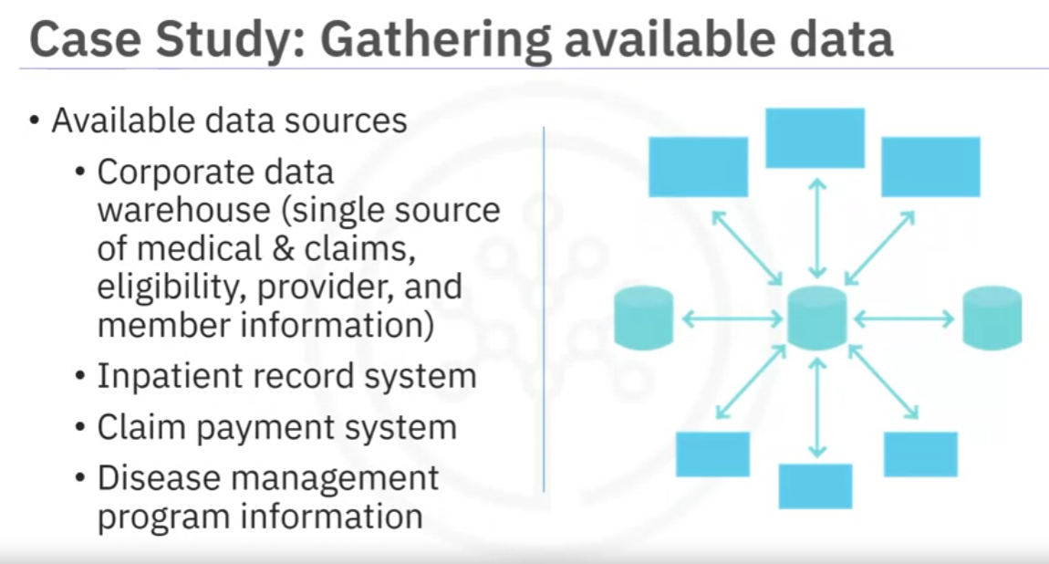
In the context of our case study, these can include:
Demographic, clinical and coverage information of patients, provider information, claims records, as well as pharmaceutical and other information related to all the diagnoses of the congestive heart failure patients.

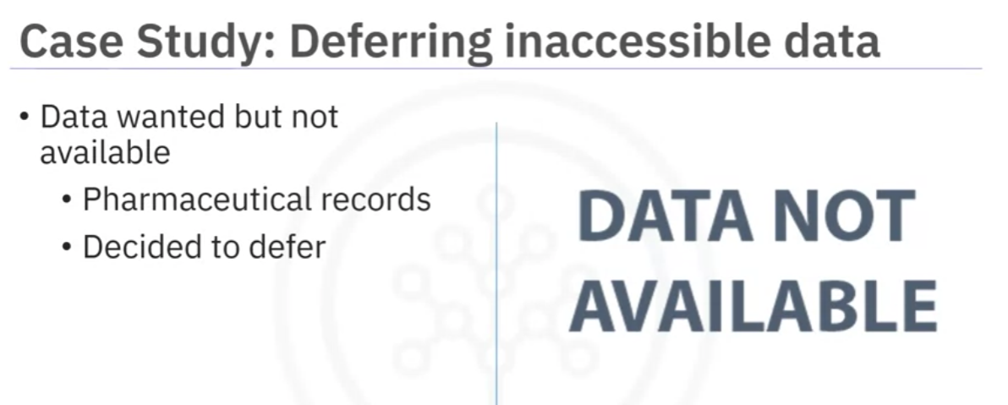

For this case study, certain drug information was also needed, but that data source was
not yet integrated with the rest of the data sources. This leads to an important point: It is alright to defer decisions about unavailable data and attempt to acquire it at a later stage.
For example, this can even be done after getting some intermediate results from the predictive modeling. If those results suggest that the drug information might be important in obtaining a good model, then the time to try to get it would be invested. As it turned out though, they were able to build a reasonably good model without this drug information.
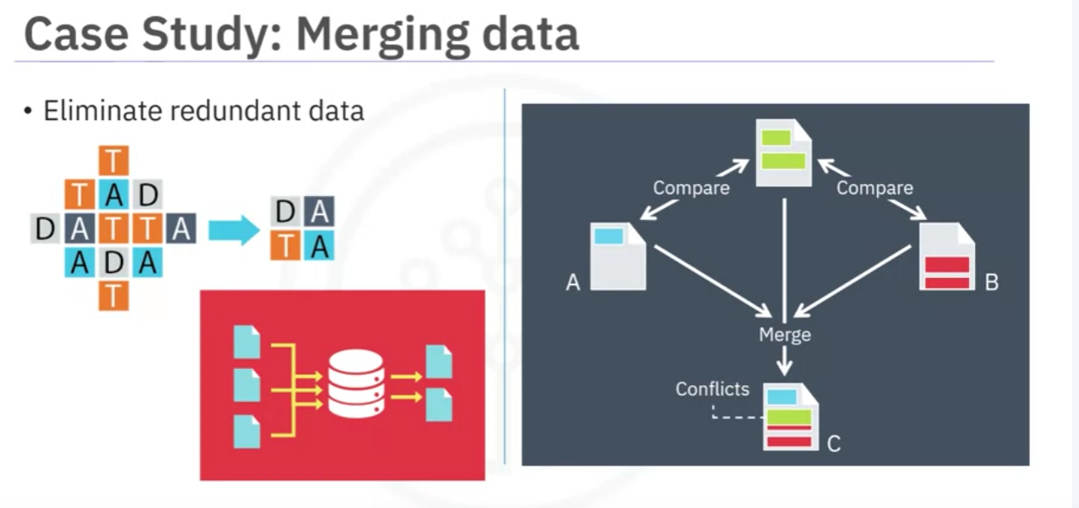
DBAs and programmers often work together to extract data from various sources, and then merge it. This allows for removing redundant data, making it available for the next stage of the methodology, which is data understanding.
At this stage, if necessary, data scientists and analytics team members can discuss various ways to better manage their data, including automating certain processes in the database, so that data collection is easier and faster.

From Requirements to collection (python notebook)
Web Scraping of Online Food Recipes
A researcher named Yong-Yeol Ahn scraped tens of thousands of food recipes (cuisines and ingredients) from three different websites, namely:
For more information on Yong-Yeol Ahn and his research, you can read his paper on Flavor Network and the Principles of Food Pairing.
Luckily, we will not need to carry out any data collection as the data that we need to meet the goal defined in the business understanding stage is readily available.
import pandas as pd
pd.set_option('display.max_columns', None)
recipes = pd.read_csv("https://cf-courses-data.s3.us.cloud-object-storage.appdomain.cloud/IBMDeveloperSkillsNetwork-DS0103EN-SkillsNetwork/labs/Module%202/recipes.csv")
recipes.head()
recipes.shape
len(recipes['country'].unique()) ## numero de países de los que hay recetas

Lesson Summary from Requirements to collection

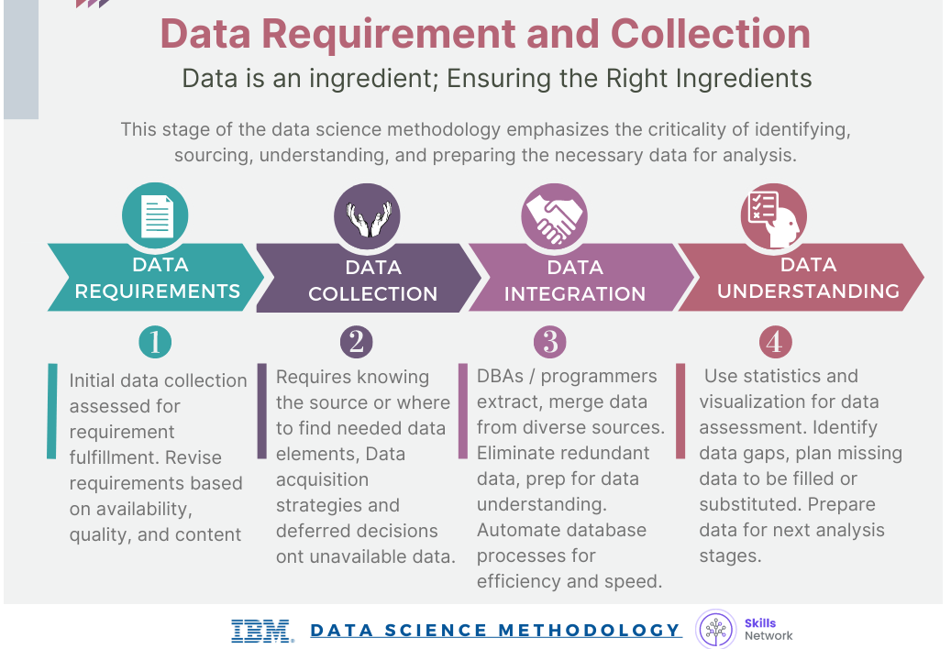

Module2: From Understanding to Preparation and From Modeling to Evaluation.

From Understanding to Preparation

Data Understanding
Data understanding encompasses all activities related to constructing the data set.
Data understanding answers the question: Is the data that you collected representative of the problem to be solved?
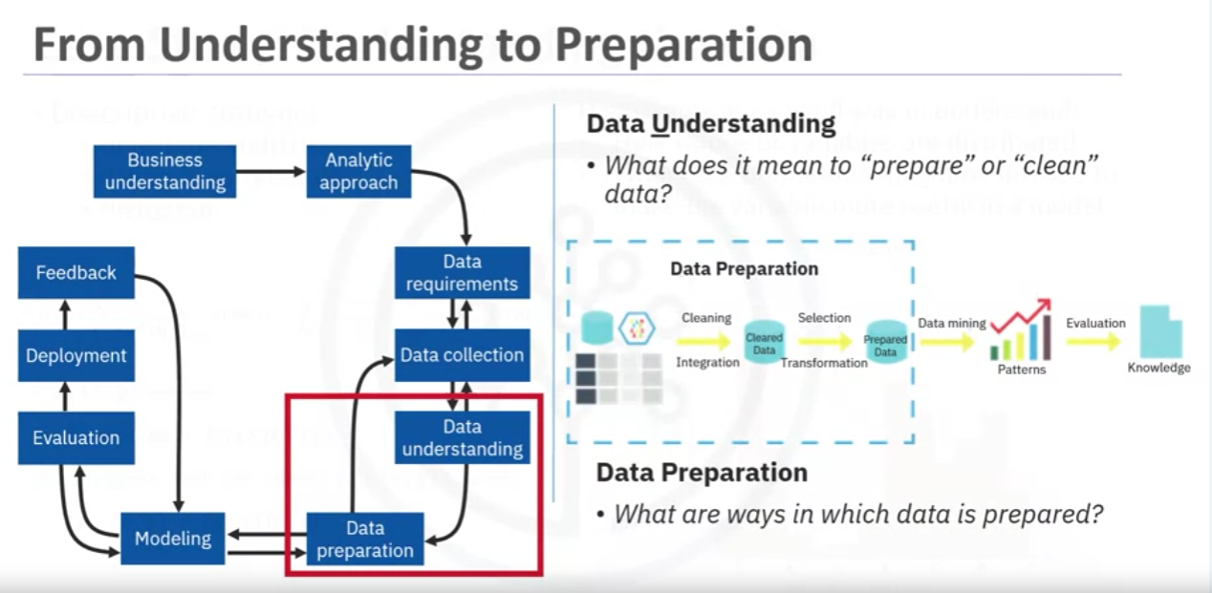

To understand the data, descriptive statistics needed to be run against the data columns that would become variables in the model:
- hurst, univariates, and statistics on each variable, such as mean, median, minimum, maximum, and standard deviation.
- Pairwise correlations were used, to see how closely certain variables were related, and which ones, if any, were very highly correlated, meaning that they would be essentially redundant, thus making only one relevant for modeling.
- Histograms are a good way to understand how values or a variable are distributed, and which sorts of data preparation may be needed to make the variable more useful in a model. For example, for a categorical variable that has too many distinct values to be informative in a model, the histogram would help them decide how to consolidate those values.
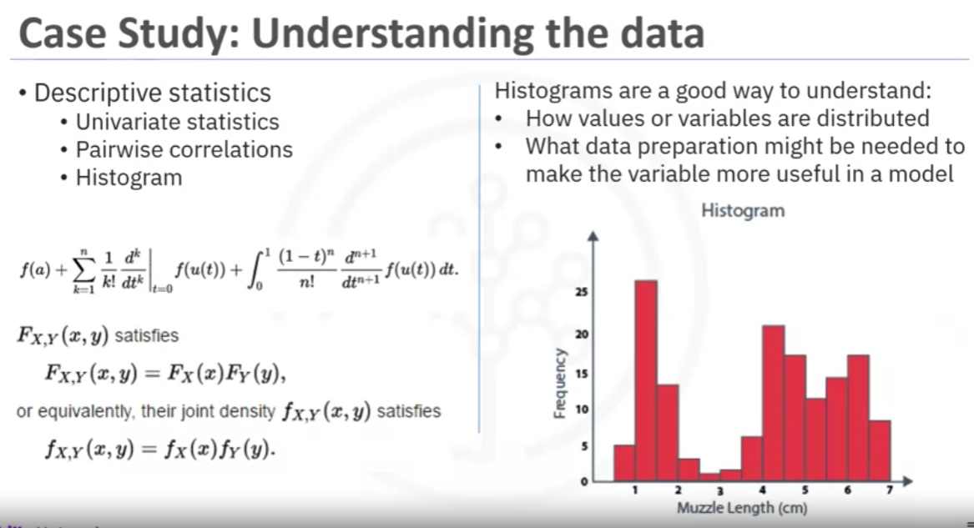
The univariates, statistics, and histograms are also used to assess data quality.
From the information provided, certain values can be re-coded or perhaps even dropped if necessary, such as when a certain variable has missing values.

The question then becomes, does "missing" mean anything?
Sometimes a missing value might mean "no", or "0" (zero), or at other times it simply means "we don't know" or, if a variable contains invalid or misleading values, such as a numeric variable called "age" that contains 0 to 100 and also 999, where that "triple-9" actually means "missing", but would be treated as a valid value unless we corrected it.

Initially, the meaning of congestive heart failure admission was decided based on a primary diagnosis of congestive heart failure. But working through the data understanding stage revealed that the initial definition was not capturing all the congestive heart failure admissions that were expected, based on clinical experience.
This meant looping back to the data collection stage and adding secondary and tertiary diagnoses and building a more comprehensive definition of congestive heart failure admission.
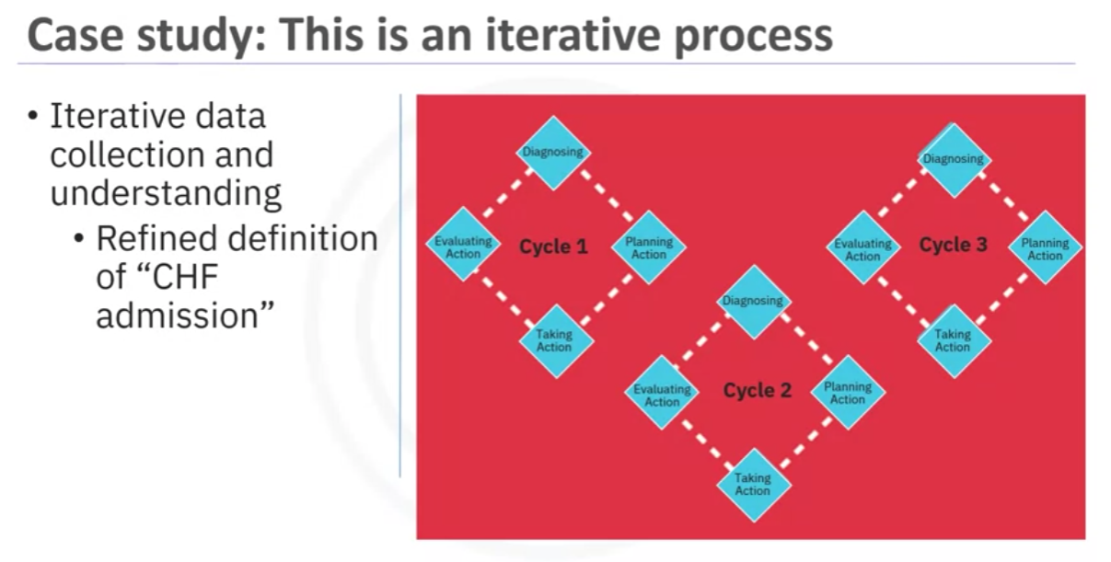
The more one works with the problem and the data, the more one learns and therefore the more refinement that can be done within the model, ultimately leading to a better solution to the problem.

Data Preparation Concepts

Cleansing data
Data preparation is the most time-consuming phase of a data science project, typically taking 70% and even up to even 90% of the overall project time. Automating some of the data collection and preparation processes in the database, can reduce this time to as little as 50%.
This time savings translates into increased time for data scientists to focus on creating models.

Transforming Data
Similarly, transforming data in the data preparation phase is the process of getting the data into a state where it may be easier to work with.
Specifically, the data preparation stage of the methodology answers the question: What are the ways in which data is prepared?
To work effectively with the data, it must be prepared in a way that addresses missing or invalid values and removes duplicates, toward ensuring that everything is properly formatted.
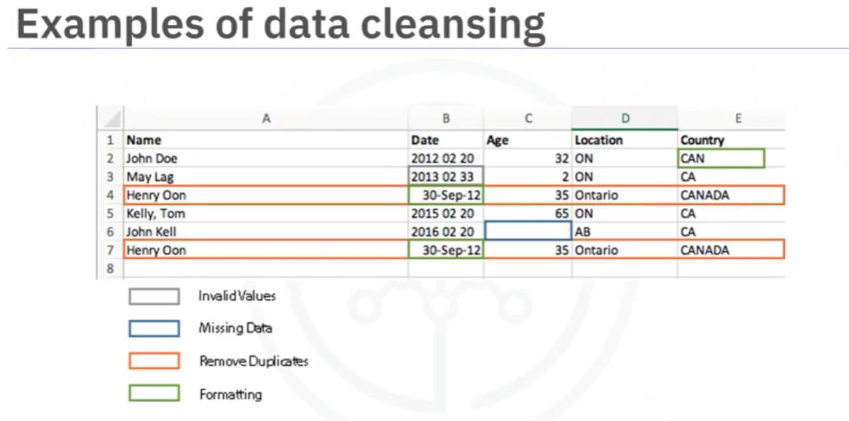

Using Domain Knowledge

Feature engineering is also part of data preparation. It is the process of using domain knowledge of the data to create features that make the machine learning algorithms work.
A feature is a characteristic that might help when solving a problem.
Features within the data are important to predictive models and will influence the results you want to achieve.
Feature engineering is critical when machine learning tools are being applied to analyze the data. 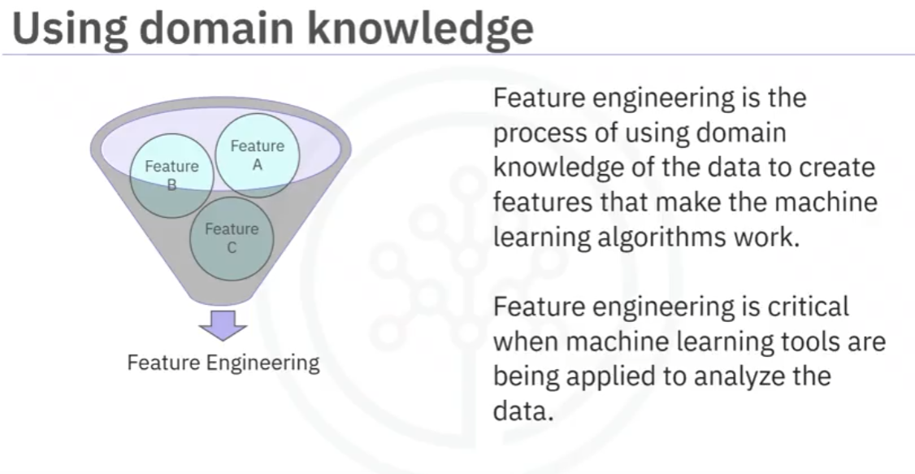

Working with text analysis
When working with text, text analysis steps for coding the data are required to be able to manipulate the data.
The data scientist needs to know what they're looking for within their dataset to address the question.
The text analysis is critical to ensure that the proper groupings are set, and that the programming is not overlooking what is hidden within.

The data preparation phase sets the stage for the next steps in addressing the question. While this phase may take a while to do, if done right the results will support the project. If this is skipped over, then the outcome will not be up to par and may have you back at the drawing board.
It is vital to take your time in this area and use the tools available to automate common steps to accelerate data preparation.
Make sure to pay attention to the detail in this area. After all, it takes just one bad ingredient to ruin a fine meal.

Data Preparation Case Study
Let's look at the case study related to applying Data Preparation concepts.
Defining congestive heart failure precisely was not straightforward.
The set of diagnosis-related group codes needed to be identified, as congestive heart failure implies certain kinds of fluid buildup. Congestive heart failure is only one type of heart failure. Clinical guidance was needed to get the right codes for congestive heart failure.
Defining the re-admission criteria for the same condition.
The timing of events needed to be evaluated to define whether a particular congestive heart failure admission was an initial event, which is called an index admission, or a congestive heart failure-related re-admission. Based on clinical expertise, a time of 30 days was set as the window for readmission relevant for congestive heart failure patients, following the discharge from the initial admission.
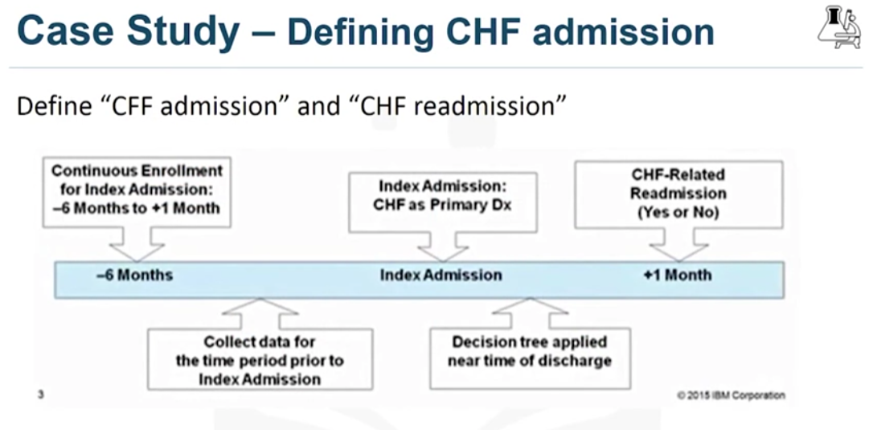
All the transactional records were aggregated to the patient level, yielding a single record for each patient, as required for the decision-tree classification method that would be used for modeling.
Transactional records included professional provider facility claims submitted for physician, laboratory, hospital, and clinical services. Also included were records describing all the diagnoses, procedures, prescriptions, and other information about in-patients and out-patients. A given patient could easily have hundreds or even thousands of these records, depending on their clinical history.
As part of the aggregation process, many new columns were created representing the information in the transactions. For example, frequency and most recent visits to doctors, clinics and hospitals with diagnoses, procedures, prescriptions, and so forth.
Co-morbidities with congestive heart failure were also considered, such as diabetes, hypertension, and many other diseases and chronic conditions that could impact the risk of re-admission for congestive heart failure.
During discussions around data preparation, a literature review on congestive heart failure was also undertaken to see whether any important data elements were overlooked, such as co-morbidities that had not yet been accounted for. The literary review involved looping back to the data collection stage to add a few more indicators for conditions and procedures.
Aggregating the transactional data at the patient level, meant merging it with the other patient data, including their demographic information, such as age, gender, type of insurance, and so forth.
The result was the creation of one table containing a single record per patient, with many columns representing the attributes about the patient in his or her clinical history. These columns would be used as variables in the predictive modeling.
Here is a list of the variables that were ultimately used in building the model.
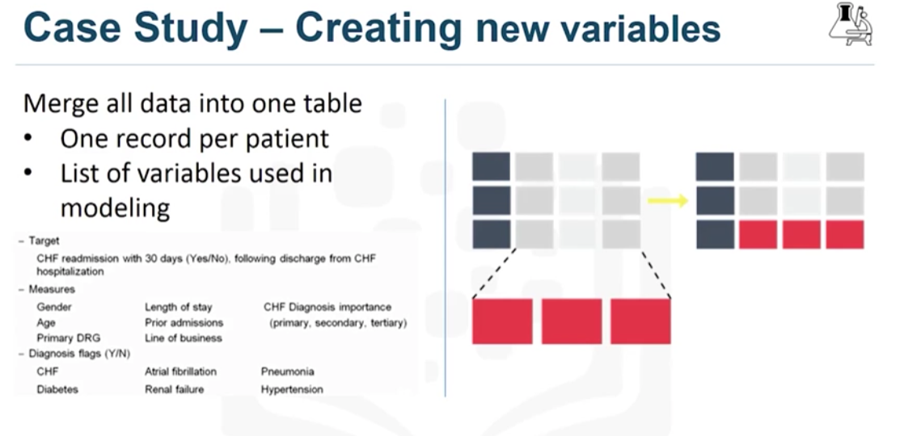
The dependent variable, or target, was congestive heart failure readmission within 30 days following discharge from a hospitalization for congestive heart failure, with an outcome of either yes or no.
The data preparation stage resulted in:
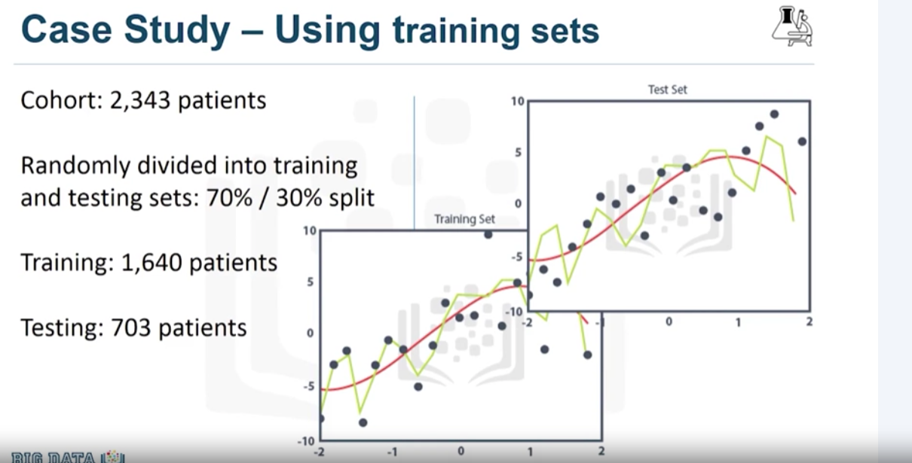

Lab From Understanding to preparation
The lab notebook
Column names is incorrect. Rename it
column_names = recipes.columns.values
column_names[0] = "cuisine"
recipes.columns = column_names

Cusine names are capitalized.
recipes["cuisine"] = recipes["cuisine"].str.lower()
Cusine names duplicated as variations.
print(sorted(list(recipes["cuisine"].unique()))) ##Asiste me to review data to normalize
recipes.loc[recipes["cuisine"] == "italy", "cuisine"] = "italian"

Remove countries with less than 50 recipes.
recipes_counts = recipes["cuisine"].value_counts()
cuisines_indices = recipes_counts > 50
rows_before = recipes.shape[0] # number of rows of original dataframe
print("Number of rows of original dataframe is {}.".format(rows_before))
recipes = recipes.loc[recipes['cuisine'].isin(cuisines_to_keep)]
rows_after = recipes.shape[0] # number of rows of processed dataframe
print("Number of rows of processed dataframe is {}.".format(rows_after))
print("{} rows removed!".format(rows_before - rows_after))

Substitute yes by 1 and no by 0
recipes = recipes.replace(to_replace="Yes", value=1)
recipes = recipes.replace(to_replace="No", value=0)

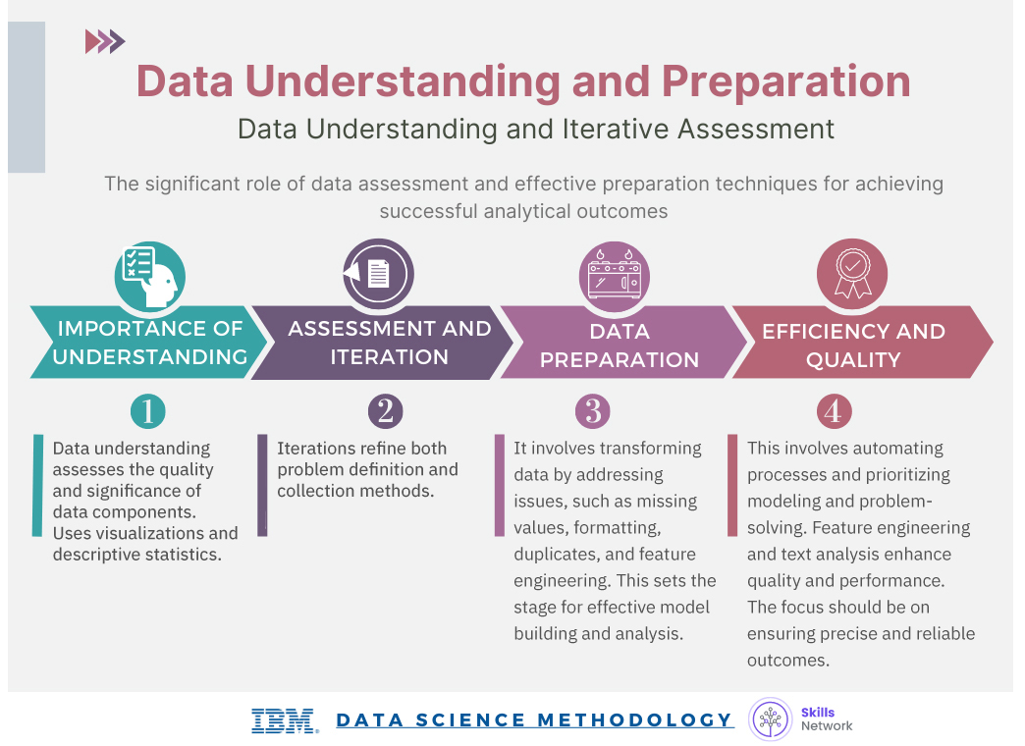

From Modeling to Evaluation.

Modeling
This portion of the course is geared toward answering two key questions:

¿What is the purpose of data modeling?

¿What are some characteristics of this process?
Data Modelling focuses on developing models that are either descriptive or predictive.
- Descriptive model: if a person did this, then they're likely to prefer that.
- Predictive model: tries to yield yes/no, or stop/go type outcomes.

These models are based on the analytic approach that was taken, either statistically driven or machine learning driven.
Use a training set for predictive modelling. A training set is a set of historical data in which the outcomes are already known. The training set acts like a gauge to determine if the model needs to be calibrated. In this stage, the data scientist will play around with different algorithms to ensure that the variables in play are actually required.

The success of data compilation, preparation and modelling, depends on the understanding of the problem at hand, and the appropriate analytical approach being taken.
The data supports the answering of the question. Constant refinement, adjustments and tweaking are necessary within each step to ensure the outcome is one that is solid.
In John Rollins' descriptive Data Science Methodology, the framework is geared to do 3 things:
- Understand the question at hand.
- Select an analytic approach or method to solve the problem.
- Obtain, understand, prepare, and model the data.
The end goal is to move the data scientist to a point where a data model can be built to answer the question.
Have I made enough to answer tje question?
In this stage of the methodology, model evaluation, deployment, and feedback loops ensure that the answer is near and relevant.
This relevance is critical to the data science field overall, as it is a fairly new field of study, and we are interested in the possibilities it has to offer.

Case Study

Parameter tuning to improve the model.

With a prepared training set, the first decision tree classification model for congestive heart failure readmission can be built.
We are looking for patients with high-risk readmission, so the outcome of interest will be congestive heart failure readmission equals "yes".

In this first model:
Overall accuracy in classifying the yes and no outcomes was 85%.
This sounds good, but it represents only 45% of the "yes".
The actual readmissions are correctly classified, meaning that the model is not very accurate.

DEFINITIONS:
Accuracy: The proportion of correct predictions made by the model.
- Interpretation: A higher accuracy indicates that the model is making more correct predictions overall.
- Caution: While accuracy is a common metric, it can be misleading, especially when dealing with imbalanced datasets. For example, if 90% of the data belongs to one class, a simple model that always predicts that class will have high accuracy, but it won't be very informative.
- Sensitivity (True Positive Rate or Recall) The proportion of actual positive cases correctly identified by the model.
  - Interpretation: A higher sensitivity indicates that the model is good at identifying positive cases.
  - Relevance: This metric is particularly important when the cost of false negatives is high. For instance, in medical diagnosis, a high sensitivity is crucial to avoid missing positive cases (e.g., not diagnosing a disease when it's present).
- Specificity (True Negative Rate)The proportion of actual negative cases correctly identified by the model.
  - Interpretation: A higher specificity indicates that the model is good at identifying negative cases.
  - Relevance: This metric is important when the cost of false positives is high. For example, in spam detection, a high specificity is crucial to avoid incorrectly classifying legitimate emails as spam.

How could the accuracy of the model be improved in predicting the yes outcome?
For decision tree classification, the best parameter to adjust is the relative cost of misclassified yes and no outcomes.

type I error, or a false-positive:
When a true, non-readmission is misclassified, and action is taken to reduce that patient's risk, the cost of that error is a wasted intervention.

type II error, or a false-negative
But when a true readmission is misclassified, and no action is taken to reduce that risk, then the cost of that error is the readmission and all its attended costs, plus the trauma to the patient.

So, we can see that the costs of the two different kinds of misclassification errors can be quite different.
For this reason, it's reasonable to adjust the relative weights of misclassifying the yes and no outcomes. The default is 1-to-1, but the decision tree algorithm allows the setting of a higher value for yes.
For the second model, the relative cost was set at 9-to-1. This is a very high ratio, but gives more insight to the model's behaviour. This time the model correctly classified 97% of the yes, but at the expense of a very low accuracy on the no, with an overall accuracy of only 49%. This was clearly not a good model. The problem with this outcome is the large number of false-positives, which would recommend unnecessary and costly intervention for patients, who would not have been re-admitted anyway.

Therefore, the data scientist needs to try again to find a better balance between the yes and no accuracies.
For the third model, the relative cost was set at a more reasonable 4-to-1. This time 68% accuracy was obtained on only yes, called sensitivity by statisticians, and 85% accuracy on the no, called specificity, with an overall accuracy of 81%.
This is the best balance that can be obtained with a rather small training set through adjusting the relative cost of misclassified yes and no outcomes parameter.
A lot more work goes into the modeling, of course, including iterating back to the data preparation stage to redefine some of the other variables, so as to better represent the underlying information, and thereby improve the model.

Evaluation
A model evaluation goes hand-in-hand with model building as such, the modeling and evaluation stages are done iteratively.

Model evaluation is performed during model development and before the model is deployed.
Evaluation allows the quality of the model to be assessed but it's also an opportunity to see if it meets the initial request.
Does the model used really answer the initial question or does it need to be adjusted?
Model evaluation can have two main phases.
- The first is the diagnostic measures phase, which is used to ensure the model is working as intended.
  - If the model is a predictive model, a decision tree can be used to evaluate if the answer the model can output is aligned to the initial design. It can be used to see where there are areas that require adjustments.
  - If the model is a descriptive model, one in which relationships are being assessed, then a testing set with known outcomes can be applied, and the model can be refined as needed.

- The second phase of evaluation that may be used is statistical significance testing. This type of evaluation can be applied to the model to ensure that the data is being properly handled and interpreted within the model. This is designed to avoid unnecessary second guessing when the answer is revealed.
Let's look at one way to find the optimal model through a diagnostic measure based on tuning one of the parameters in model building.
Specifically we'll see how to tune the relative cost of misclassifying yes and no outcomes.

Four models:
.
Each value of this model-building parameter increases the true-positive rate, or sensitivity, of the accuracy in predicting yes, at the expense of lower accuracy in predicting no, that is, an increasing false-positive rate.

Which model is best based on tuning this parameter?
For budgetary reasons, the risk-reducing intervention could not be applied to most or all congestive heart failure patients, many of whom would not have been readmitted anyway.
On the other hand, the intervention would not be as effective in improving patient care as it should be, with not enough high-risk congestive heart failure patients targeted.

How do we determine which model was optimal?
As you can see on this slide, the optimal model is the one giving the maximum separation between the blue ROC curve relative to the red base line.
We can see that model 3, with a relative misclassification cost of 4-to-1, is the best of the 4 models.
And just in case you were wondering, ROC stands for receiver operating characteristic curve, which was first developed during World War II to detect enemy aircraft on radar. It has since been used in many other fields as well.
Today it is commonly used in machine learning and data mining. The ROC curve is a useful diagnostic tool in determining the optimal classification model. This curve quantifies how well a binary classification model performs, declassifying the yes and no outcomes when some discrimination criterion is varied. In this case, the criterion is a relative misclassification cost. By plotting the true-positive rate against the false-positive rate for different values of the relative misclassification cost, the ROC curve helped in selecting the optimal model.

Hands on Lab: from Modeling to Evaluation

Create a decision tree for the recipes for just some of the Asian (Korean, Japanese, Chinese, Thai) and Indian cuisines. The reason this action is because the decision tree does not run well when the data is biased towards one cuisine or a group of cuisines, such as in this case, American cuisines. We can exclude the American cuisines from our analysis or just build decision trees for different subsets of the data. Let's go with the second solution.

FIlters the pandas dataframe over field cuisine, that has asian and indias names.
Splits the filtered subset into data subset (ingredients) and label subset (cuisine).
Construct a (3 levels) Decision tree with Ingredientes and cuisines.

The decision tree learned:
- If a recipe contains cumin and fish and no yoghurt, then it is most likely a Thai recipe.
- If a recipe contains cumin but no fish and no soy_sauce, then it is most likely an Indian recipe.
You can analyze the remaining branches of the tree to come up with similar rules for determining the cuisine of different recipes.

To evaluate the model, from the original data set of Asiatic cuisines, we removed 30 recipes from each cuisine type. We train the model again. This time with 15 levels.
To quantify how well the decision tree is able to determine the cuisine of each recipe correctly, we will create a confusion matrix which presents a nice summary on how many recipes from each cuisine are correctly classified. It also sheds some light on what cuisines are being confused with what other cuisines.
The rows represent the actual cuisines from the dataset and the columns represent the predicted ones. Each row should sum to 100%. According to this confusion matrix, we make the following observations:
- Using the first row in the confusion matrix, 50% of the Chinese recipes in bamboo_test were correctly classified by our decision tree whereas 20% of the Chinese recipes were misclassified as Korean and 10% were misclassified as Indian.
- Using the Indian row, 93,33% of the Indian recipes in bamboo_test were correctly classified by our decision tree and 3,33% of the Indian recipes were misclassified as Chinese and 3,33% were misclassified as Thai.

Lesson Summary

Module 3: From Deployment to Feedback and Final Evaluation.

Deployment
While a data science model will provide an answer, the key to making the answer relevant and useful to address the initial question involves getting the stakeholders familiar with the tool produced.
In a business scenario, stakeholders have different specialties that will help make this happen, such as the solution owner, marketing, application developers, and IT administration.
Once the model is evaluated and the data scientist is confident it will work, it is deployed and put to the ultimate test.
To build up confidence in applying the outcome for use across the board, depending on the purpose of the model, it may be rolled out to:
- a limited group of users.
- a test environment.

Case study related to applying Deployment"
In preparation for solution deployment, the next step was to assimilate the knowledge for the business group who would be designing and managing the intervention program to reduce readmission risk.
In this scenario, the (DA-team's) businesspeople translated the model results so that the clinical staff could understand how to identify high-risk patients and design suitable intervention actions. The goal, of course, was to reduce the likelihood that these patients would be readmitted within 30 days after discharge.
During the business requirements stage, the Intervention Program Director and her team had wanted an application that would provide automated, near real-time risk assessments of congestive heart failure. It also had to be easy for clinical staff to use, and preferably through browser-based application on a tablet, that each staff member could carry around.
This patient data was generated throughout the hospital stay. It would be automatically prepared in a format needed by the model and each patient would be scored near the time of discharge.
Clinicians would then have the most up-to-date risk assessment for each patient, helping them to select which patients to target for intervention after discharge.
As part of solution deployment, the Intervention team would develop and deliver training for the clinical staff.
Also, processes for tracking and monitoring patients receiving the intervention would have to be developed in collaboration with IT developers and database administrators, so that the results could go through the feedback stage and the model could be refined over time.

Example 1: Solution Deployment
This map is an example of a solution deployed through a Cognos application. In this case, the case study was hospitalization risk for patients with juvenile diabetes. Like the congestive heart failure use case, this one used decision tree classification to create a risk model that would serve as the foundation for this application.
The map gives an overview of hospitalization risk nationwide, with an interactive analysis of predicted risk by a variety of patient conditions and other characteristics.

Example 2: Solution Deployment
This slide shows an interactive summary report of risk by patient population within a given node of the model, so that clinicians could understand the combination of conditions for this subgroup of patients.

Example 3: Solution Deployment
And this report gives a detailed summary of an individual patient, including the patient's predicted risk and details about the clinical history, giving a concise summary for the doctor.

Feedback
Once in play, feedback from the users will help to refine the model and assess it for performance and impact.
The value of the model will be dependent on successfully incorporating feedback and adjusting for as long as the solution is required.
Throughout the Data Science Methodology, each step sets the stage for the next. Making the methodology cyclical ensures refinement at each stage in the game.
The feedback process is rooted in the notion that, the more you know, the more that you'll want to know. That's the way John Rollins sees it and hopefully you do too.
Once the model is evaluated and the data scientist is confident it'll work, it is deployed and put to the ultimate test: actual, real-time use in the field.

case study
The plan for the feedback stage included these steps:
- First, the review process would be defined and put into place, with overall responsibility for measuring the results of a "flying to risk" model of the congestive heart failure risk population. Clinical management executives would have overall responsibility for the review process.
- Second, congestive heart failure patients receiving intervention would be tracked and their re-admission outcomes recorded.
- Third, the intervention would then be measured to determine how effective it was in reducing re-admissions. For ethical reasons, congestive heart failure patients would not be split into controlled and treatment groups. Instead, readmission rates would be compared before and after the implementation of the model to measure its impact.

After the deployment and feedback stages, the impact of the intervention program on re-admission rates would be reviewed after the first year of its implementation.
Then the model would be refined, based on all the data compiled after model implementation and the knowledge gained throughout these stages.
Other refinements included: Incorporating information about participation in the intervention program and possibly refining the model to incorporate detailed pharmaceutical data. If you recall, data collection was initially deferred because the pharmaceutical data was not readily available at the time. But after feedback and practical experience with the model, it might be determined that adding that data could be worth the investment of effort and time.
We also must allow for the possibility that other refinements might present themselves during the feedback stage.

Also, the intervention actions and processes would be reviewed and very likely refined as well, based on the experience and knowledge gained through initial deployment and feedback.
Finally, the refined model and intervention actions would be redeployed, with the feedback process continued throughout the life of the Intervention program.

StroyTelling

What role does storytelling play in data analysis?

Richier Zitome, Data Scientist, Coursera
The role of storytelling in a data analyst's life cannot be overstated. It's supercritical to get really good at storytelling with data. I think
Humans naturally understand the world through stories.
To convince anyone to do anything with data, the first thing you must do is tell a clear, concise, compelling story.
A story helps data analysts to better understand the underlying dataset and what it's doing.
It is critical to find a balance between telling a clear, coherent, simple story, and making sure you're conveying all the complexities that you might find within the data.

Asha Barnes, Director of Market Analytics, Promedica
The art of storytelling is significant in the life of a data analyst.
It doesn't matter how much or what wonderful information you've come up with. If you can't find a way to communicate that to your audience, whether it's the consumer or a director level or executive level person, then it's for naught.
You must find a way to communicate that and it's usually best to do it visually or through telling a story, so that they understand how that information can be useful.

Erin Huang, Data Analyst
I have to say storytelling is an essential skill set. It's like the last mile in delivery.
A lot of people can handle the technical side through a short period of training.
However, the ability to extract value from data and to communicate it is in short supply. If you think about a long-term career, I think it's very critically to know how to tell a compelling story with data.

Kevin McFaul, Principal Offering Manager Cognos Analytics, IBM
Storytelling is crucial to data and analytics.
This is how you convey your message. Everyone can show numbers, but if you don't have a story around, if you don't have a compelling reason to act, then ultimately what you're presenting isn't going to resonate with your audience.

They did a study at Stanford where they had people present their pitches and, in that pitch, they had simply KPIs, numbers of statistics but they also told the story.
The audience members were then quizzed after the fact, what they remembered from each of those presentations, and it was those stories that stuck with them. Yes, there were still facts and figures contained within the story, but that is the way that you drive it home.
Having that emotional connection to the story, to the understanding, to the data is how you're going to get people to take the action that you want and need them to take.

Course summary

You've learned how to think like a data scientist, including taking the steps involved in tackling a data science problem and applying them to interesting, real-world examples.
These steps have included:
- Forming a concrete business or research problem.
- Collecting and analyzing data.
- Building a model.
- Understanding the feedback after model deployment.
In this course, you've also learned methodical ways of moving from problem to approach, including the importance of understanding the question, the business goals and objectives, and picking the most effective analytic approach to answer the question and solve the problem.
You've also learned methodical ways of working with the data, specifically, determining the data requirements, collecting the appropriate data, understanding the data, and then preparing the data for modeling!
You've also learned how to model the data by using the appropriate analytic approach, based on the data requirements and the problem that you were trying to solve
Once the approach was selected, you learned the steps involved in evaluating and deploying the model, getting feedback on it, and using that feedback constructively to improve the model.
Remember that the stages of this methodology are iterative! This means that the model can always be improved for as long as the solution is needed, regardless of whether the improvements come from constructive feedback, or from examining newly available data sources.
Using a real case study, you learned how data science methodology can be applied in context, toward successfully achieving the goals that were set out in the business requirements stage.
You also saw how the methodology contributed additional value to business units by incorporating data science practices into their daily analysis and reporting functions.
The success of this new pilot program that was reviewed in the case study was evident by the fact that physicians were able to deliver better patient care by using new tools to incorporate timely data-driven information into patient care decisions.
And finally, you learned, in a nutshell, the true meaning of a methodology! That its purpose is to explain how to look at a problem, work with data in support of solving the problem, and come up with an answer that addresses the root problem.
By answering 10 simple questions methodically, we've taught you that a methodology can help you solve not only your data science problems, but also any other problem.
Your success within the data science field depends on your ability to apply the right tools, at the right time, in the right order, to address the right problem.
And that is the way John Rollins sees it!

Module Summary

Module 4: Final Project and Assessment

Final Project

Introduction to CRISP-DM

CRISP-DM, which stands for Cross-Industry Standard Process for Data Mining.
CRISP-DM is an industry-proven way to guide your data mining efforts.
CRISP-DM is an iterative data mining model and is a comprehensive methodology for data mining projects which provides a structured approach to guide data-driven decision making.
As a data methodology, a study of the CRISP-DM model includes six data mining stages, their descriptions and provides explanations of the relationships between tasks and stages.
And as a process model, CRISP-DM provides high-level insights into the data mining cycle.
CRISP-DM requires flexibility at each stage, and communication with peers, management, and stakeholders to keep the project on track.
After any of the following six stages, data scientists might need to revisit an earlier stage and make changes.

The business understanding stage
This stage sets and outlines the intentions of the data analysis project.
This stage is common to both John Rollins data science methodology, and CRISP-DM methodology.
This stage requires communication and clarity to overcome stakeholders 'differing objectives, biases, and information related modalities. Without a clear concise and complete understanding of the business problem and project goals, the project effort will waste time and resources.

The data understanding Stage
Then, CRISP-DM combines the stages of data requirements, data collection, and data understanding from Johns Rollins methodology outline into a single data understanding stage.
During this stage, data scientists decide on data sources and acquire data.

The data preparation stage
Data scientists transform the collected data into a usable data subset and determine if they need more data. With data collection complete, data scientists select a dataset and address questionable missing or ambiguous data values.
This stage is common to both John Rollins data science methodology, and CRISP-DM methodology.
The modeling stage
The modeling stage fulfills the purpose of data mining and creates data models that reveal patterns and structures within the data.
These patterns and structures provide knowledge and insights that address the stated business problems and goals.
Data scientists select models based on subsets of the data and adjust the models as needed.
Model selection is art and science.
Both foundational methodology and CRISP-DM focus on creating knowledge information that has meaning and utility.

The evaluation Stage.
During the evaluation stage, data scientists test the selected model.
Data scientists usually prepare a pre-selected test to run the trained model. The test platform sees the data as new and data scientists then assess the model's effectiveness. These testing results determine the model's efficacy and foreshadow the model's role in the next and final stage.

The deployment Stage
Finally, during the deployment stage, data scientists and stakeholders use the model on new data outside of the scope of the dataset.
New interactions during this stage might reveal the new variables and need for a different dataset and model.
Remember that the CRISP-DM model is iterative and cyclical, deployment results might initiate revisions to the business needs and actions, the model and data, or any combination of these items.

Discussing the results
After completing all six stages, you'll have another business understanding meeting with the stakeholders to discuss the results. In CRISP-DM, the stage is not named. However, in John Rollins Data Science methodology model, the stage is explicitly named the Feedback stage.

You'll continue the CRISP-DM process stages until the stakeholders, management, and you agree that the data model and its analysis provide the stakeholders with the answers they need to resolve their business problems and attain their business goals.

Course Summary and Final Quiz

Review what you learned
After completing this course, you learned many facts about data science methodology. Here are 14 key, high-level takeaway facts you’ll want to remember from this course.
- Foundational methodology, a cyclical, iterative data science methodology developed by John Rollins, consists of 10 stages, starting with Business Understanding and ending with Feedback.
- CRISP-DM, an open-source data methodology, combines several data-related methodology stages into one stage and omits the Feedback stage resulting in a six-stage data methodology.
- The primary goal of the Business Understanding stage is to understand business problems and determine the data needed to answer the core business question.
- During the Analytic Approach stage, you can choose from descriptive diagnostic, predictive, and prescriptive analytic approaches and whether to use machine learning techniques.
- During the Data Requirements stage, scientists identify the correct and necessary data content, formats, and sources needed for the specific analytical approach.
- During the Data Collection stage, expert data scientists revise data requirements and make critical decisions regarding the quantity and quality of data. Data scientists apply descriptive statistics and visualization techniques to thoroughly assess the content, quality, and initial insights gained from the collected data, identify gaps, and determine if new data is needed, or if they should substitute existing data.
- The Data Understanding stage encompasses all activities related to constructing the data set. This stage answers the question of whether the collected data represents the data needed to solve the business problem. Data scientists might use descriptive statistics, predictive statistics, or both.
- Data scientists commonly apply Hurst, univariates, and statistics such as mean, median, minimum, maximum, standard deviation, pairwise correlation, and histograms.
- During the Data Preparation stage, data scientists must address missing or invalid values, remove duplicates, and validate that the data is properly formatted. Feature engineering and text analysis are key techniques data scientists apply to validate and analyze data during the Data Preparation stage.
- The end goal of the Modeling stage is that the data model answers the business question. During the Modeling stage, data scientists use a training data set. Data scientists test multiple algorithms on the training set data to determine whether the variables are required and whether the data supports answering the business question. The outcome of those models is either descriptive or predictive.
- The Evaluation stage consists of two phases, the diagnostic measures phase, and the statistical significance phase. Data scientists and others assess the quality of the model and determine if the model answers the initial Business Understanding question or if the data model needs adjustment.
- During the Deployment stage, data scientists release the data model to a targeted group of stakeholders, including solution owners, marketing staff, application developers, and IT administration.,
- During the Feedback stage, stakeholders and users evaluate the model and contribute feedback to assess the model’s performance.
- The data model’s value depends on its ability to iterate; that is, how successfully the data model incorporates user feedback.

Course wrap up

Term | Definition
Analytic Approach | The process of selecting the appropriate method or path to address a specific data science question or problem.
Analytics | The systematic analysis of data using statistical, mathematical, and computational techniques to uncover insights, patterns, and trends.
Business Understanding | The initial phase of data science methodology involves seeking clarification and understanding the goals, objectives, and requirements of a given task or problem.
Clustering Association | An approach used to learn about human behavior and identify patterns and associations in data.
Cohort | A group of individuals who share a common characteristic or experience is studied or analyzed as a unit.
Cohort study | An observational study where a group of individuals with a specific characteristic or exposure is followed over time to determine the incidence of outcomes or the relationship between exposures and outcomes.
Congestive Heart Failure (CHF) | A chronic condition in which the heart cannot pump enough blood to meet the body's needs, resulting in fluid buildup and symptoms such as shortness of breath and fatigue.
CRISP-DM | Cross-Industry Standard Process for Data Mining is a widely used methodology for data mining and analytics projects encompassing six phases: business understanding, data understanding, data preparation, modeling, evaluation, and deployment.
Data analysis | The process of inspecting, cleaning, transforming, and modeling data to discover useful information, draw conclusions, and support decision-making.
Data cleansing | The process of identifying and correcting or removing errors, inconsistencies, or inaccuracies in a dataset to improve its quality and reliability
Data science | An interdisciplinary field that combines scientific methods, processes, algorithms, and systems to extract knowledge and insights from structured and unstructured data.
Data science methodology | A structured approach to solving business problems using data analysis and data-driven insights.
Data scientist | A professional using scientific methods, algorithms, and tools to analyze data, extract insights, and develop models or solutions to complex business problems.
Data scientists | Professionals with data science and analytics expertise who apply their skills to solve business problems.
Data-Driven Insights | Insights derived from analyzing and interpreting data to inform decision-making
Decision tree | A supervised machine learning algorithm that uses a tree-like structure of decisions and their possible consequences to make predictions or classify instances.
Decision Tree Classification Model | A model that uses a tree-like structure to classify data based on conditions and thresholds provides predicted outcomes and associated probabilities.
Decision Tree Classifier | A classification model that uses a decision tree to determine outcomes based on specific conditions and thresholds.
Decision-Tree Model | A model used to review scenarios and identify relationships in data, such as the reasons for patient readmissions
Descriptive approach | An approach used to show relationships and identify clusters of similar activities based on events and preferences
Descriptive modeling | Modeling technique that focuses on describing and summarizing data, often through statistical analysis and visualization, without making predictions or inferences
Domain knowledge | Expertise and understanding of a specific subject area or field, including its concepts, principles, and relevant data
Goals and objectives | The sought-after outcomes and specific objectives that support the overall goal of the task or problem.
Iteration | A single cycle or repetition of a process often involves refining or modifying a solution based on feedback or new information.
Iterative process | A process that involves repeating a series of steps or actions to refine and improve a solution or analysis. Each iteration builds upon the previous one.
Leaf | The final nodes of a decision tree where data is categorized into specific outcomes.
Machine Learning | A field of study that enables computers to learn from data without being explicitly programmed, identifying hidden relationships and trends.
Mean | The average value of a set of numbers is calculated by summing all the values and dividing by the total number of values.
Median | When arranged in ascending or descending order, the middle value in a set of numbers divides the data into two equal halves.
Model (Conceptual model) | A simplified representation or abstraction of a real-world system or phenomenon used to understand, analyze, or predict its behavior.
Model building | The process of developing predictive models to gain insights and make informed decisions based on data analysis.
Pairwise comparison (correlation) | A statistical technique that measures the strength and direction of the linear relationship between two variables by calculating a correlation coefficient.
Pattern | A recurring or noticeable arrangement or sequence in data can provide insights or be used for prediction or classification.
Predictive model | A model used to determine probabilities of an action or outcome based on historical data.
Predictors | Variables or features in a model that are used to predict or explain the outcome variable or target variable.
Prioritization | The process of organizing objectives and tasks based on their importance and impact on the overall goal.
Problem solving | The process of addressing challenges and finding solutions to achieve desired outcomes.
Stakeholders | Individuals or groups with a vested interest in the data science model's outcome and its practical application, such as solution owners, marketing, application developers, and IT administration.
Standard deviation | A measure of the dispersion or variability of a set of values from their mean; It provides information about the spread or distribution of the data.
Statistical analysis | Stand deviations are applied to problems that require counts, such as yes/no answers or classification tasks.
Statistics | The collection, analysis, interpretation, presentation, and organization of data to understand patterns, relationships, and variability in the data.
Structured data (data model) | Data organized and formatted according to a predefined schema or model and is typically stored in databases or spreadsheets.
Text analysis data mining | The process of extracting useful information or knowledge from unstructured textual data through techniques such as natural language processing, text mining, and sentiment analysis.
Threshold value | The specific value used to split data into groups or categories in a decision tree.
Analytics team | A group of professionals, including data scientists and analysts, responsible for performing data analysis and modeling.
Data collection | The process of gathering data from various sources, including demographic, clinical, coverage, and pharmaceutical information.
Data integration | The merging of data from multiple sources to remove redundancy and prepare it for further analysis.
Data Preparation | The process of organizing and formatting data to meet the requirements of the modeling technique.
Data Requirements | The identification and definition of the necessary data elements, formats, and sources required for analysis.
Data Understanding | A stage where data scientists discuss various ways to manage data effectively, including automating certain processes in the database.
DBAs (Database Administrators) | The professionals who are responsible for managing and extracting data from databases.
Decision tree classification | A modeling technique that uses a tree-like structure to classify data based on specific conditions and variables.
Demographic information | Information about patient characteristics, such as age, gender, and location.
Descriptive statistics | Techniques used to analyze and summarize data, providing initial insights and identifying gaps in data.
Intermediate results | Partial results obtained from predictive modeling can influence decisions on acquiring additional data.
Patient cohort | A group of patients with specific criteria selected for analysis in a study or model.
Predictive modeling | The building of models to predict future outcomes based on historical data.
Training set | A subset of data used to train or fit a machine learning model; consists of input data and corresponding known or labeled output values.
Unavailable data | Data elements are not currently accessible or integrated into the data sources.
Univariate | Modeling analysis focused on a single variable or feature at a time, considering its characteristics and relationship to other variables independently.
Unstructured data | Data that does not have a predefined structure or format, typically text images, audio, or video, requires special techniques to extract meaning or insights.
Visualization | The process of representing data visually to gain insights into its content and quality.
Automation | Using tools and techniques to streamline data collection and preparation processes.
Data Collection | The phase of gathering and assembling data from various sources.
Data Compilation | The process of organizing and structuring data to create a comprehensive data set.
Data Formatting | The process of standardizing the data to ensure uniformity and ease of analysis.
Data Manipulation | The process of transforming data into a usable format.
Data Preparation | The phase where data is cleaned, transformed, and formatted for further analysis, including feature engineering and text analysis.
Data Preparation | The stage where data is transformed and organized to facilitate effective analysis and modeling.
Data Quality | Assessment of data integrity and completeness, addressing missing, invalid, or misleading values.
Data Quality Assessment | The evaluation of data integrity, accuracy, and completeness.
Data Set | A collection of data used for analysis and modeling.
Data Understanding | The stage in the data science methodology focused on exploring and analyzing the collected data to ensure that the data is representative of the problem to be solved.
Descriptive Statistics | Summary statistics that data scientists use to describe and understand the distribution of variables, such as mean, median, minimum, maximum, and standard deviation.
Feature | A characteristic or attribute within the data that helps in solving the problem.
Feature Engineering | The process of creating new features or variables based on domain knowledge to improve machine learning algorithms' performance.
Feature Extraction | Identifying and selecting relevant features or attributes from the data set.
Interactive Processes | Iterative and continuous refinement of the methodology based on insights and feedback from data analysis.
Missing Values | Values that are absent or unknown in the dataset, requiring careful handling during data preparation.
Model Calibration | Adjusting model parameters to improve accuracy and alignment with the initial design.
Pairwise Correlations | An analysis to determine the relationships and correlations between different variables.
Text Analysis | Steps to analyze and manipulate textual data, extracting meaningful information and patterns.
Text Analysis Groupings | Creating meaningful groupings and categories from textual data for analysis.
Visualization techniques | Methods and tools that data scientists use to create visual representations or graphics that enhance the accessibility and understanding of data patterns, relationships, and insights.
Term | Definition
Binary classification model | A model that classifies data into two categories, such as yes/no or stop/go outcomes.
Data compilation | The process of gathering and organizing data required for modeling.
Data modeling | The stage in the data science methodology where data scientists develop models, either descriptive or predictive, to answer specific questions.
Descriptive model | A type of model that examines relationships between variables and makes inferences based on observed patterns.
Diagnostic measure based tuning | The process of fine-tuning the model by adjusting parameters based on diagnostic measures and performance indicators.
Diagnostic measures | The evaluation of a model's performance of a model to ensure that the model functions as intended.
Discrimination criterion | A measure used to evaluate the performance of the model in classifying different outcomes.
False-positive rate | The rate at which the model incorrectly identifies negative outcomes as positive.
Histogram | A graphical representation of the distribution of a dataset, where the data is divided into intervals or bins, and the height of each bar represents the frequency or count of data points falling within that interval.
Maximum separation | The point where the ROC curve provides the best discrimination between true-positive and false-positive rates, indicating the most effective model.
Model evaluation | The process of assessing the quality and relevance of the model before deployment.
Optimal model | The model that provides the maximum separation between the ROC curve and the baseline, indicating higher accuracy and effectiveness.
Receiver Operating Characteristic (ROC) | Originally developed for military radar, the military used this statistical curve to assess the performance of binary classification models.
Relative misclassification cost | This measurement is a parameter in model building used to tune the trade-off between true-positive and false-positive rates.
ROC curve (Receiver Operating Characteristic curve) | A diagnostic tool used to determine the optimal classification model's performance.
Separation | Separation is the degree of discrimination achieved by the model in correctly classifying outcomes.
Statistical significance testing | Evaluation technique to verify that data is appropriately handled and interpreted within the model.
True-positive rate | The rate at which the model correctly identifies positive outcomes.
Browser-based application | An application that users access through a web browser, typically on a tablet or other mobile device, to provide easy access to the model's insights.
Cyclical methodology | An iterative approach to the data science process, where each stage informs and refines the subsequent stages.
Data collection refinement | The process of obtaining additional data elements or information to improve the model's performance.
Data science model | The result of data analysis and modeling provides answers to specific questions or problems.
Feedback | The process of obtaining input and comments from users and stakeholders to refine and improve the data science model.
Model refinement | The process of adjusting and improving the data science model based on user feedback and real-world performance.
Redeployment | The process of implementing a refined model and intervention actions after incorporating feedback and improvements.
Review process | The systematic assessment and evaluation of the data science model's performance and impact.
Solution deployment | The process of implementing and integrating the data science model into the business or organizational workflow.
Solution owner | The individual or team responsible for overseeing the deployment and management of the data science solution.
Stakeholders | Individuals or groups with a vested interest in the data science model's outcome and its practical application, such as solution owners, marketing, application developers, and IT administration.
Storytelling | Storytelling is the art of conveying your message, or ideas through a narrative structure that engages, entertains, and resonates with the audience.
Test environment | A controlled setting where the data science model is evaluated and refined before full-scale implementation.

