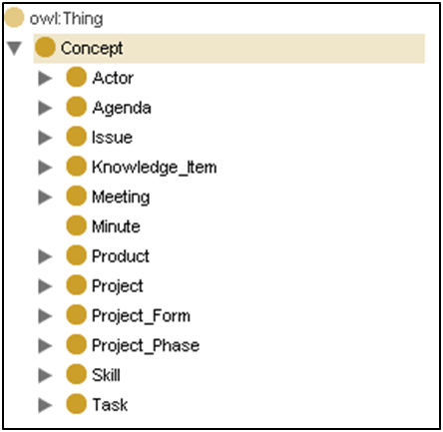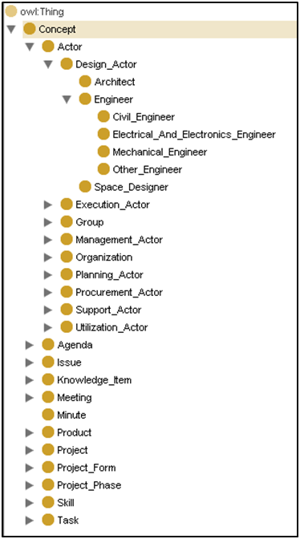

a) Concept Sub-Classes

b) Path into Engineer Sub-Classes

**OWL**

**Interconnections**

**Domain knowledge**

**RDF**

**Connections**

**XML**

**Base structure**